EngineerTrack
User Guide
Gamified internship tracking for engineering students
July 2026

Contents

1. Introduction
EngineerTrack is a mobile application that helps engineering students document their internship day by day, while mentors and academic advisors review, rate, and validate that work. A gamification layer (XP points, levels, badges, and a leaderboard) keeps students motivated throughout the internship.
The app supports seven languages (English, Turkish, Greek, Italian, Romanian, German, and Serbian) and four user roles:
Role | Who it is | What they do in the app
Student | Intern at a company | Writes daily logs with photos and a self-assessment, earns XP and badges, follows their progress
Mentor | Company supervisor | Reviews submitted logs, rates competencies, gives written feedback, approves or requests revision
Advisor | University professor | Validates mentor-approved logs, monitors compliance, exports reports
Admin | Institution administrator | Creates the institution and departments, distributes join codes, oversees all users

A daily log travels through the following lifecycle:
Draft → Submitted (student) → Approved (mentor) → Validated (advisor). A mentor can also request a revision, which sends the log back to the student.

2. Getting Started

2.1 Choosing your language
When you first open EngineerTrack, you can pick the interface language from the Login screen by tapping the Language button at the bottom. Your choice is saved to your profile after you sign in, so the app remembers it on every device.

2.2 Signing in
Enter the e-mail address and password you registered with and tap Login. Use "Forgot Password?" if you need to reset your password by e-mail.
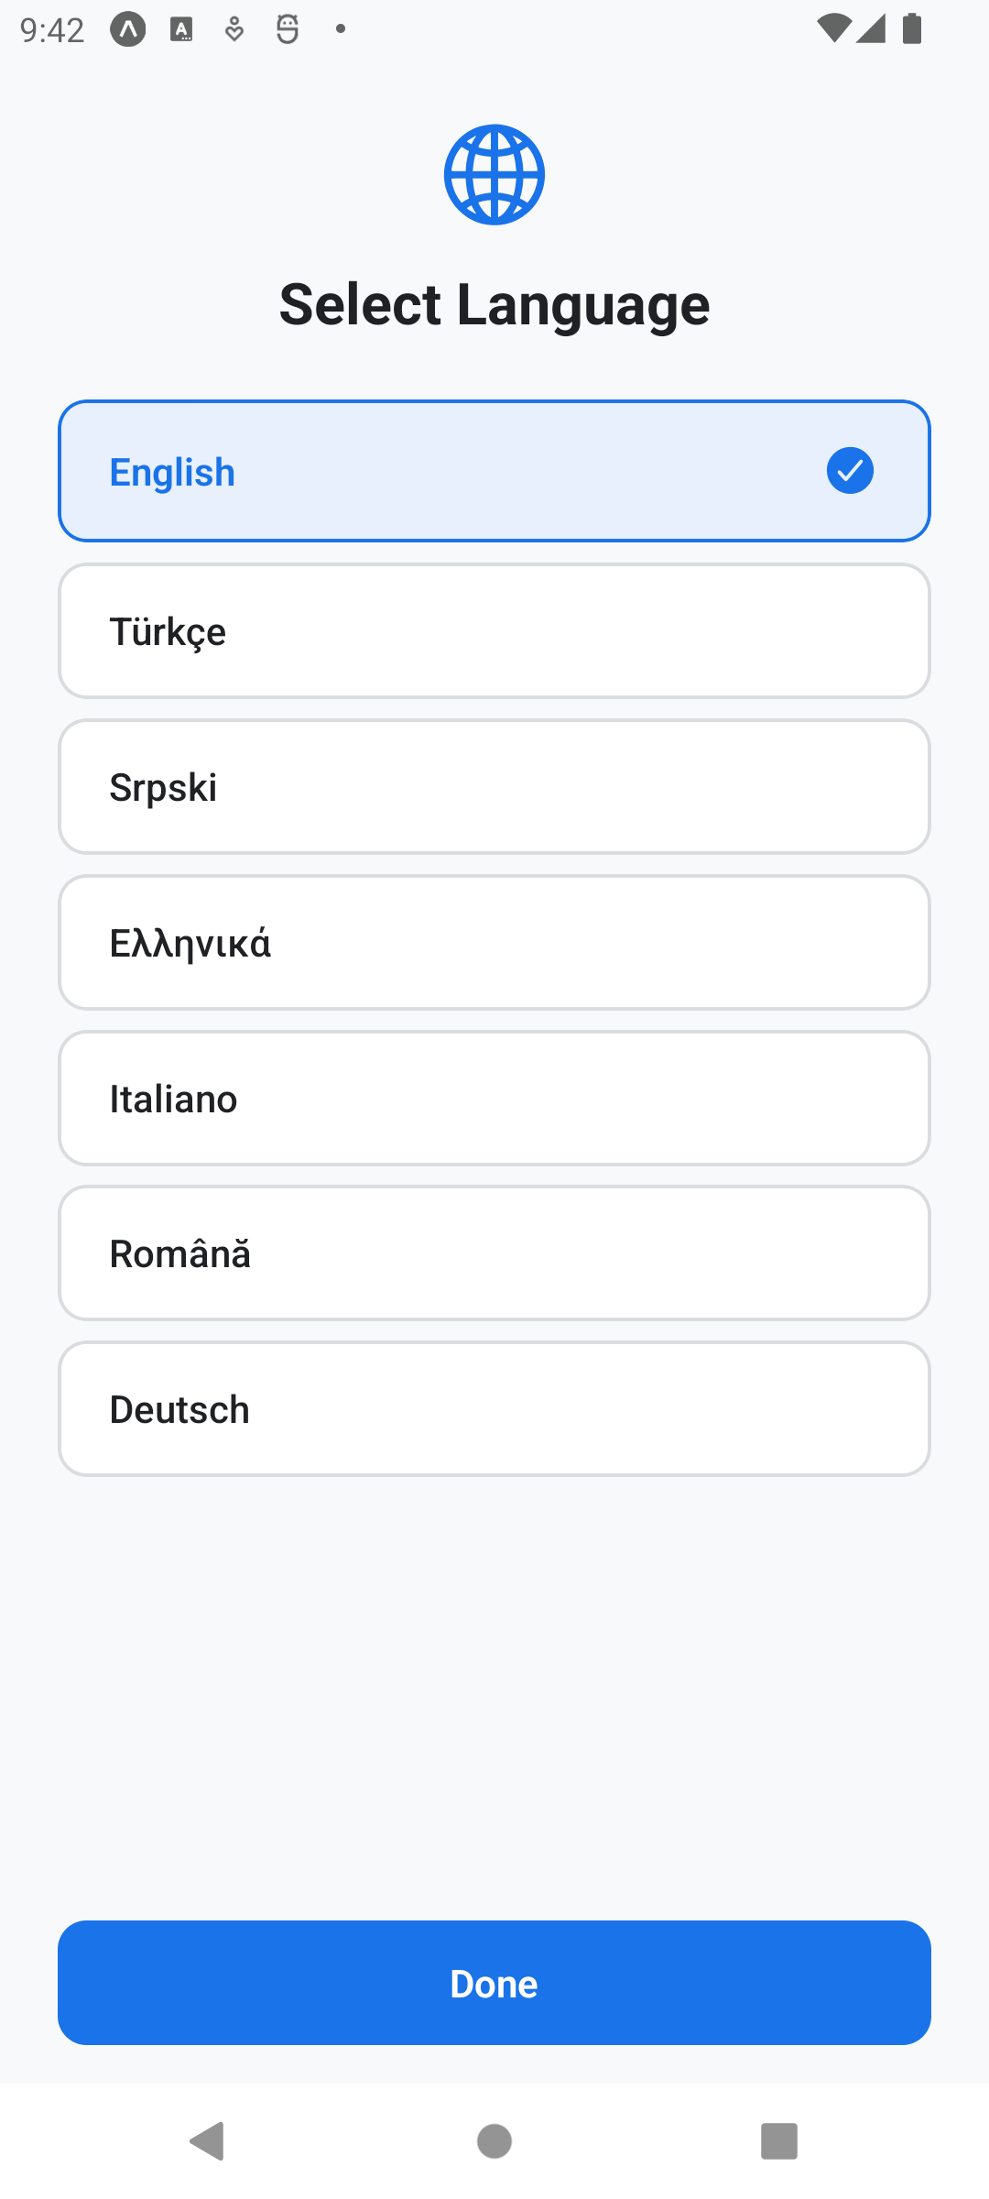  Figure 1. Language selection screen | 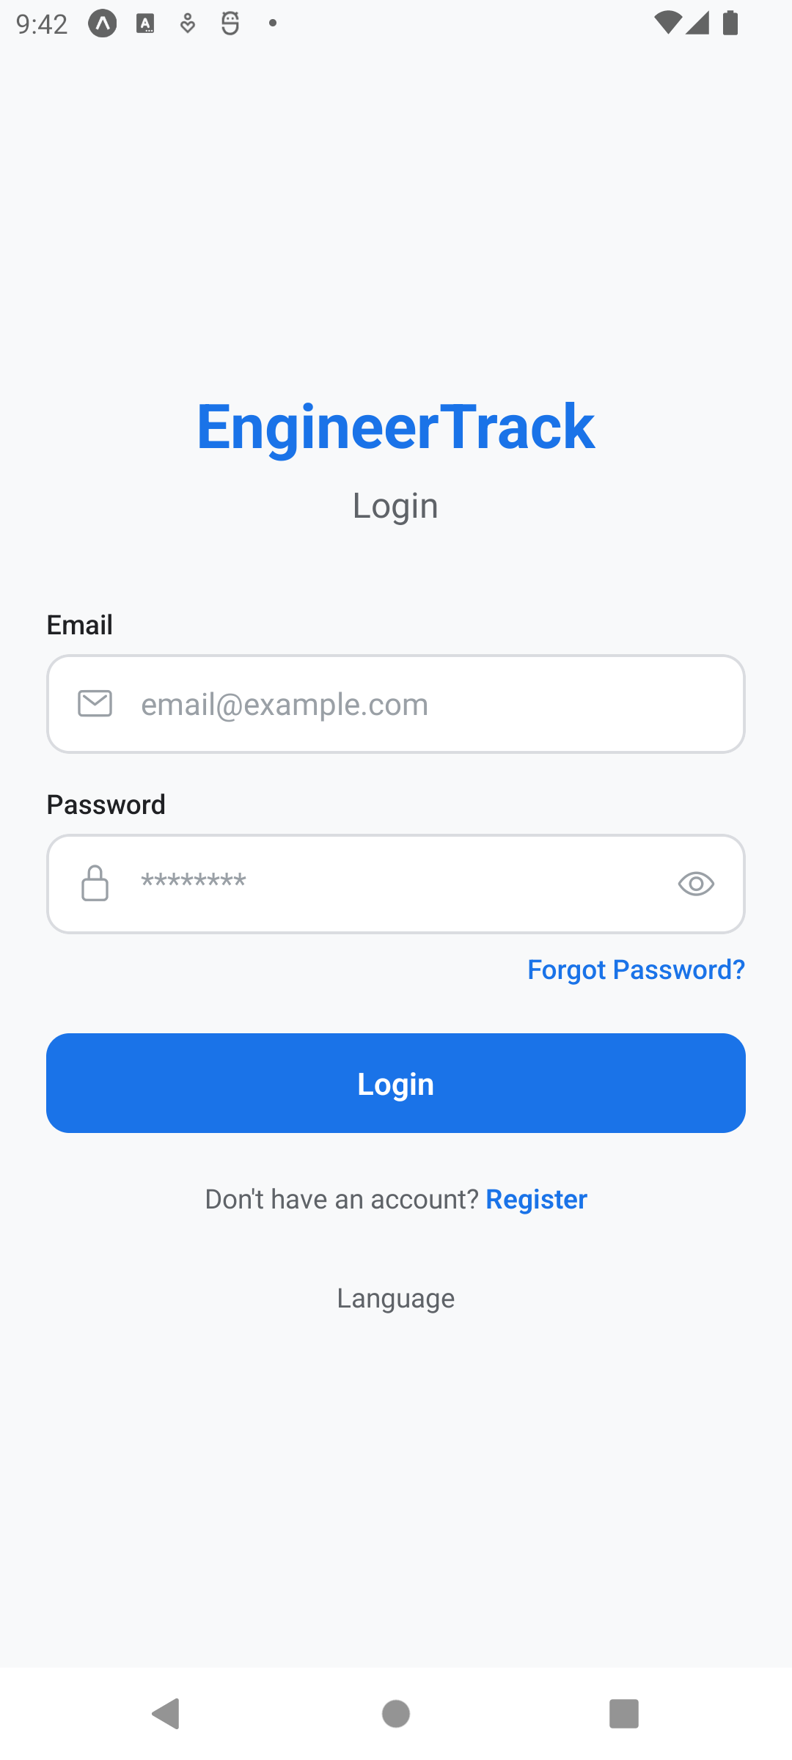  Figure 2. Login screen

2.3 Creating an account
Tap Register on the Login screen and fill in your name, e-mail, and a password (at least 6 characters). Then choose your role. Administrators must additionally provide an institutional (.edu) e-mail address.
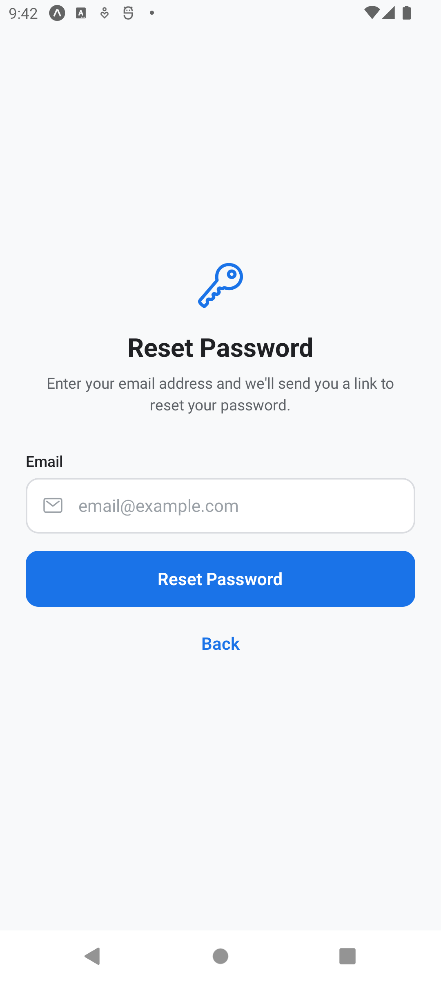  Figure 3. Password reset screen | 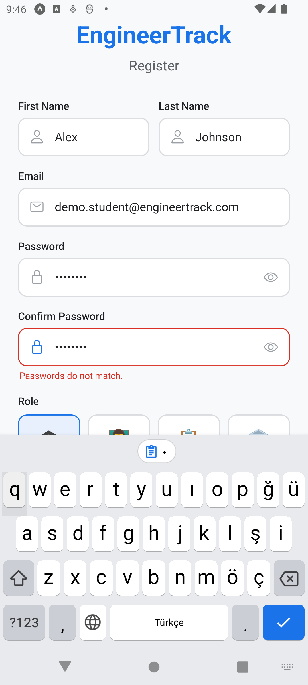  Figure 4. Registration with role selection

3. Student Guide

3.1 Completing your internship information
Right after registering, students are asked to complete their internship information: university, faculty, department, student ID, and the company where the internship takes place, including its address, sector, and the internship start and end dates. This information appears in your profile and in your advisor’s reports.
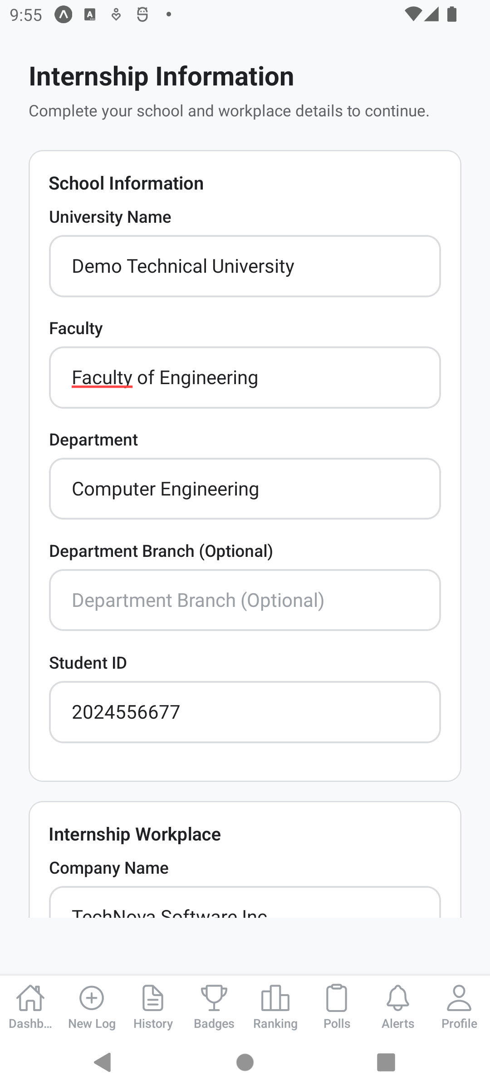  Figure 5. School and workplace details | 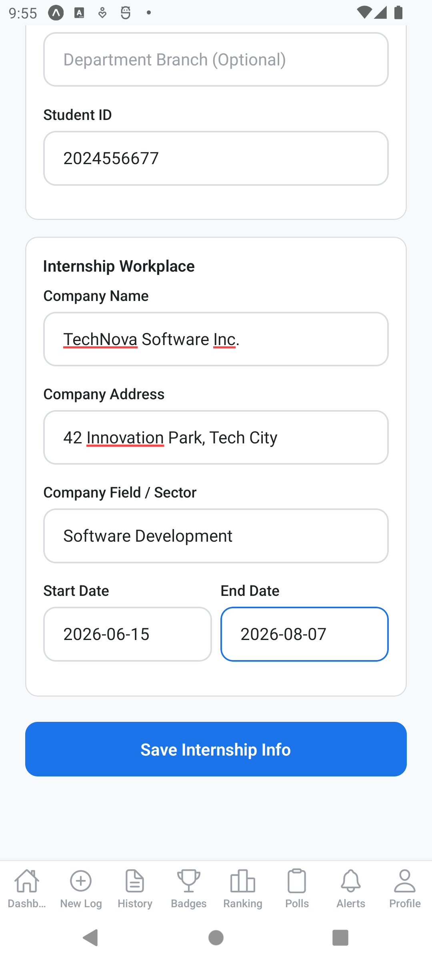  Figure 6. Company sector and internship dates

3.2 Joining your department
Your institution’s administrator will give you a 6-character department code. Open Profile, scroll to "Join Department", enter the code, and tap Join. This links your account to your university, which is required before an advisor can follow your internship.

3.3 The dashboard
The dashboard is your home screen. It shows your total XP, current level, daily streak, and completion rate, along with an XP progress bar toward the next level and a shortcut to create today’s log.
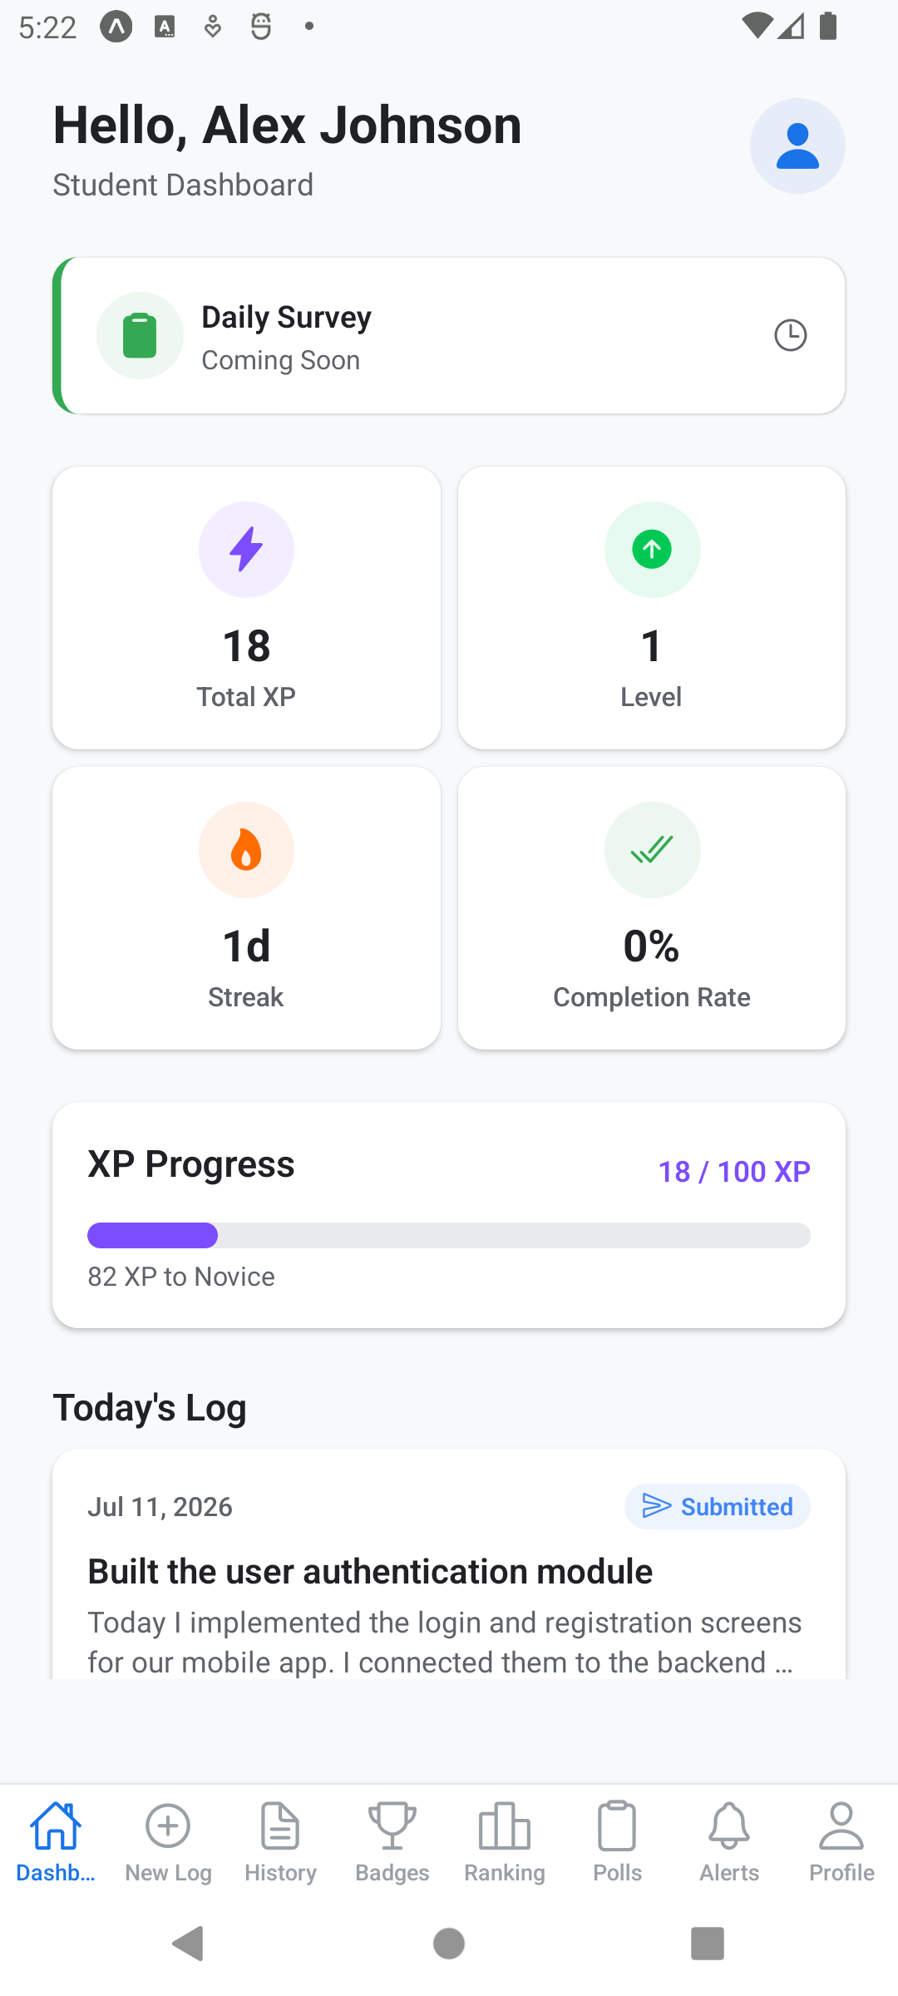
Figure 7. Student dashboard

3.4 Creating a daily log
Tap New Log in the tab bar. A complete log contains:
- Title and content – what you worked on today (content must be at least 50 characters)
- Activities performed, skills learned, and challenges faced
- A personal reflection – a short journal-style note about your day
- Time spent – hours and minutes worked
- At least one photo of your work (up to 5), and optionally up to 3 documents
- A self-assessment – rate yourself from 1 to 5 stars on eight competencies
The Submission Checklist at the bottom of the form tracks these requirements. The Submit Log button stays disabled until every item on the checklist turns green. You can always tap Save Draft and finish the log later.
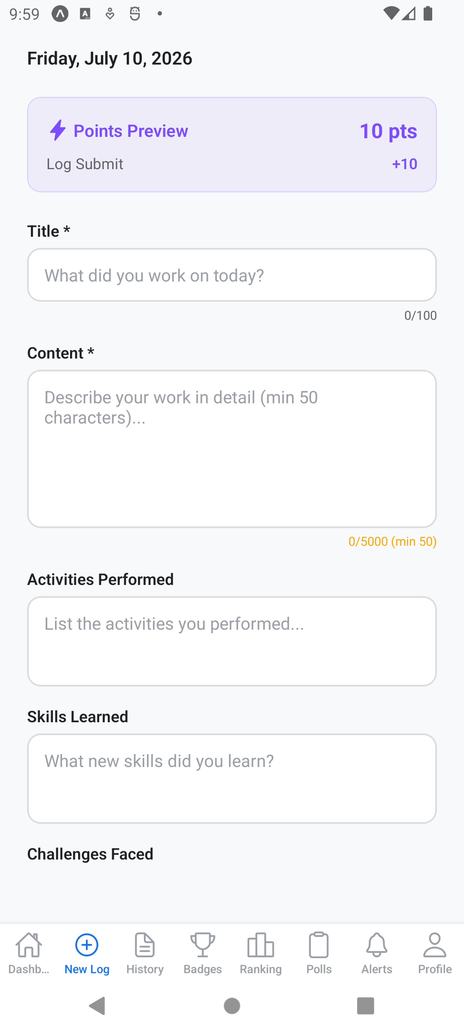  Figure 8. New log form | 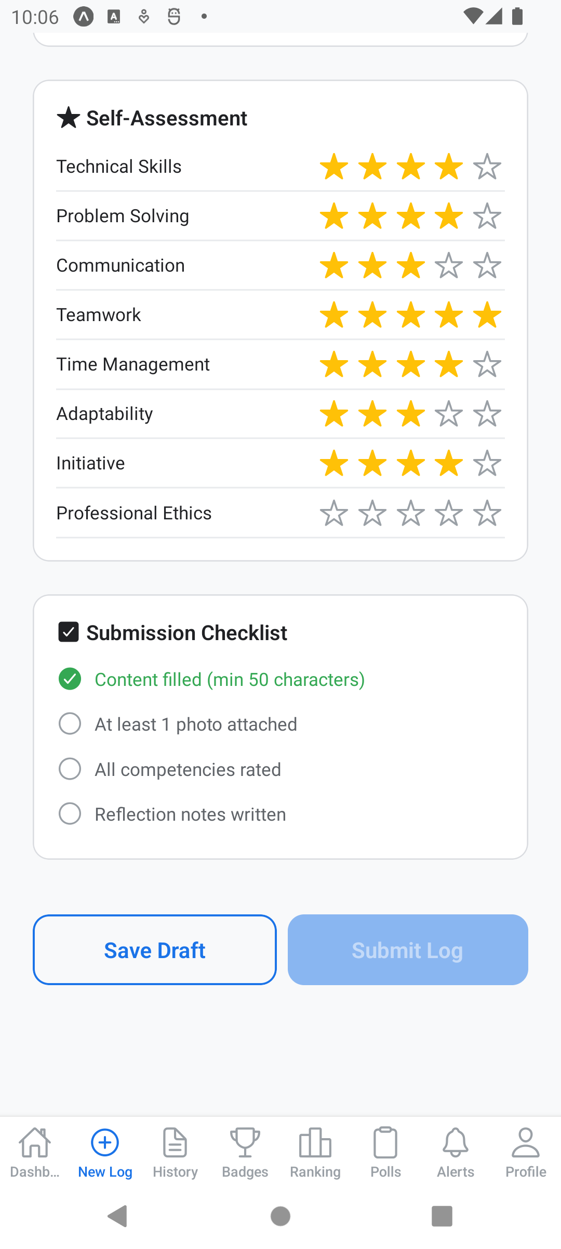  Figure 9. Submit stays disabled until the checklist is complete
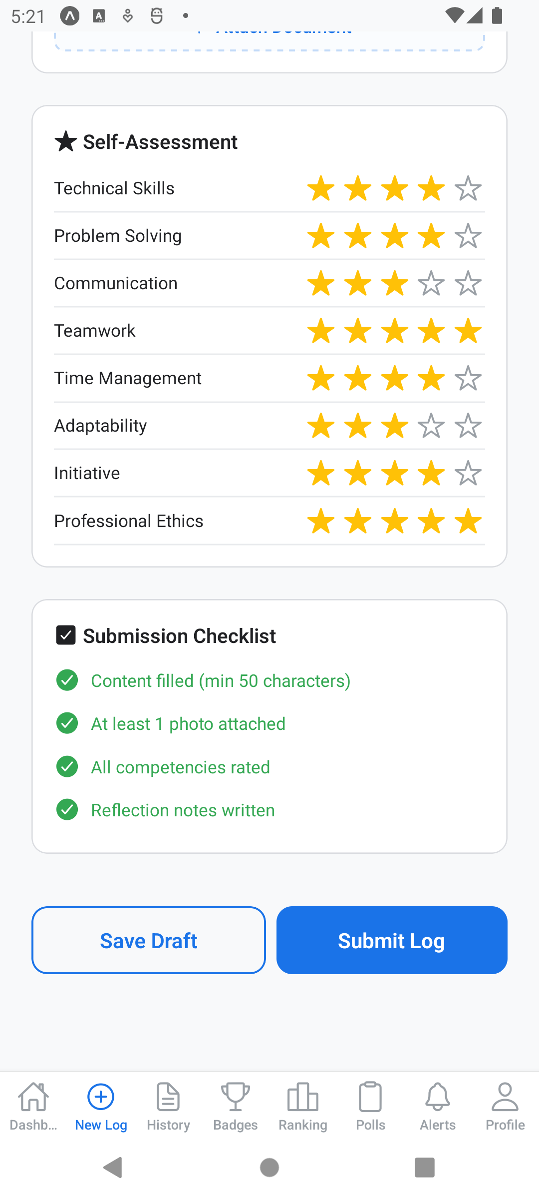
Figure 10. Completed checklist with self-assessment – Submit is now enabled

3.5 Log history and feedback
The History tab lists all your logs, filterable by status (Draft, Submitted, Approved). Tap a log to see its details, including the XP it earned and its current status. When your mentor reviews a log you receive their written feedback and competency ratings, and the advisor’s validation completes the cycle.
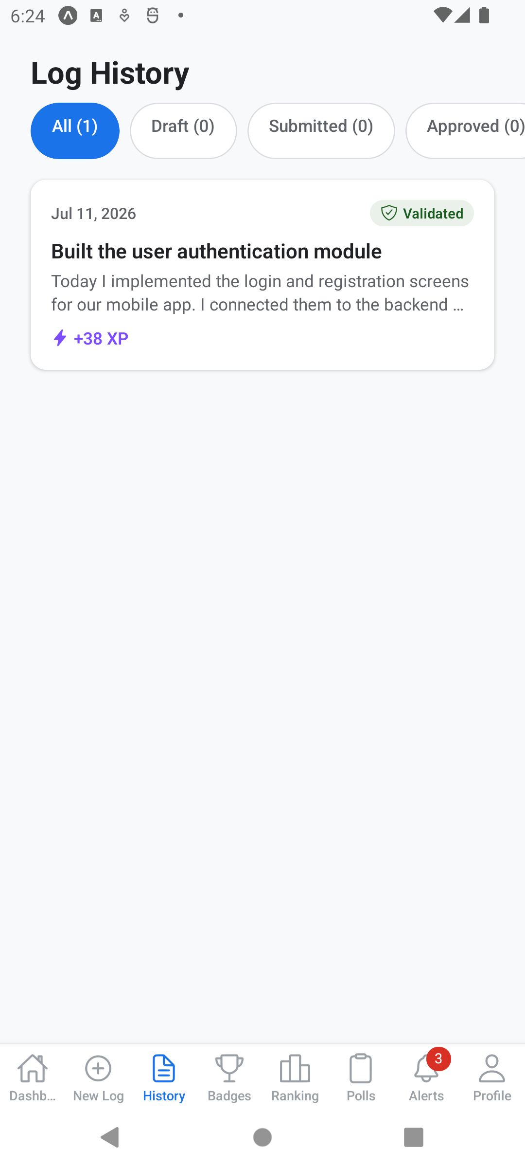  Figure 11. Log history with an approved log | 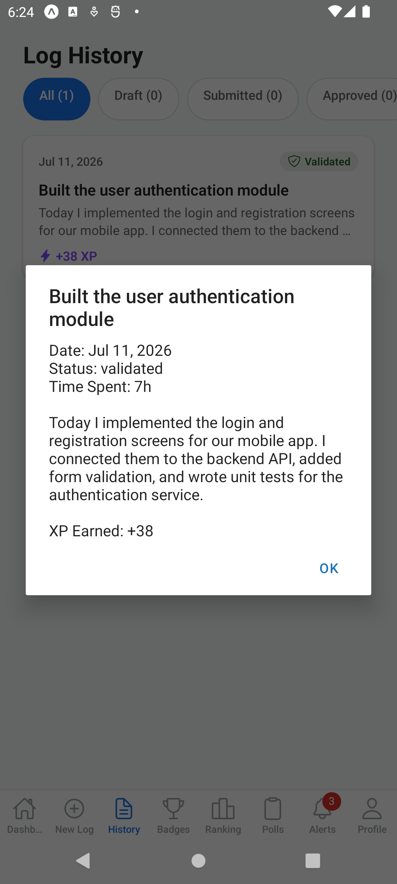  Figure 12. Log details with status and earned XP

3.6 XP, levels, and badges
You earn XP automatically as you use the app. XP is awarded by the server, and the main sources are:
Action | XP
Submitting a daily log | +10
Each photo attached (up to 5) | +3
Completing the self-assessment | +5
Log approved by mentor | +20
Answering a poll | +15
Perfect quiz score bonus | +25

Levels run from 1 to 10 (100 XP for level 2, 300 for level 3, and so on up to 4,500 XP). Badges celebrate milestones such as your first log, 7-day and 30-day streaks, and quiz mastery. The Badges tab shows what you have earned and what is still locked, and the Ranking tab compares your XP with other students.
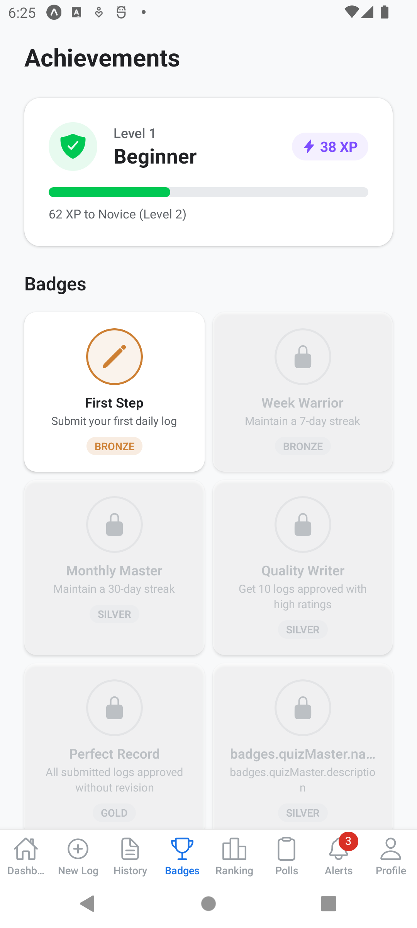  Figure 13. Badges screen with the First Log badge earned | 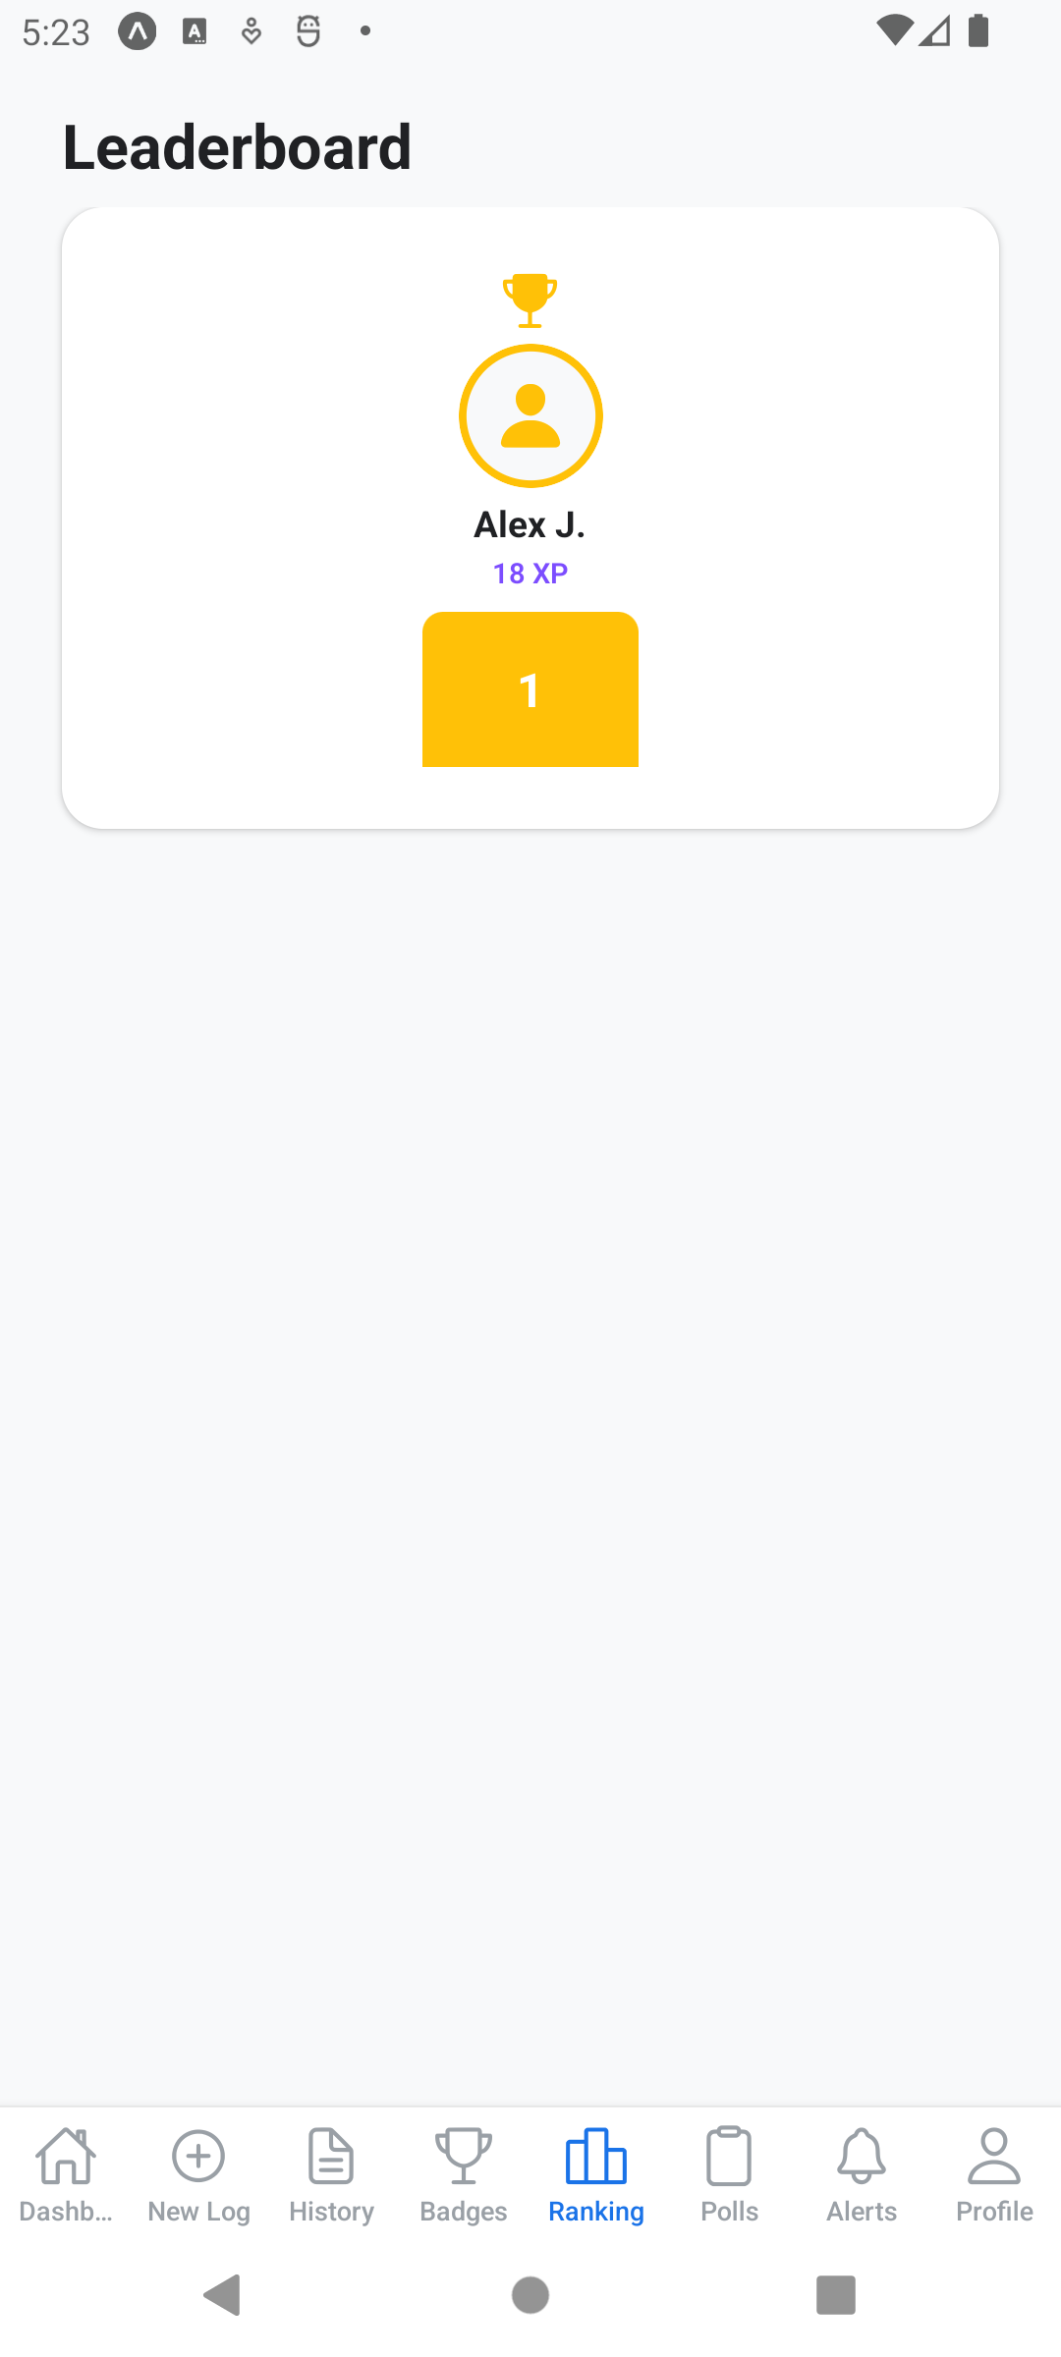  Figure 14. Student leaderboard

3.7 Polls and notifications
Mentors and advisors can publish polls and quizzes. Answering them earns XP, and a perfect quiz score earns a bonus. The Alerts tab collects your notifications: badge awards, level-ups, log approvals, new feedback, and new polls.
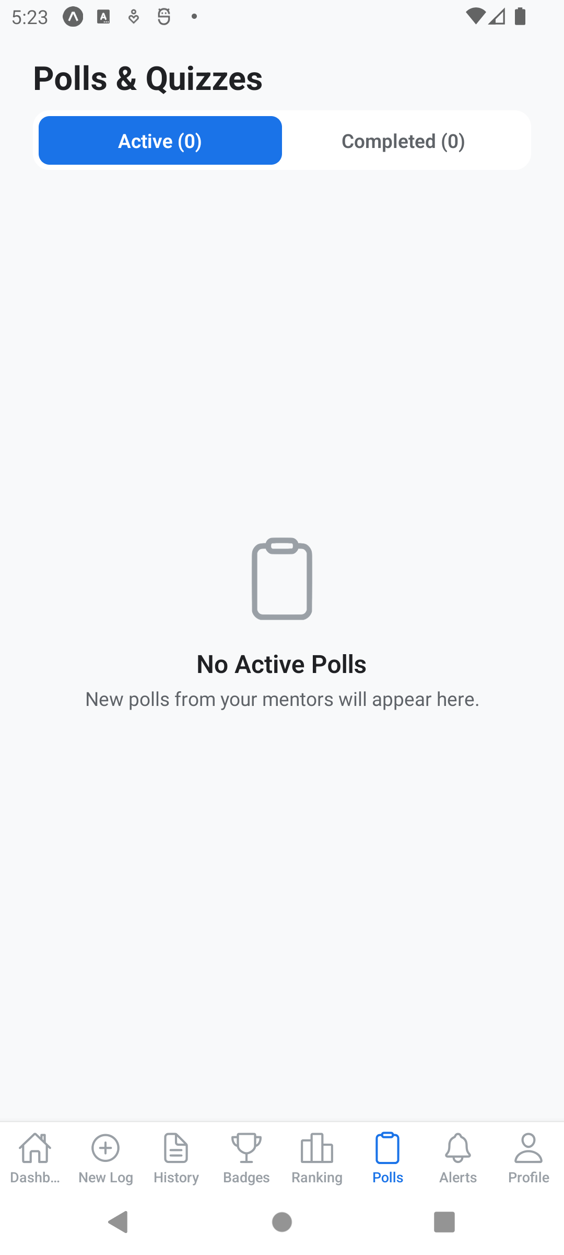  Figure 15. Polls screen | 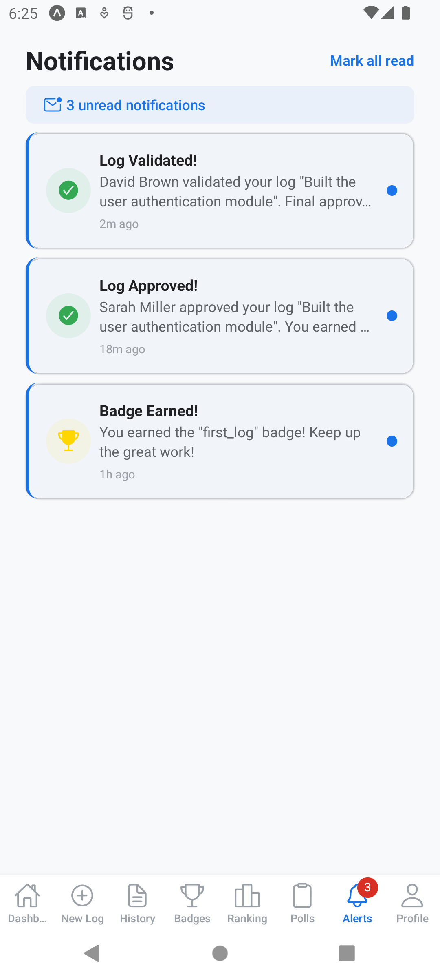  Figure 16. Notifications

3.8 Profile and your student code
The Profile tab shows your personal and internship information and your app settings (language, password). It is also where you generate your Student Code: a 6-character code your mentor and advisor use to link to your account. Generate it once and share it with both of them; generating a new code deactivates the old one.
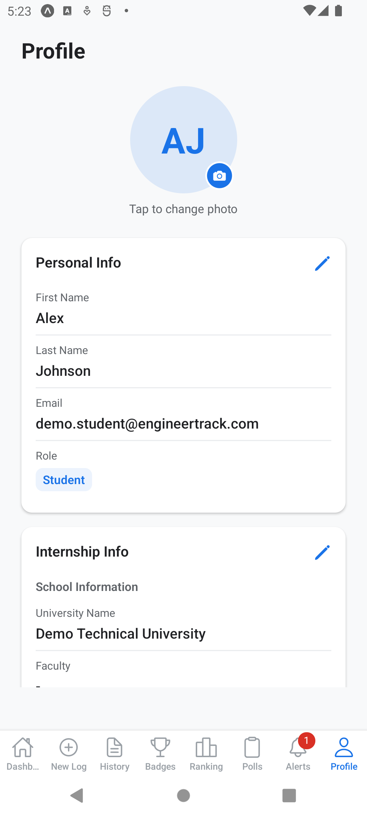  Figure 17. Student profile | 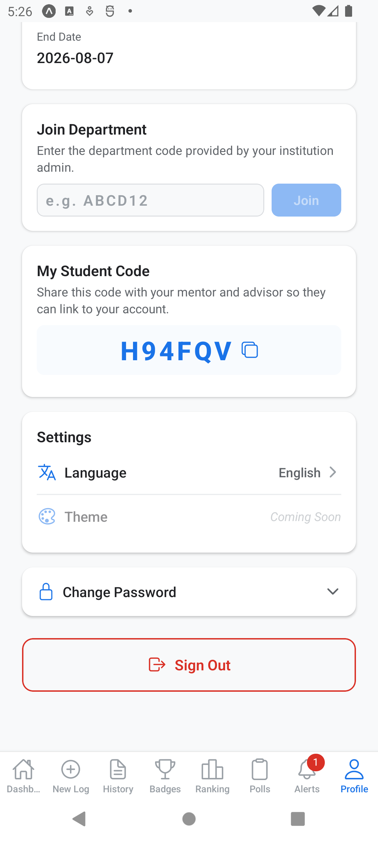  Figure 18. Generated student code

4. Mentor Guide

4.1 Dashboard
The mentor dashboard summarises your work at a glance: how many students are assigned to you, how many logs are waiting for review, how many you reviewed this week, and your average rating.
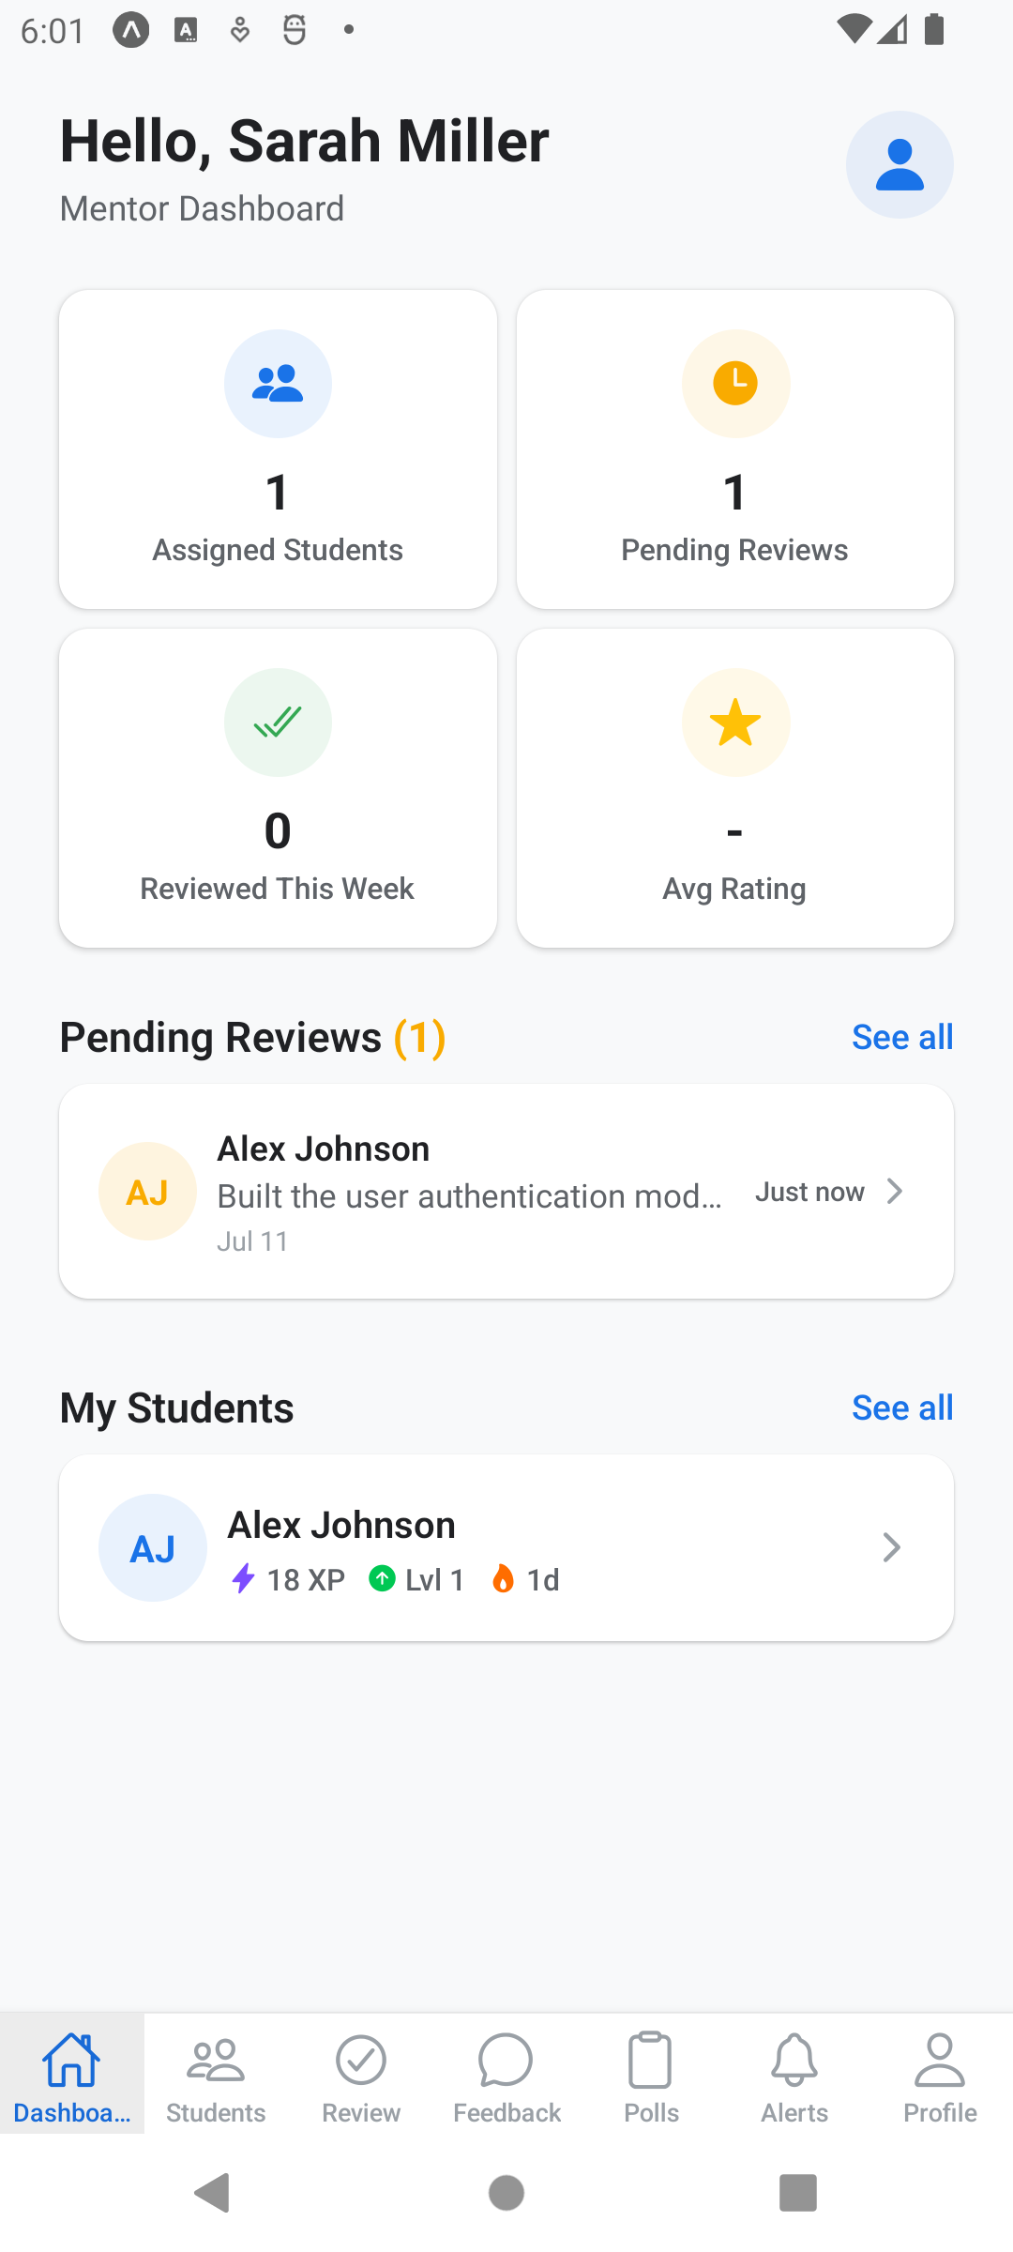
Figure 19. Mentor dashboard

4.2 Linking a student
Open the Students tab and enter the 6-character code your student generated in their profile, then tap Link. The student immediately appears in your list with their XP and log statistics.
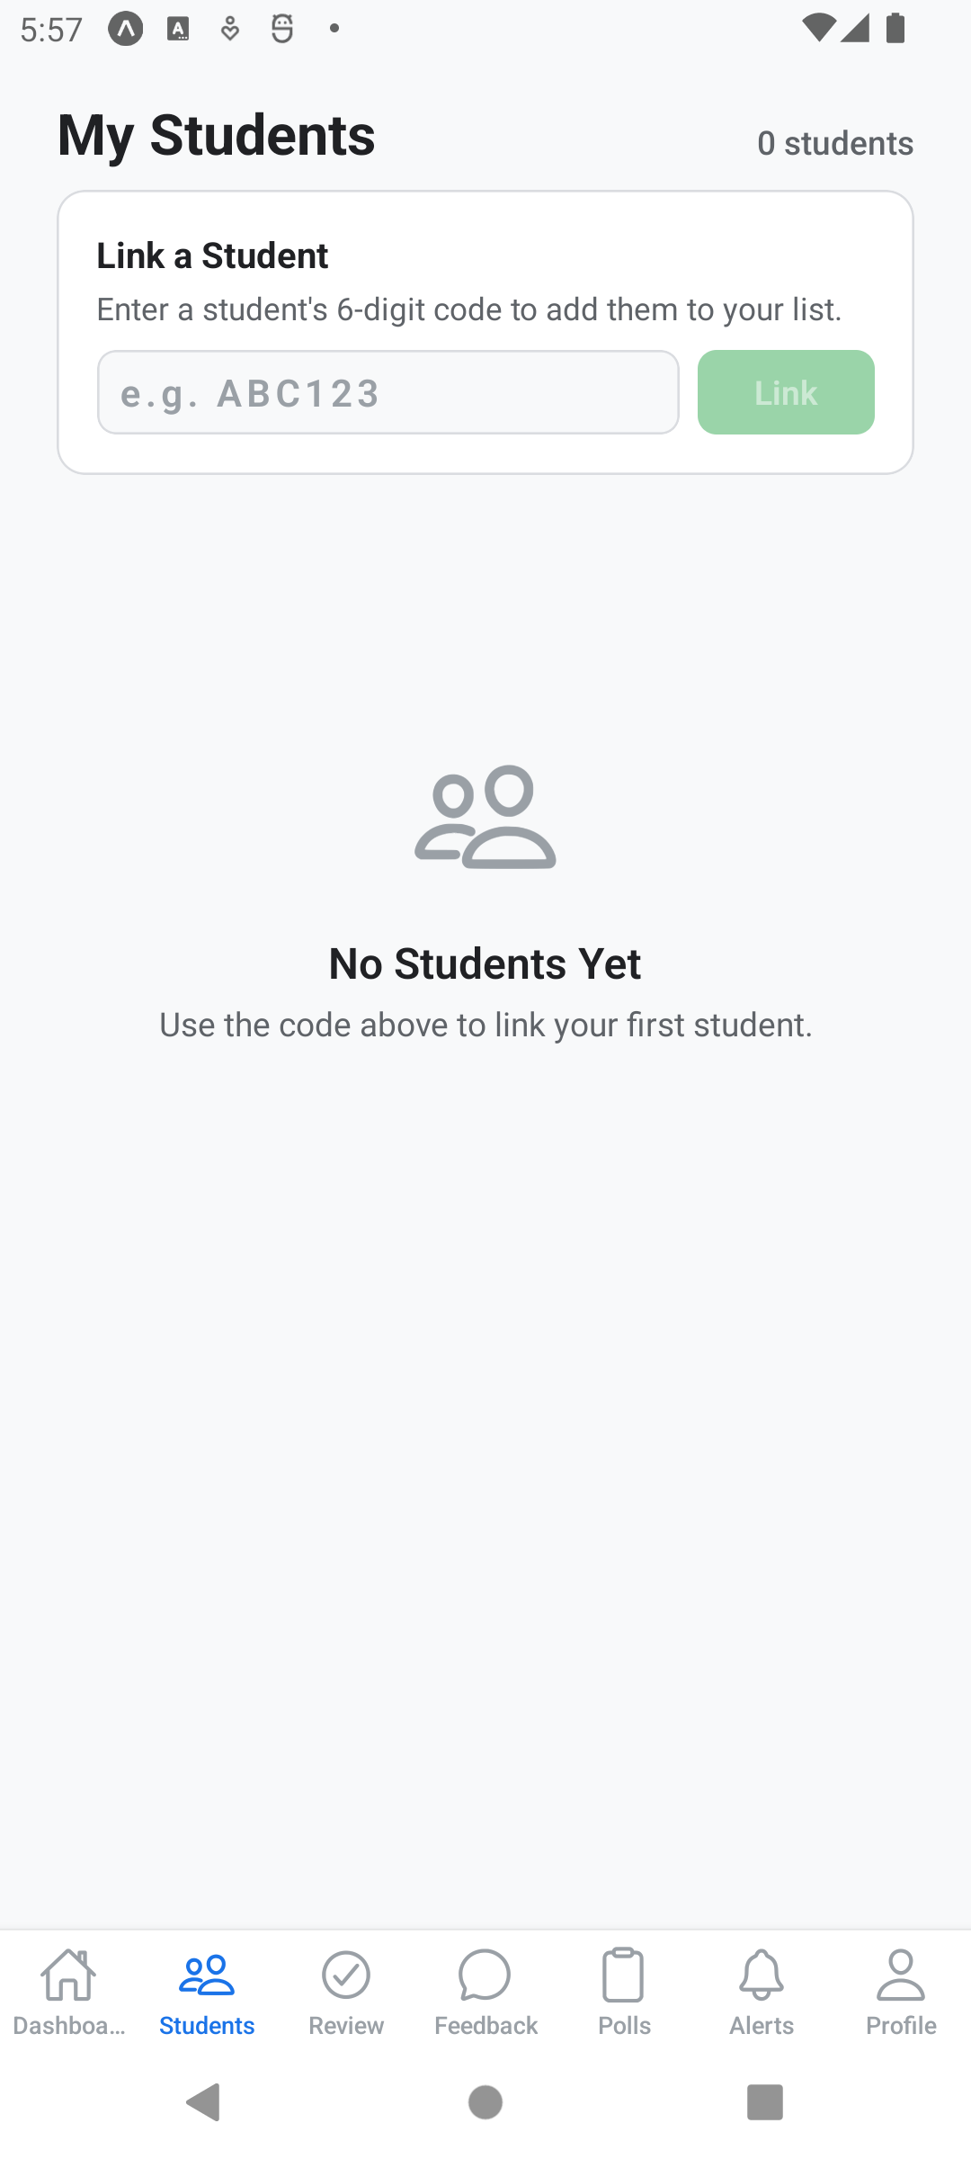  Figure 20. Students tab before linking | 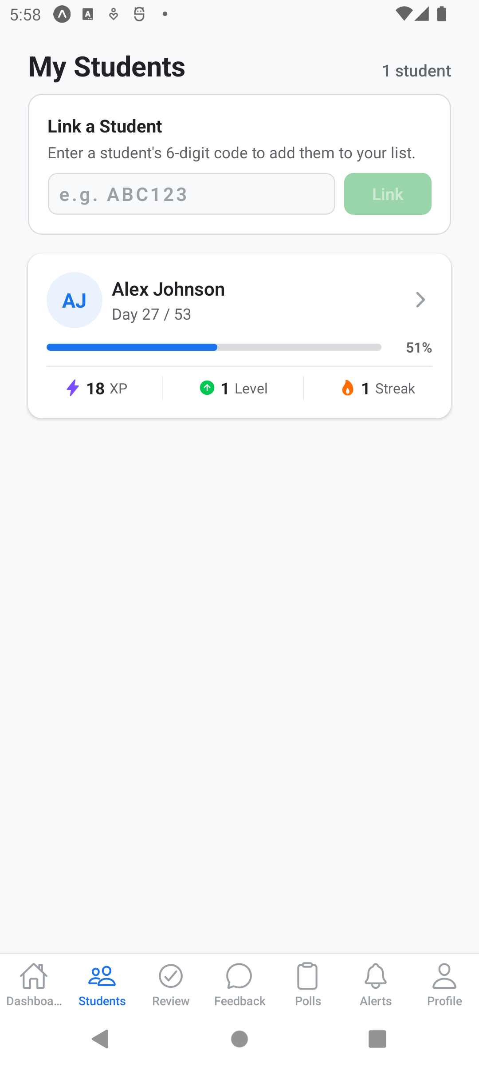  Figure 21. Student linked successfully

4.3 Reviewing a log
The Review tab lists submitted logs awaiting your review. Tap one to open the full log: content, activities, skills, challenges, time spent, photos, and the student’s self-assessment. To complete a review you must:
- Rate all eight competencies from 1 to 5 stars (the student’s own scores are shown as a reference)
- Give an overall rating
- Optionally write comments and note areas of excellence
- Tap Approve, or Request Revision to send the log back with revision items
Approving a log automatically awards the student +20 XP and notifies them.
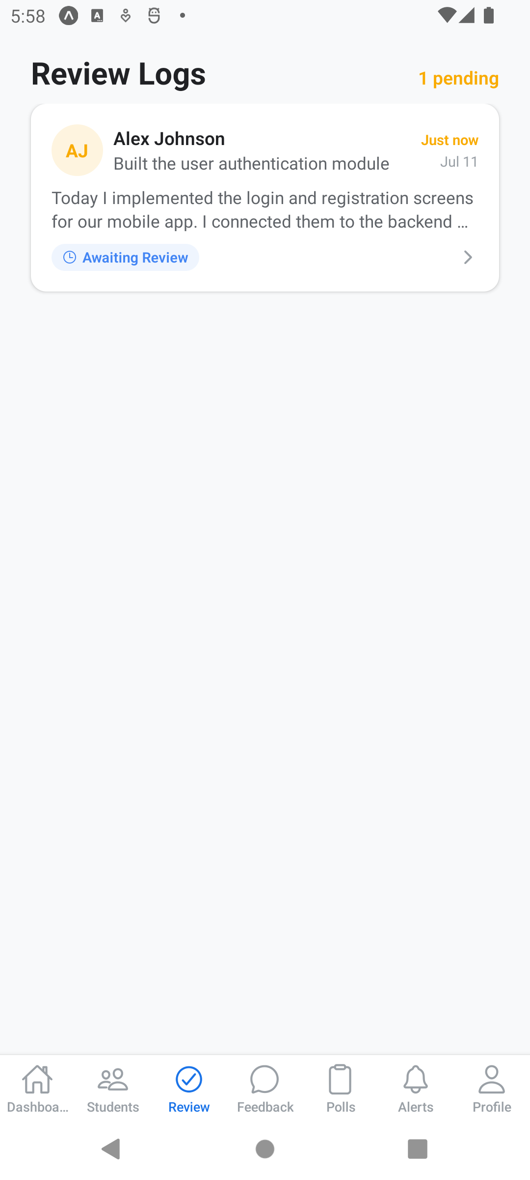  Figure 22. Pending reviews | 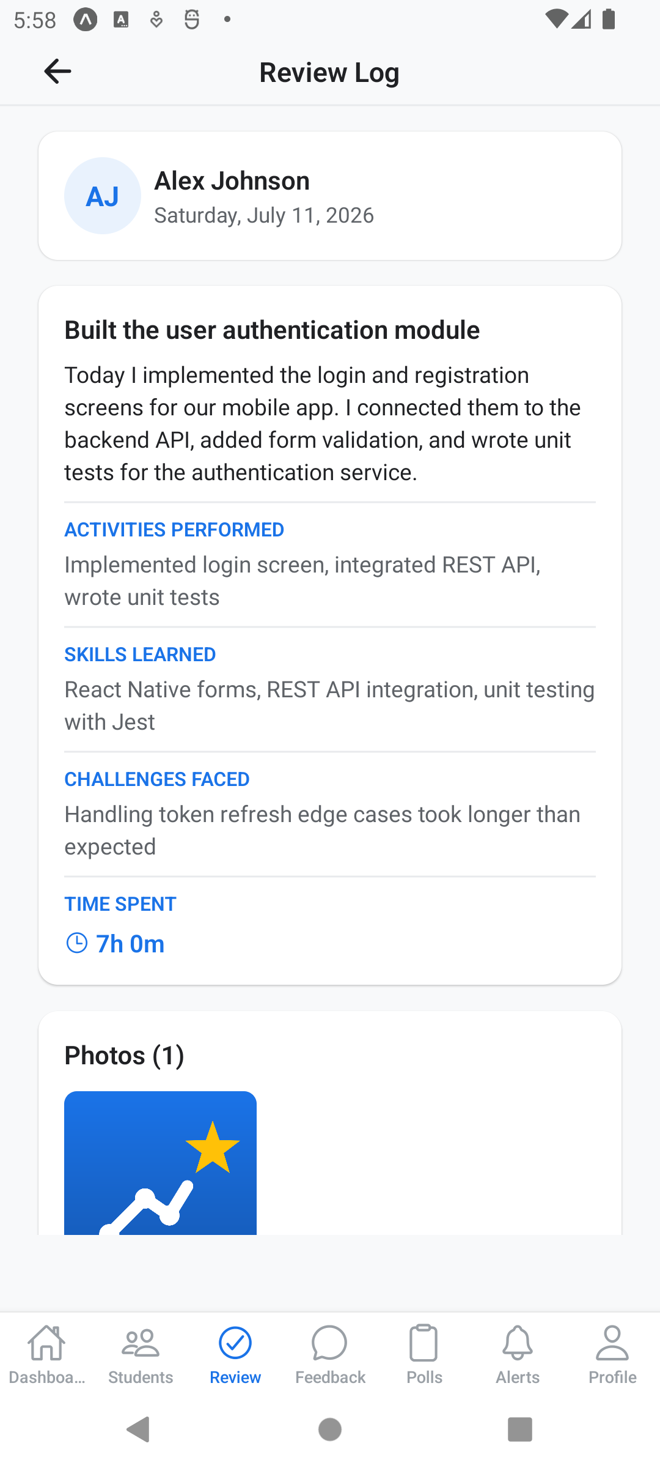  Figure 23. Log review detail
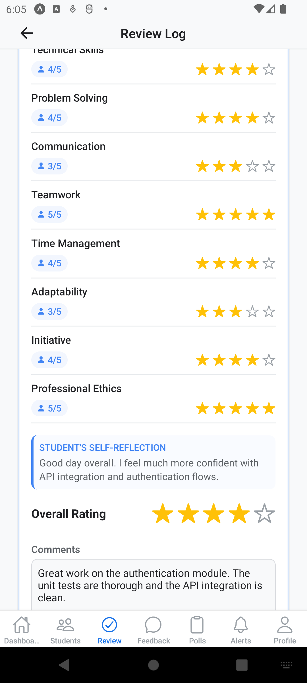  Figure 24. Competency rating with student self-scores | 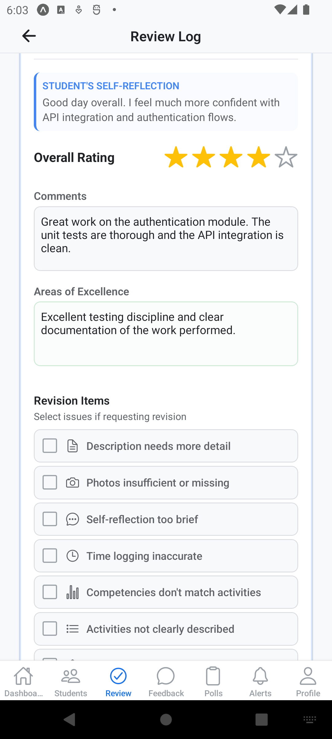  Figure 25. Written feedback before approval

4.4 Feedback history and polls
The Feedback tab keeps a history of all feedback you have given. In the Polls tab you can create polls and quizzes for your students; quiz questions can have a correct answer so students can earn the perfect-score bonus.
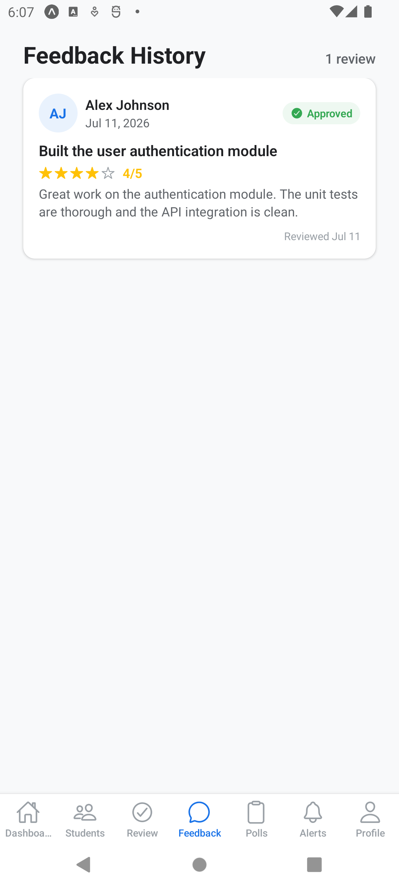
Figure 26. Feedback history

5. Advisor Guide

5.1 Joining your institution and linking students
Advisors belong to a university. In Profile, first enter the department code provided by your institution’s administrator ("Join Department"). After that, link each student with the student code they share with you ("Link Student"). Note that you can only link students who belong to the same institution as you.

5.2 Dashboard and monitoring
The advisor dashboard shows your active students, pending validations, and overall compliance. The Monitor tab gives a per-student view of log frequency, approval status, and internship progress.
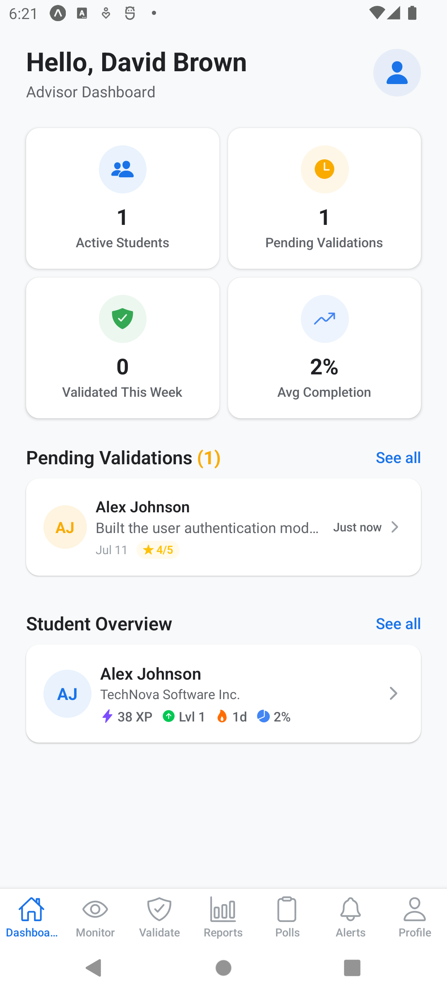  Figure 27. Advisor dashboard | 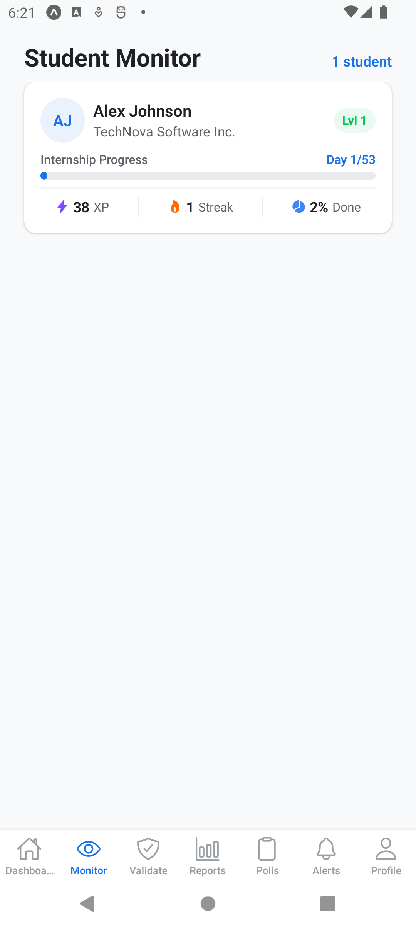  Figure 28. Student monitoring

5.3 Validating logs
The Validate tab lists logs that mentors have already approved. Open a log to see its full content together with the mentor’s rating. Add your notes if needed, then tap Validate to give the log its final, university-side seal – or Send Back (notes required) if something needs to change.
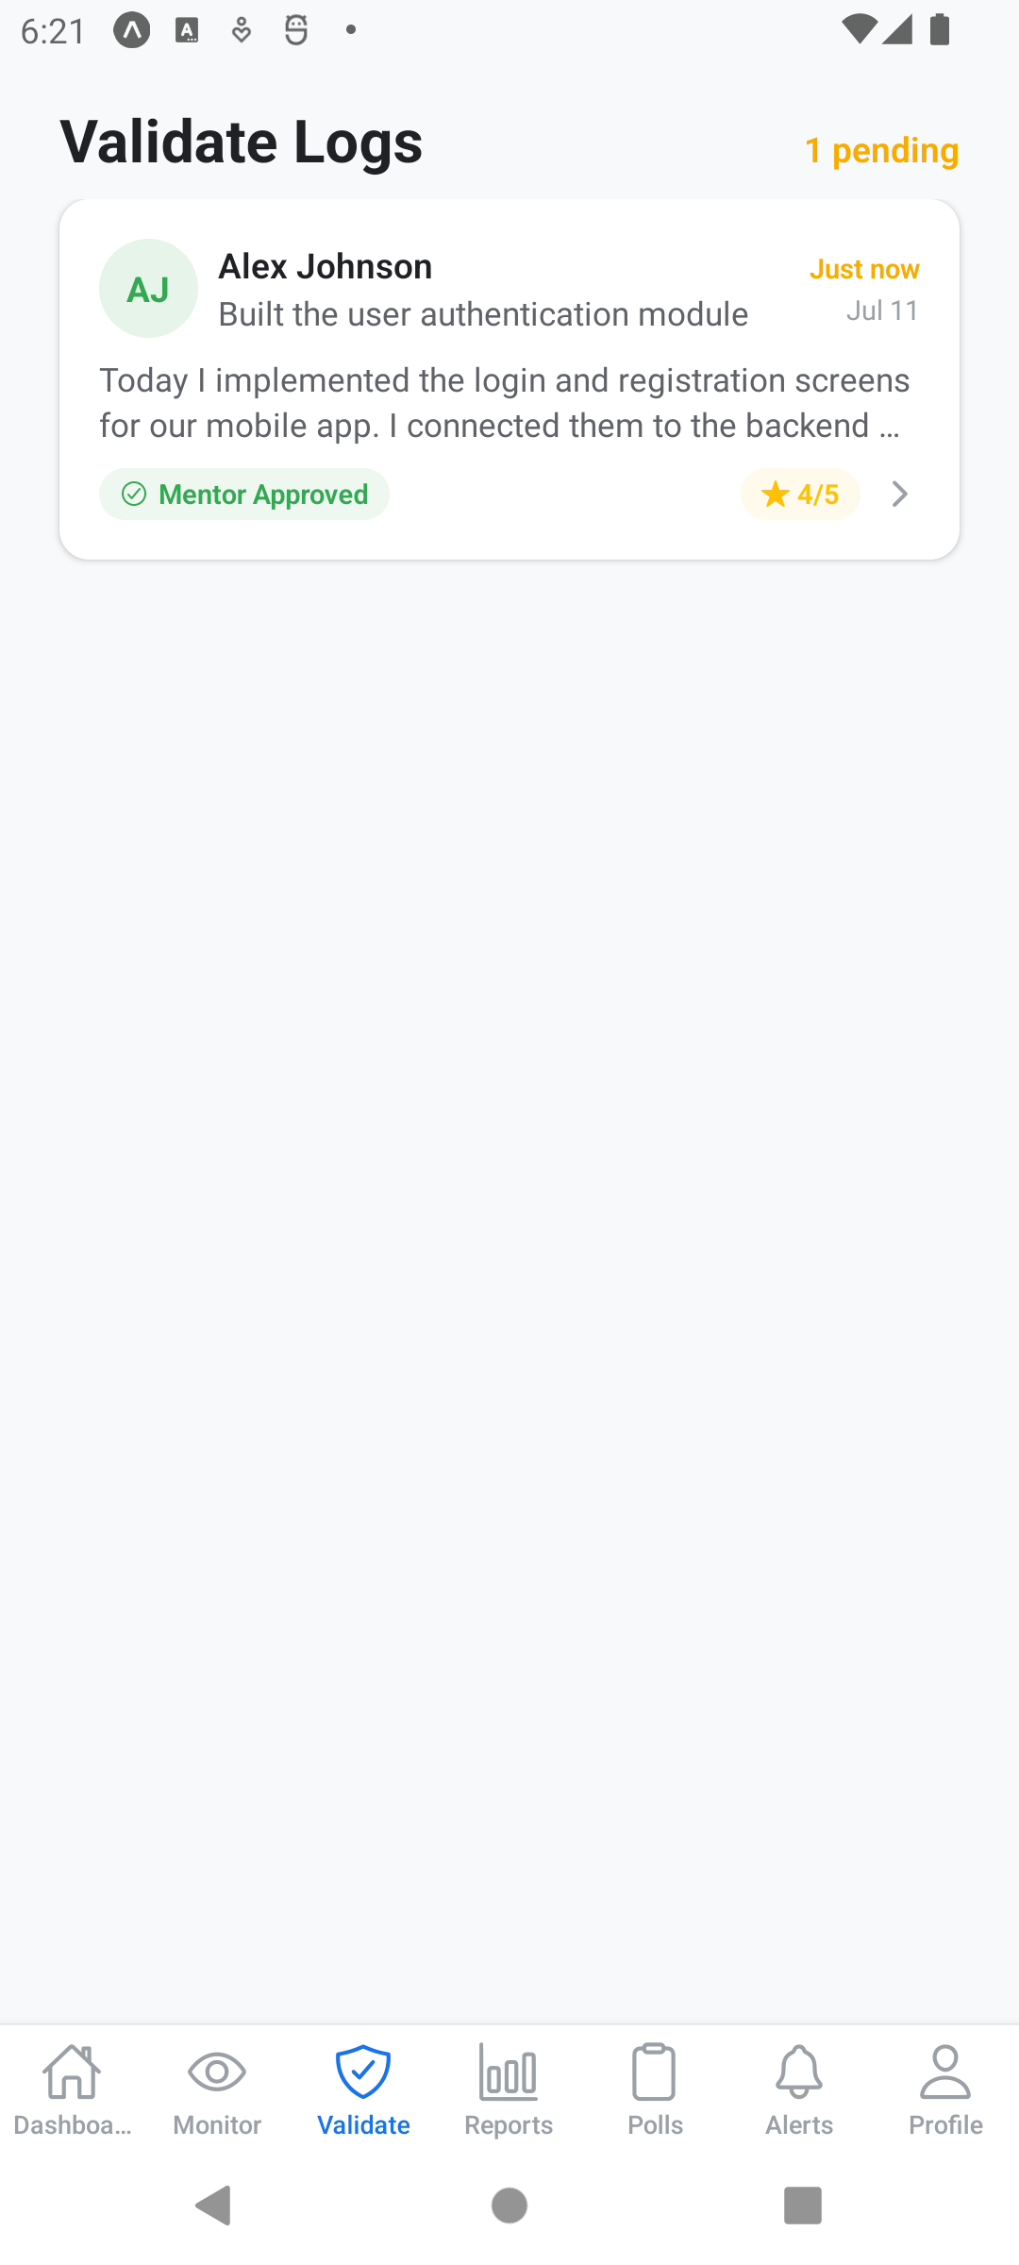  Figure 29. Logs awaiting validation | 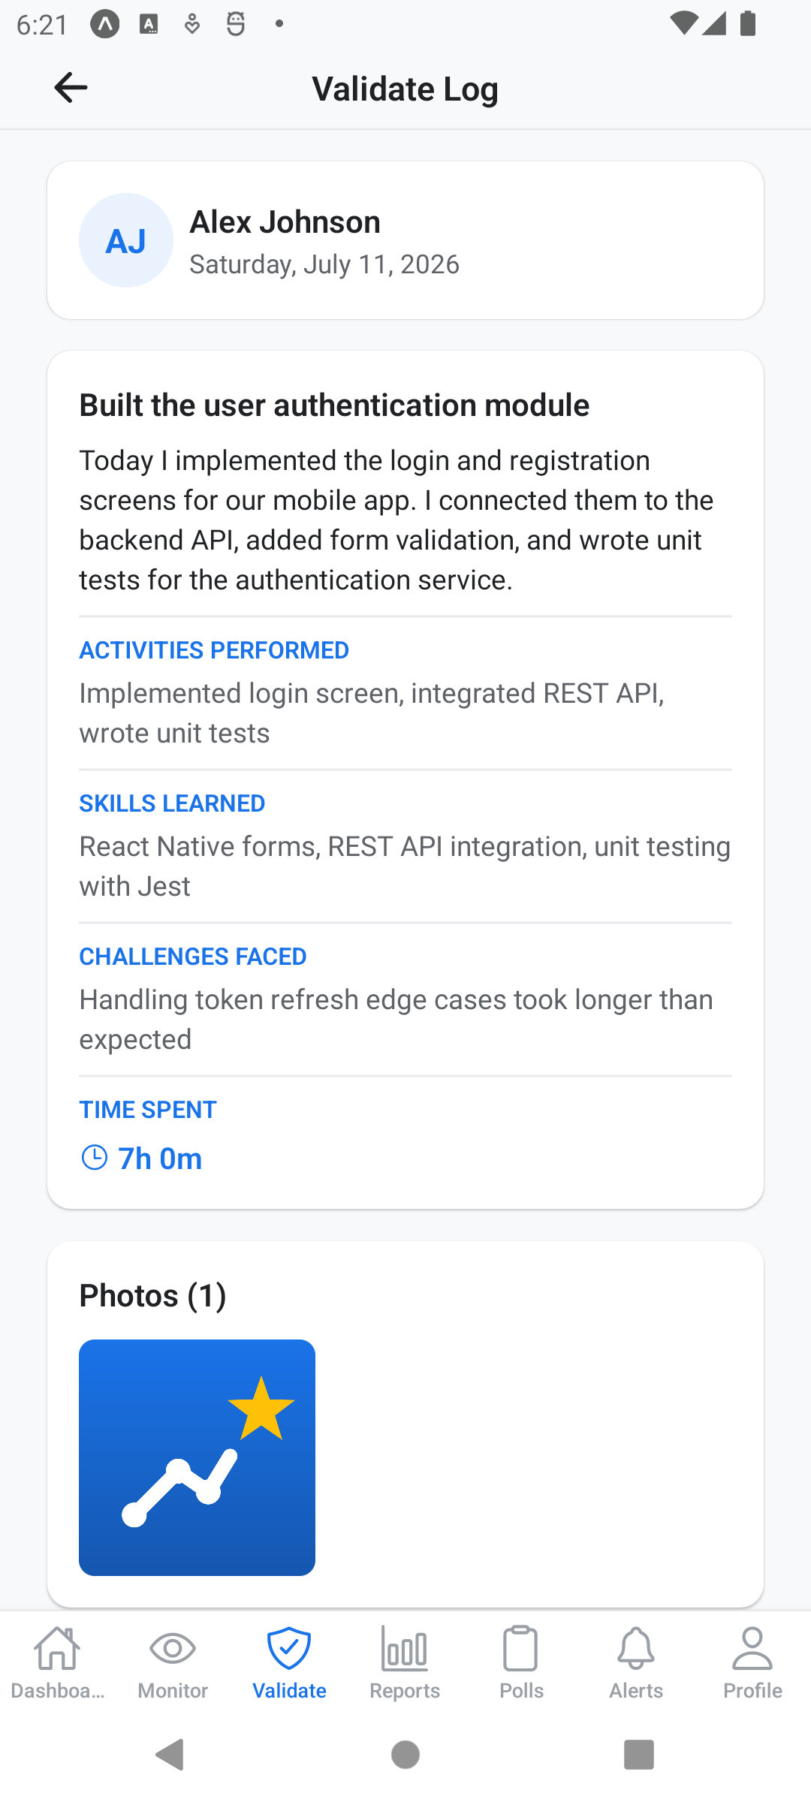  Figure 30. Validation detail

5.4 Reports
The Reports tab aggregates statistics across your students – totals, approval rates, hours worked – and offers an export for use in university paperwork.
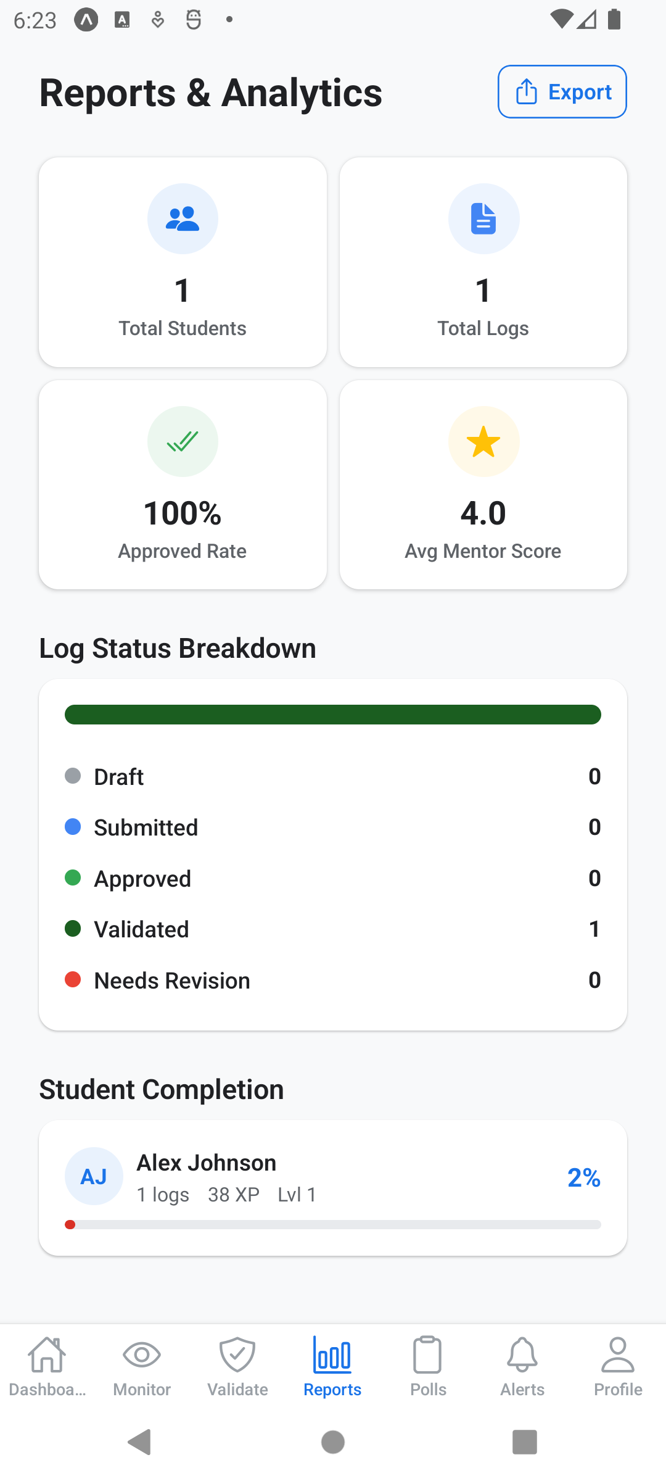
Figure 31. Reports and analytics

6. Administrator Guide

6.1 Setting up your institution
Administrators register with an institutional (.edu) e-mail. On first login, the dashboard asks you to create your institution (name, type, country). Creating it generates an institution code, and you can then add departments – each department gets its own 6-character join code to share with students and advisors.
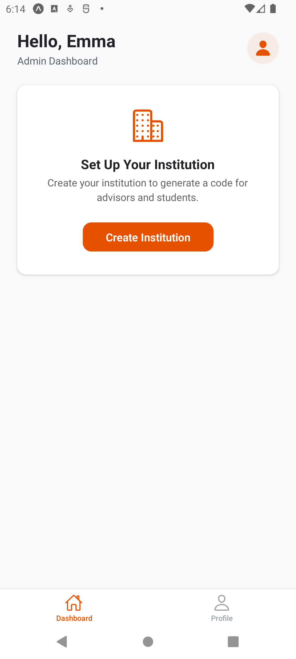  Figure 32. First login – institution setup | 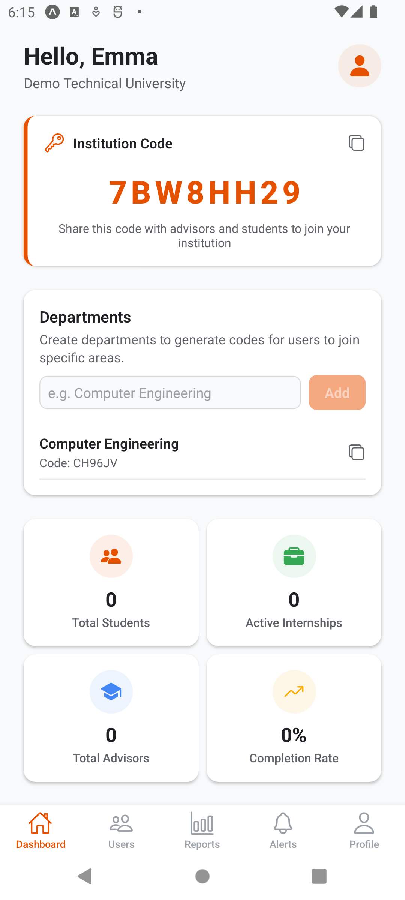  Figure 33. Institution created with department codes

6.2 Managing users and reports
The Users tab lists everyone in your institution by role, and the Reports tab summarises activity across the whole institution.
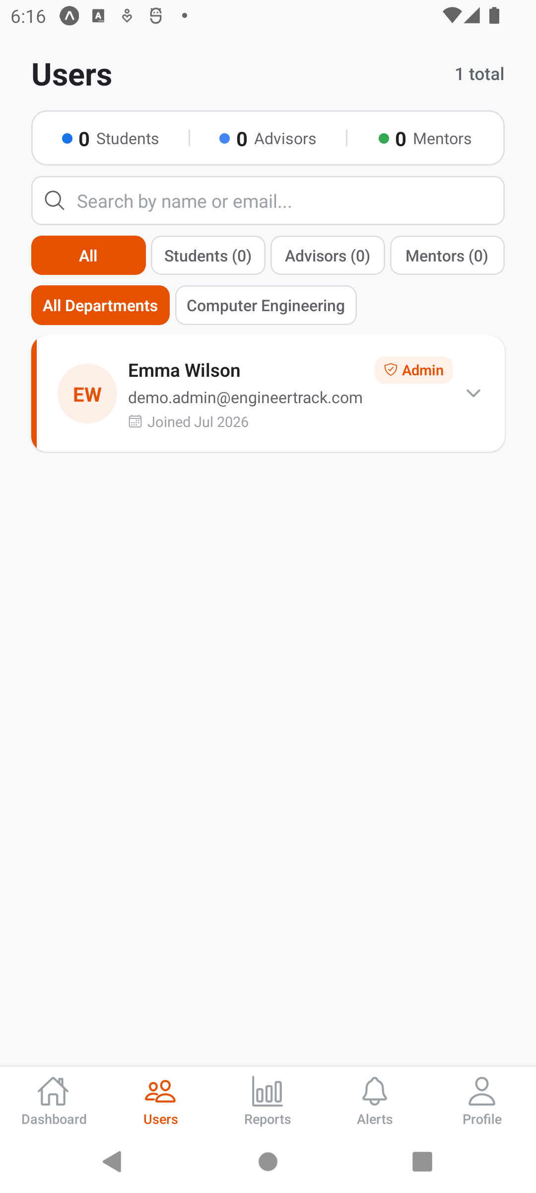  Figure 34. User management | 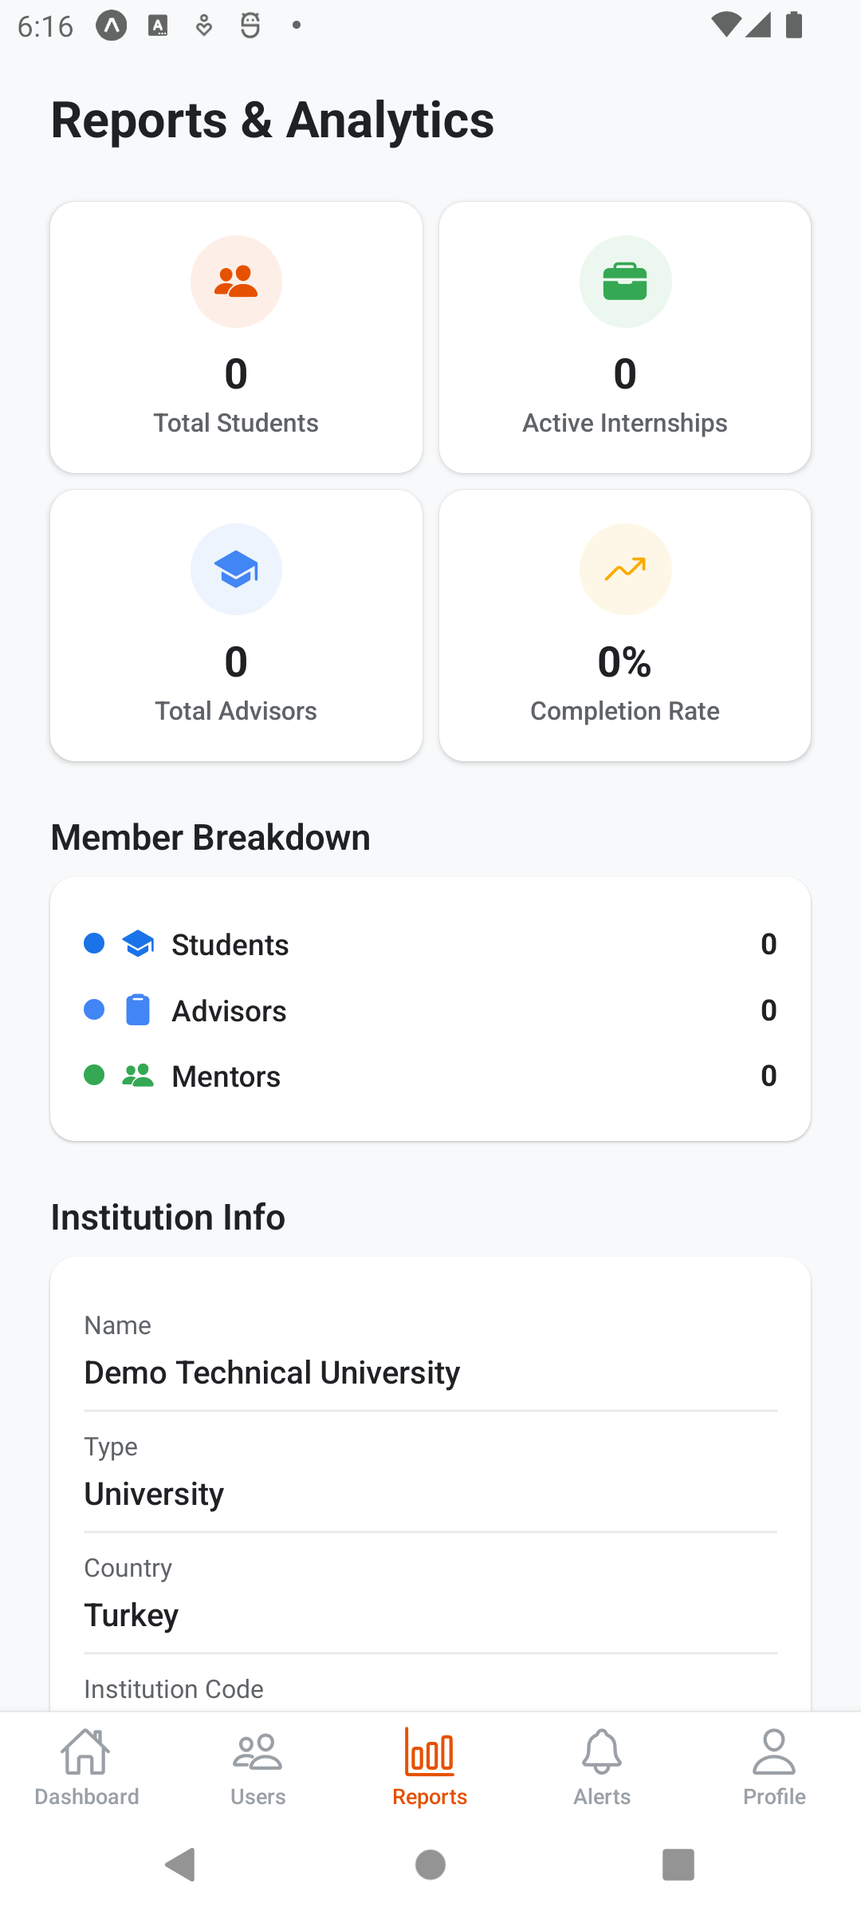  Figure 35. Institution-wide reports

7. Quick Reference

7.1 The complete workflow
- Admin creates the institution and shares department codes.
- Student and advisor join the institution with the department code (Profile → Join Department).
- Student generates a student code (Profile → My Student Code) and shares it.
- Mentor links the student (Students tab); advisor links the student (Profile → Link Student).
- Student writes and submits a daily log (+10 XP, +3 per photo, +5 self-assessment).
- Mentor reviews: rates competencies, writes feedback, approves (+20 XP to the student).
- Advisor validates the approved log – the log is now final.

7.2 Demo accounts used in this guide
All screenshots in this guide were produced with the following demo accounts (password for all: Demo1234):
Role | Name | E-mail
Student | Alex Johnson | demo.student@engineertrack.com
Mentor | Sarah Miller | demo.mentor@engineertrack.com
Advisor | David Brown | demo.advisor@engineertrack.com
Admin | Emma Wilson | demo.admin@engineertrack.com

