Setting up ‘iptables’ for forwarding nodes.

Based on input from 🡪 <https://access.redhat.com/documentation/en-US/Red_Hat_Enterprise_Linux/4/html/Security_Guide/s1-firewall-ipt-fwd.html>

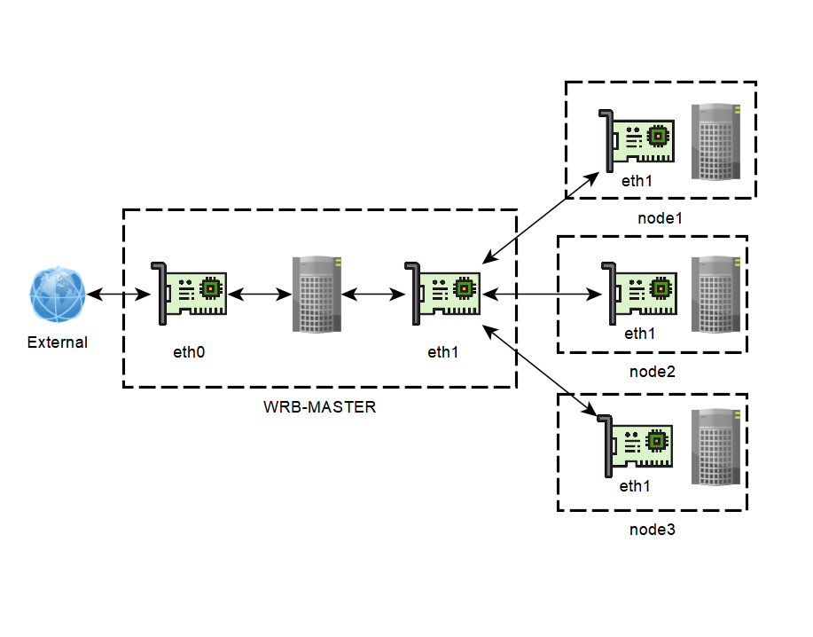

Figure 1- Current WRB-Master/Node configuration and naming

Setup Assumes:

On Host Machine:  
‘eth0’ 🡪 external access   
‘eth1’ 🡪 node[1-4] access

On Node:  
‘eth1’ 🡪 wrb-master access

On WRB-MASTER

1. $sudo -i
2. $iptables -A FORWARD -i eth1 -j ACCEPT
3. $iptables -A FORWARD -o eth1 -j ACCEPT
4. $nano /etc/sysctl.conf ADD🡪 net.ipv4.ip_forward = 1
5. $iptables -t nat -A POSTROUTING -o eth0 -j MASQUERADE

On NODE1

1. sudo -i
2. $nano /etc/sysconfig/network-scripts/ifcfg-eth1 ADD 🡪 “GATEWAY=10.0.0.1”
3. $nano /etc/hosts/ ADD 🡪 192.168.17.57 wrb-license.alionscience.com wrb-licence  
    192.168.17.58 wrb-master.alionscience.com wrb-master