
HR Management Application
Recruiters are looking for recruitment management software which will help them to manage their interview process very effectively along with the recruiters & candidate information. As a developer you have been asked to develop the solution using Salesforce Platform. Here is the complete information of the project.

Scope of Work

A custom Salesforce application for a company to oversee their HR management, Candidate & Interviewer processes. The purpose is to provide a comprehensive solution for managing their systems. The application will include several features:
- This app will include a private admin portal, and an available site for public usability.

- The company can create different Positions and Candidates, and make them visible on the portal with information including the start date, end date, etc.

- A Candidate needs to provide some mandatory information such as first name, last name, phone number and email address before creating the booking for the Position.
- Salesforce must be integrated with an address gateway to process and confirm the address of the location (Smarty Street Api).
- A manager will also receive an email for deleted Positions daily.

- We will write several automation, validation, and duplicate rules in the system for automatically checking the Candidates of the Position.
- We will create an email feature from the newly created Position Candidate to send information about the new Position details such as Position start date, location, etc.
- We will create a web service for other apps and share the Position details with any necessary app, so that you can publish your Position on any platform.
- On the portal, the admin user can see lots of LWC components and the user can complete tasks easily on the LWC components.

Lead Management: The company can capture leads for prospective customers who fill out the web-to-lead form on their showroom or website. They can track the source of the lead and also store lead contact information and relevant details such as the Position preferences, etc.
Opportunity Management: Once a lead expresses interest in booking an Position, the company can create an opportunity in Salesforce. This would include details such as the Position type, start-end dates, features, and expected-to-publish date. Sales representatives can update the opportunity as they progress through the sales cycle by scheduling demos and sending quotes.
Appointment Scheduling: The company can schedule bookings for Candidates to visit the Position. They can use custom trigger features to keep track of upcoming appointments and to avoid double bookings. The Position details can also be sent as reminders to Candidates via email.
Service Requests: Candidates can log service requests for their Position issues, these would include online check-ins, location issues, etc. The company can use Salesforce’s case management feature to track service requests, assign them to the appropriate service team, and to provide status updates.

Service History: Salesforce can store a customer’s Position service history, such as when the Candidate was last serviced, what issues were done, and how long it took. This information can be used to recommend upcoming services and estimate times.
Analytics and Reporting: Salesforce can generate reports and dashboards to provide insights into key metrics such as lead sources, sales pipeline, appointment conversion rates, and service request volume.
This data can be used to identify areas for improvement and optimize the dealership’s operations.
Overall, a Salesforce CRM project for a HRmanagement company can help them to manage their customer interactions more efficiently and provide a better experience for their customers. It can streamline their sales and service processes, improve communication and collaboration among employees, and provide valuable insights into their business performance.
What are the possible integrations after this project is completed?
There are several integrations for a Salesforce CRM project that an HR Management dealership could include:

Email Integration: The dealership could integrate its email system with Salesforce to enable automatic email tracking and logging of email interactions with customers. This would help to ensure that all email communications with customers are captured in Salesforce, and can be viewed by sales representatives and service teams.
Telephone Integration: The dealership could integrate its telephone system with Salesforce to enable automatic call logging and tracking of telephone interactions with customers. This would help to ensure that all telephone communications with customers are captured in Salesforce, and can be viewed by sales representatives and service teams.
Social Media Integration: The dealership could integrate its social media accounts with Salesforce to capture leads and monitor customer interactions on social media platforms. This would help to ensure that all social media interactions with customers are captured in Salesforce, and can be viewed by sales representatives and service teams.
Marketing Automation Integration: The dealership could integrate its marketing automation system with Salesforce to enable lead nurturing and lead scoring. This would help to automate the lead follow-up process and ensure that leads are contacted at the right time with the right message.
Accounting Integration: The dealership could integrate its accounting software with Salesforce to ensure that sales and service transactions are automatically synced between systems. This would help to reduce errors and eliminate manual data entry.
Dealer Management System Integration: The dealership could integrate its dealer management system with Salesforce to ensure that all customer interactions and transactions are captured in one system. This would help to ensure that sales representatives and service teams have a complete view of the customer, and their history with the dealership.
eSignature Integration: An integration with an e-signature platform could enable managers to send and receive signed documents directly from Salesforce. This would help to speed up the contract and agreement process, and reduce the need for manual paper-based processes.
Overall, integrations can help to streamline operations, and improve efficiency by automating tasks and eliminating manual data entry. Integrating Salesforce with other systems can help to provide a seamless experience for customers and enable the dealership to provide better service.

Entities(Objects) Involved
Location - Location : This object refers to Recruiters office location.
Event Organizer - HR Manager: This object refers to the HR Manager.
Event - Position: This object refers to the job positions.
Attendee - Candidate :This object refers to the Candidate.
Speaker - Interviewer : This object refers to an Interviewer.
Event/Attendee - Position/ Candidate : This is a junction object for Position and Candidate objects.
Event/Speaker - Position/ Interviewer : This is a junction object for a Position and Interviewer objects.
Error Log - Error Log : This object refers to error logs.
Entities(Objects) Involved
Locations
- Recruiters office Name ( Standard Field ) - Required
- Street ( Text Area) - Required
- City ( Text , 40) - Required
- State ( Text Area) - Required
- Postal Code ( Text ) - Required
- Country ( PickList ) (USA, Germany, UK, Australia, New Zealand, Finland)- Required
- Land Mark ( Text Area)
- Verified? ( checkbox )
HR Manager
- Name ( Standard Field )
- Email ( Email ) - Required
- Alternative Email ( Email )
- Phone ( Phone ) - Required
- Alternative Phone ( Phone )
- Location ( Lookup - Location )
Position
- Position# (Standard Auto Number )
- Name (Text, 255 ) - Required
- Status (Picklist )(Planned, In Progress, Completed, Postponed, Canceled )
- HR Manager ( MasterDetail - HR Manager )
- Start Date/Time (Date/Time) - Required
- End Date/Time (Date/Time)
- Location ( Lookup- Location )
- Location Verified ( Formula field -Checkbox- “Location__r.Verified__c” )
- Live? ( Checkbox )
- Prerequisites? ( Checkbox )
- Position Type (Picklist ) ( In Person, Remote)

Candidate
- Name ( Standard Field)
- Email ( Email ) - Required
- Phone ( Phone ) - Required
- Current Company Name ( Text, 255 )
- Location ( Lookup - Location )
Interviewer
- Name ( Standard Field )
- Email ( Email ) - Required
- Phone ( Phone ) - Required
- Company ( Text, 255 )
Position/ Candidate
- Candidate# ( Standard Auto Number )
- Position( MasterDetail, Position)
- Candidate ( MasterDetail, Candidate)
Position/ Interviewer
- Interviewer ( Standard Auto Number )
- Position( MasterDetail, Position)
- Interviewer ( MasterDetail, Interviewer)

Error Log
- Log Date/Time ( Store the Date & Time details when the Error Occurred )(Date/Time)
- Log Details ( Stores the Complete Stack Track about the Problem )-(Text Area Long, 32768)
- Process Name ( The Name of Either Apex Class or Apex Trigger ) - (Text, 255)
- Log # ( Standard Auto Number )
- Apex Class Name( Store the apex class name to be able to check it )-(Text,255)-Optional
During the discussion between the business & client, a total 15 steps have been decided which are as follows.
Before we start - Please do not forget to watch the below playlist by SFDCPanther for salesforce development .
- Back to Basic
- LWC

Step 1 ( Object Setup )
#1 Complete the Object Structure, Choose the correct Data Type for each field.
#2 Create a Lightning Application & name it “Recruitment Management App” Use a logo of your choice. If you want to use the logo which I have used Click Here.
Must Have - Each Field must have a valid description & help text,
After Creating the Object/Fields & Type your app will look like below.
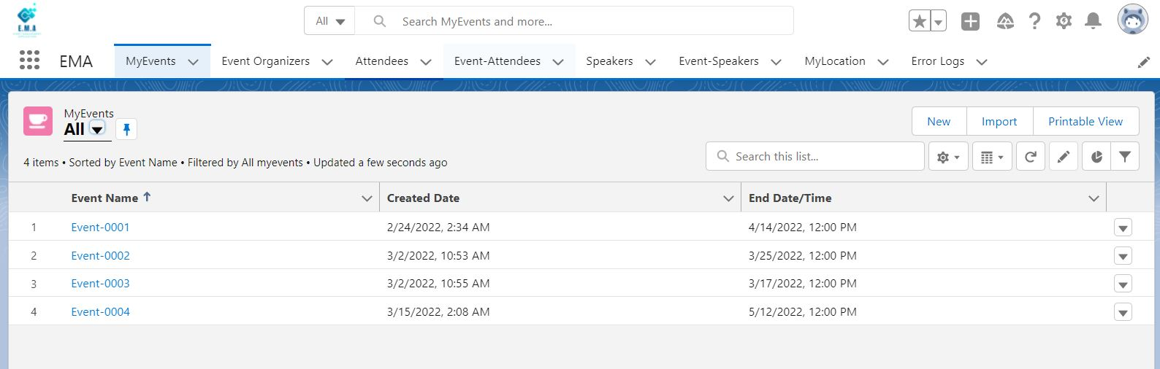

Here is the Entity Relationship Diagram;
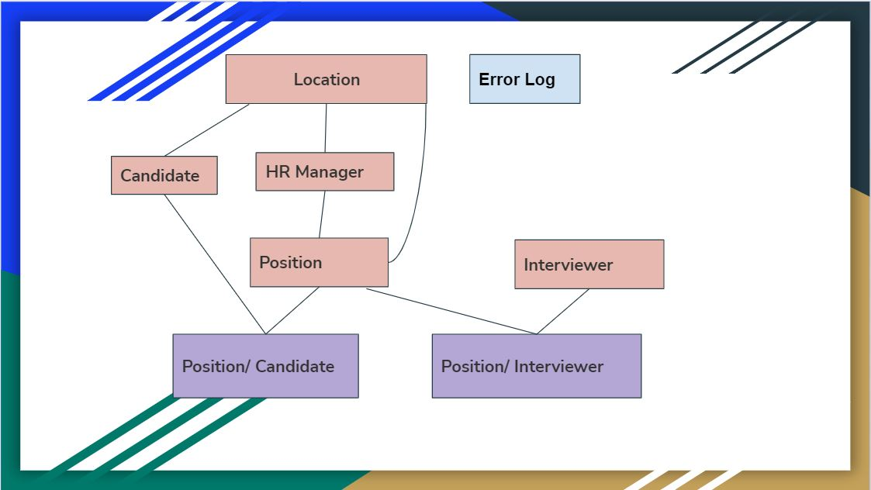

Step 1.1

Validation Rule Setup
1 - Validation Rule on Position Object
1.1 -If Prerequisites checkbox is checked then user must fill Position Type and also If checkbox is unchecked then User can not select Position field. .

1.2 - If remote is Selected as Value for Position Type field then Prevent User to Select Location on Position Record.

1.3 - End Date/Time must be at-least 1 day ahead of Start Date/Time ( If there is a value in End Date/Time field )

1.4 - If the Position Type field value is In-Person then the user must select Location on the Position Record.
2 - Position Interviewer Object
2.1 - Interviewer can only be associated with the position whose End Date is in future & Position Live Checkbox is checked

Step 1.2

Duplicate Rule Setup
1.Interviewer Object
1.1 - User can not create duplicate interviewer record with the same Email & Phone
2.Candidate Object
2.1 - User can not Create duplicate candidate with the Same Name, Email & Phone

3.HR Manager Object
3.1 - Apply the same rule as the candidate object for not having duplicate HR Manager records in the System.

Step 1.3
Prerequisite:
1. https://www.youtube.com/watch?v=J_KKclXGqIQ ( Organization Level Security )
2. https://www.youtube.com/watch?v=MLIKI2oe28E ( Object Level Access )
3. https://www.youtube.com/watch?v=8Xrgy_I8whM ( Record Level Access )
4.https://www.youtube.com/watch?v=uUowcuyfaGs ( Field Level Access )
Profile, User, OWD & Role Setup
1.3.1 - Profile Setup
1.3.1.1 Create 3 Profiles ( Clone from Standard User ), the name of the profile will be HR Manager, Position Candidate and Position Interviewer.
1.3.2 - User Setup
1.3.2.1 - Create users for the testing purpose( System Admin ) (Ignore this step)
1.3.3 - Role Setup
1.3.3.1 - Create Roles ( HR Manager & Candidate & Interviewer ). All roles must report to the CEO.
1.3.3.2 - Role Hierarchy
- CEO
  - HR Manager
  - Interviewer
  - Candidate
1.3.4 - OWD Setup -
1.3.4.1 - Check the table for OWD below and make the changes
Object Permission Set-up : Please provide the objects & fields level permission at the Profile level as per the table below.
Profile | Profiles
ObObject Namet gegrergNgdfgame | HR Manager | Position Interviewer | Position Candidate
Position | CRED | R | R
HR Manager | CRE | R | R
Interviewer | CRE | CRED | R
Candidate | R | X | CRE
Location | CRED | R | CRE
Position - Interviewer | CRED | CRE | R
Position - Candidate | CRED | X | RC
Error Log | CRE | CRE | CRE

Note:
C - Created
R - Read
E - Edit
D - Delete
X - No Access

Organization Wide Default :

OObject Namet Name | Organization Wide Default
Position | Public Read Only
HR Manager | Public Read Only
Interviewer | Private
Candidate | Private
Location | Public Read Only
Position - Interviewer | Public Read Only
Position - Candidate | Public Read Only
Error Log | Public Read/Write

Sharing Rule Setup: As per the business requirement, we need to share every Interviewer & Candidate record with HR Manager Role. For this, you need to set up 2 Sharing Rules as per the details below.
Interviewer Object - Create a Sharing Rule which will share the Candidate records with the HR Manager. And the permission should be Read/Edit.
Candidate Object - Create a Sharing Rule which will share the Candidate records with the HR Manager. And the permission should be Read/Edit.

Step 2

(Create Report and Dashboard)

- Create a report for the Position-Candidate object. (Show how many candidates each Position.)
  - Add this report to the dashboard.

- Create a report for the Position object. (Show how many Positions each year.)
  - Add this report to the dashboard.

Step 3.1
Prerequisite
- https://www.youtube.com/watch?v=_E8vl3OJOkA&list=PLV3ll8m0ZlprzM-qGJ5nQfo35_HWaNsTu&index=13
- https://www.youtube.com/watch?v=bFHJDXRBEt8&list=PLV3ll8m0ZlprzM-qGJ5nQfo35_HWaNsTu&index=12

Trigger Development ( Position - Interviewer Object ) Develop a Trigger on Position - Interviewer object which will throw an error if the Interviewer Selected on Position - Interviewer Record already has a Position against his name. i.e - For an Interviewer there will be only one Position at a time. Reject Duplicate Bookings. An Interviewer cannot register for the same Position twice.

Q1 - In which object the Trigger will be ( Position - Interviewer )
Q2 - What are the trigger events ( before insert, before update)
Output - Check the duplicate bookings and throw the error.

Step 3.2
Prerequisite -
- https://www.youtube.com/watch?v=JsaNYYPht8o&list=PLV3ll8m0ZlprzM-qGJ5nQfo35_HWaNsTu&index=14
- https://www.youtube.com/watch?v=w8KnSnsLQHA&list=PLV3ll8m0ZlprzM-qGJ5nQfo35_HWaNsTu&index=21
Develop Unit Test Cases- Develop the Unit Test for the above Apex Trigger(s) & The code coverage must be at-least 90% for Trigger & Handler/Helper class.
Must Have -
- At-least 90% code coverage
- Use of @TestSetup annotation
- Use of Test.startTest & Test.stopTest
- Use of Asserts Methods
- Test must be a test case for a negative test case.
- All test cases must be successfully passed.
- Use of TestUtility Class ( optional )

Step 4
Apex Class Development: Develop a reusable Apex Class which contains a method to insert the Error log Object records. This method must contains the parameters to get the dynamic details of the fields ( Log Date/Time, Log Details & Process Name )

Step 5

Prerequisite
- Batch Apex Day 1
- Batch Apex Day 2
Develop Schedulable Batch Apex - Write a Schedulable Batch Apex which should purge(delete) all the Position records which are more than 2 months old & have been Completed.
Hint - Use End Date of the Position & live? checkbox of Position Record. In the finish method of the batch apex sends an email to the “Public Group“ email address saying that execution of the batch has been processed. (Run everyday 3.00AM automatically)
1. A handler class must be used for the batch.
2. Send Email from the finish method as outlined in the requirement .
- Create a Public Group named “Daily Job”.
  - Add two active users into the Public Group.
  - Send Email to those users.

Step 6

Prerequisite
Testing Batch Apex

Develop Unit Test - Develop the unit test for the above batch with at-least 85% code coverage. Must Have
1. Unit Test must be tested for at-least 199 records.
2. Code coverage must be 85%.

Step 7
(Create a Web to Lead Form)

- Create some fields in the Lead object.
  - Create a picklist field named as type. Values(Candidate - Interviewer)
  - Create a checkbox field name as “is Approved?”. (Default value: false)
- Create a Web-to-Lead form. On the form use these fields:
  - Type__c
  - First Name
  - Last Name
  - Email
  - Phone
  - Set your forms return URL as https://bit.ly/3Ssi84z
- Create an Approval Process.
  - When the user selects an Interviewer in the Web to Lead form send an Approval email to Admin. (Create an email template for Approval message email.)
  - Set Approved? Checkbox field true for Approve scenarios.
  - Create two different email templates for Approve and Rejected scenarios.
- Create a “Flows” for Lead object. When a new Web to Lead form record is created.
  - if Type is Interviewer; first add an action for Interviewer Approval than end the flow.
  - if Type is Candidate create a new Candidate automatically.
- Create Process Builder => If the Interviewer request is approved by Admin, automatically a new Interviewer record will be created.
  - Use Lead object for record updated scenarios.

Step 8
Prerequisite
- https://www.youtube.com/watch?v=og6WyT2Ry-Y
- https://www.youtube.com/watch?v=9-5jwPs5Mu4
Create a Flow - Develop an Flow on Position Candidate Object ( Whenever a New Record gets created ) to send the email to Candidate saying that registration has been confirmed . In the email include the basic details of the Candidate like name, email, phone. Also, send an email to Candidate. Use the below format for email.
Subject - “Position name Here” your Candidate record is created.
Email Body - Dear “Candidate Name,”
Thank you for registering for the “Position Name Here” Position which will be Organized on “ Position Date Here ” & will be held in “Position Location Here”. We are excited to have you, see you in the Position.
Find the Google Map Location for the Position Here. (https://www.google.com/maps/place/) + Add your Location Here
Thanks,
“HR Manager Name Here”
Must Have - Bulk record handling.

Step 9

Make Call-out to SmartyStreets API
PreRequisite : Invocable Apex Method with Flows
SmartyStreets API is used to verify the address. In this Step you need to
consume https://smartystreets.com/products/apis/us-street-api.
(You have to sign up this api and get your secret keys)
Requirement - The business task is to verify the address of the Location Object. Use the above API to verify the address & update “Location Verified” field on Location Object. (Create an @invocable method and call this method from a flow...)

Must Have - Use of Error Handling and code reusability.
The Verify field must be read-only.

Step 10

Expose Salesforce Object
Develop & Apex Rest to make it available for 3rd party systems to retrieve Position Details in JSON format.
Note - Only the position which is live and the start date is greater than today should be exposed.
You only need to develop the class. Need not to worry about 3rd parties.
Use Workbench to test this class.

Step 11
Custom Lookup in LWC

Step 11.1( Ignore this step )
Check this link for more information
https://www.apexhours.com/how-to-setup-visual-studio-code-for-salesforce/
a. Setup VS Code for your existing project org into your Machine and Connect with Salesforce.
b. Retrieve the Salesforce Metadata From Salesforce to VS Code
c. Deploy code to VS code.

Step 11.2
Create a Custom Lookup in Lightning Web Component.
Prerequisite for Custom Lookup in LWC ( Position - Interviewer - Candidate )
https://lwcfactory.com/custom-lookup-salesforce-lwc/
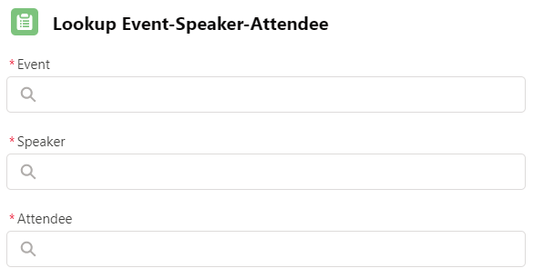

Step 11.3
Prerequisite for Custom Lookup in LWC
https://lwcfactory.com/custom-lookup-salesforce-lwc/
Add Event to Salesforce:
Before we start, create a new RichText Area field on the Position object and Label it as Position Detail.
Develop a Lightning Web Component which will display the Form Input for the Position to take the input from the user and save the Position Record. The Input Form should contain the below fields from the Position object.
- Name ( Custom Field )
- HR Manager ( Lookup )
- Start Date
- End Date
- Position Detail RichText field
Note:
1. We will be using Lightning ui record API to create the record that means no Apex Class is required.
2. After Creating the Record, the user should be redirected to the Position detail page.
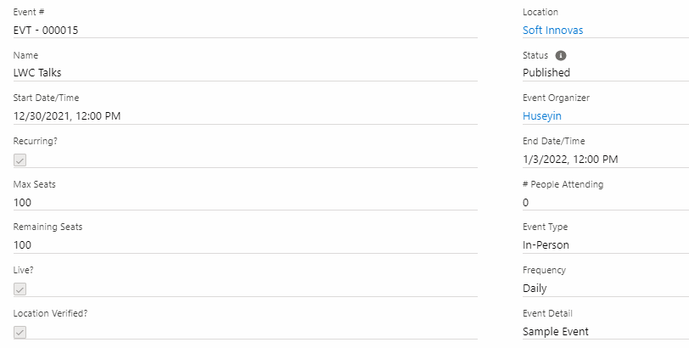

Step 12

Position Detail Component
Develop a Lightning Web component to display the Position details. This Component will contain some additional details like Interviewer Details, Location Details & All Candidates who are attending the Position. So basically this component will have multiple tabs like below. Clicking on Each Tab it should open the detail related to Position.
Note-1: This component will be used to display the Position Details.
Position Details | Interviewer Details | Location Details | Candidate Details

Note-2: Modify Position Detail Component
Add New Interviewer Button on Position-Interviewer Tab and New Candidate on Position-Candidate Tab to associate the Interviewer and Candidate to a Position.
Note- We are going to use Lightning Navigation to open the create record wizard for the same. For Example, to create the Position-Interviewer record we can use below code.
import { NavigationMixin } from 'lightning/navigation';
import { encodeDefaultFieldValues } from 'lightning/pageReferenceUtils'; const defaultValues = encodeDefaultFieldValues({
Position__c: this.recordId
});
this[NavigationMixin.Navigate]({
type: 'standard__objectPage',
attributes: {
objectApiName: 'PositionInterviewers__c',
actionName: 'new'
},
state: {
defaultFieldValues: defaultValues
}
});

Part 1
1 - Position Details - LDS ( Lightning Data Services )
2 - Interviewer - Data-table -
- Modify the Interviewer Object
  - Create a URL field ( Profile URL )
  - Create a Rich Text Area Field ( About Me )
- Add Interviewer Lightning Web Component
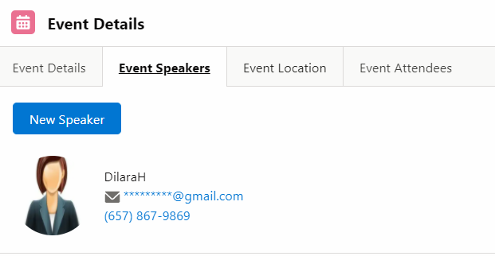

Part 2
3 - Location Details
4 - Candidate Details
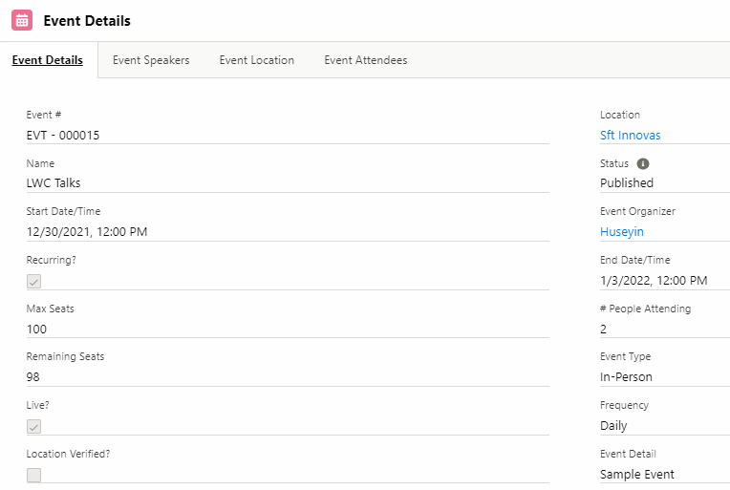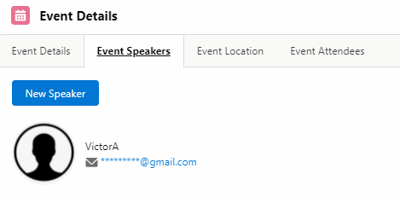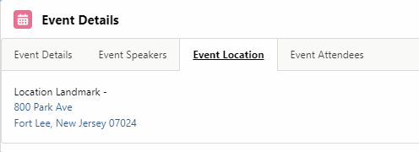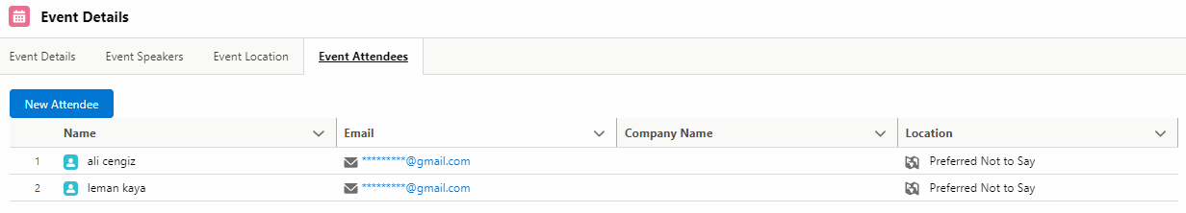

Step 13
Develop Position List Component
Develop a Lightning Web Component which displays all the Positions in a DataTable which are Live and on clicking on the Position Name page it should redirect to Position Detail Page. Positions that are displayed in the data-table that StartDate of the Position record should be either equal to today or greater.
Must Have: Search Functionality to search the Position based on the name, start date & location. We will implement this component in 2 parts and details are as below.
Part 1 - Develop the component and Display the record in the data-table
Part 2 - Implement the search functionality
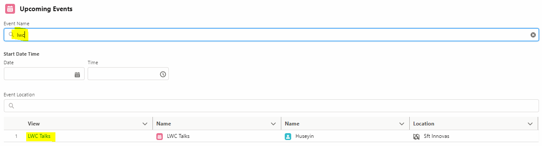

Step 14

CandidatePosition Component
Develop a Lightning web component which will sit inside the detail page of the Candidate object and display the details of the Position that Candidate has attended or registered.
The component must have 2 sections
1 - Upcoming Position: - Display all the Positions that a candidate has registered in a data table. The user should be able to click and create new Position-Candidate records at once. Put a checkbox at the left side of the table and make it clickable for only the Position that the Candidate is not already a member of.
2 - Past Position - Display all the Positions that the user was part of. The past Position-Candidate records should be shown in a datatable as read only lines.
Like the Position Detail Component & Position List Component, we will also implement it in 2 parts. Find the details below.
Part 1 - Implement the Upcoming Position functionality and use lightning datatable to have two separate sections.
Part 2 - Implement the Past Positions functionality.

Step 15
DataTable LWC With Flows
Create a Screen Flow and use a data table LWC component in it.
- Create a new action on the Candidate object called Edit Position. Open a screen flow.
- Show a picklist on the screen called “Please select a type”: Values are “Clear Membership” and “Add Membership”
- If Clear Membership is selected on the screen flows
  - Go to the next screen and list all the Positions which that Client is a member of. (show data table in a LWC)
  - Show the list as selected checkboxes and let the user be able to deselect as many lines he/she wishes.
  - For the deselected lines delete Position-Candidate records for this Position and Candidate.
- If Add Membership is selected on the screen flows
  - Go to the next screen and list all the upcoming Positions which that Candidate could be a member of. (show data table in a LWC)
  - Show the list as blank checkboxes and let the user be able to select as many lines he/she wishes.
  - For the selected lines insert Position-Candidate records for this Position and Candidate.
- After the successful operation close the popup.

Step 16
Community Cloud
Prerequisite for Community Cloud
Introduction to Community Cloud
- Identify and Setup the Community
  - Identify the community for the Project
  - Enable the Community
  - Create the Community name with HR
  - Select Customer Services template
- Setup Login & Registration Page (Ignore this step)
  - Create a Pick-list field on User Object
    - You Are ? ( HR Manager , Candidate )
    - Default “Candidate” value for Pick-list
- Setup Community Profiles
  - Add Custom objects Tabs in Community for navigation
  - Clone “Customer Community Plus User” Profile and Create 2 new profiles
    - HR Manager
    - HR Candidate
  - Provide the Object Level Permission same as HR Manager & Candidate Profile
  - Set the Field Level Access to all 2 profiles that we have created.
( This step is going to explain in the solution record. )

Community Profile
Object Name | HR Manager | HR Candidate
Position | CRED | R
Position - HR Manager | CRE | R
Interviewer | CRE | R
Candidate | R | CRE
Location | CRED | RCE
Position - Interviewer | CRED | R
Position - Candidates | CRED | RC
Note:
C - Created
R - Read
E - Edit
D - Delete
X - No Access

Step 17
Cosmetic Changes In The Community Cloud

Make some cosmetic changes in the community.
  - Add header
  - Add footer
  - Add Position list components
  - Add calendar
  - Add activities

Step 18
Position Detail Component in Community Cloud
1. Add Position Detail Component in Community
a.Modify PositionDetails Component
<targetConfigs>
<targetConfig targets="lightningCommunity__Default"> <property
name="recordId"
type="String"></property>
</targetConfig>
</targetConfigs>
b. Create a Custom Page for Position Object
2. Add CandidatesPosition component in Community

a.Modify CandidatesPositions Component
<targetConfigs>
<targetConfig targets="lightningCommunity__Default"> <property
name="recordId"
type="String"></property>
</targetConfig>
</targetConfigs>
b. Create a Custom Page for Candidate Object
3. Make “New” button visible in Community
4. Add Image URL to CSP Sites
5. Add Logo for Community
6.Provide field Level Permission to Community Guest User Profile
7.Add your two component( CandidatesPositions Component , PositionDetails Component )

Step 19
Email to Case

Before starting please take the “Service Cloud for Lightning Experience” trailhead module.
- Create an Email-to-Case in Salesforce and set up mail forwarding. https://help.salesforce.com/s/articleView?id=sf.setting_up_email-to-case.htm&type=5
- Assign the new case into a queue called “Email Cases”. Add yourself and one other user in this Queue.
- Reply several emails between Salesforce and your Email client. Check Salesforce Email Message records to see if all the emails logged as Email Message records.
- Prepare a record triggered flow. Whenever a new Email Message received from a customer for an open Case, send custom notification to the Case owner which says “Please follow up the Case with Id <CaseId>”

