**INSTRUMENTAL ANALYSIS LABORATORY**

**NAME OF THE EXPERIMENT:** AAS

**DATE OF THE EXPERIMENT:** 29.05.2023 – 30.05.2023

**NAME OF THE ASSISTANT:** Begüm AVCI

**NAME OF THE STUDENT:** Elif Nazenin GİRAY

**GROUP MEMBERS:** Berkay YAPICI,Batuhan GÜNEŞ,Alper İREZ,Bekirhan ERDAŞ

**GROUP NUMBER:** 6

**DATE SUBMISSION:** 5.06.2023

**INSTRUMENTATION**

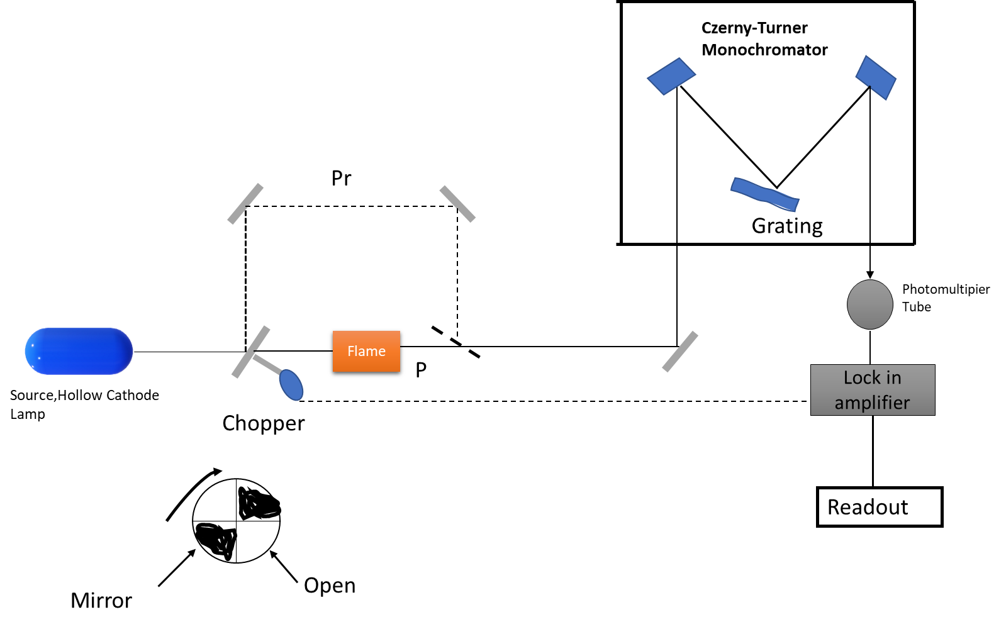

**Instrument Brand is Thermo Scientific and model is Ice 3000 Series AA Spectrometer**

**Source, Hollow Cathode Lamp:** The Hollow cathode lamp is structurally cylindrical line source, and the cathode part is a cylinder with a space inside, the spectrum of which is formed by the structure of the metal sought. The inside of the lamp is filled with Ar or Neon gases, which are inert. Is observed. The part called quartz or UV-glass at the end of the lamp is in the structure for the highest efficiency of radiation transmittance. Lamps have limited lifetimes, and their efficiency depends on the geometry of the lamp and the voltage.

**Chopper:** It performs modulation to prevent interference from flame. This results in higher resolution and more accurate results**.**

**Nebulizer:** An ultrasonic nebulizer transforms the solution into small droplet-sized aerosols

**Flame:** Air/ acetylene flame is used. The flame temperature is around 2300, a type of flame used to determine the spectra of many elements (35).

**Monochromator:** Czerny-Turner monochromator, an echelle monochromator for selecting maximum efficiency in selecting wavelength bands, was used..Additionally, more selective than filters.

**Detector:** A photomultiplier tube is used. The absorption of photons in the photomultiplier tube results in the emission of electrons. The electrons that amplify due to the photon flow are amplified by this detector.

**Locking amplifier**: It amplifies weak signals to reduce the noise that may be displayed in the signals, thus achieving high resolution, precision, and accurate results.

**Readout**: This is the section where the data from the device is collected and read and which is software is observed in the digital environment.

**CALCULATION**

1. **Atomic Absorption Spectrometry for the Determination of Ca**
2. **Direct Method for Ca**

**Graph 1**. Absorbance vs Concentration of Ca Graph for Direct Method

Equation from graph is y = 0,0334x - 0,0095 and R² = 0,9904

**b)Standard Addition Method for Ca**

**Graph 2.** Absorbance vs Concentration of Ca Graph for Standard Addition Method

Equation from graph is y = 0,0505x - 0,027 and R² = 1

**Direct Method for Ca,**

From Graph 1, y = 0,0334x - 0,0095

Absorbance for + 0 Cherry Juice equal to 0,027 and y = 0,0334x - 0,0095 then

x = (y+0,0095)/(0,0334) =(0,027+0,0095)/(0,0334) =1,0926 ≈ 1,1 mg/L

Dilution factor equal to (100 mL)/(2 mL)= 50 then

Concentration of Ca = (1,0926 mg/L)x(50) =54,64 mg/L

**Standard Addition Method for Ca,**

From Graph 2, y = 0,0505x + 0,027

y have to be equal to zero then

y = 0 x=(-0,027)/(0,0505) = -0,5346 ≈ -0,54 = 0,5346 mg/L ≈ 0,54 mg/L

Dillution factor equal to 50 then

Concentration of Ca = (0,5346 mg/L)x(50) = 0,01069 ≈0,01 mg/L

**c)Calculate LOD and reciprocal sensitivity S/N ratio**

**0,5 mg/L Ca:**

**Table 1.Repeat at 0,5 ppm and Absorbance Values**

|  |  |
| --- | --- |
| **0,5 ppm** | **Abs** |
| **1** | **0,013** |
| **2** | **0,013** |
| **3** | **0,013** |
| **4** | **0,013** |
| **5** | **0,015** |
| **6** | **0,013** |
| **7** | **0,013** |
| **8** | **0,013** |
| **9** | **0,013** |
| **10** | **0,014** |

Mean = 0,0133 Standard Deviation= 0,00067

Limit of Detection (LOD) = $\frac{(standard concentration)×(3)×(standard deviation)}{Mean of Absorbance}$ then

LOD = $\frac{(0,5)×(3)×(0,00067)}{(0,0133)}=0,0755564≈0,076$

Sensitivity = $\frac{(concentration of standard solution)×(standard deviation)}{Measured Absorbance}$ then

Sensitivity $=\frac{(0,5)×(0,00067)}{(0,076)}={4,4078×10}^{-3}≈{4,4×10}^{-3}$

$\frac{S}{N}$ = $\frac{Mean}{Standard Deviation}$ = $\frac{0,0133}{0,00067}$ = 19,85

**Atomic Emission Spectrometry for the Determination of Na**

**Table 2.**Concentration of Na and Emission Values

|  |  |  |
| --- | --- | --- |
| Concentration(ppm) | Ems | Blank Corrected |
| Blank | 6,8 | 6,8 |
| 1 | 100,3 | 93,5 |
| 0,8 | 85,9 | 79,1 |
| 0,6 | 71,4 | 64,6 |
| 0,4 | 55,6 | 48,8 |
| 0,2 | 36,3 | 29,5 |
| TAP WATER | 81,9 | 75,1 |

**Graph 3.** Concentration of Na and Emission Values

From Graph 3, y = 79,15x + 15,61 Emission for Tap Water = 75,1 then

75,1 = 79,15x + 15,61 => x= 0,7516108 mg/L ≈ 0,7516 mg/L

Dilution Factor = (100 mL)/(0,5mL) = 200

Concentration of Na = ( 0,7516 mg/L) × (200) = ≈ 150,322 mg/L

Calculate LOD and reciprocal sensitivity S/N ratio

**Na = 0,2 mg/L**

**Table 3. Reputation of 0,2 ppm Na Emission and Blank Corrected Emission Values**

|  |  |  |
| --- | --- | --- |
| **0,2 ppm** | **Emission** | **Blank corrected Emission** |
| **Blank** | **6,8** | **6,8** |
| **1** | **36,3** | **29,5** |
| **2** | **36,4** | **29,6** |
| **3** | **36,4** | **29,6** |
| **4** | **36,4** | **29,6** |
| **5** | **35,9** | **29,1** |
| **6** | **36,0** | **29,2** |
| **7** | **36,4** | **29,6** |
| **8** | **35,9** | **29,1** |
| **9** | **36,0** | **29,2** |
| **10** | **36,2** | **29,4** |

Mean = 26,74 Standard Deviation= 0,2183

Limit of Detection (LOD) = $\frac{(standard concentration)×(3)×(standard deviation)}{Mean of Blank Corrected Emission}$ then

LOD = $\frac{(0,2)×(3)×(0,2183)}{(26,74)}=4,8983×{10}^{-3}≈4,89×{10}^{-3}$

$\frac{S}{N}$ = $\frac{Mean}{Standard Deviation}$ = $\frac{26,74}{0,2183}$ = 122,491 ≈ 122,4

**QUESTIONS**

1. When compared, the Ca concentration is less in the standard addition method than in the direct addition method. The reason for this is that in the standard addition method, the samples are diluted by adding standard solutions to bring the matrix effect to the same value for all samples, and as a result, the Ca concentrations decrease**.**
2. It is known as the matrix effect when the substances in the samples but whose signal is not sought affect the sample signals and are in an environment that causes interference. The standard addition method is used to prevent the matrix effect. This method eliminates the matrix effect by adding standard solutions in different volumes to samples with different concentrations but the same total volume where the same matrix effect is effective. In AAS, many interferences originate from flame, and one of the best ways to reduce them is the standard addition method.
3. ICP-MS

It has wide dynamic ranges, and collision cells are used. The mass spectroscopy of the atom is measured. The samples are diluted and introduced to the device, and the detection limit is in ppt measurements.

ICP-OES

It is used to discover the wavelength ranges of excited atoms and ions. It is used for suspended solids. It is used for samples with high matrix effect. It is cheaper than ICP-MS and the detection limit is in ppb measurements.

* Considering this information, the low detection limit of ICP-MS is used in areas where more sensitive measurements are required. AAS sensitivity and detection limit are not as good as ICP-MS, but ICP-OES and AAS sensitivity are comparable. The most sensitive and low detection limit devices are ICP-MS, respectively. It can be listed as ICP-OES and, finally, AAS.

1. With the excitation of the element in the samples, the atoms return to a lower energy level, and AAS measures the radiated energy. The elements are separated from their chemical bonds, atomized, and brought to their ground state. With the flame, the atom is in the line spectrum with a narrow bandwidth. It can absorb radiation at a low energy level. On the other hand, in flame emission spectrophotometry, characteristic light emission is observed with the atoms of metals due to sufficient energy provided by the flame. The wavelength used for measuring the element should be close to the interference lines, relative to the selected wavelength, and the closest wavelength is selected. This selection is vital for sensitivity. Based on this information, the flame sodium used for the Na element is sufficient for excitation, and no other power source is needed. In summary, spectral interferences, of which external radiation and insufficient spectral line resolution, are essential for FES and cannot be neglected for AAS. Elements other than Li, K, Na, and Ca are challenging to detect in FES because atomic line interferences are too severe for background absorption FES. In addition, an additional power source is needed for the Ca element to excite and then emit. Therefore, the absorption method is used for calcium.
2. There are a lot of interferences in the spectrum due to the flame. By reducing the effects of this, it has been optimized to receive signals with high resolution and precision.

In optimization processes,

* First, an adjustment was made by changing the flow/oxidation ratio.
* The burner, which is the place where the flame is formed, was moved up and down with the computer. When the burner is moved up, the flame height decreases; when pushed down, it increases.
* The burner is also manually moved back and forth, which should be done carefully to avoid burns from the flame.
* Computer control moves a hollow cathode lamp up and down, and this optimizing process causes descent changes as it changes the source of the instrument.
* The drop sizes inside the nebulizer are adjusted by manually turning the impact bead back and forth right and left. The adjustment makes the drop sizes into tiny drops, thus improving atomization and efficiency.

**REFERENCES**

1) Kricka, L. J., & Park, J. Y. (2014). Assay principles in clinical pathology. *Pathobiology of Human Disease*, 3207–3221. <https://doi.org/10.1016/b978-0-12-386456-7.06302-4>

2) Baker, D. E., & Suhr, N. H. (2015). Atomic absorption and flame emission spectrometry. *Agronomy Monographs*, 13–27. <https://doi.org/10.2134/agronmonogr9.2.2ed.c2>

3) Skoog, D. A., & Crouch, S. R. (2018). Chapter 9 Atomic Absorption and Atomic Fluorescence Spectrometry Chapter 10 Atomic Emission Spectrometry and Chapter. In F. J. Holler (Ed.), *Principles of Instrumental Analysis Seventh Edition* (7th ed., pp. 210–252). essay, Cengage Learning.

4) Lonergan, G. A., & Pepper, D. C. (1965). Transport numbers and Ionic mobilities by the moving boundary method. *Journal of Chemical Education*, *42*(2), 82. <https://doi.org/10.1021/ed042p82>

5) Menzies, A. C. (1960). A study of atomic absorption spectroscopy. *Analytical Chemistry*, *32*(8), 898–904. <https://doi.org/10.1021/ac60164a001>