**INSTRUMENTAL ANALYSIS LABORATORY**

**NAME OF THE EXPERIMENT:** UV-VIS

**DATE OF THE EXPERIMENT:** 22.05.2023 – 23.05.2023

**NAME OF THE ASSISTANT:** Gökçe TİDİM

**NAME OF THE STUDENT:** Elif Nazenin GİRAY

**GROUP MEMBERS:** Berkay YAPICI,Batuhan GÜNEŞ,Alper İREZ,Bekirhan ERDAŞ

**GROUP NUMBER:** 6

**DATE SUBMISSION:** 31.5.2023

**INSTRUMENTATION**

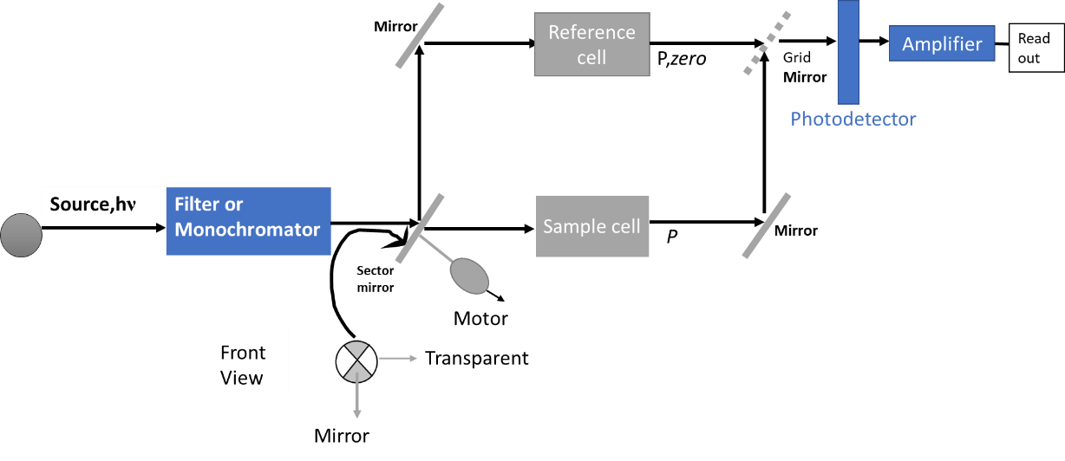

The brand of the UV-VIS Spectrometry is T80+ UV/VIS Spectrometer, PG Instruments Ltd.

**Source:** The source is the Deuterium lamp. As a result of the electrical excitation of deuterium at low pressure, a continuous spectrum can be produced in the UV field.

P,*zero*

*P*

Amplifier

Grid **Mirror**

Readout

**Mirror**

Photodetector

**Monochromator:** Making wavelength selection with the scanning technique.The brand is Czerny-Turner 0.278 m.

**Cells:** Quartz cells were used. Since plastic and silica in the UV region can absorb the light in that region, quartz was chosen as the cell material.

**Photodetector:** A photomultiplier tube, which is a detector with high sensitivity, is used. It is a single-channel photodetector.

**CALCULATION**

**Experiment 1:** Determination of MnO4- and Cr2O72- mixture solution,

**Beer’s Law, A=εbc** A: Absorbance b: Path length in centimeters

ε: Molar absorptivity (L/mol.cm) c: Concentration (M=mol/L)

**For Cr2O72-**

**Table 1.** Different Cr2O72- concentrations at 310 and 350 nm

|  |  |  |
| --- | --- | --- |
| **Cr2O72-** | **310 nm** | **350 nm** |
| 1x104- | 0,138 | 0,294 |
| 2x104- | 0,283 | 0,592 |
| 3x104- | 0,421 | 0,856 |
| 4x104- | 0,567 | 1,087 |

**Graph 1.** Absorbance at 310 nm for. Different Cr2O72- concentrations

From Graph 1, equation is y = 1425x - 0,004 then **m=(ε)x(b)** b: 1 cm then

ε1= 1425 L/mol.cm

**Graph 2.** Absorbance at 350 nm for. Different Cr2O72- concentrations

From Graph 2, equation is y = 2643x + 0,0465 then **m=(ε)x(b)** b: 1 cm then

ε2= 2643 L/mol.cm

**For MnO4-,**

**Table 2.** Different MnO4-, concentrations at 310 and 350 nm

|  |  |  |
| --- | --- | --- |
| MnO4- | **310 nm** | **350 nm** |
| 1x104- | 0,091 | 0,062 |
| 2x104- | 0,175 | 0,120 |
| 3x104- | 0,255 | 0,172 |
| 4x104- | 0,353 | 0,240 |

**Graph 3.** Absorbance at 310 nm for. Different MnO4-, concentrations

From Graph 3, equation is y 1303,3x - 0,019 then **m=(ε)x(b)** b: 1 cm then

ε3= 1303,3 L/mol.cm

**Graph 4.** Absorbance at 350 nm for. Different MnO4-, concentrations.

From Graph 4, equation is y = 1073,3x - 0,024 then **m=(ε)x(b)** b: 1 cm then

ε4= 1073,3 L/mol.cm

* *Absorption for mixture,*

**A= ε1b1c1 + ε2b2c2 +… c1 = [Cr2O72-] c2 = [MnO4-]**

***Mixture= 10 mL of 2x104- M MnO4-, and 10 mL 3x104-M Cr2O72***

**Theoretical Value for [Cr2O72-] =**

**Theoretical Value for [MnO4-] =**

**A310 = 0,285 A350 =0,478**

* At 310 nm,

0,285 = (1425 L/mol.cm)×(1 cm)×(c1) + (2643 L/mol.cm)×(1 cm)×(c2)

* At 350 nm,

0,478 = (1303,3 L/mol.cm)×(1 cm)×(c1) + (1073,3 L/mol.cm)×(1 cm)×(c2)

c1 = [Cr2O72-] = 1,6179 × 10-4 M c2 = [MnO4-] = 5,007 × 10-4 M

for [Cr2O72 ] =

for [MnO4-] = 4,01 %

**Experiment 2:** Photometric Titration of Cu2+ by EDTA

**Corrected Absorbance = $\frac{(Absorbance ×Total Volume)}{Original volume }$**

At 607 nm, corrected absorbance = $\frac{(0,403 ×62 mL)}{(60 mL) }$ = 0,4164 ≈ 0,42

**Table 3.** Corrected Absorbance and Absorbance at 607 and 727 nm

|  |  |  |  |  |
| --- | --- | --- | --- | --- |
| **EDTA (mL)** | **Absorbance at 607 nm** | **Corrected Absorbance at 607 nm** | **Absorbance at 727 nm** | **Corrected Absorbance at 727 nm** |
| 2 | 0,403 | 0,4164 | 0,291 | 0,3007 |
| 3 | 0,370 | 0,3885 | 0,335 | 0,3518 |
| 4 | 0,299 | 0,3147 | 0,359 | 0,3829 |
| 5 | 0,235 | 0,2546 | 0,383 | 0,4149 |
| 6 | 0,171 | 0,1881 | 0,408 | 0,4488 |
| 7 | 0,138 | 0,1541 | 0,416 | 0,4645 |
| 8 | 0,136 | 0,154133 | 0,410 | 0,4647 |
| 9 | 0,135 | 0,15525 | 0,404 | 0,4646 |

**Graph 5.** Adding volume of EDTA vs Corrected Absorbance

From Graph 5 equivalence point at 7 mL EDTA

EDTA, M= 0,10 M

Molecular Weight of Cu = 63,546 g/mol

**Experimental value of Cu2+ equal to**

Cu2+ + EDTA → Cu(EDTA)2- + 2H+

nCu2+ = n EDTA

**Mol of EDTA** = then 7,0×10-4 mol Cu+2

**Grams Cu2**+ = (7,0 × 10-4 mol Cu (NH4)3)× (

**Theoretical Value of Cu2+**

60 mL of Cu (NH4)3 used in the experiment then.

(0,01 M) ×(0,06 L)×(63,54 g/mol) = 0,0381 grams

Percent Error = $\frac{\left(0,0445-0,0381 \right)grams}{0,0381 grams}×100=16,8 \%$

**QUESTIONS**

1. It is the line represented as a function of wavelength, of the absorbance value of the matrix of the solvent or sample. This curve is obtained because of scanning in the wavelength range where the solvent or matrix is present, or the blank sample is desired to be examined. It is important because it is used to repair any absorption or possible light scattering from the matrix or solvent.
2. The vital point in the valid beer law for mixtures is that the different compounds should not interact. The formula required for the mixtures:

Atotal =A1C1 +A2C2 + … Number as 1 and 2 shows to absorbing components

1. The curve of the R2 value closest to one is used to select the most appropraite wavelength. As can be observed from the graphs, a linear increase is observed between the absorbance and concentration values. While drawing the graphs in Excel, the curve equation was added so that the R2 values of the line equations were closest to 1 It is seen that these graphs are the most suitable graphs for MnO-4 and Cr2O72 at 310 and 350 nm values.
2. Potassium dichromate's properties make it a suitable reference for calibrating the UV-VIS spectrometer. First, its high molar absorption feature in the UV spectrum region is very effective in being a suitable reference. Due to its stable molecular structure, it does not react with other compounds in the environment and is a compound that does not deteriorate quickly. Its absorption spectra are verified known spectra, making it reliable as a reference compound. Being a cheap material and finally easily soluble in water, it contributes to obtaining verifiable measurements in examining the prepared aqueous solutions in the UV-VIS spectrometer. Lastly, its structural and chemical properties allow the craetion of calibration curves for UV-VIS that are sure to be accurate.
3. Cu2+ + EDTA → Cu(EDTA)2- + 2H+
4. Analyte amount decreases and titrant all amount’s used thus products amount increases.At end point analyte and titrant used and only product in present..After end point all analyte uses product will remain same but titrant’s amount become excess. Considering this information, if the absorbance values decrease after the endpoint, it can be said that the reason for this is that the molar absorptivity values are more significant than zero for the titrant and product and value of molar absorptivity is higher than titrant’s value.Still, this value is zero for the analyte.

**Figure 1.** Photometric titration curve for εp > εT and εA = 0

**REFERENCES**

1) Skoog, D. A., & Crouch, S. R. (2018). Chapter 14 Applications of Ultraviolet-Visible Molecular Absorption Spectrometry . In F. J. Holler (Ed.), *Principles of Instrumental Analysis Seventh Edition* (7th ed., pp. 331–362). essay, Cengage Learning Cengage Learning.

2)Berberan-Santos, M. N. (1990). Beer’s Law Revisited. *Journal of Chemical Education*, *67*(9), 757. <https://doi.org/10.1021/ed067p757>

3)Taft, W. S., & Mayer, J. W. (2000). *The Science of Paintings*. <https://doi.org/10.1007/b97567>

4)Klamt, A. (1996). Calculation of UV/vis spectra in solution. *The Journal of Physical Chemistry*, *100*(9), 3349–3353. <https://doi.org/10.1021/jp950607f>

5)Haiss, W., Thanh, N. T., Aveyard, J., & Fernig, D. G. (2007). Determination of size and concentration of gold nanoparticles from UV−Vis Spectra. *Analytical Chemistry*, *79*(11), 4215–4221. <https://doi.org/10.1021/ac0702084>