**INSTRUMENTAL ANALYSIS LABORATORY**

**NAME OF THE EXPERIMENT:** IR

**DATE OF THE EXPERIMENT:** 5.06.2023 – 6.06.2023

**NAME OF THE ASSISTANT:** Doğan AKBULUT

**NAME OF THE STUDENT:** Elif Nazenin GİRAY

**GROUP MEMBERS:** Berkay YAPICI,Batuhan GÜNEŞ,Alper İREZ,Bekirhan ERDAŞ

**GROUP NUMBER:** 6

**DATE SUBMISSION:**10.06.2023

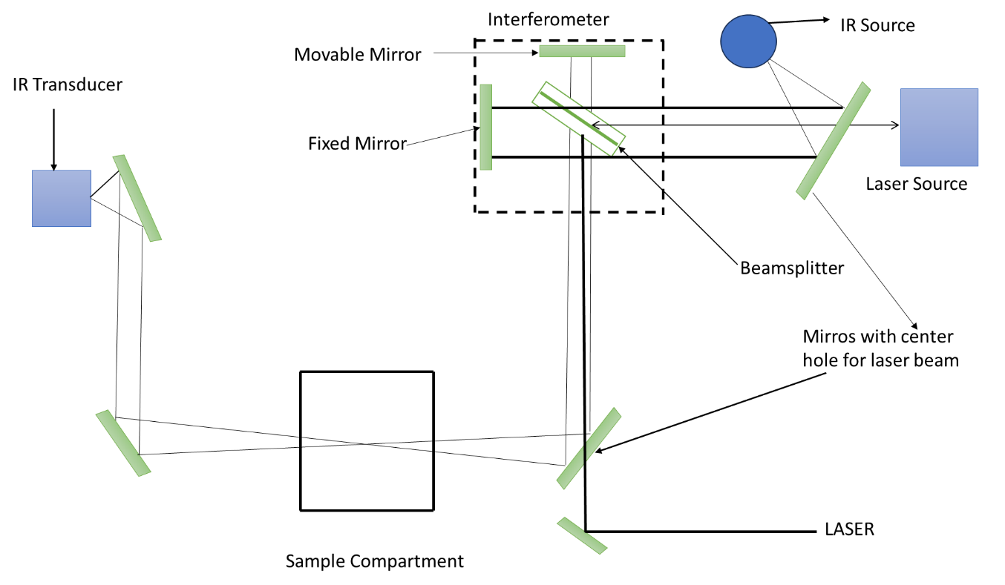**INSTRUMENTATION**

**The brand of FTIR is Bruker/Alpha-T Single Beam FTIR**

**Source:** It is a type of welding that has a cylindrical shape with a diameter of 1-3 mm and a length of 2-5 cm and contains earth oxides in its structure. Platinum cables are placed at the ends of the cylinder to allow the passage of electric currents equivalent to the resistance that heats the ends of the cylinder. In case of an increase in temperature, a decrease in the resistance is observed. To observe this situation, there must be a current limitation. Without limitation, the source may be irreversibly damaged due to rapid heating.

**Michelson Interferometer:** The beam splitter inside the Michelson interferometer divides the beam of light into two, allowing the rays to be refracted in different directions, and transmits and reflects half of the light. After this process, a fixed mirror and a movable mirror send these beams back to the beam splitter and help them combine. it also concentrates the light separately and transmits it to the detector as a function of these intensity differences.

**Detector (Pyroelectric Transducer):** It comprises crystal layers of pyroelectric materials that are electrically insulating and have special thermal sensitivity. For IR detection, DTGS with deuterium and often some of the glycine are replaced by alanine, DLaTGS, making them one of the most important detectors for IR. If the external field is removed, the induced polarization continues to maintain polarization depending on the temperature. The value of the current in the electrical circuit changes with the polarization and surface area, which changes in direct proportion to the temperature. In addition, the rapid response of these transducers to the signals is among the reasons for preference.

**Laser:** Since it is a powerful source, it is used to locate the moving mirror.

**CALCULATION**

1. The IR Spectra of Standard PMMA-PVC Films In Transmittance Mode.

T0= %89,5

Blue arrow represents the %2 PPMA which has Ts =% 77

Red arrow represents the %4 PPMA which has Ts = % 47

Purple arrow represents the %6 PPMA which has Ts =% 28,5

Green arrow represents the %8 PPMA which has Ts =% 17

$A=log\frac{T_{0}}{T_{S}}$ then

%2 PPMA Absorbance is $log\frac{89,5}{077}=0,065$ same calculations process for %4 %6 and %8

%4 PPMA Absorbance =0,279

%6 PPMA Absorbance =0,469

%8 PPMA Absorbance = 0,6557

**Graph 1.** The Calibration curve for PPMA

The using of Graph 1,determining the unknown concentration. From the IR Spectrum y value found from the carbonyl group signal and it is the 8,5 cm then

. y = 0,9811x - 0,1234 => 8,5 = 0,9811x - 0,1234 x which is the concentration of unknown it is 8,0238 ≈8,0

1. Acetone for IR, C=O stretching at 1690-1740 interval

1. Acetone for ATR the C=O stretching at 1690-1760 cm-1 interval and C-H stretching Peaks at 2850-3010 interval

1. Acetonitrile for IR, C-H stretching at 2850-3000 cm-1, C-N triple bond stretching peaks at 2200-2300 cm-1

1. Acetonitrile for ATR, C-H stretching at 2900-3010 cm-1 interval, C-N triple bond stretching peaks at 2250-3000 cm-1 interval

1. n-butanol for IR, C-H stretching at 2850-2970 cm-1 interval O-H stretching 3300-3600 cm-1 interval

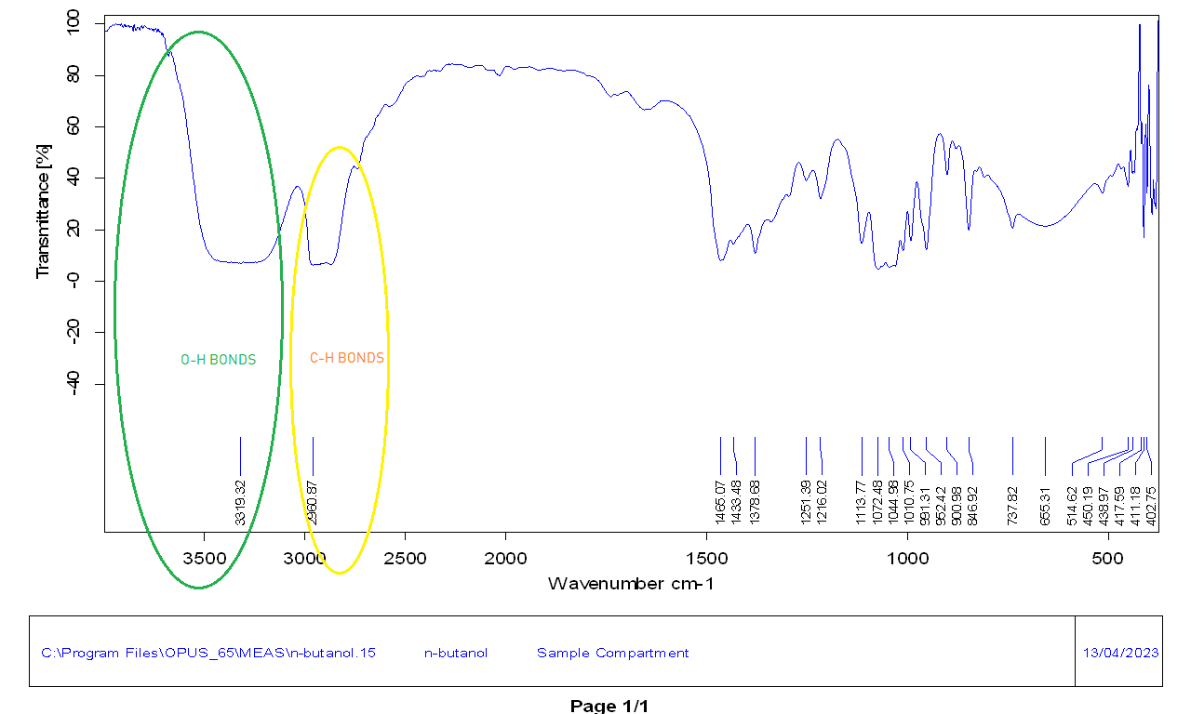

1. n-butanol for ATR, C-H peaks at 2850-2970 cm-1 interval, O-H stretching peaks for H bonded alcohols cm-1 interval

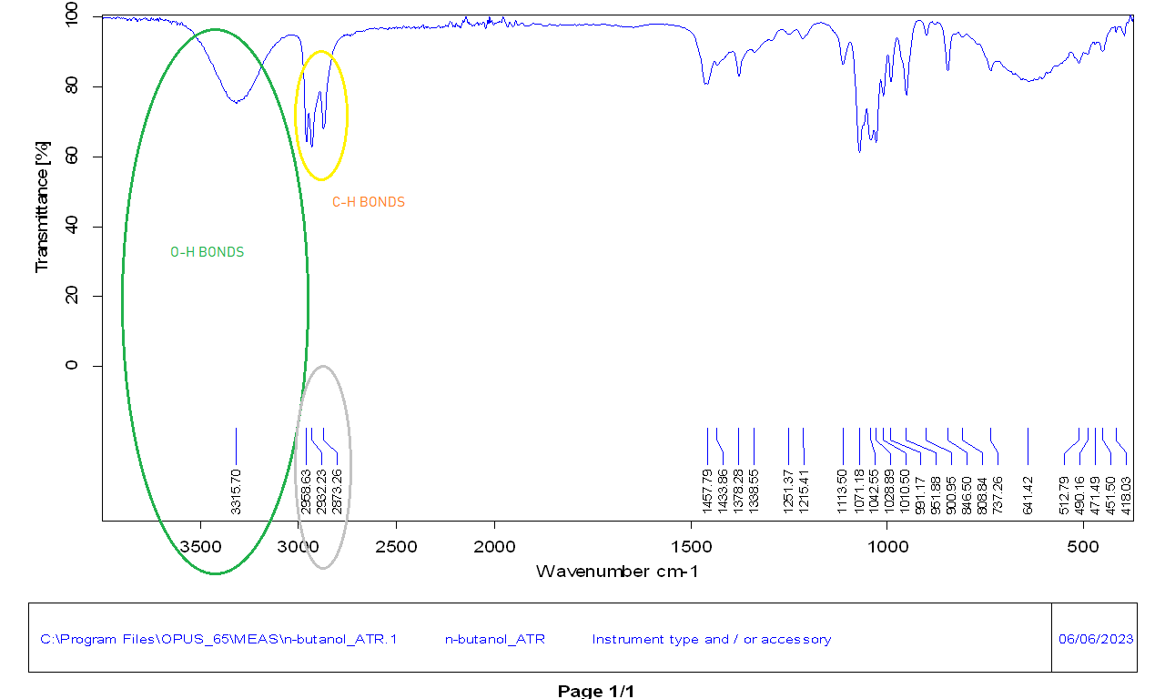

1. PP for IR C-H bonds for alkanes 2500- 2970 peak range

1. PS for IR C-H stretching 2850- 2900 cm-1 interval, C-H stretching for Aromatic Rings 3000-3120 cm-1 interval and C=C bonds for Aromatic Rings 1540-1670cm-1 interval

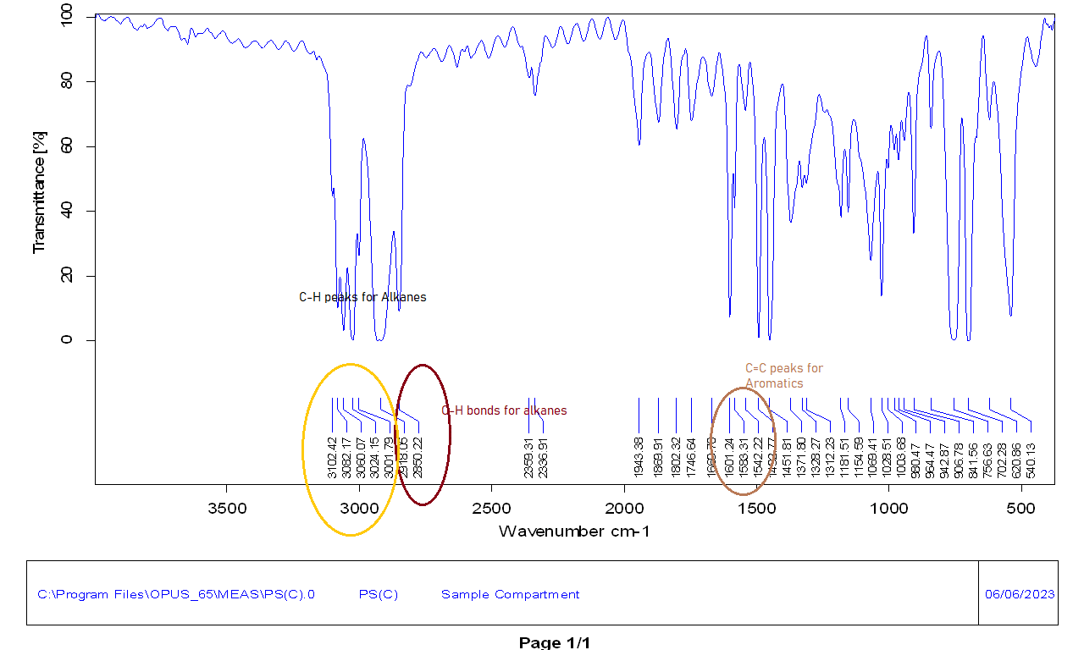

1. PVC for IR C-H stretching is 2800-2970 cm-1 interval 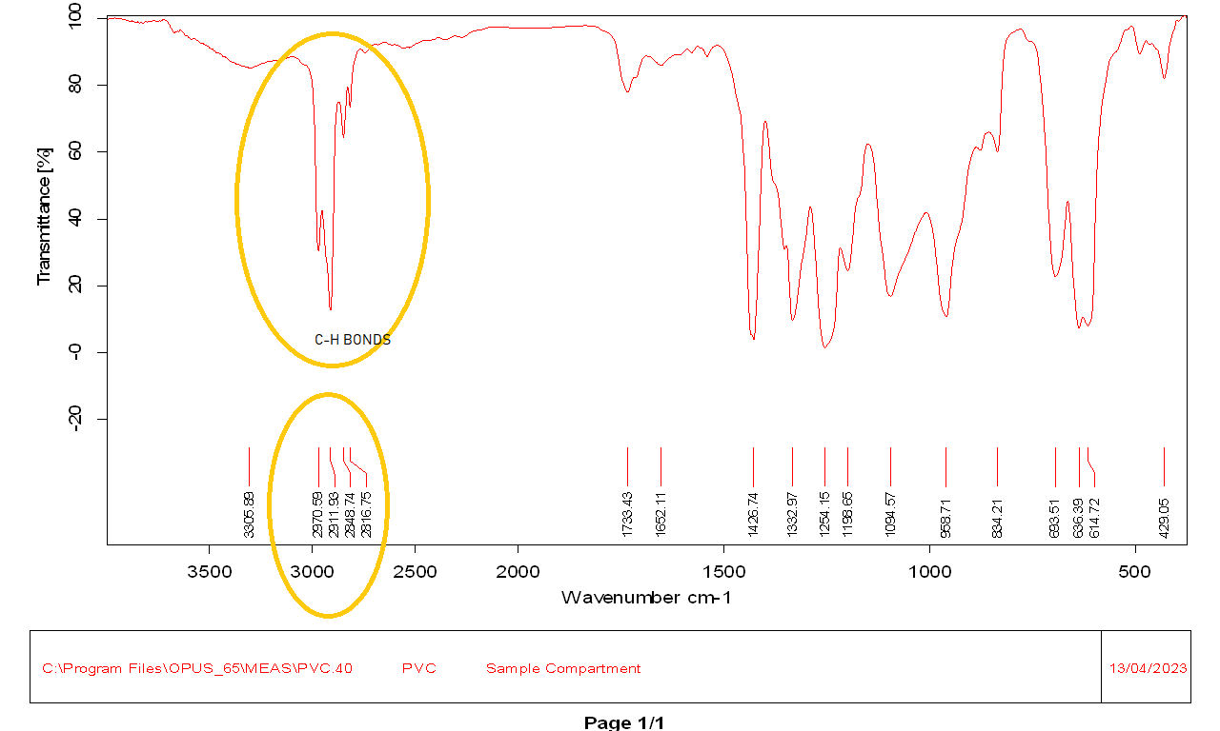
2. Sucrose for IR C-H 2700-3020 cm-1 interval and O-H stretching for 3300-3600 cm-1 interval

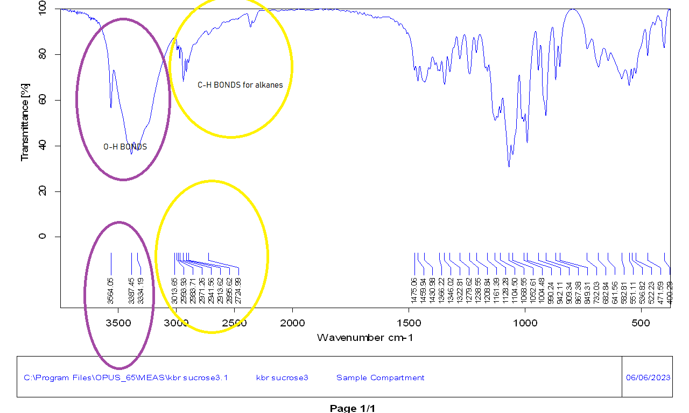

1. Sucrose for ATR C-H stretching 2800-3000 cm-1 interval and O-H bonds for 3300-3500 cm-1 interval 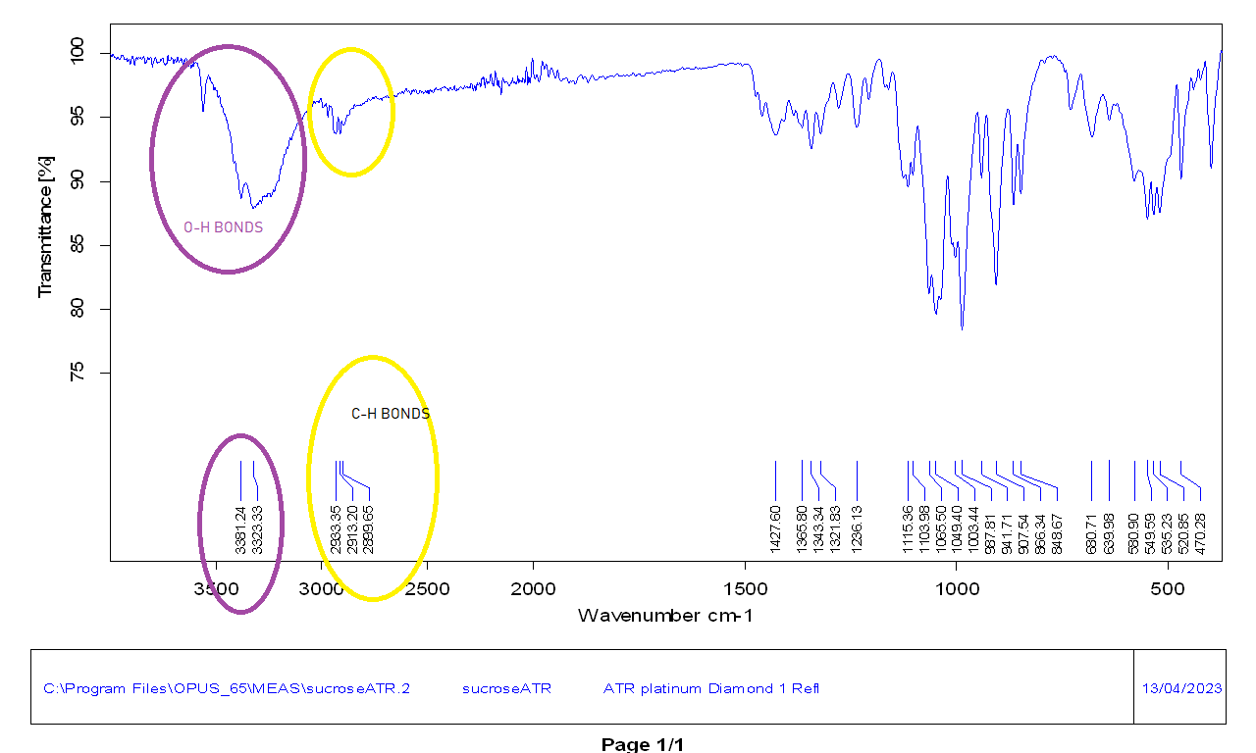
2. Unknown for IR C-H stretching 2700-3020 cm-1 interval and C=O bonds for 1690-1760 cm-1 interval 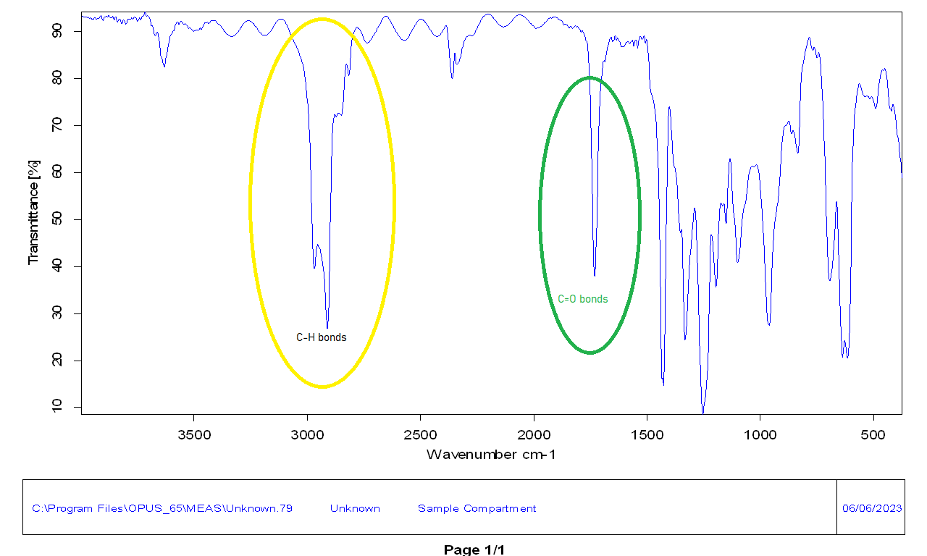
3. Calculating the film thicknesses of PP and PS films.

$b=\frac{∆N}{2(ν_{1}-ν_{2})}$ b: Thickness of the film

N: Number of interference fringes

ν : Wavenumber

**For PP,**

, and then

= 2,8776 ×10-3 ≈2,9 ×10-3 cm

**For PS,**

, and then

= 7,4204 ×10-3 ≈ 7,4 ×10-3 cm

**QUESTIONS**

1. In the IR spectrum, the 200-4000 cm-1 range is considered among the most measured regions. With the change in the distance between the atomic nuclei in the molecules, excitations occur with vibrations. Some rays sent in IR may not absorb the radiation in the infrared region. There is mostly nitrogenous oxygen and carbon dioxide in the air. While carbon dioxide can be observed in the IR spectrum, nitrogen and oxygen cannot be observed. Changes in the dipole moments of the molecules make them IR-active molecules because, because of these changes, the tension movement of the nuclei in the molecules is different. On the other hand, the dipole moments of the molecules that cannot absorb IR radiation are the same. As a result, the tension movements between the nuclei are the same, and they become inactive for IR. The degree of freedom determines the number of vibrations in the carbon dioxide molecule. When we look at the molecular geometry of carbon dioxide, it is linear, and for ***the degree of freedom, 3N-5*** where ***N represents the total atomic number***. It is seen that the degree of freedom value for carbon dioxide is four.

***The number four represents***:

***Symmetrical Stretching***: does not change the dipole moment; its molecules are IR inactive.

***Asymmetric Stretching:*** It changes the dipole moment and provides the appearance of molecules in the IR spectrum.

***Bending Vibrations with Two Vibrational Modes In Different Planes:*** They make molecules IR active by changing the net dipole moment.

In addition to this information, C-O asymmetric stretching is observed at 2565cm-1 and O-C-O bending vibrations at 526cm-1.

**Figure 1.** Types of Molecular Vibrations

1. Although the spectrum gives signals in the expected place, it is a very noisy spectrum. Noise can occur in places and situations where there is energy restriction. Among the reasons for this situation, spectral reflection techniques, decrease or increase in temperature, or spectra of samples can be counted. The S/N ratio can be increased by increasing the number of scans, but this can also cause a waste of time. Even though there is a loss of resolution, smoothing can significantly reduce noise.
2. It can work in the area that covers the entire middle IR region in the spectrum but is inactive as IR. Thanks to this feature, it prevents the formation of peaks that will create interference. The refractive index is in good agreement with most organic samples.
3. The specific range in the IR spectrum for O-H stretching is between 3200-3600 cm-1. The bands formed due to the polarity and hydrogen bonds in the water are very strong and wide-ranging, and in this case, these bands become invisible in the IR spectrum. The IR spectrum is deteriorated by samples containing water. In addition, the KBr disc used in IR is sensitive to water and can be damaged by water beyond repair.
4. Since there are different vibrations and bent motions for different compounds and atoms in IR, peaks appearing in different wavenumbers occur for each in the spectrum. The environment where the IR device is located, and the device must be free from moisture and protected from damage to the composite material mechanism. Because if the composite material mechanism is damaged, the spectrum will be affected, and there will be doubts about its accuracy. The presence of water droplets or steam caused by moisture on the protective glass lens of the device, or the lens of the thermal imaging device may prevent the radiation from reaching the infrared imaging lens. This affects the accuracy of the results as it will negatively affect the IR light transmission. Humidity shows its effect differently on regions in the spectrum. In the near IR region, moisture causes an increase in absorption. In the whole spectrum, band values can be very high due to the hydrogen bonds of water.
5. A peak due to C-N triple bond stretching is observed in the reactant part of the reaction in the IR spectrum. A peak of C=O stretching will be seen in the products part.

CH3MgI + CH3CN → CH3-(NMgI)CH3 + H3O+ → CH3COCH3

1. ***Answers of the that question at the other pages***





**REFERENCES**

**1)** Skoog, D. A., & Crouch, S. R. (2018). chapter SIXTEEN An Introduction to Infrared Spectrometry and chapter seventeen Applications of Infrared Spectrometry. In F. J. Holler (Ed.), *Principles of Instrumental Analysis Seventh Edition* (7th ed., pp. 389–436). essay, Cengage Learning

**2)**Silverstein, R. M., Bassler, G. C., & Morrill, T. C. (1991). *Spectrometric identification of Organic Compounds*. Wiley.

**3)**CROOKS, R. M., XU, C., SUN, L., HILL, S. L., & RICCO, A. J. (2010). Cheminform abstract: The characterization of organic monolayers by FTIR external reflectance spectroscopy. *ChemInform*, *25*(9). <https://doi.org/10.1002/chin.199409332>

**4)** Fujimoto, C., & Jinno, K. (1992). Chromatography/FT-IR spectrometry approaches to analysis. *Analytical Chemistry*, *64*(8). <https://doi.org/10.1021/ac00032a001>

**5)** Weeks, S. J., McClelland, J. F., Wright, S. L., & Jones, R. W. (1997). Transient infrared spectroscopy for on-line analysis of solids and viscous liquids. *Progress in Fourier Transform Spectroscopy*, 801–802. <https://doi.org/10.1007/978-3-7091-6840-0_212>