REPORT
OF
INTRODUCTION TO DATA SCIENCE

Submitted To
School of Computer Science and Engineering
IILM University, Greater Noida, U.P.
In partial fulfilment of the requirement of degree of
B.Tech CSE

By
SATYAM KUMAR
Roll Number: 2410031099
Batch: 2024–2028

CANDIDATE’S DECLARATION
I, SATYAM KUMAR, hereby declare that the report titled “Introduction to Data Science” has been prepared by me as part of my academic/training work to fulfil the requirement for the award of the degree of Bachelor of Technology in Computer Science and Engineering. The report presents the learning and subject matter associated with the certified course “Introduction to Data Science” offered by Networking Academy through the Cisco Networking Academy program.
I further declare that the work presented in this report is prepared for academic submission and that the certificate reproduced in this report is the certificate issued in my name. Wherever external concepts or terminology are discussed, they are presented for educational purposes.

Signature: __________________________
Student Name: SATYAM KUMAR
Roll No.: 2410031099

ACKNOWLEDGEMENT
I take this opportunity to express my sincere gratitude to everyone who supported me during the completion of this academic training report. I am thankful to the School of Computer Science and Engineering, IILM University, Greater Noida, for providing an academic environment in which I could develop my understanding of computer science and data-oriented technologies.
I am also grateful to Networking Academy and Cisco Networking Academy for providing the certified learning opportunity titled “Introduction to Data Science.” The course gave me a structured exposure to the foundations and practical relevance of data science.
Finally, I express my gratitude to my teachers, mentors, friends, and parents for their guidance, encouragement, and support throughout my learning journey.

Signature: __________________________
Student Name: SATYAM KUMAR
Roll No.: 2410031099

INTERNSHIP / TRAINING COMPLETION CERTIFICATE
Certificate issued by Cisco Networking Academy
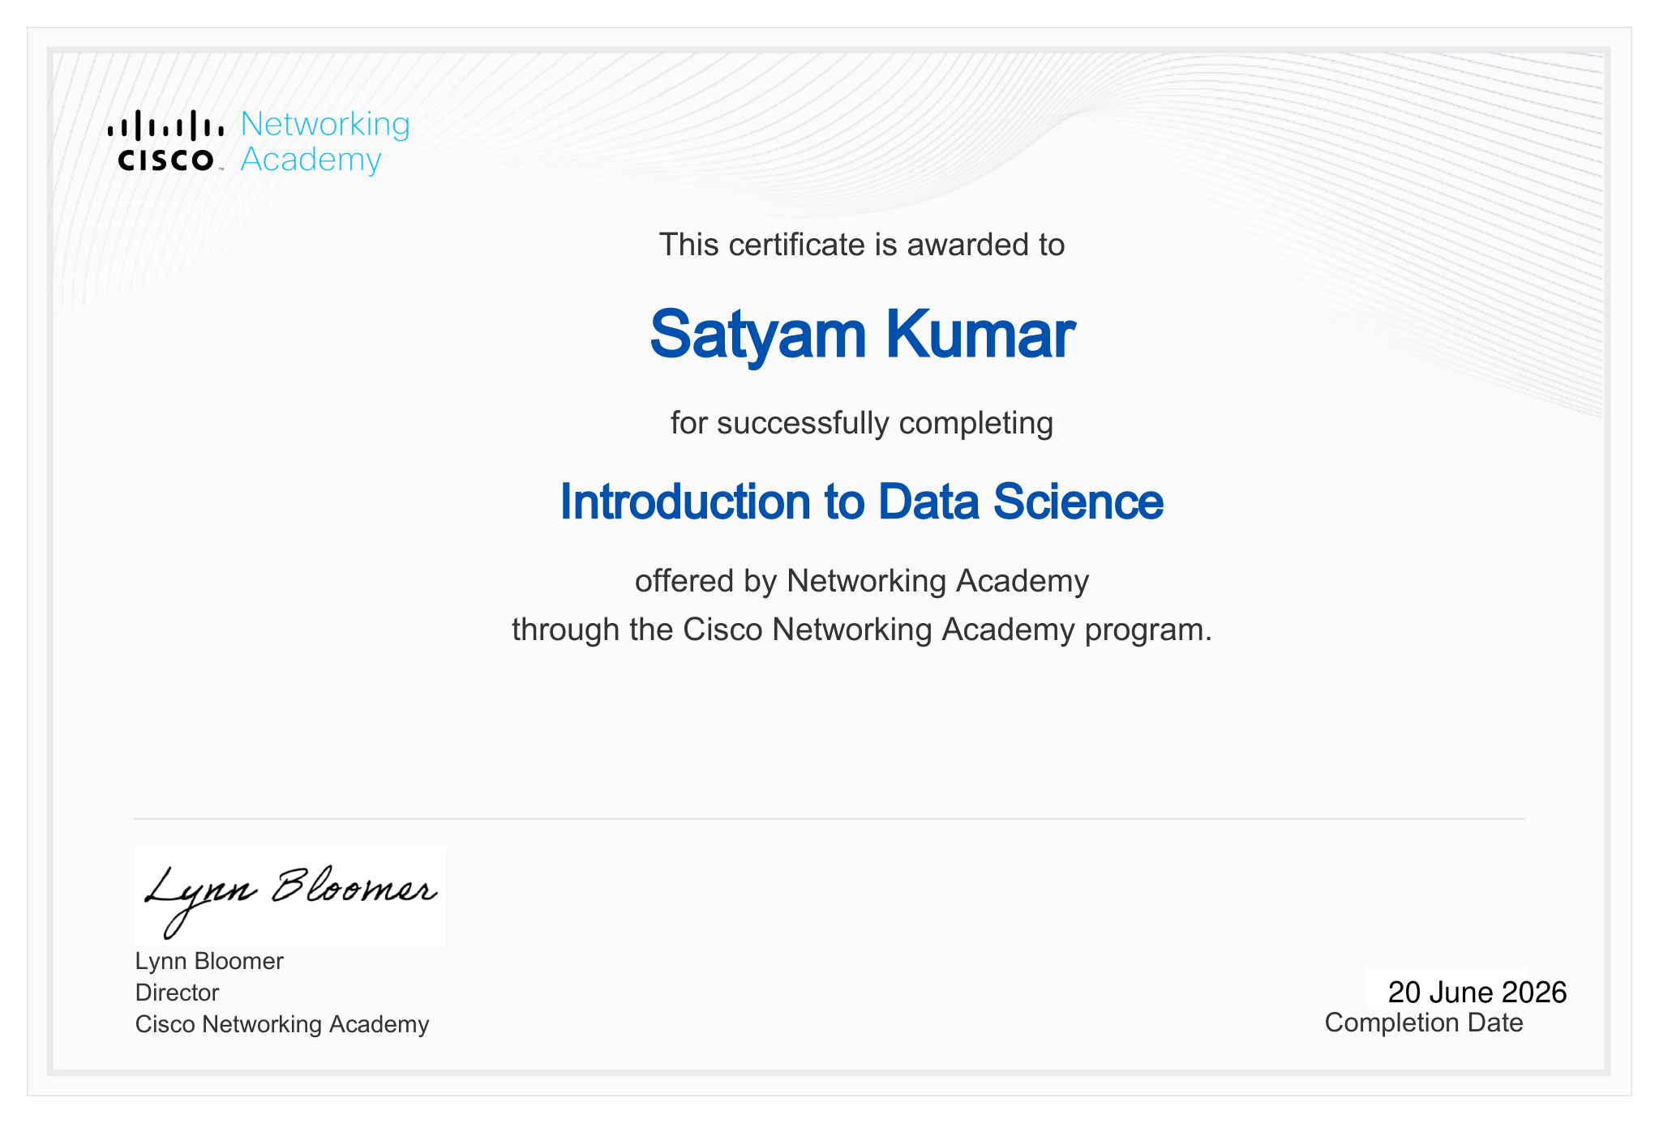
The certificate confirms that Satyam Kumar successfully completed “Introduction to Data Science” through the Cisco Networking Academy program, with a completion date of 20 June 2026.

TABLE OF CONTENTS
1. Candidate’s Declaration
2. Acknowledgement
3. Internship / Training Completion Certificate
4. Project Description
4.1 Introduction
4.2 Organization / Learning Platform Profile
4.3 Problem Statement
4.4 Project Objectives
4.5 Scope of the Project
4.6 Technologies and Tools Used
4.7 System Architecture
4.8 Methodology
4.9 Expected Outcomes
4.10 Certificate and Completion Evidence
5. Bibliography / References

4. PROJECT DESCRIPTION
4.1 Introduction
Data science is an interdisciplinary area concerned with working with data to obtain useful information, identify patterns, support decisions, and communicate findings. The certified learning activity completed by the student was titled “Introduction to Data Science.” The purpose of this report is to document the learning theme, objectives, scope, methodology, tools, and expected outcomes associated with this training.
The report treats the activity as a structured learning and training project rather than claiming specific industrial deliverables that are not stated on the certificate. The certificate establishes successful completion of the Introduction to Data Science course through Networking Academy under the Cisco Networking Academy program, completed on 20 June 2026.
4.2 Organization / Learning Platform Profile
The certificate identifies Networking Academy as the provider of the “Introduction to Data Science” course and states that the course was delivered through the Cisco Networking Academy program. For the purpose of this academic report, Networking Academy is therefore considered the learning platform associated with the certified activity.
The certificate itself does not provide a detailed organization profile, course duration, module list, instructor details, grading scheme, or project-specific implementation details. Accordingly, this report does not attribute such unsupported details to the certificate.
4.3 Problem Statement
Modern organizations generate and collect large quantities of data. A learner entering the field of computer science needs a foundational understanding of how data can be viewed, prepared, analyzed, interpreted, and communicated. The problem addressed by this training report is therefore the development of a structured introductory understanding of data science and its role in transforming raw data into meaningful information.
The training focus is educational: to build conceptual familiarity with the data science workflow and the tools and practices commonly associated with data-oriented problem solving.
4.4 Project Objectives
• To develop a foundational understanding of data science and its applications.
• To understand the role of data in analytical and decision-making processes.
• To become familiar with the major stages of a typical data science workflow.
• To understand why data preparation and organization are important before analysis.
• To build awareness of analytical thinking, patterns, trends, and interpretation.
• To strengthen the learner’s readiness for further study in data analytics, machine learning, and related areas.
4.5 Scope of the Project
The scope of this report is limited to the introductory data science learning activity evidenced by the certificate. It covers the conceptual workflow of data science, the role of data preparation and analysis, commonly used categories of tools, and the expected learning outcomes.
The report does not claim a specific industrial dataset, deployed model, production application, or organization-specific business problem because those details are not present in the supplied certificate or report template.
4.6 Technologies and Tools Used
The supplied certificate confirms the course title and learning platform but does not list specific software packages, programming languages, datasets, or laboratory tools. Therefore, no specific tool is represented here as a confirmed course requirement.
Category | Role in Data Science | Status in supplied evidence
Data | Raw material for analysis and interpretation | General concept
Data preparation | Cleaning, organizing and preparing data for analysis | General concept
Analysis | Finding patterns, relationships and trends | General concept
Visualization | Communicating analytical findings clearly | General concept
Programming / analytics tools | Can support data manipulation and analysis | Specific tools not listed on certificate
4.7 System Architecture
A generic introductory data science architecture can be represented as a sequence from data collection to preparation, analysis, interpretation, and communication. This architecture is included as a conceptual model for the report and is not claimed to be a proprietary architecture of Cisco Networking Academy.
Stage | Component | Description
1 | Data Sources | Data is obtained from relevant structured or unstructured sources.
2 | Data Preparation | Data is organized, cleaned, and checked for consistency.
3 | Exploratory Analysis | Patterns, distributions, relationships, and trends are examined.
4 | Model / Analytical Layer | Appropriate analytical methods can be applied to answer the problem.
5 | Interpretation | Results are converted into meaningful conclusions.
6 | Communication | Findings are presented through summaries, tables, or visualizations.
4.8 Methodology
The learning methodology followed in this report is organized as a progressive data science workflow. First, the learner develops an understanding of the data science problem and the type of information required. Next, the data is considered in terms of quality, structure, and relevance. After preparation, exploratory analysis is used to identify patterns and relationships. Analytical results are then interpreted in context and communicated in a form that can be understood by the intended audience.
• Understand the problem and define the information needed.
• Identify the relevant data and understand its structure.
• Prepare and organize the data for reliable analysis.
• Explore the data to identify patterns, trends, and relationships.
• Apply suitable analytical approaches where required.
• Interpret the results and communicate the findings clearly.
• Review the outcome and identify opportunities for further analysis.
4.9 Expected Outcomes
• Improved understanding of the purpose and scope of data science.
• Awareness of the importance of data quality and preparation.
• Ability to describe a basic data science workflow.
• Improved analytical thinking and interpretation of data-driven findings.
• Better understanding of how data can support evidence-based decisions.
• Foundation for advanced learning in data analytics, machine learning, and artificial intelligence.
4.10 Certificate and Completion Evidence
The supplied certificate is the primary completion evidence for this report. It states that the certificate was awarded to Satyam Kumar for successfully completing “Introduction to Data Science,” offered by Networking Academy through the Cisco Networking Academy program. The certificate bears the name of Lynn Bloomer, Director, Cisco Networking Academy, and records the completion date as 20 June 2026.
A full copy of the certificate is attached in Section 3 of this report. The certificate text is reproduced only as supporting information for the academic submission.

CONCLUSION
The “Introduction to Data Science” learning activity provided a foundation for understanding how data can be organized, analyzed, interpreted, and communicated to generate useful information. The report has documented the purpose, objectives, scope, conceptual architecture, methodology, and expected learning outcomes of the activity.
Successful completion of the course is evidenced by the certificate issued through Networking Academy under the Cisco Networking Academy program on 20 June 2026. The learning serves as a foundation for continued study and practical work in data analytics, machine learning, artificial intelligence, and related computer science domains.
5. BIBLIOGRAPHY / REFERENCES
1. Cisco Networking Academy, Certificate of Completion: “Introduction to Data Science,” issued to Satyam Kumar, completion date 20 June 2026.
2. IILM University, School of Computer Science and Engineering, “Internship Report Format updated 26-27,” supplied report-format document.

