## Appendix

**Table 1. Variable Description**

|  |  |
| --- | --- |
| Variables | Definition and Data Sources |
| Ri | Return rate of stock prices |
| =(price time t - price time t-1)/price time t-1 |
| [Source: CRSP from WRDS database and Yahoo Finance] |
| Rm | Return rate of NASDAQ index |
| =(price time t - price time t-1)/price time t-1 |
| [Source: Yahoo Finance] |
| Abri | Abnormal Return of stock prices or Residuals of Single Index Model |
| = **Ri – (α + β Rm)** |
| CAR(0,y) | Cumulative Abnormal Return |
| **= abri + abri(1) + … + abri(y)** |

**Table 3. Datastep**

|  |  |  |  |
| --- | --- | --- | --- |
| Step | Actions (1) | Sample size (2) | Name of data (3) |
| 1 | Find the **list of firms, types of crimes, misconduct event dates** using Google news with keywords: SEC charges listed firms, bribery, fraud, accounting fraud, misleading, illegal payment, securities fraud. Time frame: 13/08/2019 to 07/01/2021 | 39 | Initial |
| 2 | Find the **stock codes** of firms and downloaded the **data**  Check the time frame and misconduct date | 36  (Remove 2 firms with no stock codes and 1 firm who does not have values before its misconduct date) | Final |
| 3 | Use Single Index Model to find abnormal returns and cumulative abnormal returns on the firms’ misconduct events | 36 | Misconduct |
| 4 | Cross out some firms with no punishments  Combine them with the election events | 31  (Remove 5 firms with no negative reactions) | Election 1  Election 2  **At this step I run t-test to test the effect of president event on punishment** |

**Table 4. Descriptive Statistics (of Misconduct data)**

|  |  |  |  |  |  |  |  |  |  |
| --- | --- | --- | --- | --- | --- | --- | --- | --- | --- |
| **Variable** | **Label** | **N** | **Mean** | **Median** | **Minimum** | **Maximum** | **Std Dev** | **Lower Quartile** | **Upper Quartile** |
| **Ri** | **Ri** | 21635 | 0.0268 | 0 | -1 | 109 | 1.3560 | -0.0167 | 0.0152 |
| **Rm** | **Rm** | 21642 | 0.0010 | 0.0019 | -0.1232 | 0.1532 | 0.0171 | -0.0048 | 0.0087 |
| **abri** | **Residual** | 21635 | 0.0000 | -0.0030 | -2.6127 | 108.2697 | 1.3495 | -0.0221 | 0.0116 |

**Table 5. Correlation Matrix (of Misconduct data)**

|  |  |  |  |
| --- | --- | --- | --- |
| **Pearson Correlation Coefficients** | | | |
| **Prob > |r| under H0: Rho=0** | | | |
| **Number of Observations** | | | |
|  | **Ri** | **Rm** | **abri** |
| **Ri** | 1 | 0.0055 | 0.9952 |
|  | 0.4207 | <.0001 |
| 21635 | 21635 | 21635 |
| **Rm** | 0.0055 | 1 | 0 |
| 0.4207 |  | 1 |
| 21635 | 21642 | 21635 |
| **abri** | 0.9952 | 0 | 1 |
| Residual | <.0001 | 1 |  |
|  | 21635 | 21635 | 21635 |

**BLUE tests**

**Table 6. Normality**

|  |  |  |  |  |  |
| --- | --- | --- | --- | --- | --- |
| **Tests for Normality** | | | | | **Result** |
| **Test** | **Statistic** | | **p Value** | |
| **Kolmogorov-Smirnov** | **D** | 0.434 | **Pr > D** | <0.0100 | **non-normality** |
| **Cramer-von Mises** | **W-Sq** | 1523.3 | **Pr > W-Sq** | <0.0050 | **non-normality** |
| **Anderson-Darling** | **A-Sq** | 7199.36 | **Pr > A-Sq** | <0.0050 | **non-normality** |

**Picture 1. Normality**

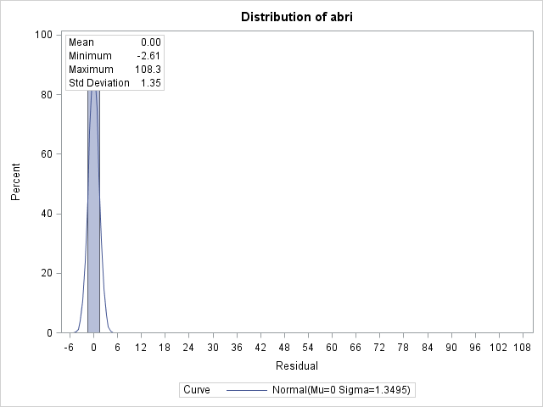

**Table 7. Collinearity**

|  |  |  |  |  |
| --- | --- | --- | --- | --- |
| **Collinearity Diagnostics** | | | | |
| **Number** | **Eigenvalue** | **Condition** | **Proportion of Variation** | |
| **Index** | **Intercept** | **Rm** |
| **1** | 1.0586 | 1 | 0.4707 | 0.4707 |
| **2** | 0.9414 | 1.0604 | 0.5293 | 0.5293 |

**Table 8. Homoskedasticity**

|  |  |  |  |  |  |  |
| --- | --- | --- | --- | --- | --- | --- |
| **Heteroscedasticity Test** | | | | | | **Result** |
| **Equation** | **Test** | **Statistic** | **DF** | **Pr > ChiSq** | **Variables** |
| **Ri** | White's Test | 0.12 | 2 | 0.9398 | Cross of all vars | homoskedasticity |

**Picture 2. Outliers**

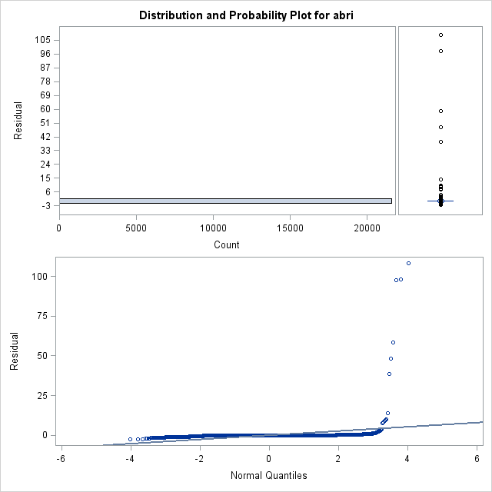

**Election Event 1 (9/11/2020)**

**Table 9. Expected Results**

|  |  |  |  |
| --- | --- | --- | --- |
| **Variable** | **Event window** | **Expected Sign** | **H0-no effect of president event on the punishment** |
| abri | 0 | + | accept |
| CAR01 | (0,1) | + | accept |
| CAR04 | (0,4) | + | accept |

**Table 10. Variable Means**

|  |  |  |  |  |  |  |
| --- | --- | --- | --- | --- | --- | --- |
| **Variable** | **Label** | **N** | **Mean** | **Std Dev** | **Minimum** | **Maximum** |
| **abri** | **Residual** | 31 | 0.0096 | 0.2306 | -1.0834 | 0.2013 |
| **CAR01** |  | 31 | 0.0137 | 0.4473 | -2.1411 | 0.8280 |
| **CAR04** |  | 31 | -0.0985 | 0.8207 | -4.2743 | 0.3879 |

**Table 11. t-test Result of abri**

|  |  |  |  |
| --- | --- | --- | --- |
| **DF** | **t Value** | **Pr > |t|** | **Result** |
| 30 | 0.23 | 0.819 | insiginificant accept h0 |

**Table 12. t-test Result of CAR01**

|  |  |  |  |
| --- | --- | --- | --- |
| **DF** | **t Value** | **Pr > |t|** | **Result** |
| 30 | 0.17 | 0.8654 | insiginificant accept h0 |

**Table 13. t-test Result of CAR04**

|  |  |  |  |
| --- | --- | --- | --- |
| **DF** | **t Value** | **Pr > |t|** | **Result** |
| 30 | -0.67 | 0.509 | insiginificant accept h0 |

**Election Event 2 (6/1/2021)**

**Table 14. Expected Results**

|  |  |  |  |
| --- | --- | --- | --- |
| **Variable** | **Event window** | **Expected Sign** | **H0-no effect of president event on the punishment** |
| abri | 0 | + | accept |
| CAR01 | (0,1) | + | accept |

**Table 15. Variable Means**

|  |  |  |  |  |  |  |
| --- | --- | --- | --- | --- | --- | --- |
| **Variable** | **Label** | **N** | **Mean** | **Std Dev** | **Minimum** | **Maximum** |
| **abri** | **Residual** | 31 | -0.0546 | 0.2790 | -1.1264 | 0.3254 |
| **CAR01** |  | 31 | 1.8755 | 10.3225 | -0.8801 | 57.4814 |

**Table 16. t-test Result of abri**

|  |  |  |  |
| --- | --- | --- | --- |
| **DF** | **t Value** | **Pr > |t|** | **Result** |
| 30 | -1.09 | 0.2844 | insiginificant accept h0 |

**Table 17. t-test Result of CAR01**

|  |  |  |  |
| --- | --- | --- | --- |
| **DF** | **t Value** | **Pr > |t|** | **Result** |
| 30 | 1.01 | 0.3198 | insiginificant accept h0 |

**Robustness Test**

**Table 18. Robustness Test of event 1**

|  |  |  |  |  |  |
| --- | --- | --- | --- | --- | --- |
| **Variable** | **Types of Crime** | **DF** | **t Value** | **Pr > |t|** | **Result** |
| abri | accounting fraud | 12 | 5.34 | 0.0002*** | significant, reject ho |
| CAR01 | accounting fraud | 12 | 7.4 | <.0001*** | significant, reject ho |
| CAR04 | accounting fraud | 12 | 5.17 | 0.0002*** | significant, reject ho |
| abri | bribery | 4 | 4.6 | 0.0101** | significant, reject ho |
| CAR01 | bribery | 4 | 3.69 | 0.0211** | significant, reject ho |
| CAR04 | bribery | 4 | 3.25 | 0.0315** | significant, reject ho |
| abri | illegal payment | 0 | . | . | accept h0 |
| CAR01 | illegal payment | 0 | . | . | accept h0 |
| CAR04 | illegal payment | 0 | . | . | accept h0 |
| abri | misleading | 7 | -1.14 | 0.2907 | accept h0 |
| CAR01 | misleading | 7 | -0.8 | 0.4473 | accept h0 |
| CAR04 | misleading | 7 | -1.18 | 0.2772 | accept h0 |
| abri | securities fraud | 2 | 1.02 | 0.4158 | accept h0 |
| CAR01 | securities fraud | 2 | 0.62 | 0.5969 | accept h0 |
| CAR04 | securities fraud | 2 | -0.16 | 0.8893 | accept h0 |

**Table 19. Robustness Test of election event 2**

|  |  |  |  |  |  |
| --- | --- | --- | --- | --- | --- |
| **Variable** | **Types of Crime** | **DF** | **t Value** | **Pr > |t|** | **Result** |
| abri | accounting fraud | 12 | 2.88 | 0.0138** | significant, reject ho |
| CAR01 | accounting fraud | 12 | 3.83 | 0.0024*** | significant, reject ho |
| abri | bribery | 4 | 4.42 | 0.0115** | significant, reject ho |
| CAR01 | bribery | 4 | 2.25 | 0.0872* | significant, reject ho |
| abri | illegal payment | 0 | . | . | accept h0 |
| CAR01 | illegal payment | 0 | . | . | accept h0 |
| abri | misleading | 7 | -1.75 | 0.1237 | accept h0 |
| CAR01 | misleading | 7 | 0.98 | 0.3578 | accept h0 |
| abri | securities fraud | 2 | -1.08 | 0.3933 | accept h0 |
| CAR01 | securities fraud | 2 | 0.8 | 0.5082 | accept h0 |