What makes bank-dependent SMEs survive during bank crises?

To Le Anh Nguyet

*Postgraduate of Banking and Finance, Southampton Business School, SO17 1BJ, Southampton, The UK*

**Abstract**

Access to finance is among top constraints on SMEs’ survival. Facing credit crunch during bank crises but some SMEs still survive. We study what makes those survivors financial resilient, which is not clearly defined in previous studies. We contribute empirical evidence of SMEs in the UK during the crisis of 2008. We find that financial resilience is possibly affected by supplier network, profitability, internal equity, financing diversity and bank loans dependence, and profitability is the main driver during crises. We suggest that policy makers should offer stable financing support for SMEs.

Keywords: *financial resilience, SMEs, survival, credit crunch, bank crises*

**Introduction**

SMEs in the UK rely on bank lending as their main external financing (Annual Small Business Survey 2007/08, 2009). During the crisis of 2008, 70% of the SMEs failed to apply for bank loans and did not get any alternative finance (Department for Business, Innovation & Skills and HM Treasury, 2013); the numbers of firm closures rose (Scruton, 2016). However, some SMEs survived. On previous studies, opinions about what affects their survival are contrasting and financial resilience is not yet clearly defined. We study factors contributing to financial resilience of survivors.

We use panel data of unlisted firms in the UK from 2003 to 2012. Financial resilience is measured by Z-score following the studies of McGuiness (2018) and Altman (2000) and explained by 17 explanatory variables mentioned from previous studies using Fixed Effect model.

SMEs would have better financial resilience if having wider supplier networks, higher profitability, less bank loans dependence, more diverse financing sources and internal equity. Because financing diversity and bank lending have strong effects on financial resilience, policy makers should keep financing support to SMEs. SME owners should build their business position and capacity by enhancing profitability, supplier network and financing diversity.

**Literature review**

Resilience generally is defined by how quickly an individual can adapt to unexpected things and by its internal strength that enables it to do that (Windle, 2011; McDonald, 2006; Bhamra et al, 2011). In business, resilience definition varies but focuses on flexibility, continuity, and the capacity of a firm (Weick and Sutcliffe, 2011; Hamel and Valikangas, 2004). There is no definition of financial resilience to be found but Ryan and Irvine (2012) consider NGOs’ financial resilience affected by stability, liquidity, gearing and sustainability ratios.

We suppose financial resilience affected by bank lending dependence, flexibility (including financial management, business network and diversity of financing sources) and internal strength (including equity and profitability).

#### A. Bank lending

The role of bank loans is contrasting. Bank loans are the main external finance SMEs rely on (Cosh and Hughes, 1994) with over 50% of British SMEs preferred (Department for Business, Innovation & Skills and HM Treasury, 2013). Bank-dependent SMEs are more vulnerable to financing constraints (Ryan et al, 2014; Beck et al, 2008; Stiglitz and Weiss, 1981) and sensitive to uncertainty (Byrne et al, 2016) when the banking system deteriorates (Chava and Purnanandam, 2011). However, British SMEs are less affected by credit crunch compared to other countries, only 19% of them (Smallbone et al, 2012).

#### B. Equity

Equity’s role is contrasting. Pecking Order Theory (Myers, 1984) and Ou and Haynes (2004) show internal financing (equity) is main financing source for SMEs. During bank crises, 75% of firms unaffected by credit crunch rely on self-financing (Smallbone et al., 2012); private-equity backed firms increased investments compared to their peers during the crisis of 2008 (Bernstein, 2017). Modified Pecking Order Theory says that retained profits and new equity capital injections from existing owners are top choices for SMEs (Zoppa and McMahon, 2002). Nonetheless, British SMEs do not value equity as primary funding source before 2008 (Small Business Service, 2005).

#### C. Financial management

Liquidity management is considered a key factor for firms’ survival (Deakins et al (2000), Ekanem (2010). To measure, Ekanem uses cash and credit management while Gupta et al (2014) and Gentry et al. (1987) use operating cash flow. We measure liquidity using cash and cash flow.

‘Cash at bank is a strong predictor of firms’ resilience’ (Smallbone et al, 2012). British SMEs generally are not good at cash management after a long period of easy credit before 2008 (Economist Intelligence Unit, 2009). Herbane (2010) shows SMEs lack cash sources to adapt in economic crises. Cash flow management is a forecasting factor in corporate bankruptcy (Aziz et al, 1988; Altman et al, 1977; Gombola et al, 1987; Gilbert et al, 1990).

#### D. Profitability

Earning power is important for firms to adapt to difficult situations (Hamel and Valikangas, 2004). Profitability supports new firms’ survival (Delmar et al, 2013; Bercovitz and Mitchell, 2007). Lack of profits is linked to firm mortality (Levinthal, 1991; Carroll and Harrison, 1994; Besanko et al, 2000). We use profit margin ratio (ROS) to represent profitability as supported below. Insufficient profits and low demand for products are main constraints on Nigerian SMEs’ survival (Okpara, 2011). Resilient British SMEs were less likely to reduce selling prices, but generated revenues and cut costs during the crisis of 2008 (Smallbone et al, 2012).

#### E. Business network

Trade credit plays an important role on financing SMEs during crises (McGuinness et al, 2018; Casey and O'Toole, 2014). To SMEs, it is important and can supplement short-term bank lending (Demirguc-Kunt and Maksimovic, 2001). For credit-constrained SMEs, trade credit is the main reliance replacing bank loans (Valverde et al, 2012). The important role of trade credit on SMEs is confirmed in the cases of the US (Berger and Udell, 1998), Asia (Arzeni and Akamatsu, 2014), and the UK (Department for Business, Innovation & Skills and HM Treasury, 2013). However, in Japan, during the 1990s’ financial crisis, there is little evidence of this role.

#### F. Financing diversity

Financial flexibility is important for firms’ survival (Clarke et al, 2012). The diversification of financing options along with lending efficiency improvement can ease SMEs’ access to finance, especially in Asia (Cusmano, 2015). In OECD report, he mentions innovative financing for SMEs such as corporate bonds, securitized debt, covered bonds, hybrid instruments, crowdfunding. Venture funding is used in the UK to seek external finance (BIS, 2012). SMEs rely much on hire purchase and leasing arrangements (Cosh and Hughes, 1994), but limited on alternative forms of debt (Cusmano, 2015).

Two-sided hypothesis about what affects SMEs’ financial resilience are listed below:

##### H1. Bank lending affects financial resilience.

##### H2. Internal equity affects financial resilience.

##### H3a. Cash management affects financial resilience.

##### H3b. Cash flow management affects financial resilience.

##### H4. Profitability affects financial resilience.

##### H5. Business network affects financial resilience.

##### H6. Financing diversity affects financial resilience.

**Methodology**

The data are secondary data from the financial statements of 9,998 randomly selected SMEs in the UK from 2003 to 2012 collected via Fame database (Bureau Van Dijk). They are panel data and divided into pre-crisis period (2003-2007) and during- and post-crisis period (2008-2012) following McGuinness (2018).

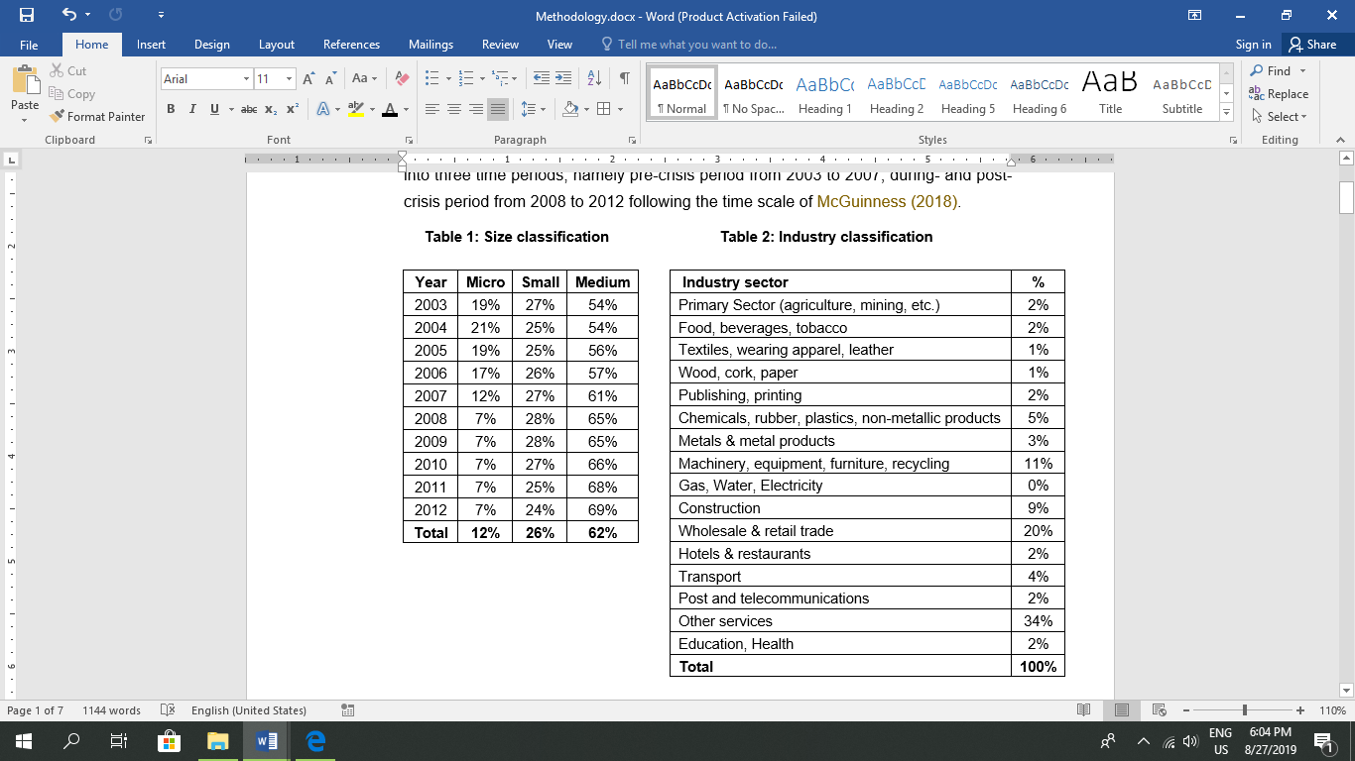

The dependent variable is financial resilience explained by 17 independent variables.

1. Financial resilience

As there is no definition of financial resilience of an SME yet, we consider financial resilience the survival or failure probability or vulnerability of a firm. We follow McGuiness (2018): using Z-score to set up a cut-off and give it a binary choice. We use the adjusted Z-score model for private firms (Altman, 2000):

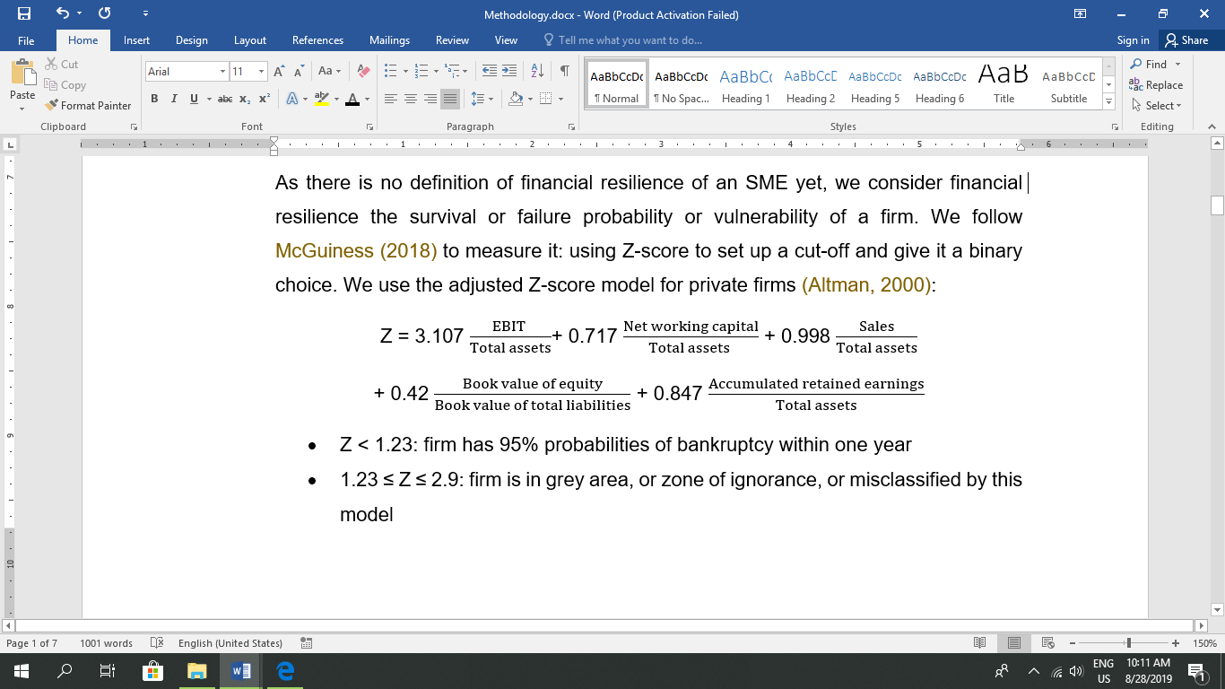

* Z < 1.23: firm has 95% probabilities of bankruptcy within one year
* 1.23 ≤ Z ≤ 2.9: firm is in grey area, or zone of ignorance
* Z > 2.9: firm is classified as non-bankrupt

Financial resilience has binary values: 0 and 1. If Z-score less than the 1.23, financial resilience is 0.

### b. Bank lending

We use the dependence ratio of bank lending:

Bank lending = (Short-term loan overdraft + Bank overdraft)/Total assets

### c. Internal equity strength

We use the ratio of total equity over total assets based on the trade-off theory of capital structure when making a financing decision (Brealey, 2012).

Internal equity power = Net asset/Total assets

### d. Financial management

We use two ratios namely operating cash flow and total cash over sales. Hillier (2013) says that if a firm cannot generate enough cash flows to meet its payments, it will suffer from financial distress.

Operating cash flow ratio = Cash flows from operations/Total liabilities

Besides, the ratio of cash over sales is used to measure how much cash a firm can collect from the real turnover. Due to insufficient information, cash is measured by increase (decrease) cash in the end of period.

Cash/Sales = Final increase (decrease) cash/Turnover

### e. Profitability

The profit margin ratio (ROS) is used to find how much expenditure a firm requires to make turnover, when cost reduction is a common method for corporates during crises (Economist Intelligence Unit, 2009).

ROS = Net income/Turnover

### f. Wide business network

Gianneti et al (2011) show trading relationships important to understand trade credit when suppliers consider financing firms with financial difficulties. Firms more creditworthy and better buyer market power can easily get discounts at trade credit. Also, McGuiness (2018) proves the role of trade credit on financially constrained European SMEs.

Trade credit = Trade credit/Total Assets

### g. Financing Diversity

We use the ratio of diverse financing sources. On Balance Sheet, they are the sum of Group loan, Hire purchasing and liabilities and Other short- and long-term loans.

Diverse financing methods = Total financing sources/Total assets

In addition, the independent variables *lag one period* compared to the dependent variable because we assume explanatory variables would have an effect on main dependent variable after one year following Gollob and Reichardt (1987). Besides, control variables are *size and growth* without lagged time, because we do not focus on them.

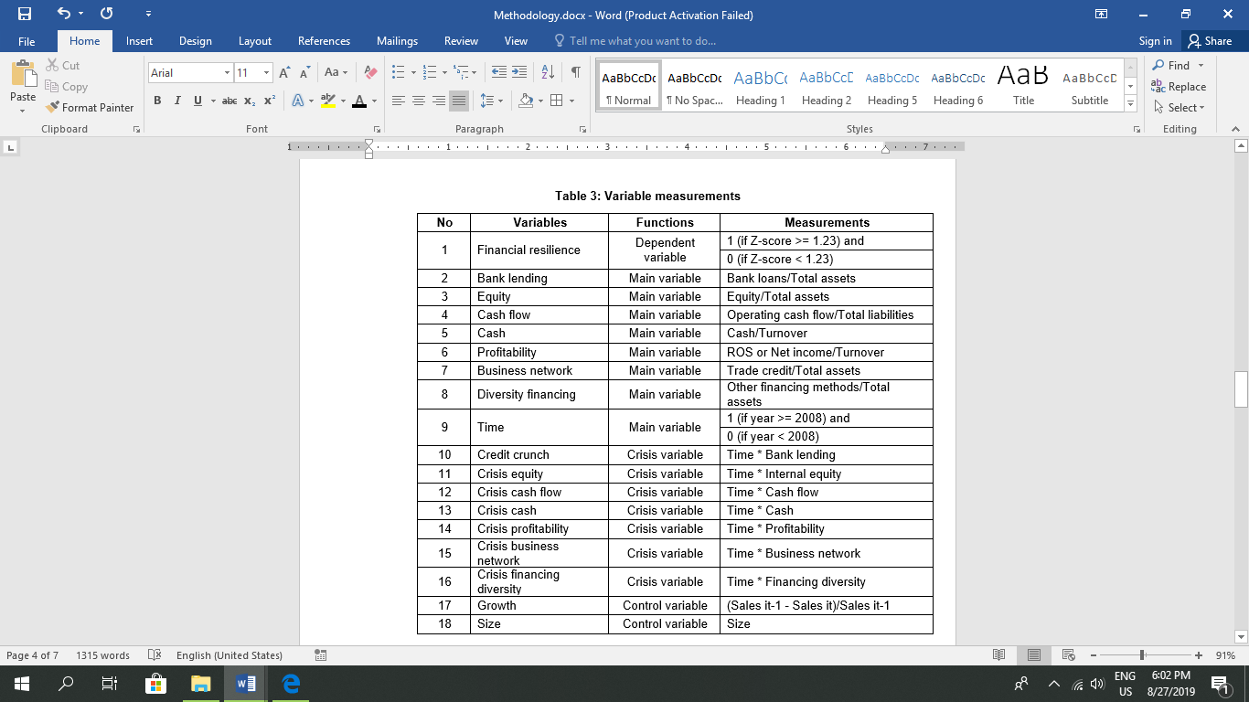

The data has some features. First, observations of each variable are different, as some variables have error or missing values. Second, the means of most variables are less than 1 because they are ratios. Third, only *crisis cash* and *growth* vary significantly. Fourth, only *financial resilience, size, equity* have right-skewed distributions. Also, some explanatory variables strongly correlate with each other like main independent variables and their crisis variables or variables relate to liabilities*.*

# **Table 4. Variable description**

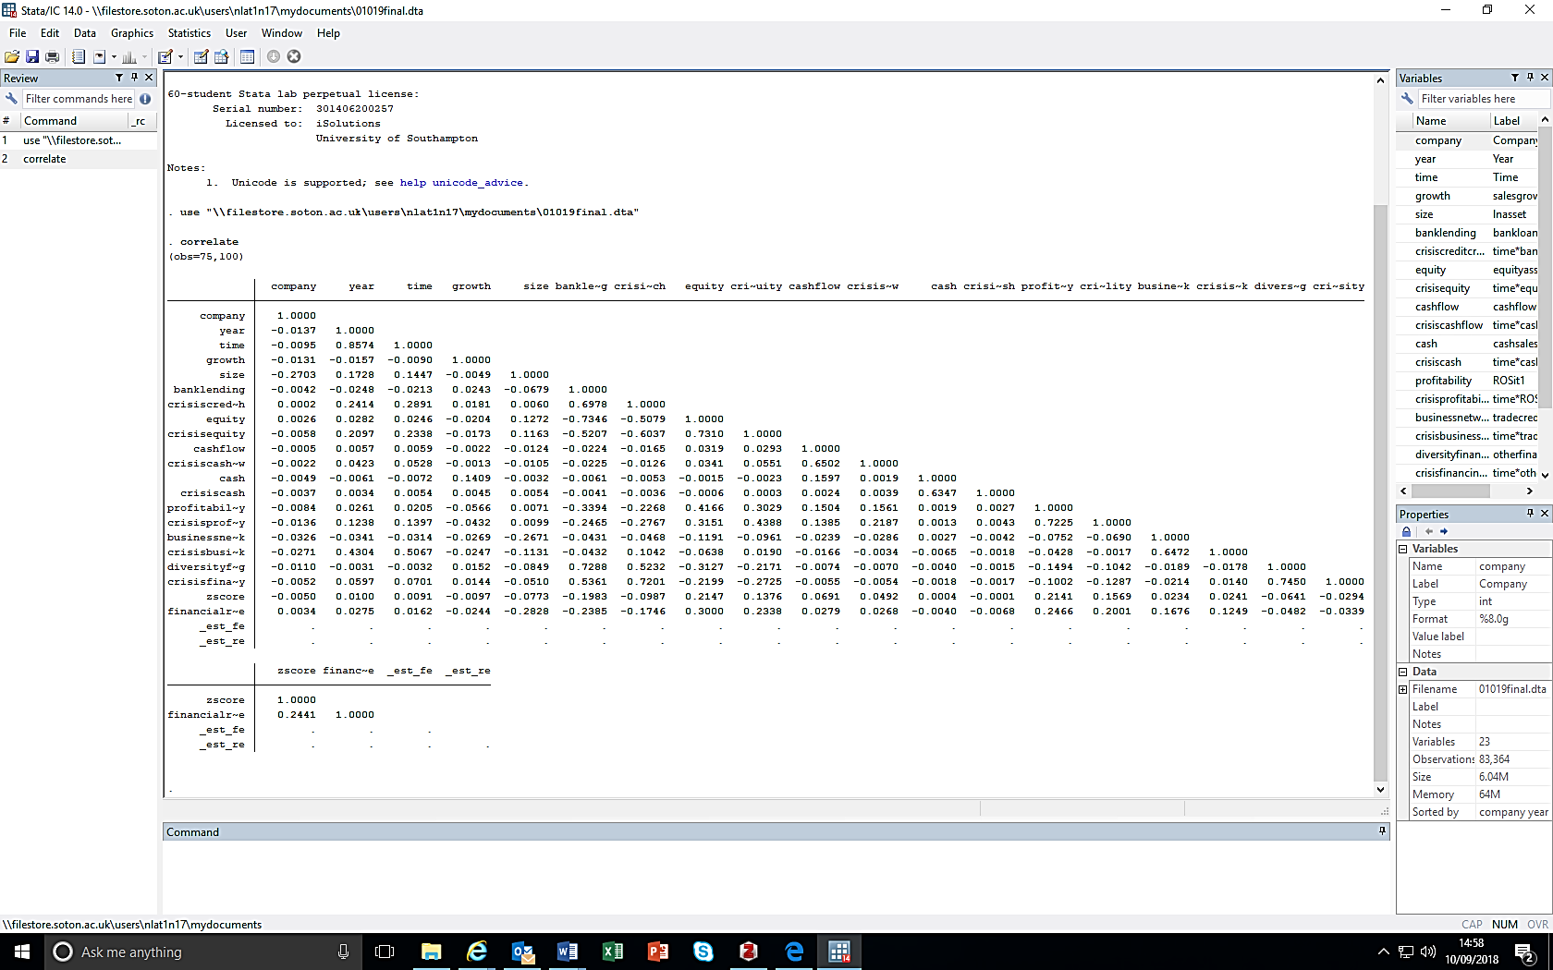**Table 5. Correlation Matrix**

We use panel data regression with Fixed Effects model. According to Baltagi (2008): . After using Durbin–Wu–Hausman, Breusch-Pagan Lagrange multiplier (LM) tests and performing Fixed Effects regression, Fixed Effects model is selected. Our model is:

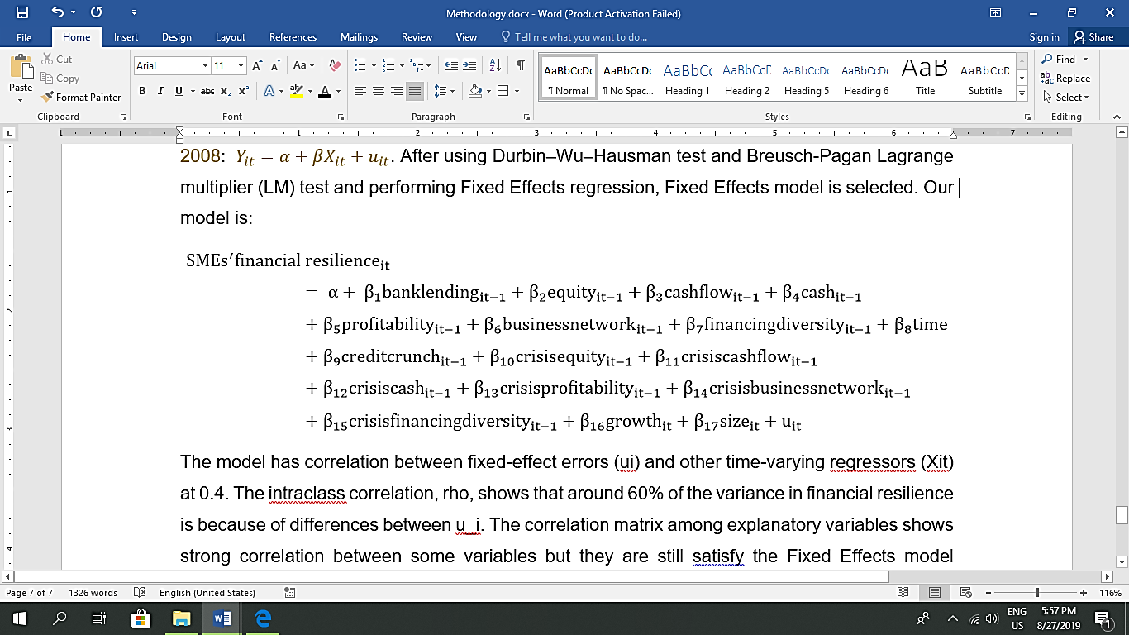The model has correlation between fixed-effect errors (ui) and other time-varying regressors (Xit) at 0.4. The intraclass correlation, rho, shows that around 60% of the variance in financial resilience is because of differences between u_i. Explanatory variables are strong correlated but still satisfy the model because Stata shows no omitted variables in regression.

The model is significant in explaining financial resilience’s variation. The F-test with H0: All coefficients of the variables are zero has P-value at 0, smaller than any significance level: 1%, 5% or 10%. This strongly rejects the null hypothesis, and the model fits well enough to explain financial resilience. The goodness of fit of the model is displayed by within R-square (1.77%), overall R square (18.65%), and between R square (33.43%). Overall, the data fits with the model at around 19% to explain financial resilience.

**Results, Discussion and Conclusion**

##### H1. Bank loans affect financial resilience.

*bank lending* has a robust negative effect on financial resilience, similar with Byrne et al (2016), Chava and Purnanandam (2011) and Ryan et al (2014). But *credit crunch* has no effect on financial resilience of a firm like the study of Smallbone et al (2012).

##### H2. Internal equity affects financial resilience.

*Equity* has a robust positive effect, along with the study of Smallbone et al (2012) and Bernstein et al (2017). However, *crisis equity* has a robust negative influence on financial resilience.

##### H3. Financial management (cash and cash flow) affect financial resilience.

In terms of cash and cash flow, there are few evidences to prove the role of financial management skills on financial resilience. It confirms the result of Casey and Bartczack (1985).

##### H4. Profitability affects financial resilience.

Both *profitability* and *crisis profitability* have robust positive effects on financial resilience. The study supports Delmar et al (2013) and Bercovitz and Mitchell (2007) and contributes to the explanation of Smallbone et al (2012) on resilient British SMEs in terms of profitability.

H5. Business network affects financial resilience.

*business network* measured by trade credit positively affects financial resilience most, giving empirical evidences for McGuinness et al (2018) and Casey and O'Toole (2014), but *crisis business network* has no effect.

H6. Financing diversity affects financial resilience.

##### *diversity financing* has a robust positive effect on financial resilience, hence we confirm with Clarke et al (2012). During crisis it has no effect.

**In short**, to have better financial resilience, SMEs should widen their supplier network (H5); have higher profitability (H4); be less dependent on bank loans (H1); have more sources of financing (H6); and have more internal equity (H2) regarding the value of their coefficients. During crisis, the key for survival of SMEs is profitability, supported by Gunasekaran et al (2011) and Smallbone et al (2012). Besides, *time* and *growth* have positive effect while *size* impacts SMEs’ financial resilience negatively.

We contribute to previous studies the negative role of internal equity during crisis on financial resilience. When crisis occurs, an SME needs to adapt quickly and flexibly thus it needs to spend an unusual amount of money for adaption. But internal equity is difficult to change in a short time, which would partly deteriorate financial resilience. Also, we find no relationships between some factors and financial resilience during crisis partly because of missing values of some variables and crisis variables’ values smaller than their main variables’ values.

We recommend policy makers provide stable financing strategies to support SMEs. During crisis, we find that bank loans’ or other financing sources’ values vary significantly, causing no effects on financial resilience. But for the 10-year period, they have strong effects. We suggest SME owners enhance their financial resilience by focusing on their profitability and supplier network and their financing sources, especially profitability during crisis.

The study has several limitations. Firstly, financial resilience’s value has only 0 and 1 but it should have more values. Secondly, choosing only unlisted SMEs restricts the values of hypothesis 6. Thirdly, some variables have high correlation, which could reduce the reliability of the study. Finally, Fixed Effects model control some unobserved variables which may affect financial resilience while only 19% of financial resilience is explained by the observed variables. Future study can use a set of variables to make a range of values for financial resilience and add more aspects i.e. sustainability to solve the issue of reliability.

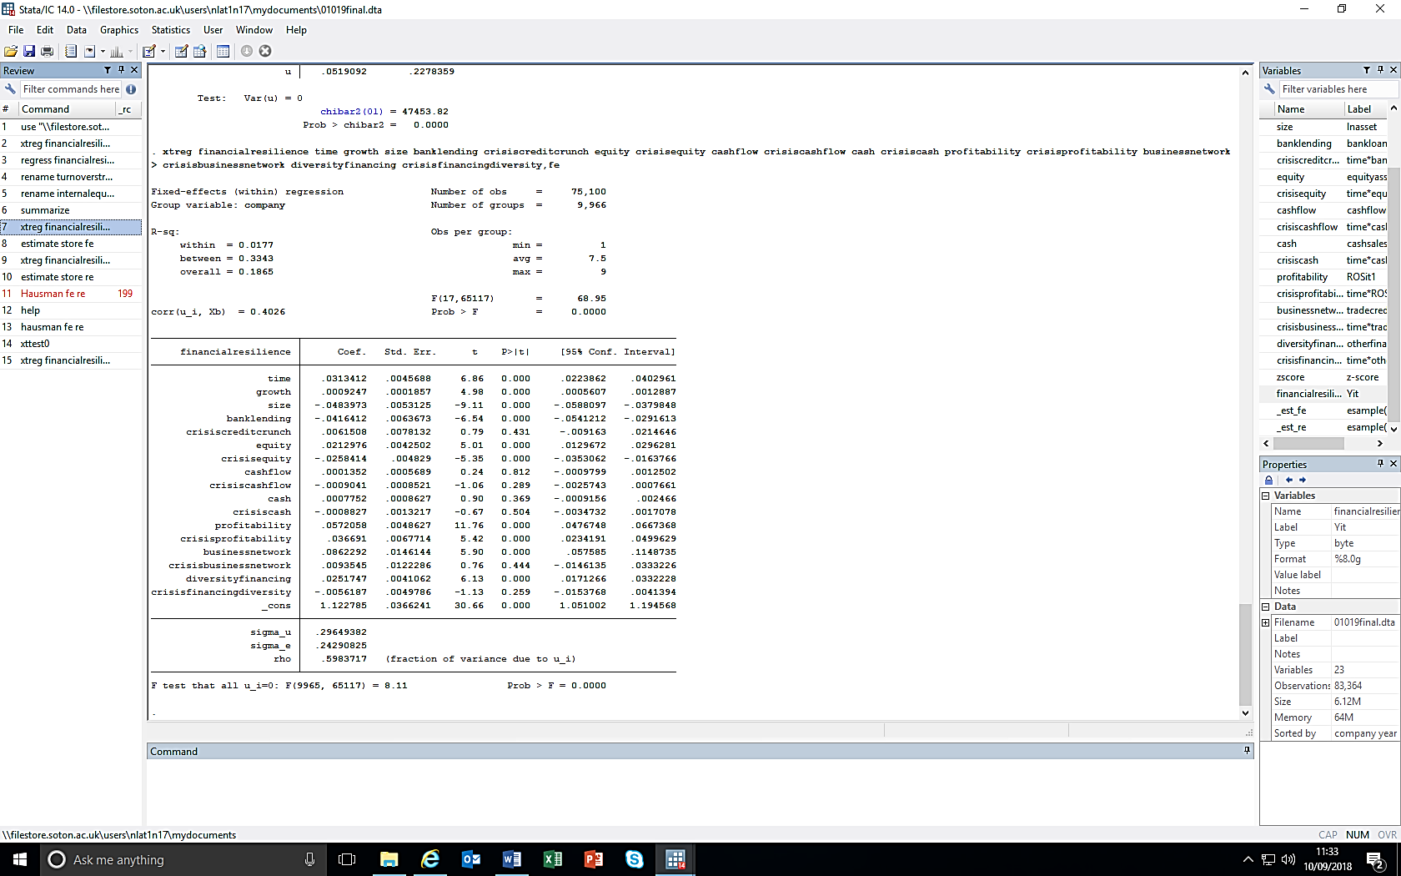**Table 6. Fixed Effect Regression Results**

**References**

1. Access to Finance for the Small and Medium Sized Enterprise Sector Evidence and Conclusions. (2009). The Economist Intelligence Unit, p.2.
2. Altman, E. I., Haldeman, R. G., & Narayanan, P. (1977). ZETATM analysis A new model to identify bankruptcy risk of corporations. Journal of banking & finance, 1(1), 29-54.
3. Altman, E.I. (2000). Predicting financial distress of companies: revisiting the Z-score and ZETA models. *Stern School of Business, New York University*, pp.9-12.
4. ANNUAL SMALL BUSINESS SURVEY 2007/08. (2009). London: BERR (Department for Business Enterprise & Regulatory Reform), p.2.
5. Arzeni, S. and Akamatsu, N. (2014). ADB-OECD Study on Enhancing Financial Accessibility for SMEs: Lessons from Recent Crises.
6. Aziz, A., Emanuel, D.C. and Lawson, G.H. (1988). Bankruptcy prediction‐an investigation of cash flow based models [1]. Journal of Management Studies, 25(5), pp.419-437.
7. Baltagi, B. (2008). *Econometric analysis of panel data*. John Wiley & Sons.
8. Beck, T., Demirgüç-Kunt, A. and Maksimovic, V. (2008). Financing patterns around the world: Are small firms different?. *Journal of Financial Economics*, *89*(3), pp.467-487.
9. Bercovitz, J. and Mitchell, W. (2007). When is more better? The impact of business scale and scope on long‐term business survival, while controlling for profitability. *Strategic Management Journal*, *28*(1), pp.61-79.
10. Berger, A.N. and Udell, G.F. (1998). The economics of small business finance: The roles of private equity and debt markets in the financial growth cycle. Journal of banking & finance, 22(6-8), pp.613-673.
11. Bernstein, S., Lerner, J. and Mezzanotti, F. (2017). Private Equity and Financial Fragility during the Crisis (No. w23626). National Bureau of Economic Research.
12. Besanko, D., Dranove, D. and Shanley, M. (2000). Sustaining Competitive Advantage. BESANKO, D. et al. Economics of strategy. 2nd ed. New York: John Wiley & Sons, pp.443-481.
13. Bhamra, R., Dani, S. and Burnard, K. (2011). Resilience: the concept, a literature review and future directions. *International Journal of Production Research*, *49*(18), pp.5375-5393.
14. BIS, S. (2012). Access to External Finance in BIS Economics Papers. *BIS, Editor*.
15. Brealey, R.A., Myers, S.C., Allen, F. and Mohanty, P. (2012). *Principles of corporate finance*. 12nd ed. New York: McGraw-Hill.
16. Byrne, J.P., Spaliara, M.E. and Tsoukas, S. (2016). Firm Survival, Uncertainty, and Financial Frictions: Is There a Financial Uncertainty Accelerator?. Economic Inquiry, 54(1), pp.375-390.
17. Carroll, G.R. and Harrison, J.R. (1994). On the historical efficiency of competition between organizational populations. American Journal of Sociology, 100(3), pp.720-749.
18. Casey, C. and Bartczak, N. (1985). Using operating cash flow data to predict financial distress: Some extensions. *Journal of Accounting Research*, pp.384-401.
19. Casey, E. and O'Toole, C.M. (2014). Bank lending constraints, trade credit and alternative financing during the financial crisis: Evidence from European SMEs. *Journal of Corporate Finance*, *27*, pp.173-193.
20. Chava, S. and Purnanandam, A. (2011). The effect of banking crisis on bank-dependent borrowers. Journal of Financial Economics, 99(1), pp.116-135.
21. Clarke, G.R., Cull, R. and Kisunko, G. (2012). External finance and firm survival in the aftermath of the crisis: Evidence from Eastern Europe and Central Asia. The World Bank.
22. Cosh, A. and Hughes, A. (1994). Size, financial structure and profitability: UK companies in the 1980s.
23. Cusmano, L. (2015). New Approaches to SME and Entrepreneurship Financing: Broadening the Range of Instruments.
24. Deakins, D. and Whittam, G. (2000). Business start-up: theory, practice and policy. Enterprise and Small Business Principles, Practice and Policy, pp.115-131.
25. Delmar, F., McKelvie, A. and Wennberg, K. (2013). Untangling the relationships among growth, profitability and survival in new firms. *Technovation*, *33*(8-9), pp.276-291.
26. Demirguc-Kunt, A. and Maksimovic, V. (2001). Firms as financial intermediaries: Evidence from trade credit data.
27. Ekanem, I. (2010). Liquidity management in small firms: a learning perspective. Journal of Small Business and Enterprise Development, 17(1), pp.123-138.
28. Gentry, J.A., Newbold, P. and Whitford, D.T. (1987). Funds flow components, financial ratios, and bankruptcy. Journal of business finance & accounting, 14(4), pp.595-606.
29. Giannetti, M., Burkart, M., & Ellingsen, T. (2011). What you sell is what you lend? Explaining trade credit contracts. The Review of Financial Studies, 24(4), 1261-1298.
30. Gilbert, G.A. (1990). Discounted-Cash-Flow Approach to Valuation. ICFA Continuing Education Series, 1990(2), pp.23-30.
31. Gollob, H.F. and Reichardt, C.S. (1987). Taking account of time lags in causal models. *Child development*, pp.80-92.
32. Gombola, M.J., Haskins, M.E., Ketz, J.E. and Williams, D.D. (1987). Cash flow in bankruptcy prediction. Financial Management, pp.55-65.
33. Gunasekaran, A., Rai, B.K. and Griffin, M. (2011). Resilience and competitiveness of small and medium size enterprises: an empirical research. *International journal of production research*, *49*(18), pp.5489-5509.
34. Gupta, J., Wilson, N., Gregoriou, A. and Healy, J. (2014). The value of operating cash flow in modelling credit risk for SMEs. Applied Financial Economics, 24(9), pp.649-660.
35. Hamel, G. and Valikangas, L. (2004). The quest for resilience. *Revista Icade. Revista de las Facultades de Derecho y Ciencias Económicas y Empresariales*, (62), pp.355-358.
36. Herbane, B. (2010). Small business research: Time for a crisis-based view. International Small Business Journal, 28(1), pp.43-64.
37. Hillier, D., Ross, S., Westerfield, R., Jaffe, J. and Jordan, B. (2013). *Corporate finance*. 2nd European ed. Berkshire: McGraw Hill.
38. Levinthal, D.A. (1991). Organizational adaptation and environmental selection-interrelated processes of change. Organization science, 2(1), pp.140-145.
39. McDonald, N. (2006). Organisational resilience and industrial risk. *Resilience engineering. Concepts and precepts. Aldershot: Ashgate*, pp.155-179.
40. McGuinness, G., Hogan, T. and Powell, R. (2018). European trade credit use and SME survival. *Journal of Corporate Finance*, *49*, pp.81-103.
41. Myers, S.C. (1984). The capital structure puzzle. *The journal of finance*, *39*(3), pp.574-592. Holmes and Kent (1991, p. 145)
42. Okpara, J.O. (2011). Factors constraining the growth and survival of SMEs in Nigeria: Implications for poverty alleviation. *Management Research Review*, *34*(2), pp.156-171.
43. Ou, C. and Haynes, G.W. (2004). Uses of Equity Capital by Small Firms: Findings from the Surveys of Small Business Finances (for 1993 & 1998). Office of Advocacy, US Small Business Administration.
44. Ryan, C. and Irvine, H. (2012). Not‐For‐Profit Ratios for Financial Resilience and Internal Accountability: A Study of Australian International Aid Organisations. *Australian Accounting Review*, *22*(2), pp.177-194.
45. Ryan, R.M., O’Toole, C.M. and McCann, F. (2014). Does bank market power affect SME financing constraints?. *Journal of Banking & Finance*, *49*, pp.495-505.
46. Scruton, J. (2016). Business demography, UK - Office for National Statistics. [online] Ons.gov.uk. Available at: https://www.ons.gov.uk/businessindustryandtrade/business/activitysizeandlocation/bulletins/businessdemography/2016#business-births-and-deaths-2011-to-2016 [Accessed 30 Aug. 2019].
47. Small Business Service. (2005). Annual Survey of Small Businesses: UK. Brighton: INSTITUTE FOR EMPLOYMENT STUDIES, p.136.
48. Smallbone, D., Deakins, D., Battisti, M. and Kitching, J. (2012). Small business responses to a major economic downturn: Empirical perspectives from New Zealand and the United Kingdom. International Small Business Journal, 30(7), pp.754-777.
49. Stiglitz, J.E. and Weiss, A. (1981). Credit rationing in markets with imperfect information. *The American economic review*, *71*(3), pp.393-410.
50. Valverde, S.C., Fernández, F.R. and Udell, G.F. (2012). Trade credit, the financial crisis, and firm access to finance. *Documentos de trabajo FUNCAS*, (683), p.1.
51. Weick, K.E. and Sutcliffe, K.M. (2011). *Managing the unexpected: Resilient performance in an age of uncertainty* (Vol. 8). John Wiley & Sons.
52. Windle, G. (2011). What is resilience? A review and concept analysis. Reviews in Clinical Gerontology, 21(2), pp.152-169.
53. Zoppa, A. and McMahon, R.G. (2002). Pecking order theory and the financial structure of manufacturing SMEs from Australia’s business longitudinal survey. Small Enterprise Research, 10(2), pp.23-41.