# 

**Network-as-a-Service Runbook**

**Primer**

**Measure Deployment Performance**

**(Draft)**

**Facebook NaaS Runbook**

*April, 2020*

# Deployment Performance

At any point in the project, the Deployment Manager should be able to accurately answer the following questions:

1. Is the project on time? Is it delayed? By how much?
2. Is the project within budget? Over budget? By how much?
3. What is the performance of the project regarding to Schedule? What about cost?
4. How will the project behave in the future if keep the current pace?
5. What preventative or corrective actions need to be done?

To accurately answer these questions, the Deployment Manager should understand the following concepts.

**Earned Value Management (EVM) basics**

EVM is a method used by best practices to measure project progress and compare it against the Schedule and Cost Baselines. Three key values are necessary to come up with the performance indicators:

* **Earned Value (EV)**. Defined as the monetary value of the work achieved so far by the project. E.g. If the project involves 100 sites, at $10k / site, and 8 sites have been delivered by week 4, the Earned Value equals:

EV = (8 sites) *($10,000/site) = $80,000

* **Planned Value (PV).** Defined as the monetary value of the work planned to have been delivered by the project in a moment in time. Example: If it is planned to have delivered 10 sites by week 4, at $10k/sites, then the Planned Value for week 4 is:

PV = (10 sites) *($10,000/site) = $100,000

* **Actual Cost (AC).** Defined as the accumulated costs incurred to deliver the work carried out by the project so far. It is the result of adding up all the individual expenses of the project up to a moment in time. For example, if $75,000 have been spent by week 4, that is the Actual Cost (AC).

AC = (Actual Project Expenses) = $75,000

From these three fundamental values, crucial indicators allow to calculate the health of the project. The first two indicators are:

* **Schedule Variance (SV).** Defined as the difference between the Earned Value (EV) minus the Planned Value (PV):

**SV = EV – PV**

So, using data from the above examples:

SVWeek 4 = EVWeek 4 – PVWeek 4

SV = $80,000 - $100,000

**SV = -$20,000**

* A negative SV means, that the project is delayed. By how much? By $20,000
* A positive SV would mean the project is ahead of schedule
  + Tip: Most people understand that being behind schedule is bad, but sometimes being ahead of schedule can be bad as well. For example, if a team works overtime and gets a task finished early this may mean that they sit around idle waiting for the next task to start. This is a waste of resources, and project budget. Basically, if a project has a Schedule Variance that isn’t zero, the Deployment Manager must investigate why and mitigate the risks.
* **Cost Variance (CV).** Defined as the difference between the Earned Value (EV) minus the Actual Costs (AC):

**CV = EV – AC**

Using data from the above examples:

CVWeek 4 = EVWeek 4 – ACWeek 4

CV = $80,000 - $75,000

**CV = +$5,000**

* A positive CV means, that the project is under budget. By how much? By $5,000
* A negative CV would mean, that the project is above budget
  + Tip: An important point to remember is that on a perfect project, the CV is $0. This because a CV of $0 is neither over budget or under budget. Most people understand instinctively why being over budget is bad. But why is being under budget bad? It could be a sign that the team has missed a requirement, forgot to install a piece of equipment, or failed to integrate a feature into the deliverable. Anytime the CV isn’t $0, the Deployment Manager needs to investigate.

Below are graphical examples of these variances throughout a project execution:

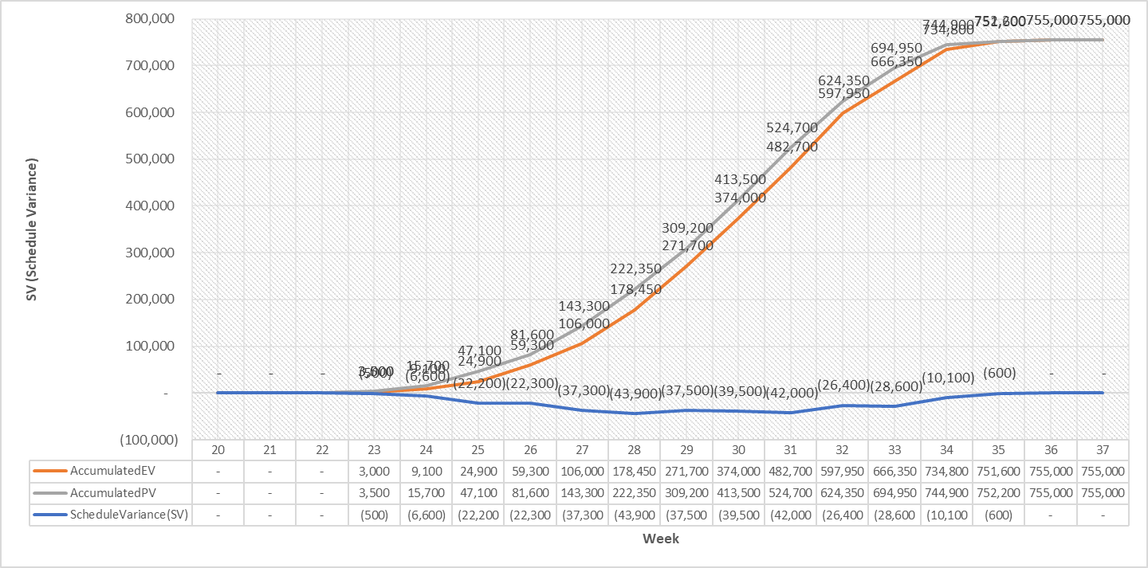

Figure 1 Variances through a project execution

In the above chart:

* The orange line represents Earned Value (EV), or how much monetary value has been delivered by the project at each point in time.
* The gray line represents Planned Value (PV), or how much monetary value was planned to be delivered by the project at each point in time.

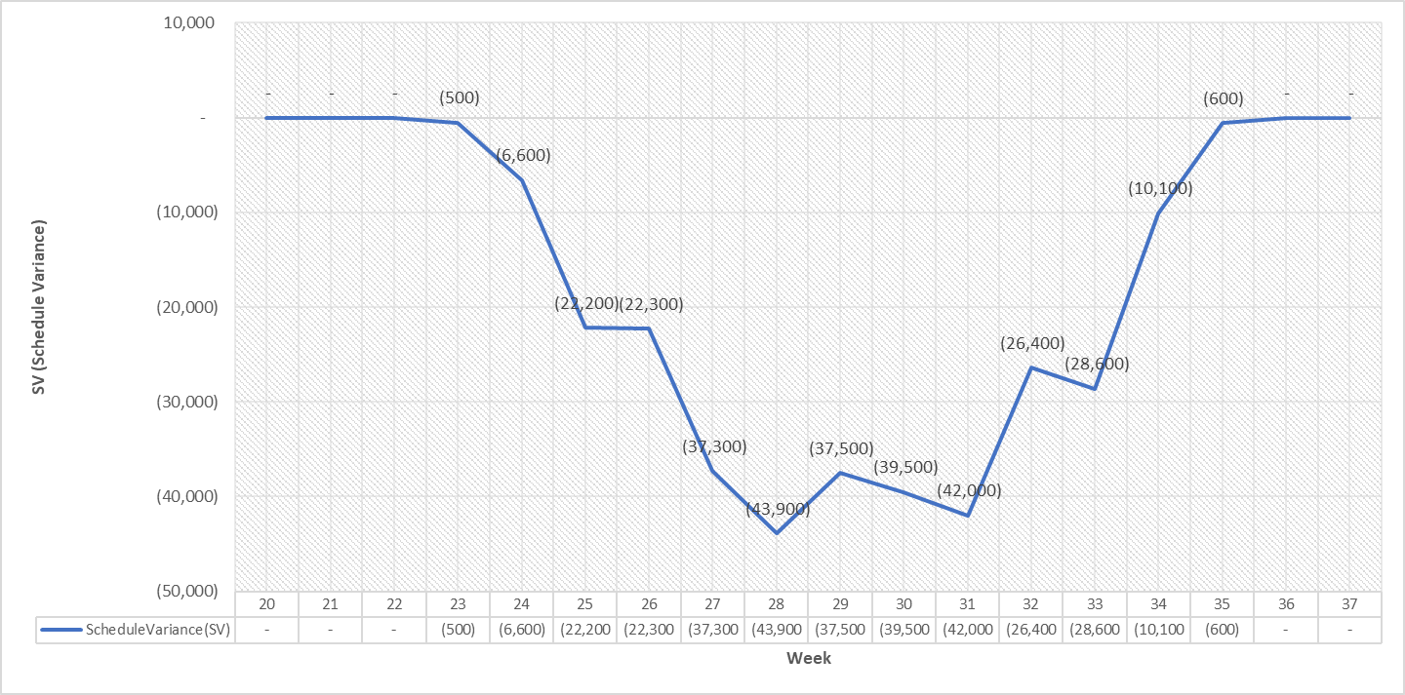

Figure 2. Schedule Variance charts

In the above chart:

* The blue line is the Schedule Variance (SV), which since week 23 has shown a slight variance of -$500, which grew to -$6,600 and beyond, indicating the project had a slight delay up to week 36, when the variance was compensated, and returned to zero.
* It is crucial to understand, that once the project completes its delivery, the Schedule Variance becomes zero, regardless of the delay. This is because the Earned Value now equals the Planned Value.

As information is gathered by monitoring and controlling processes, the Deployment manager organizes it and analyzes it in order to understand how the project's current status measures up compared to the selected KPIs.

* **Cost Performance Indicator (CPI).** Is usedto show the efficiency of the money being spent by the project. Defined as the ratio between the Earned Value (EV), and the Actual Costs (AC):
 $$CPI= \frac{EV}{AC}$$

 + A CPI greater than 1 means the project is under budget.
  + A CPI value of 1, means the project is spending budget exactly as planned
  + A CPI value smaller than 1, means the project is spending more than planned

Using data from the above examples:

$$CPI= \frac{\$80,000}{\$75,000}=1.06$$

As CPI > 1, the project is under budget. In this particular case, a CPI of 1.06 means that for every $1 of money spent, the value delivered is $1.06.

* **Schedule Performance Indicator (SPI).** Is used to show whether a project is behind or ahead of schedule. In other words, the SPI shows whether the project will deliver late, on time, or early. It is defined as the ratio between the Earned Value (EV), and the Planned Value (PV):
 $$SPI= \frac{EV}{PV}$$

 + A SPI value less than 1 means the project is behind schedule and will not finish on time.
  + A SPI value of 1, means the project is progressing exactly as planned.
  + A SPI value greater than 1, means the project will be completed early.

Using data from the above examples:

$$SPI= \frac{\$80,000}{\$100,000}=0.8$$

As SPI < 1, the project is behind schedule. Concretely, a SPI of 0.8 means that for the time that $1 of value has been planned, only $0.80 were delivered. In terms of sites, it would mean that the project is working only at 80% the estimated rate (8 sites delivered of 10 planned).