**Network-as-a-Service Runbook**

**Primer**

**Critical Path Method & Dimensioning Guidelines**

**(Draft)**

**Facebook NaaS Runbook**

*April, 2020*

# Critical Path Method

The critical path method is used to estimate the minimum project duration and determine the amount of schedule flexibility on the logical network paths within the schedule mode. The critical path is the sequence of activities that represents the longest path through a project, which determines the shortest possible project duration.

The longest path has the least total float, usually zero. Float is the amount of time an activity or chain of activities may be delayed without affecting the project duration. Scheduling tools often include functionality to detect and graphically display critical paths , to allow NaaS Operator to increase their focus in these chains of activities or reallocate more resources to them to reduce total project duration. Below is the Gantt Chart of the Planning phase presented in section 3.1.1, of Deployment Management Module showing the critical path highlighted in red:

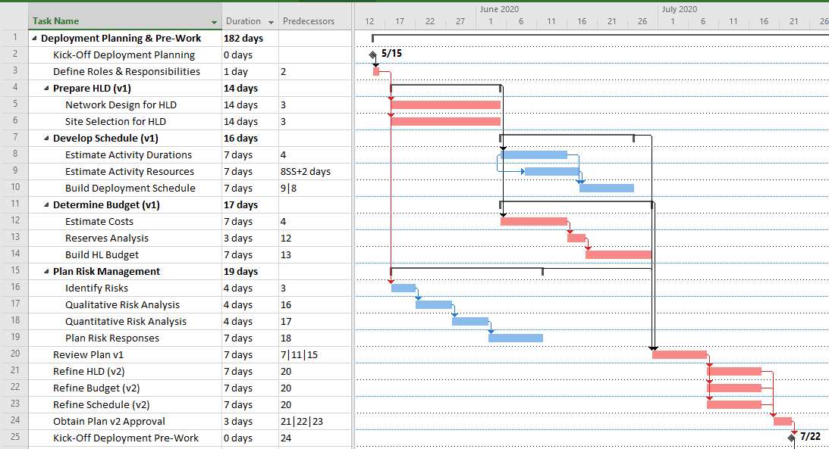

Figure 1. Critical Path highlighted in Planning

From the activities highlighted in the above diagram, it can be seen that:

* If any of the activities highlighted in red incur in a delay, the delivery date of the Deployment Plan will be affected (ID 24).
* The activities under Plan Risk Management have more leeway (or float) for delays, because these do not directly depend on the HLD preparation being finished.
* If the Risk Planning is not completed before the Plan v1 review starts, it will become another critical path, and thus affect the end date for this Planning phase.

This analysis allows the NaaS Operator to focus efforts and resources where they are most critical, and to shorten project duration. Nevertheless, resources are always finite, and not always available for a single project. Therefore, Planning and Managing Resources becomes crucial.

## Dimensioning Guidelines

To determine activities duration, the Deployment Manager needs a clear understanding of the Scope of Work and Milestones for the project, as well as resources availability for activities. Estimation is an iterative process.

Initial estimates allow the Deployment Manager to build the Schedule Baseline (Gantt Chart), a Cost Baseline (Budget), and Resource Requirements (team, materials and tools). Best practices introduce several estimation techniques, each with their own advantages, disadvantages, methods and accuracy.

For example, the following considerations were applied to the Gantt chart described in 3.1.1 of Deployment Management Module:

* For initial activities such as Establishing Roles & Responsibilities, a direct Analogous Estimating is applied based on past projects experiences. A single full workday is enough to gather the NaaS Operator to make agreements and establish responsibilities for activities. The duration of activities that involve organizational agreements is related to the number of stakeholders in the project. Small teams may only need a single day to establish roles and responsibilities to start working right away, while larger and complex organizations may have more elaborate processes to authorize engagement of crucial resources and balancing the commitment of team members among several projects.
* To estimate the time needed for the HLD preparation, use Parametric Estimating by multiplying a set time needed to produce the HLD per site, then multiply per the number of sites. E.g. if a single engineer needs 1 hr to prepare the HL design for a single site, and the total is 100 sites, then 100 hours are needed for this activity. Considering 40hr workweeks, it will take a single engineer 2.5 weeks to prepare the HLD for 100 sites. If this activity needs to be completed faster, two engineers may share the workload. The right thing to do is to have a standard Design Process that several team members in parallel can follow to produce consistent results, splitting the workload.
* For activities that depend on external stakeholders and vendors, such as hardware manufacture and shipment, it’s possible to apply a combination of Parametric Estimating and PERT Estimating. Normally, the manufacture and shipment of X number of units varies little even if the number of units is doubled, because manufacturers often have very streamlined processes. Thus, the bulk of the delay is consumed in shipping, handling and customs clearing. A very simplified example follows:
  + Case A: Order of 500 units
    - Manufacture: 24 days
      * Setup time: 14 days
      * Production capacity: 50 units/day
      * Production time: 500 units / (50 units/day) = 10 days
    - Maritime shipping and handling + customs: 30.83 days
      * Optimistic estimate: 20 days; Most Likely: 30 days; Pessimistic: 45 days
      * TB=(TO+4*TML+TP)/6 = (20+4*30+45)/6
      * PERT estimate: 30.83 days
    - Total duration: 24 days + 30.83 days = 54.83 days
    - Average delay per unit: 0.109 days/unit
  + Case B: Order of 1000 units
    - Manufacture: 34 days
      * Setup time: 14 days
      * Production capacity: 50 units/day
      * Production time: 1000 units / (50 units/day) = 20 days
    - Maritime shipping and handling + customs: 30.83 days
      * Optimistic estimate: 20 days; Most Likely: 30 days; Pessimistic: 45 days
      * TB=(TO+4*TML+TP)/6 = (20+4*30+45)/6
      * PERT estimate: 30.83 days
    - Total duration: 34 days + 30.83 days = 64.83 days
    - Average delay per unit: 0.064 days/unit
  + By doubling the order size, the delivery time is only extended 10 more days. Notice the average delay per unit is not linear, therefore parametric estimation may not be enough by itself to come up with the activity duration without breaking it down to its subsidiary activities.
* Now, to plan for activities to be carried out during Deployment Execution, it’s also possible to apply Three-Point Estimating. For example. A given site installation may take 2 days as optimistic estimate (TO), 3 days most likely (TML), and 6 days as pessimistic estimate (TP). By using a beta distribution, the estimated duration is:

TB=(TO+4*TML+TP)/6 = (2+4*3+6)/6 = **3.33 days**

Now, applying Three-Point Estimating for actual activity durations at the site-level, results in the following:

|  |  |  |  |  |  |
| --- | --- | --- | --- | --- | --- |
| **Three-Point Estimates** | | | | | |
| **ID** | **Optimistic Duration** | **Most Likely Duration** | **Pessimistic Duration** | **Weighting Equation** | **Expected Duration Estimate** |
| **t1_SiteSurveyBL** | **1** | **2** | **3** | **TTP= (TO+4*TML+TP)/6** | **2.0** |
| **t2_SiteAcquisitionBL** | **7** | **10** | **14** | **TTP= (TO+4*TML+TP)/6** | **10.2** |
| **t3_CivilWorksBL** | **7** | **7** | **10** | **TTP= (TO+4*TML+TP)/6** | **7.5** |
| **t4_PowerInstallBL** | **3** | **5** | **7** | **TTP= (TO+4*TML+TP)/6** | **5.0** |
| **t5_TxintegrationBL** | **4** | **6** | **9** | **TTP= (TO+4*TML+TP)/6** | **6.2** |
| **t6_InstallationBL** | **2** | **3** | **10** | **TTP= (TO+4*TML+TP)/6** | **4.0** |
| **t7_IntegrationBL** | **2** | **3** | **7** | **TTP= (TO+4*TML+TP)/6** | **3.5** |
| **t8_AcceptanceBL** | **2** | **3** | **7** | **TTP= (TO+4*TML+TP)/6** | **3.5** |
| **t9_HandoverBL** | **6** | **8** | **10** | **TTP= (TO+4*TML+TP)/6** | **8.0** |

Table 1. Three-Point Estimates for Deployment Execution activities

From the above table:

* The column ID contains the codename for the Activity Durations in between Deployment Milestones, introduced in Section 3.1.1
* From the Optimistic Estimate, Pessimistic Estimate and Most Likely Duration, a beta-distribution equation is used to obtain the Expected Duration Estimate in days.
* The values above are subject to change to the particular deployment scenario

Similarly, this technique can be applied for costs, which are more closely linked with contractual clauses, and negotiations to be carried out by the Supply Chain Management team. The NaaS Operator is encouraged to use the Duration Estimating Template to perform these estimations according to its own parameters.