Superstore Sales Performance Dashboard
Dashboard Description and Interpretation Report
Student name: Mohamed Ezzat Mohamed
Student ID: 42510326
Tool used: Python (pandas for data preparation, Matplotlib for the dashboard, openpyxl for the Excel dataset)
Date: October 2026

1. Purpose of the Dashboard
The dashboard gives a one-page overview of the sales performance of a Canadian office-supplies retailer (“Superstore”) over four years, 2009 to 2012. It is designed for a sales or business manager who needs to answer five questions quickly:
- How large is the business, and is it growing or shrinking over time?
- Which product categories and sub-categories bring in sales, and which ones actually make profit?
- Which regions and customer segments generate most of the revenue?
- How do discounts affect profitability?
- Where is the company losing money, and what should be changed?
The dashboard combines headline numbers (KPI cards) with seven visualizations so that the overall picture and the details can be read on the same page.

2. Description of the Dataset
Source: the “Superstore Sales” sample dataset (Canadian edition), a widely used public business dataset for data-analysis practice. It records individual order lines of an office-supplies company.
Size: 8,399 rows (order lines) and 21 original columns, covering 5,496 orders from 795 customers, with order dates from 1 January 2009 to 31 December 2012. All money values are in Canadian dollars (CAD).
Variables: the columns fall into five groups. Five extra columns were derived during data preparation (marked “new”).
Group | Variables | Type
Order details | Row ID, Order ID, Order Date, Ship Date, Order Priority, Ship Mode | IDs, dates, categories
Sales measures | Sales, Profit, Order Quantity, Unit Price, Discount, Shipping Cost, Product Base Margin | Numeric (CAD / %)
Customer | Customer Name, Customer Segment (Corporate, Home Office, Consumer, Small Business) | Text, category
Location | Province (13), Region (8) | Category
Product | Product Category (3), Product Sub-Category (17), Product Name, Product Container | Category, text
Derived (new) | Shipping Days, Order Year, Order Month, Profit Margin (Profit ÷ Sales), Shipping Outlier | Numeric, Yes/No

A full data dictionary with a description of every variable is included in the submitted Excel file (sheet “Data Dictionary”).

3. Data Preparation and Cleaning
Before any chart was built, the raw CSV file was checked and cleaned in Python (pandas). Every step is recorded in the “Cleaning Log” sheet of the Excel file, and the untouched original data is kept in the “Raw Data” sheet for comparison.
Step | Problem found | Action taken | Rows
Encoding | Product names showed broken symbols (e.g. “¨” instead of ®) | Read the file with its real encoding (Mac Roman) | 1,207
Spelling | Region “Prarie” and province “Saskachewan” misspelled | Corrected to “Prairie” and “Saskatchewan” | 1,706 / 913
Data types | Order Date and Ship Date stored as text | Converted to real date values | 8,399
Missing values | Product Base Margin was empty | Filled with the median margin of the same sub-category | 63
Duplicates | Checked for repeated rows | None found | 0
Validity | Ship date before order date; zero or negative sales/prices | Checked — none found | 0
Outliers | A few orders took 31–92 days to ship | Flagged in “Shipping Outlier”; kept because the sales are valid | 3
Categories | Order Priority “Not Specified” | Kept as its own category | 1,672
New columns | Analysis needs time and margin fields | Added Shipping Days, Order Year, Order Month, Profit Margin, Shipping Outlier | 8,399

After cleaning, the dataset has 8,399 rows and 26 columns with no missing values. In the Excel file the derived columns are live formulas (for example Profit Margin = Profit ÷ Sales), so they update if the data changes.

4. The Dashboard
The full dashboard is shown below (it is also submitted separately as a PDF and a high-resolution PNG image). It has a title, a subtitle describing the data, five KPI cards, and seven numbered visualizations, each with its own title, axis labels and a legend where more than one series is shown.
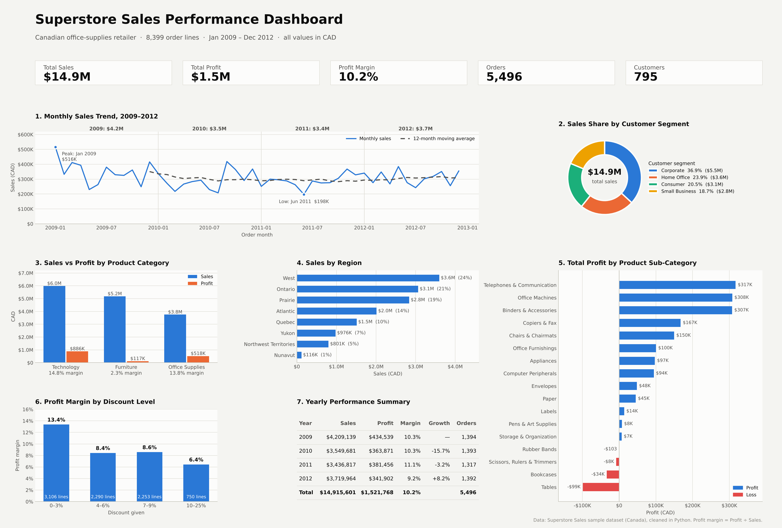

5. Explanation of Each Visualization

KPI cards (top row)
Five headline numbers summarise the whole period: Total Sales $14.9M, Total Profit $1.5M, Profit Margin 10.2%, 5,496 Orders and 795 Customers. They give the reader the scale of the business before looking at the charts.

Chart 1 – Monthly Sales Trend, 2009–2012 (line chart)
What it shows: total sales for each of the 48 months (blue line), a 12-month moving average (dashed grey line), the yearly sales total above each year, and markers for the best and worst months.
Why this chart: a line chart is the standard way to show change over time; the moving average removes month-to-month noise so the long-term direction is visible.
What it tells us: monthly sales are volatile, between $198K (June 2011) and $516K (January 2009). The yearly totals fell from $4.2M in 2009 to $3.4M in 2011 and partly recovered to $3.7M in 2012; the moving average is almost flat at about $300K per month from 2010 onward. December and January are usually strong months, while June is the weakest month on average.

Chart 2 – Sales Share by Customer Segment (donut chart)
What it shows: how total sales are split between the four customer segments, with the percentage and value in the legend.
Why this chart: a donut (pie) chart suits a part-to-whole comparison of only four groups; values are labelled so the reader does not have to judge slice sizes by eye.
What it tells us: Corporate customers are the largest segment with 36.9% of sales ($5.5M), followed by Home Office (23.9%), Consumer (20.5%) and Small Business (18.7%). No single segment dominates, but corporate clients are the most important.

Chart 3 – Sales vs Profit by Product Category (grouped bar chart)
What it shows: sales (blue) and profit (orange) side by side for the three product categories, with each category’s profit margin under its name.
Why this chart: a grouped bar chart lets the reader compare two measures in the same unit (CAD) across categories on one axis.
What it tells us: Technology is the strongest category: $6.0M of sales and $886K of profit (14.8% margin). Furniture is the second-biggest seller ($5.2M) but earns only $117K profit (2.3% margin). Office Supplies sells the least ($3.8M) but is very profitable (13.8% margin).

Chart 4 – Sales by Region (horizontal bar chart)
What it shows: total sales of each of the eight regions, sorted from largest to smallest, with value and share labels.
Why this chart: horizontal bars are easy to rank and leave room for long region names.
What it tells us: West ($3.6M, 24%), Ontario ($3.1M, 21%) and Prairie ($2.8M, 19%) together produce about 64% of all sales. The northern territories are small markets; Nunavut contributes only about 1%.

Chart 5 – Total Profit by Product Sub-Category (diverging bar chart)
What it shows: the total profit of all 17 sub-categories, sorted, with profitable ones in blue and loss-making ones in red.
Why this chart: a diverging bar chart with a zero line makes it immediately clear which products earn money and which lose it.
What it tells us: Telephones & Communication ($317K), Office Machines ($308K) and Binders & Accessories ($307K) are the top profit makers. Four sub-categories lose money: Tables (−$99K), Bookcases (−$34K), Scissors, Rulers & Trimmers (−$8K) and Rubber Bands (−$103). Tables lose money even though they are one of the best-selling sub-categories ($1.9M in sales).

Chart 6 – Profit Margin by Discount Level (bar chart)
What it shows: the profit margin achieved on order lines grouped by the discount given (0–3%, 4–6%, 7–9%, 10–25%), with the number of order lines in each group.
Why this chart: a bar chart compares one value across a few ordered groups clearly.
What it tells us: the higher the discount, the lower the margin: 13.4% with 0–3% discount, about 8.5% with 4–9%, and only 6.4% with discounts of 10% or more.

Chart 7 – Yearly Performance Summary (table)
What it shows: sales, profit, profit margin, sales growth and number of orders for each year, with a total row.
Why this chart: a table is the best choice when the reader needs exact numbers, which charts only show approximately.
What it tells us: sales dropped 15.7% in 2010 and 3.2% in 2011, then grew 8.2% in 2012. However, 2012 had the lowest margin (9.2%), so the sales recovery did not bring a profit recovery. The number of orders stayed stable at about 1,320–1,390 per year, which means the decline came from smaller orders, not fewer orders.

6. Main Findings and Insights
- The business is stable, not growing. Sales fell from $4.2M (2009) to $3.4M (2011) and recovered only partly to $3.7M in 2012. The 12-month average has been flat at around $300K per month since 2010.
- Technology is the profit engine. It brings 40% of sales but 58% of all profit ($886K of $1.52M).
- Furniture sells well but earns almost nothing. It makes up 35% of sales but only 8% of profit, with a 2.3% margin. The cause is clear in Chart 5: Tables and Bookcases lose a combined $133K.
- Some small products are very profitable. Binders & Accessories earn a 30% margin and Envelopes 28%, much higher than the company average of 10.2%.
- Discounts reduce profit. Order lines with a discount of 10% or more have less than half the margin (6.4%) of lines with almost no discount (13.4%).
- Sales are concentrated in three regions. West, Ontario and Prairie produce about 64% of sales. West is the largest region but has a below-average margin (8.3%).
- Corporate is the key customer segment (36.9% of sales). Small Business has the best margin (11.3%) and Home Office the lowest (8.9%).
- Profitability slipped in 2012. Even though sales grew 8.2%, the margin fell to 9.2%, the lowest of the four years.

7. Conclusions
The dashboard shows that the company’s main problem is not the amount it sells but how much of that it keeps as profit. A large share of revenue comes from products (furniture, especially tables and bookcases) and practices (high discounts) that earn little or lose money, while technology and small office supplies carry the company’s profit. Based on these results, the following actions are recommended:
- Review Tables and Bookcases: raise prices, reduce discounts or shipping costs on them, or reduce their range, since together they lost $133K over the four years.
- Control discounting: limit discounts above 10% to cases where they clearly bring extra volume.
- Grow the profitable lines: promote Technology products and high-margin supplies such as binders, envelopes and labels.
- Protect the core: keep Corporate customers and the West, Ontario and Prairie regions as the main focus, while improving the margin in the West.
- Plan for seasonality: prepare stock and promotions for the strong December–January period and look for ways to lift the weak summer months.
In short, the company can raise its profit noticeably without selling more, simply by fixing its loss-making products and its discount policy.

8. Submitted Files
File | Content
Superstore_Dashboard.pdf / .png | The completed dashboard
Superstore_Dashboard_Report.docx | This description and interpretation report
Superstore_Sales_Dataset.xlsx | The dataset: Cleaned Data, Raw Data (original), Data Dictionary and Cleaning Log sheets

