NCS

National Criminal Search

# Document Control

## Record of Changes

|  |  |  |
| --- | --- | --- |
| **Author** | **Date** | **Description** |
| **Mohamed Salah** | 30/10/2016 |  |
|  |  |  |

## Distribution

|  |  |
| --- | --- |
| **Name** | **Designation** |
|  |  |
|  |  |

## Approvals

|  |  |  |
| --- | --- | --- |
| **Name** | **Designation** | **Signature** |
|  |  |  |
|  |  |  |

## Related Documentation

|  |  |  |
| --- | --- | --- |
| **Title** | **Version &/or Date** | **Description of Relationship** |
|  |  |  |
|  |  |  |

Contents

1 Document Control 1

1.1 Record of Changes 1

1.2 Distribution 1

1.3 Approvals 1

1.4 Related Documentation 1

2 Introduction 3

3 List of Technologies and Patterns 4

3.1 I used the following technologies 4

3.2 Patterns 4

4 System Modules 4

5 Activity Diagram 5

6 Sequence Diagram 6

7 Missing due to time limitation 7

# Introduction

This documentation is descripting the work in National Criminal Search that done in the last three days

# List of Technologies and Patterns

## I used the following technologies

1. MVC 5
2. LINQ to SQL
3. Sql Server LocalDB v11
4. WCF Service
5. Visual Studio 2015

## Patterns

1. MVC Pattern
2. Repositorty pattern: To create an abstract data access layer for the application which allows to centralise all data access logic in one place. With generic feature, we can reduce the amount of code we need for common scenarios
3. UnitOfWork pattern:  To combine a set of interactions and commit them at once using a transaction.
4. Dependency Injection pattern: Basically, instead of having your objects creating a dependency or asking a factory object to make one for them, you pass the needed dependencies in to the constructor or via property setters, and you make it somebody else's problem (an object further up the dependency graph, or a dependency injector that builds the dependency graph)
5. IOC desing pattern: is used to increase modularity of the program and make it extensible

# System Modules

There are 8 modules in the system

1. NationalCriminal.Web: is the web MVC project that contains UI and the controlers of the project that take the action from the UI and parameters form model and send it to WCF service
2. NationalCriminal.DAL: is data access layer of the system that contains LINQ to SQL module
3. NationalCriminal.Repository: abstraction layer provides an in-memory like collection interface for accessing domain objects (Configuration, CriminalProfile, …). So as far as the consuming component is concerned, it uses the repository just like a collection when working with Domain objects.
4. NationalCriminal.Service: is the BLL (Business logic layer) of the system,
5. NationalCriminal.Helper: contains the helper classes that used by other modules
6. NationalCriminal.WCF: this is wcf web service which MVC project call for getting criminal data.
7. NationalCriminal.Tests: (for unit testing, mocking …etc)
8. NationalCriminal.Modeling: Contains system diagrams

Repository

Database

DBContext

Unit Of work

NationalCriminal.Service (BLL)

NationalCriminal.Web

NationalCriminal.WCF

NationalCriminal.Helper

# Activity Diagram

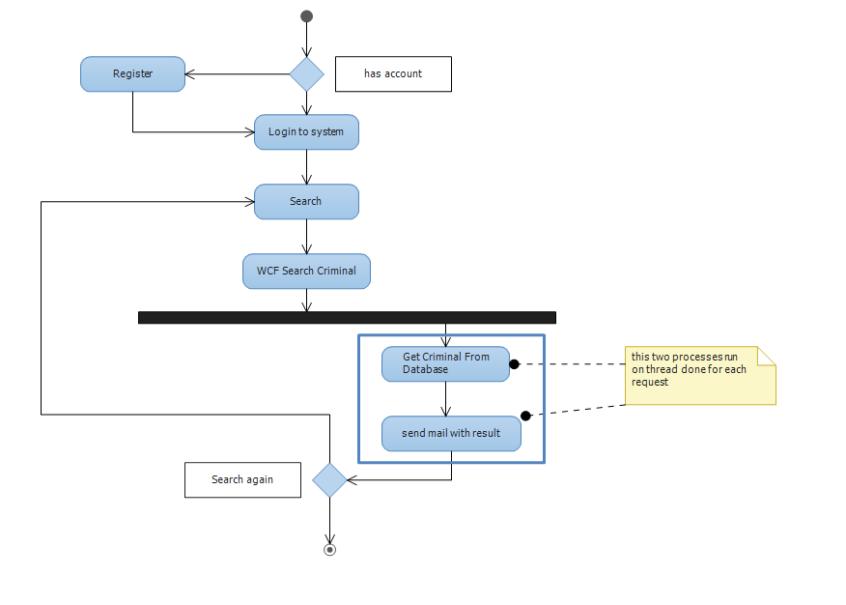

# Sequence Diagram

The following is Search National Criminal sequence diagram. Also, you can find it in the project under **NationalCriminal.Modeling**

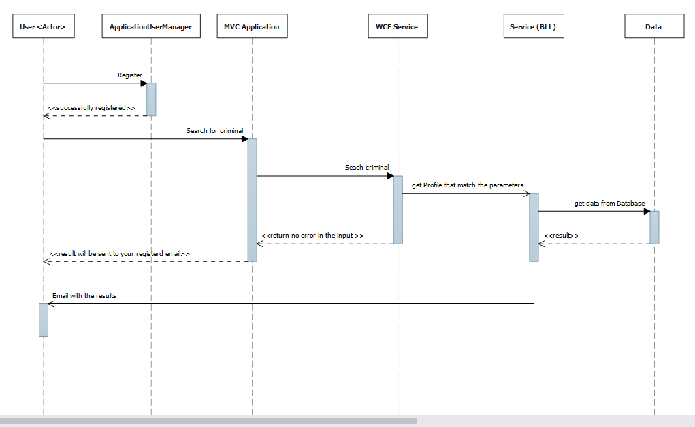

# Missing due to time limitation

Due to the time delivery limitation, I was hopping to add the following feature to the demo

1. Logging module: so, that I can track the system for any issue happened or results not sent to the users   
   and in that module, I will use log4net or make custom loging in the database
2. Localization module: so, that I can avoid make any hard-codded strings and also support multi-languages
3. Automapper: so I can map between models and modelviews