T316 | ADVANCED NETWORKING
TECHNICAL NETWORK REPORT
Scenario Option 2: Government e-Services Contact Centre
Dual-Stack IPv4/IPv6 • Voice • Network Security • Troubleshooting

Submission detail | Information
Course | T316 Advanced Networking | Fall 2026
Student name | _____________________________________
Student ID | _____________________________________
Section / tutor | _____________________________________
Submission date | _____________________________________
Simulation tool | Cisco Packet Tracer
Simulation files | T316_Scenario2_PartA_Working.pkt / T316_Scenario2_PartB_Faulty.pkt

Report prepared from recorded configuration and verification evidence. The separate Packet Tracer project files must accompany this document.

Academic Integrity Declaration
I hereby declare that this submitted TMA work is a result of my own efforts and that I have not plagiarised another person’s work. I have acknowledged sources used in this report.
Student name: _____________________________________
Student signature: _________________________________
Date: ____________________________________________
The student must review and personally sign the declaration before submission.

Report Overview
1. Introduction and Network Architecture
2. Addressing and Services
3. Security, QoS and Validation
4. Part B Troubleshooting Results
5. Network Analysis (~500 words)
6. Evidence Limitations and References

1. Introduction and Network Architecture
This report documents the design, configuration and testing of Scenario Option 2, a Government e-Services Contact Centre using a dual-stack IPv4/IPv6 campus network with IP telephony. The aim was to give agents reliable access to the citizen-service platform while separating voice, ordinary workstation traffic, supervisors, servers and network management. Cisco Packet Tracer was used to build the topology and to record command-line and end-device test evidence. The project includes an operational Part A file and a separately saved Part B file containing deliberately introduced faults. The observations in this report are based on the screenshots and test outputs collected during the exercise, rather than on assumed performance.
The campus design follows a small hierarchical model. One Catalyst 3650 multilayer switch performs inter-VLAN routing, while two Catalyst 2960 access switches connect to the core through independent two-member LACP EtherChannels. The edge consists of an ISR4331 router connected to a simulated ISP router and internet server. A separate Cisco 2811 router provides CallManager Express (CME) services. The end-user environment contains four Cisco 7960 IP phones, four agent PCs connected through the phone PC ports, two supervisor PCs, one management PC, a CRM server and an internet/DNS server. This gives 19 devices before the extra rogue switch used in troubleshooting.
ACCESS-1 serves phones and agents 01-02 on Fa0/1 and Fa0/2, with SUP-01 on Fa0/5; ACCESS-2 has the corresponding phones and agents 03-04 and SUP-02. Each phone-facing access port carries data VLAN 110 and voice VLAN 150, while supervisors use VLAN 120. The core ports Gi1/0/10, Gi1/0/11, Gi1/0/12 and Gi1/0/24 connect respectively to MGMT-PC, CRM-SRV, CME-R1 and EDGE-R1. Trunk Port-channel1 uses core Gi1/0/1-2 and Port-channel2 uses Gi1/0/3-4. The tested EtherChannel summary displayed Po1(SU) and Po2(SU), with all four member links marked (P). This confirms aggregation and operational membership rather than simply configured channel groups.
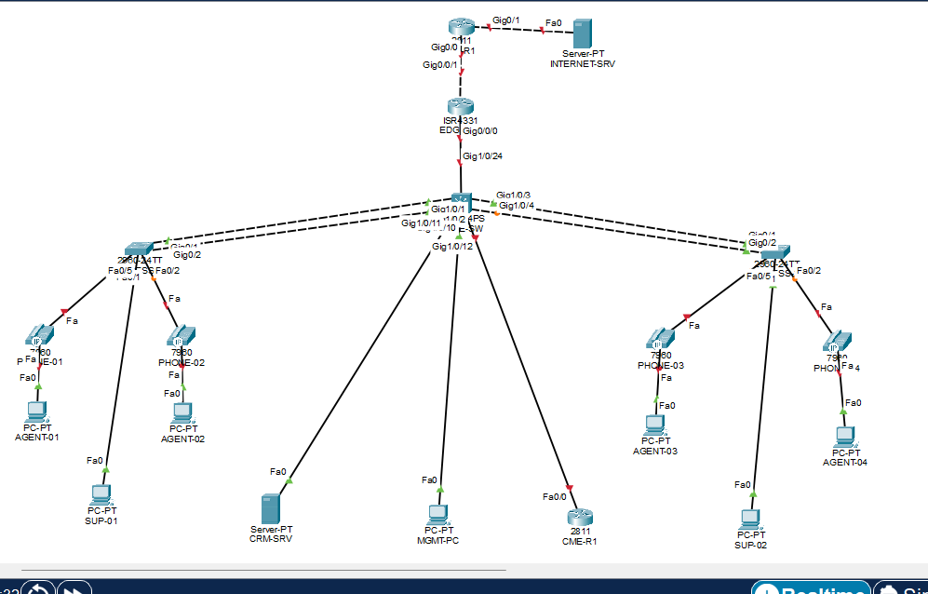
Figure 1. Physical Packet Tracer topology showing the core, two access switches, voice devices and ISP.
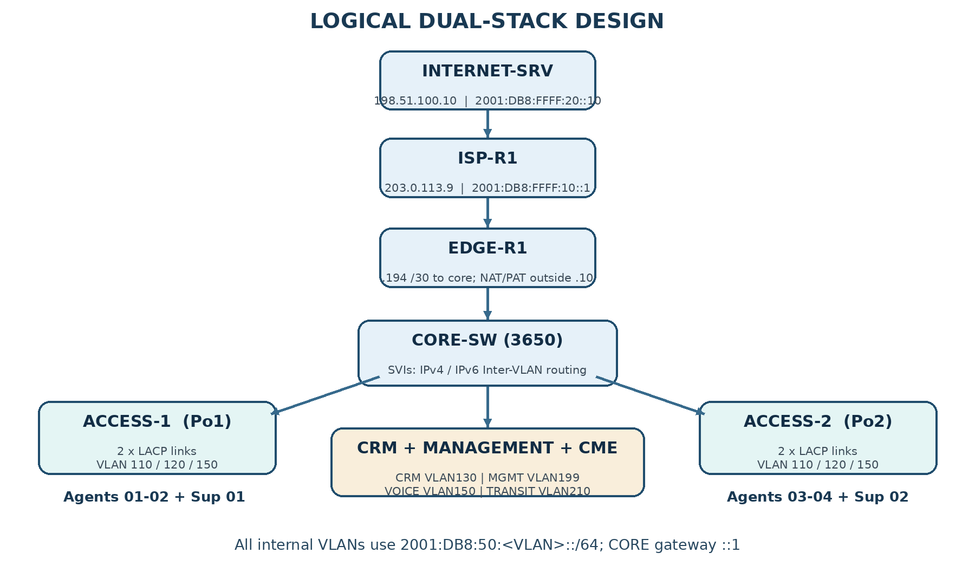
Figure 2. Logical dual-stack and VLAN design (schematic, not a wiring diagram).

2. Addressing and Services

2.1 VLSM Addressing Plan
IPv4 VLSM was calculated from the allocated 10.50.0.0/24 block, placing the two /26 networks first, followed by /27, two /28 subnets and a /30 transit link. Exactly 196 of the 256 addresses in the /24 were assigned to these subnet blocks, leaving 60 unused for later requirements. The advertised requirement of 55 voice hosts fits a /26 because that subnet provides 62 usable addresses. IPv6 uses one /64 for every VLAN, with the VLAN number placed in the fourth hextet and the core gateway set to ::1. The IPv4 and IPv6 addresses used for the external ISP and internet server are example/documentation prefixes in a controlled simulation, not live internet allocations.
VLAN | Purpose | Subnet / Mask | Usable host range | Broadcast | Gateway | DHCP / fixed devices
150 | Voice | 10.50.0.0/26  255.255.255.192 | 10.50.0.1–62 | 10.50.0.63 | 10.50.0.1 | DHCP .3–.62; CME .2
110 | Agents | 10.50.0.64/26  255.255.255.192 | 10.50.0.65–126 | 10.50.0.127 | 10.50.0.65 | DHCP .66–.126
120 | Supervisors | 10.50.0.128/27  255.255.255.224 | 10.50.0.129–158 | 10.50.0.159 | 10.50.0.129 | DHCP .130–.158
130 | CRM | 10.50.0.160/28  255.255.255.240 | 10.50.0.161–174 | 10.50.0.175 | 10.50.0.161 | CRM-SRV .162 static
199 | Management | 10.50.0.176/28  255.255.255.240 | 10.50.0.177–190 | 10.50.0.191 | 10.50.0.177 | MGMT-PC .178; SW1 .179; SW2 .180 static
210 | Core–Edge | 10.50.0.192/30  255.255.255.252 | 10.50.0.193–194 | 10.50.0.195 | 10.50.0.193 | CORE .193; EDGE .194

2.2 IPv6 Prefixes
VLAN / Network | IPv6 prefix | Gateway / device assignment
110 Agents | 2001:DB8:50:110::/64 | CORE ::1; hosts via SLAAC
120 Supervisors | 2001:DB8:50:120::/64 | CORE ::1; SLAAC + stateless DHCPv6
130 CRM | 2001:DB8:50:130::/64 | CORE ::1; CRM-SRV ::10
150 Voice | 2001:DB8:50:150::/64 | CORE ::1; phone IPv6 not independently tested
199 Management | 2001:DB8:50:199::/64 | CORE ::1; MGMT-PC ::10
210 Transit | 2001:DB8:50:210::/64 | CORE ::1; EDGE ::2
External EDGE–ISP | 2001:DB8:FFFF:10::/64 | ISP ::1; EDGE ::2
ISP–Internet Server | 2001:DB8:FFFF:20::/64 | ISP ::1; Internet Server ::10

2.3 Routing and Client Services
On CORE-SW, both ip routing and ipv6 unicast-routing were enabled and six switched virtual interfaces (SVIs) were configured. CORE-SW uses the IPv4 default route 0.0.0.0/0 through 10.50.0.194 and the IPv6 default route ::/0 through 2001:DB8:50:210::2. EDGE-R1 holds reverse static routes for 10.50.0.0/24 and 2001:DB8:50::/48 as well as upstream default routes to ISP-R1. The ISP has routes back to internal addressing. The visible CORE-SW route output showed the IPv6 default route and connected /64 prefixes for VLANs 110, 120, 130, 150, 199 and 210. Following the routing configuration, agent PCs successfully pinged the external simulated server over both IP versions.
CORE-SW supplies DHCPv4 pools named AGENTS, SUPERVISORS and VOICE. The pools exclude the gateway addresses; the voice network also reserves the CME address 10.50.0.2 and advertises it with DHCP option 150. Screenshots showed agent addresses 10.50.0.66-69 with gateway 10.50.0.65, and supervisor addresses 10.50.0.130-131 with gateway 10.50.0.129. The voice pool issued addresses to phones, and the CME registration output showed the phones at 10.50.0.3, .6, .5 and .4. This verifies dynamic allocation in the separate voice segment, including the directory-number association.
For IPv6 hosts, Router Advertisements support SLAAC. AGENT-01 was shown with the global address 2001:DB8:50:110:202:16FF:FEE5:926B/64 and a learned link-local gateway. On VLAN 120, the O flag and a stateless DHCPv6 pool were configured to distribute the DNS address 2001:DB8:FFFF:20::10 and the domain contact.gov.test. The SUP-01 screenshot in the supplied evidence document displayed a global VLAN 120 address and the specified DNS value. These observations support SLAAC and stateless DHCPv6 operation; the individual phone IPv6 client operation was not separately verified. The DNS service hosted A and AAAA records for portal.gov.test and crm.gov.test. A final agent test resolved portal.gov.test to 2001:DB8:FFFF:20::10 and returned four IPv6 replies.
EDGE-R1 marks its core interface as ip nat inside and its ISP-facing interface as ip nat outside, applying overload to the 10.50.0.0/24 source network. The translation table contained ICMP and DNS/UDP sessions mapping inside local 10.50.0.66 to inside global 203.0.113.10. IPv6 used normal routing and did not pass through NAT44. CME-R1 listened at 10.50.0.2 on port 2000 and assigned extension numbers 2101 to 2104. The show ephone output verified four REGISTERED devices. A telephone screenshot showed the call state Connected between extensions 2101 and 2102. These are direct service tests, not only configuration checks.
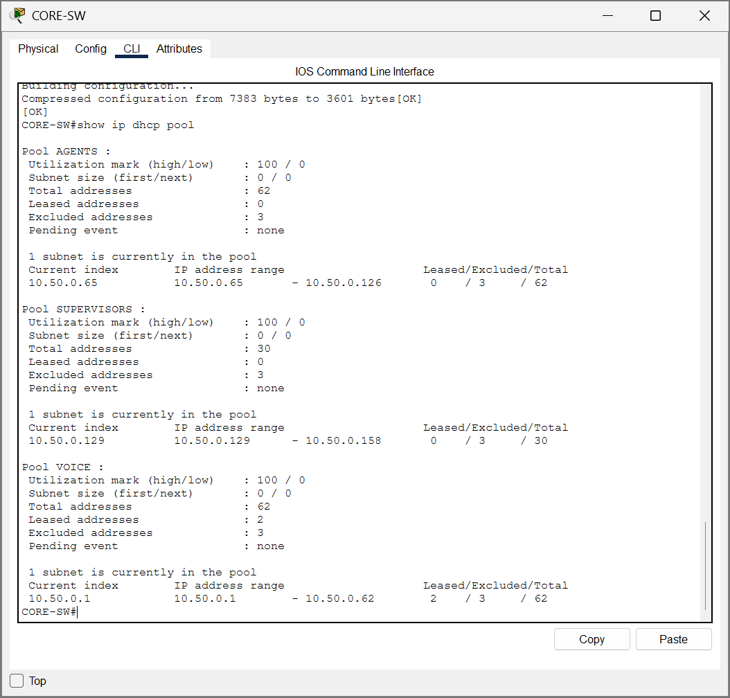  Figure 3. DHCPv4 pool output. | 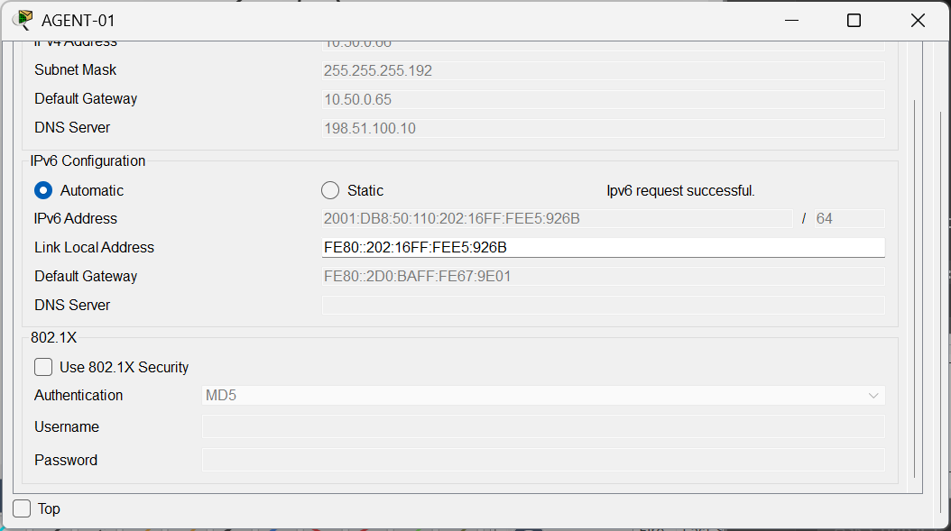  Figure 4. Agent SLAAC global IPv6 address.

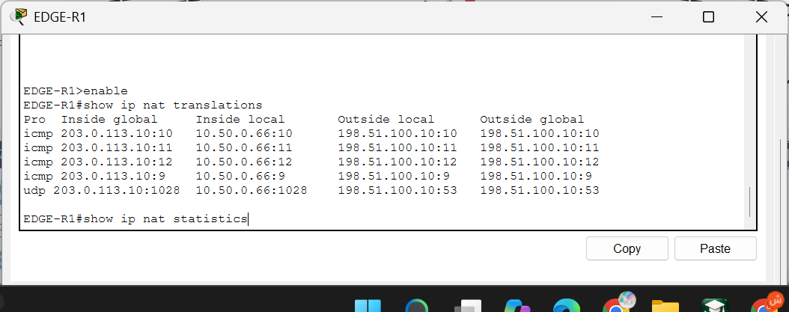  Figure 5. NAT/PAT translation entries. | 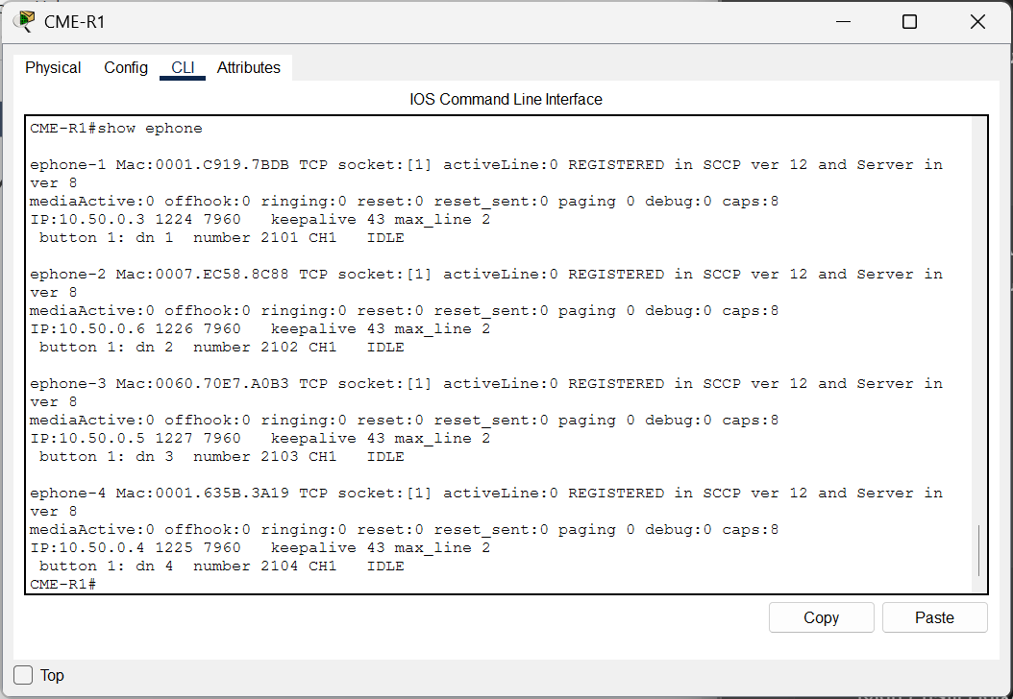  Figure 6. Four IP phones registered on CME.

2.4 Additional Evidence of Network Setup and Address Allocation
The following screenshots support the actual switch, routing, DHCP and service configurations. They show both the configured control-plane settings and the address information received by clients, rather than relying on a topology drawing alone.
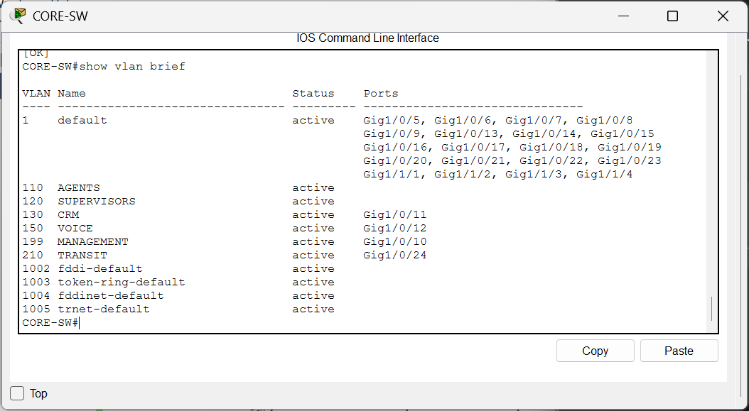  Figure 6a. CORE-SW: six active VLANs and assigned access interfaces. | 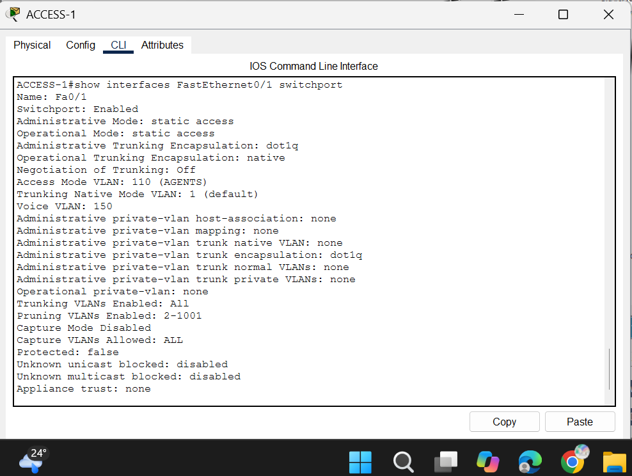  Figure 6b. ACCESS-1: separate data VLAN 110 and voice VLAN 150 on the phone port.

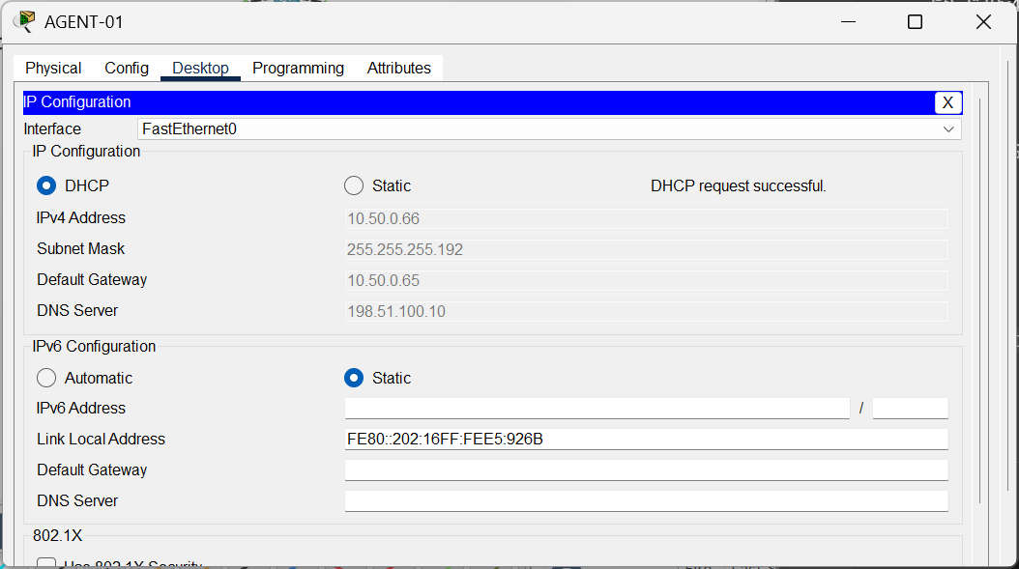  Figure 6c. AGENT-01: DHCPv4 allocation 10.50.0.66/26, gateway .65 and DNS. | 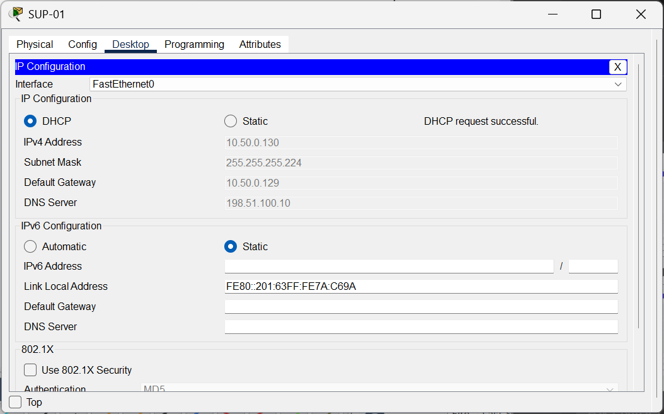  Figure 6d. SUP-01: DHCPv4 allocation 10.50.0.130/27, gateway .129 and DNS.

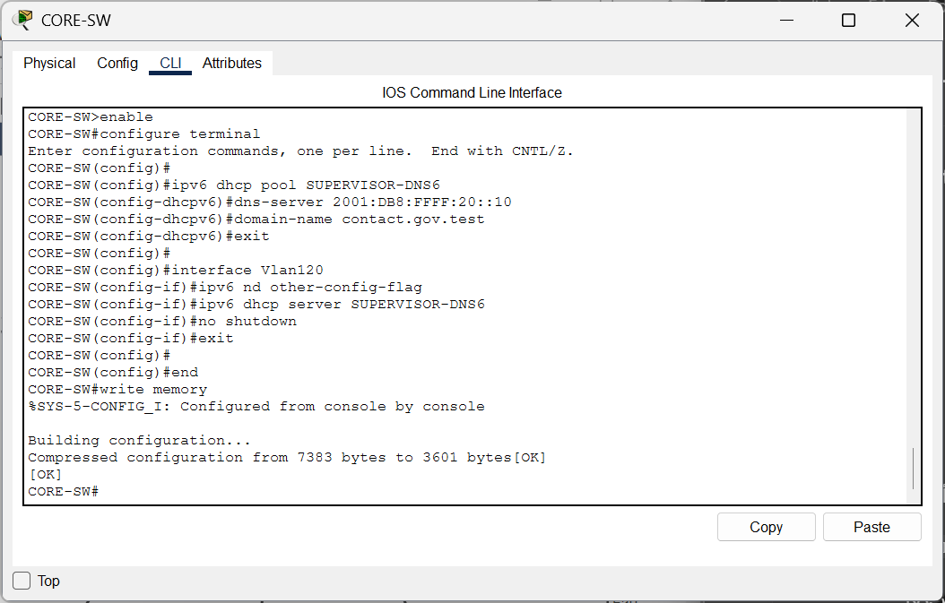  Figure 6e. CORE-SW: stateless DHCPv6 pool and VLAN120 O flag. | 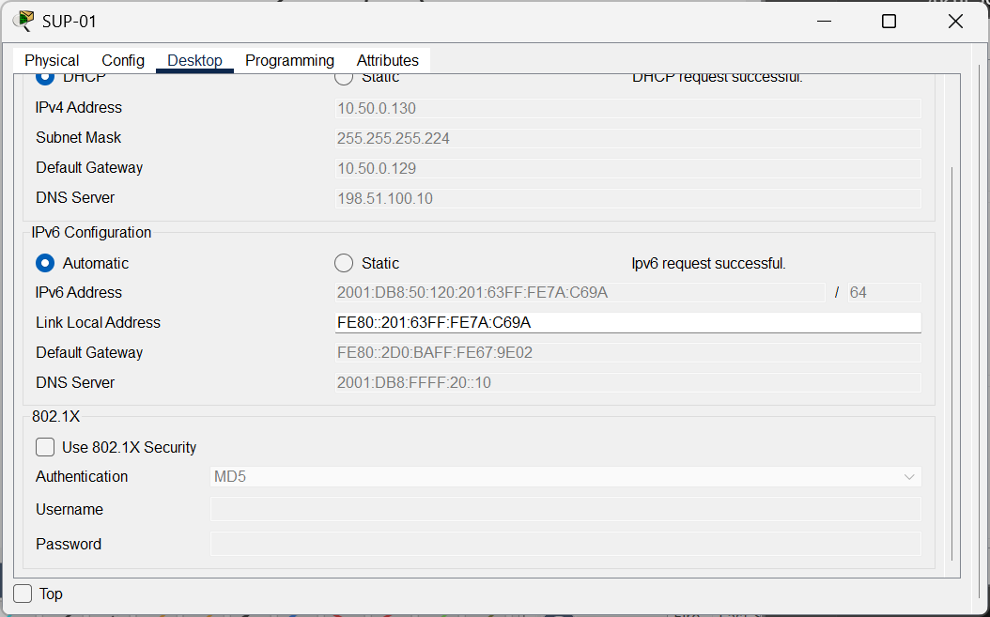  Figure 6f. SUP-01: IPv6 SLAAC plus stateless DHCPv6 DNS setting.

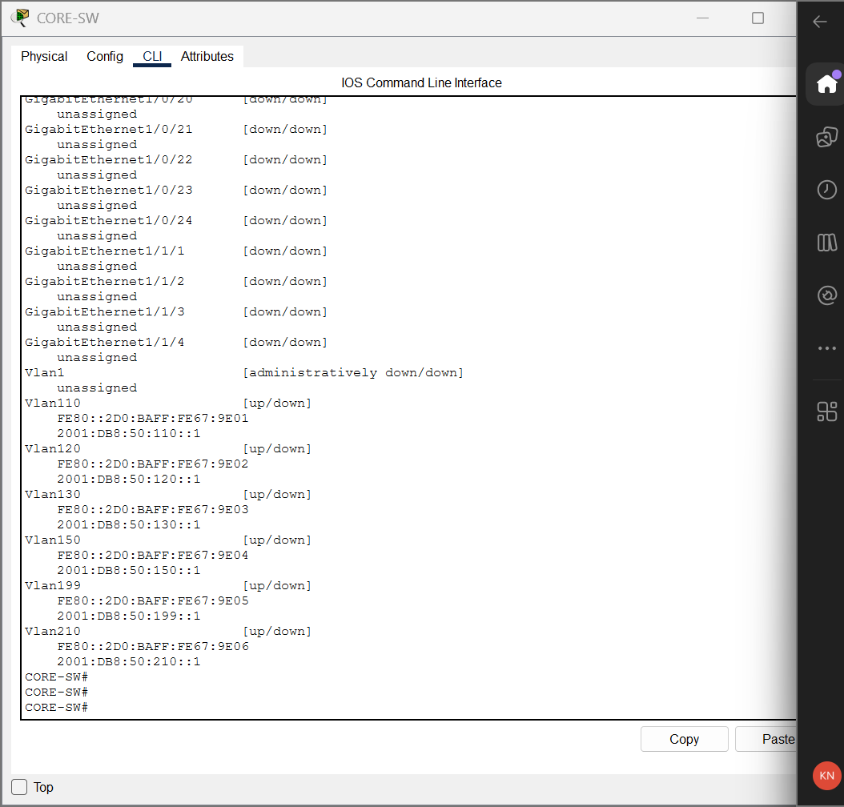  Figure 6g. CORE-SW: IPv6 SVI gateway assignments. | 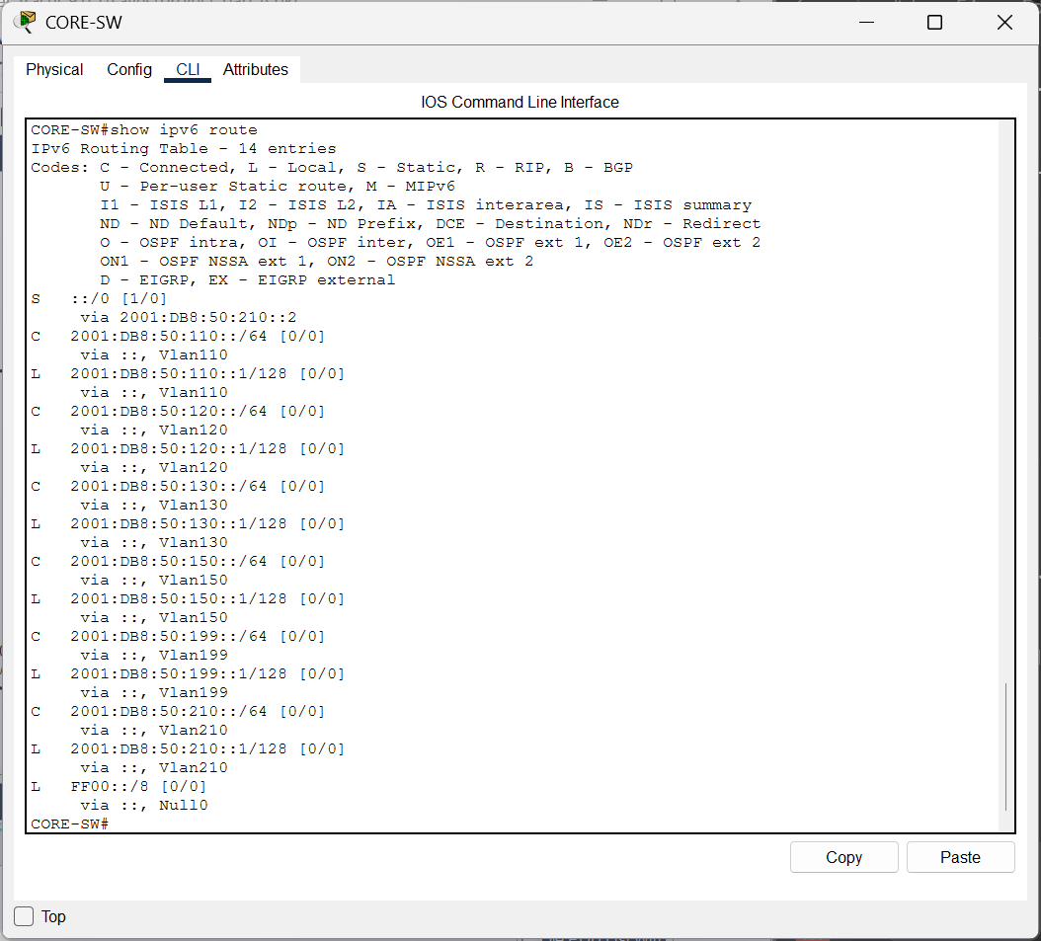  Figure 6h. CORE-SW: installed IPv6 route table and ::/0 route.

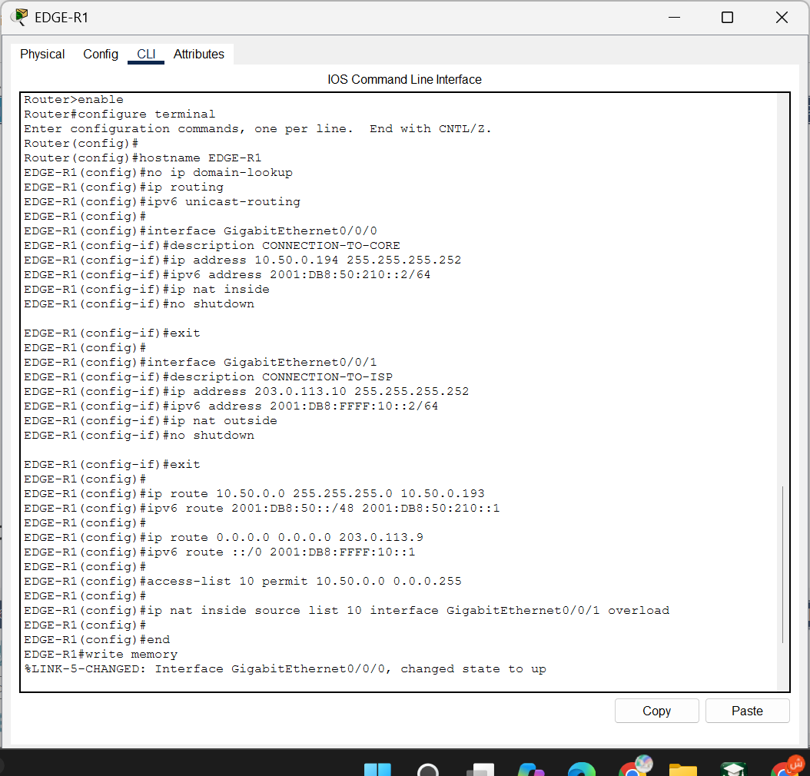  Figure 6i. EDGE-R1: dual-stack interfaces, static routes and PAT. | 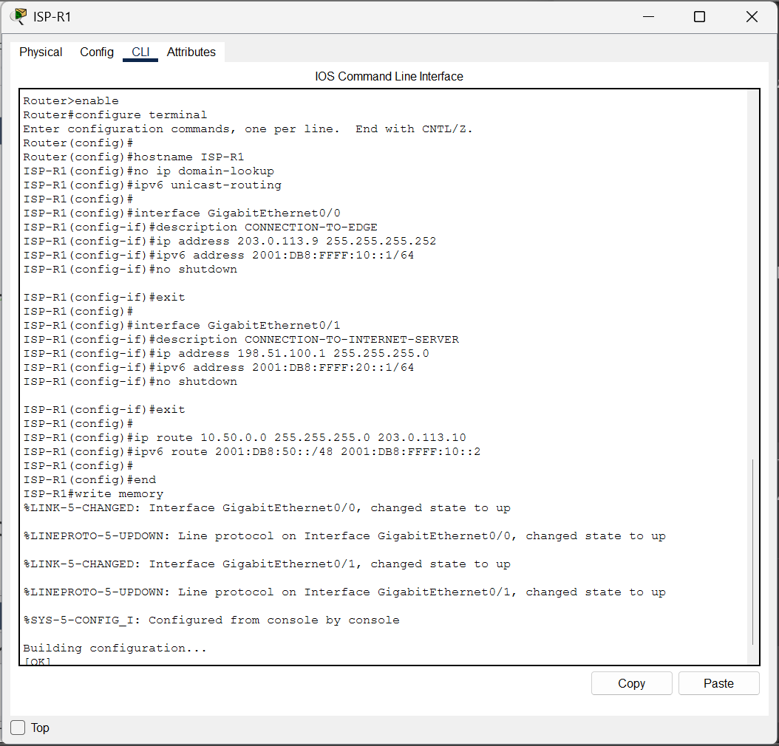  Figure 6j. ISP-R1: uplink and server networks, with return routes.

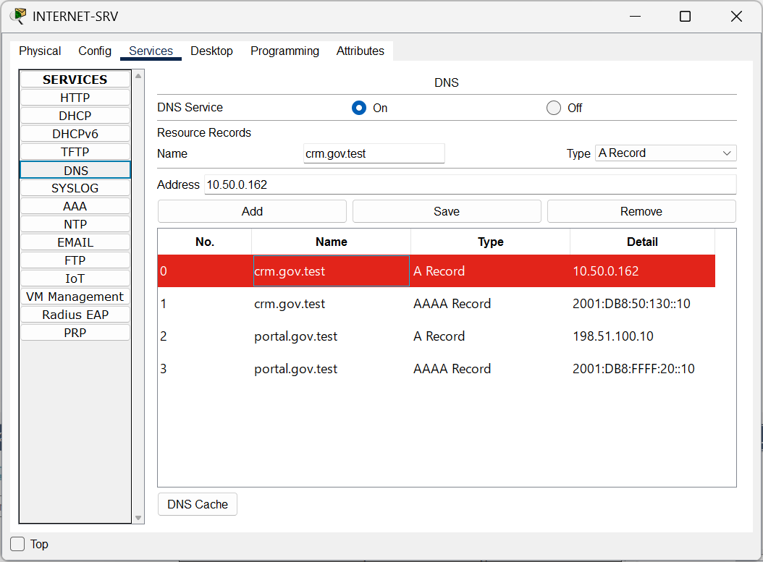  Figure 6k. INTERNET-SRV: A and AAAA DNS resource records. | 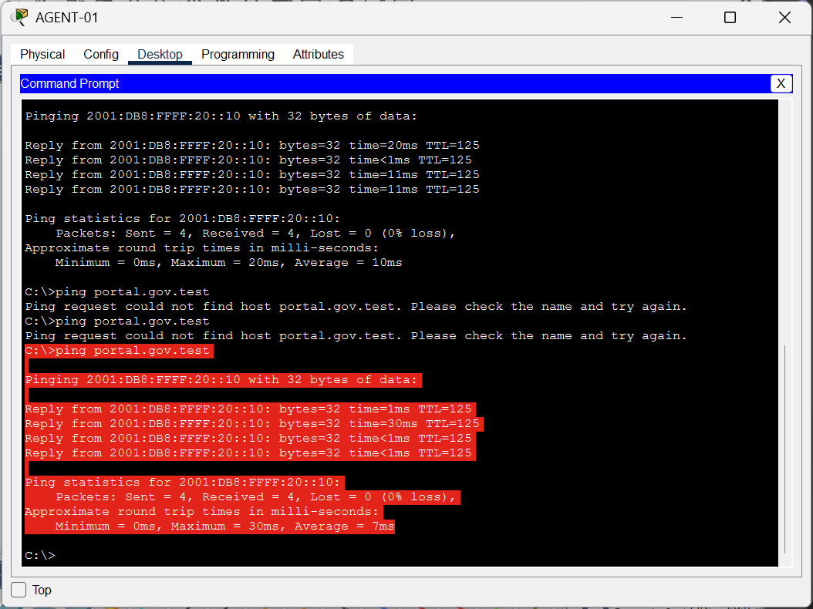  Figure 6l. AGENT-01: successful portal DNS resolution and IPv6 replies.

3. Security, QoS and Validation
The access switches were configured with PortFast and BPDU Guard on the agent and supervisor desk ports. CORE-SW enforced named IPv4 and IPv6 CRM ACLs outbound on VLAN 130. Each policy permits TCP destination port 443 from VLAN 110 and VLAN 120, denies remaining traffic aimed at the CRM subnet, and then permits unrelated traffic. The successful HTTPS tests to 10.50.0.162 and 2001:DB8:50:130::10, together with denied ICMP/ICMPv6 tests, demonstrate that the intended allowed and prohibited cases were exercised. Restricting voice-to-CRM traffic is part of these destination-based rules, although a separate explicit Voice-to-CRM test was not captured in the supplied evidence.
SSH version 2 was enabled on CORE-SW and both access switches, with local login and Telnet excluded from VTY transport. A standard VTY ACL permits the management subnet 10.50.0.176/28 for IPv4 management sessions. Initially CORE-SW reported 'SSH Disabled' because RSA keys had not been generated. After creating a 1024-bit RSA key for the lab, show ip ssh reported version 2.0 enabled, and MGMT-PC successfully opened sessions to 10.50.0.177, .179 and .180. This proves the intended IPv4 management path. A separate check of IPv6-based remote-management restrictions was not supplied, and a 1024-bit training key would need strengthening for production use.
Voice QoS was configured on both 2960 access switches with global mls qos and mls qos trust cos on the phone-facing interfaces. Their show mls qos interface output displayed 'trust state: trust cos' and 'trust enabled flag: ena'. This establishes Layer-2 classification trust at the access-port boundary. The CORE-SW show policy-map interface command returned no active service policy. Therefore the test supports access-layer CoS trust, but not a claim that a complete end-to-end priority queue or measured jitter target had been implemented. The design would require further QoS policy and measurement before a production call-quality guarantee could be made.
The final working-state evidence included active VLAN configuration, Po1/Po2 operational LACP output, IPv4 DHCP leases, a global agent IPv6 address, supervisor DNS learning, functioning dual-stack external pings, NAT/PAT translations, SSH sessions and HTTPS ACL tests. The simulated internet service returned four of four responses over IPv6 after the temporary missing-route fault was repaired. All four IP phones were registered by CME, and a call test reached Connected state. These successful outcomes relate to the observed Packet Tracer scenario and should not be interpreted as a resilience, security or quality-of-service stress test on physical equipment.
The initial voice-system verification includes the CME registration list shown earlier and both phone GUI screenshots during an established call. The two displays identify the communicating extensions and report Connected.
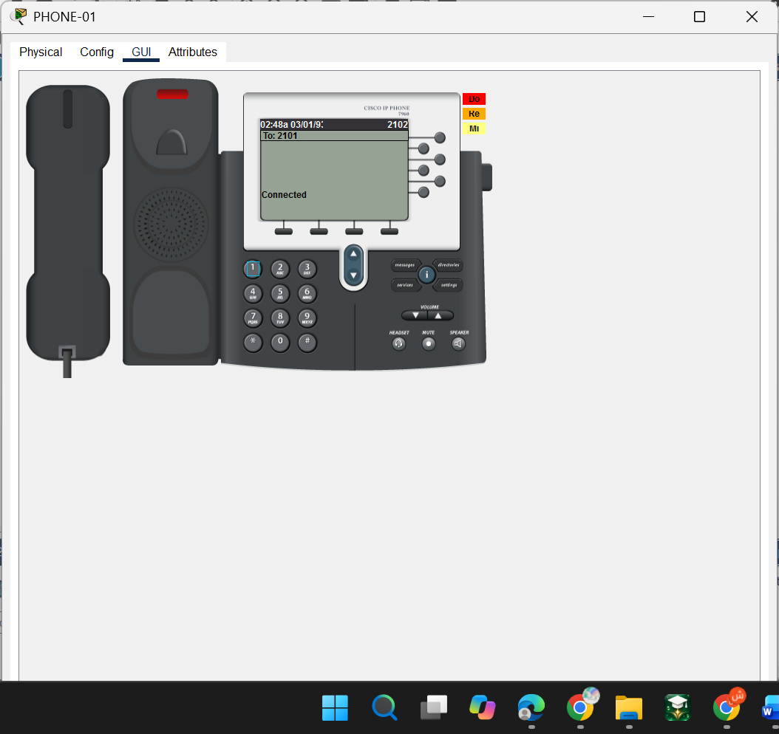  Figure 7a. PHONE-01: connected call between extensions 2101 and 2102. | 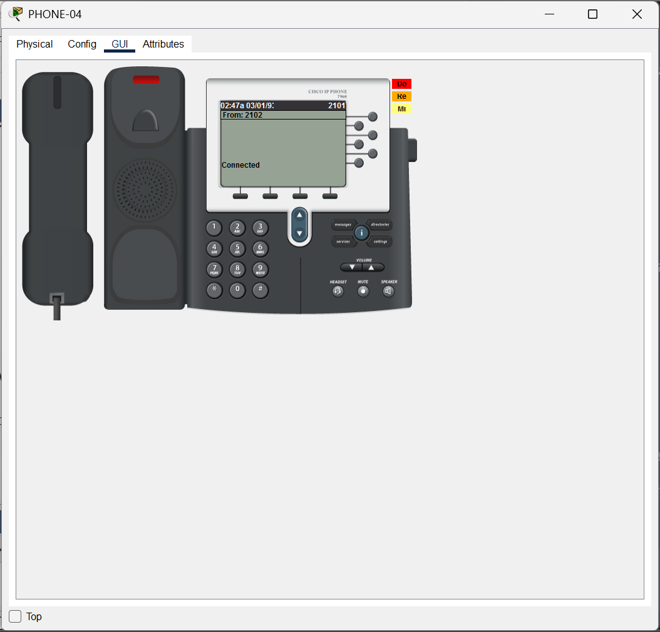  Figure 7b. PHONE-04: the same established call, showing Connected.

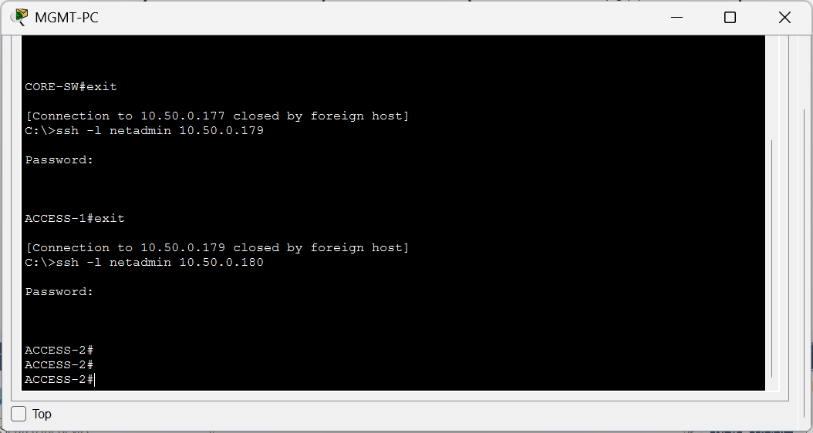  Figure 8. Successful SSH access to the managed switches. | 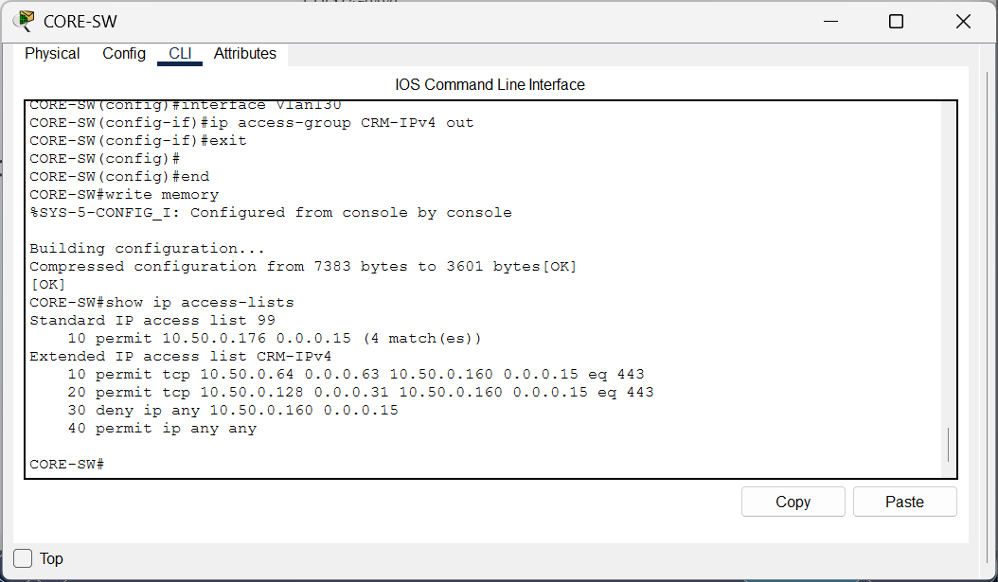  Figure 8a. CORE-SW: IPv4 CRM access-control rules.

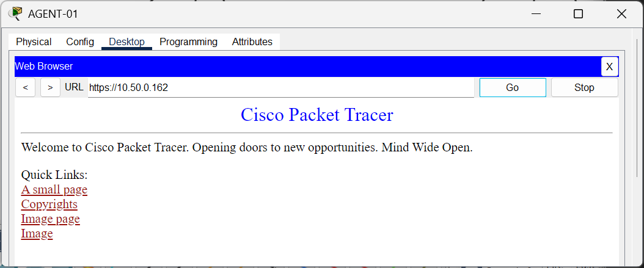  Figure 9. Allowed CRM HTTPS over IPv4. | 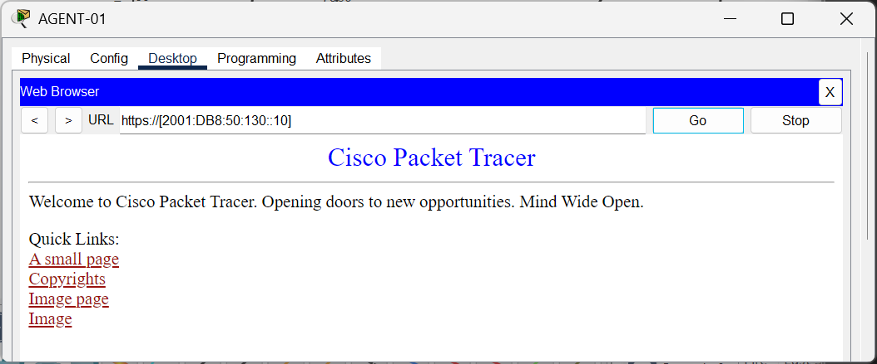  Figure 10. Allowed CRM HTTPS over IPv6.

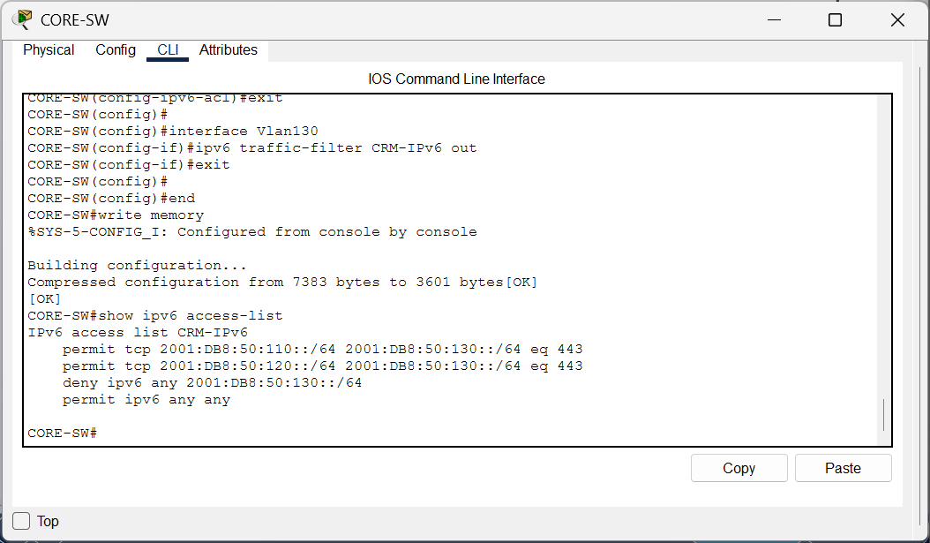  Figure 10a. CORE-SW: IPv6 CRM ACL applied and displayed. | 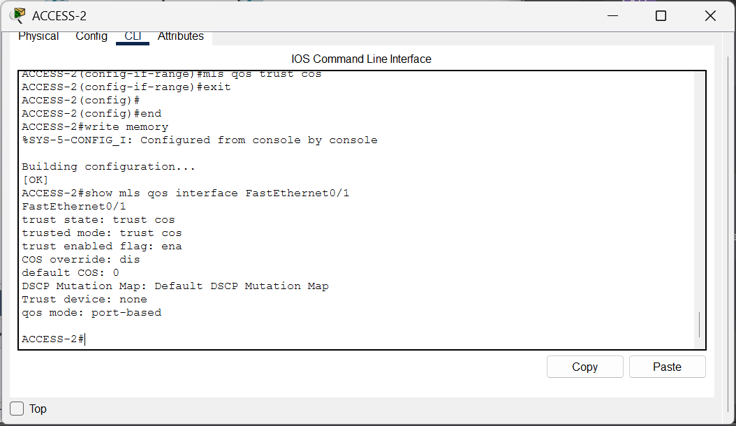  Figure 10b. ACCESS-2: QoS trust cos on the phone access port.

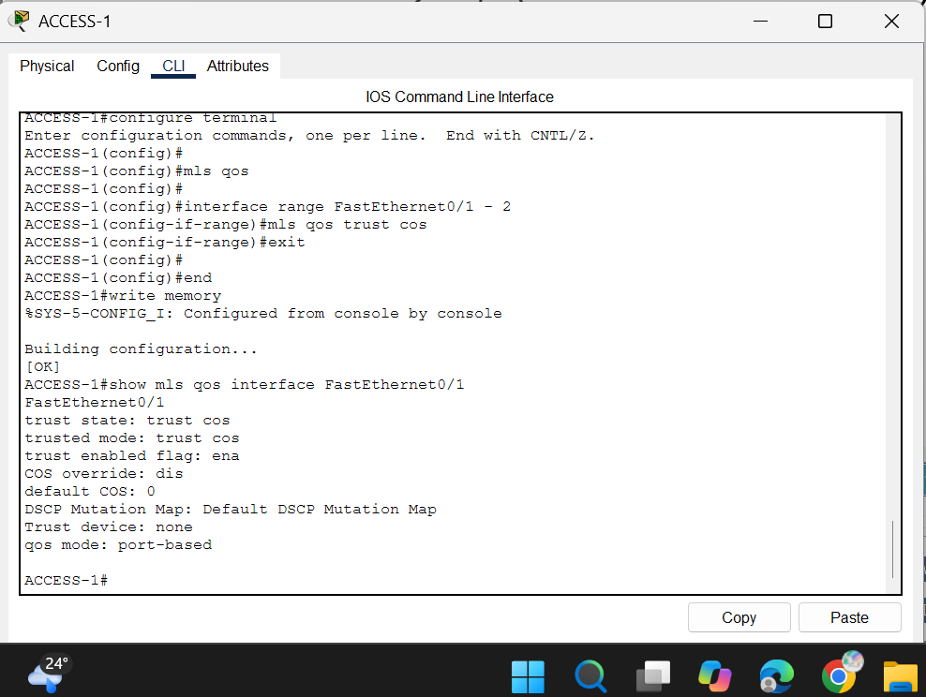  Figure 11. ACCESS-1 CoS trust state. | 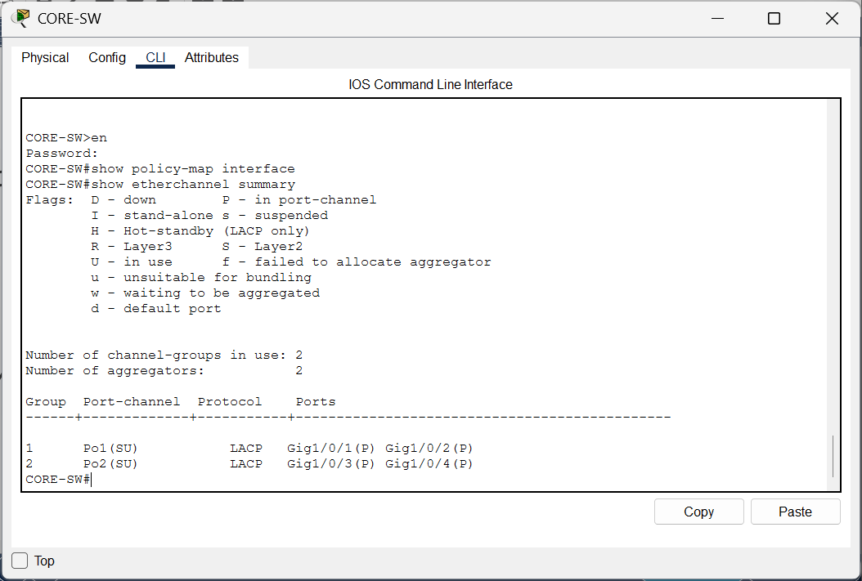  Figure 12. Final LACP Po1 and Po2 operational.

4. Part B Troubleshooting Results
Part B was tested by deliberately applying one fault, recording the symptom and diagnostic output, correcting the cause, and recording the working retest. After these individual demonstrations, the five prescribed faults were restored to a separate Part B file; the student confirmed that this faulty file was saved. Part A remained the working baseline. The five incidents below follow the official assignment numbering: SLAAC/Router Advertisement failure, wrong voice-VLAN configuration, missing external IPv6 route, erroneous IPv6 CRM filtering, and a BPDU Guard violation. The saved Packet Tracer files themselves were not provided for independent inspection.
Fault | Symptom confirmed | Corrective action confirmed
1. RA / SLAAC | FE80:: only on AGENT-01 | Global address and gateway returned
2. Voice VLAN | Voice VLAN: none; phone registration loss | VLAN150; all phones REGISTERED
3. IPv6 Default | No ::/0; external IPv6 ping failed | Restored ::/0; ping 4/4
4. CRM IPv6 ACL | HTTPS timeout | Permit TCP/443; HTTPS successful
5. BPDU Guard | Fa0/6 err-disabled | Removed switch; notconnect

4.1 Fault 1 — No IPv6 Global Address (RA/SLAAC Failure)
Before: on CORE-SW, the interface command ipv6 nd ra suppress was accepted under Vlan110. The extended syntax ending in all was rejected by the simulated IOS. After AGENT-01 was switched from Static back to Automatic IPv6 configuration, it displayed its FE80:: link-local address but no global 2001:DB8:50:110::/64 address or IPv6 default gateway. This is the required observed SLAAC failure. Diagnosis used the interface configuration and the host's IP Configuration screen. Repair: no ipv6 nd ra suppress under Vlan110; reset the client to Automatic again. The PC then showed 'IPv6 request successful', global address 2001:DB8:50:110:202:16FF:FEE5:926B/64, and a learned FE80:: gateway. The student later reported reapplying the suppress command to the faulty delivery file. The host outcome, rather than a timer line in show ipv6 interface, is the decisive evidence in this simulator.
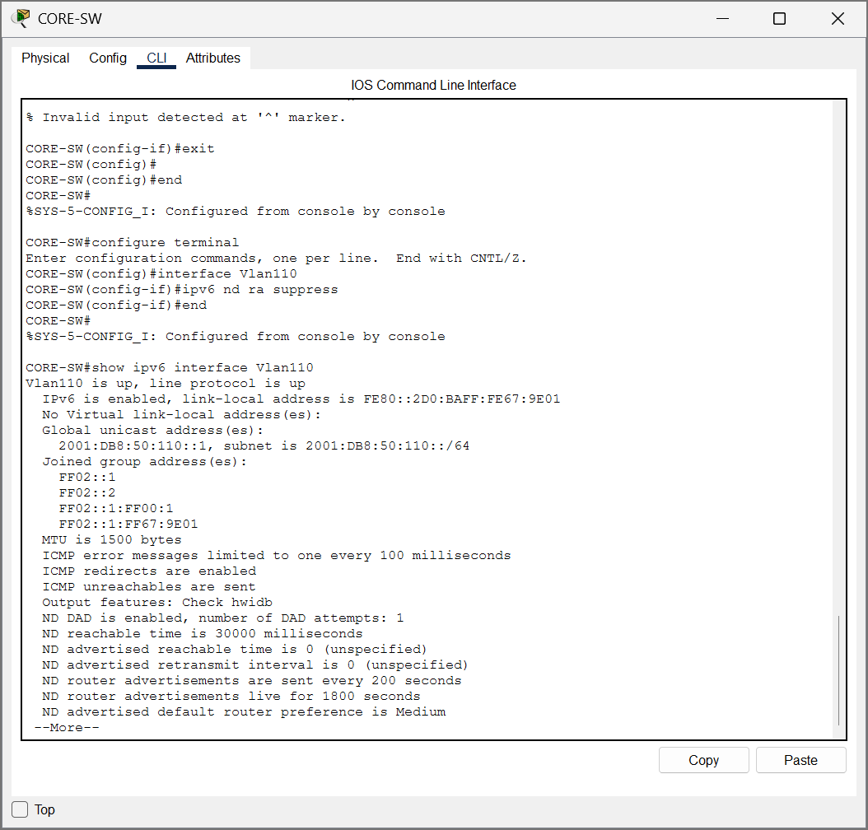  Figure 13a. Before: Vlan110 RA suppression accepted. | 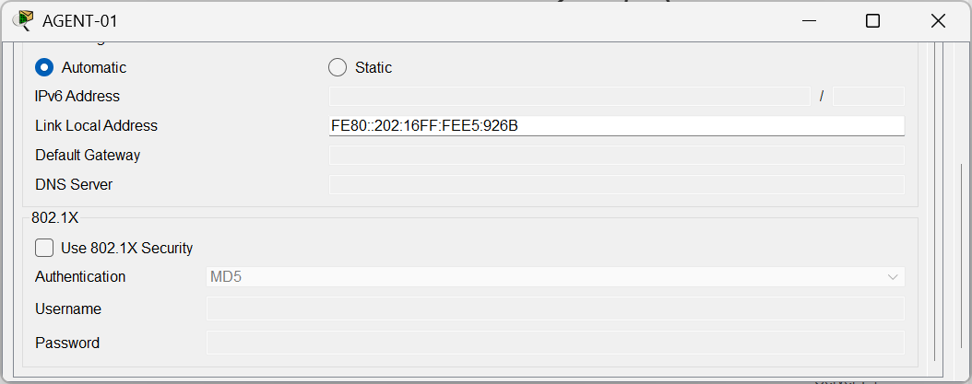  Figure 13b. Before: AGENT-01 FE80:: only.

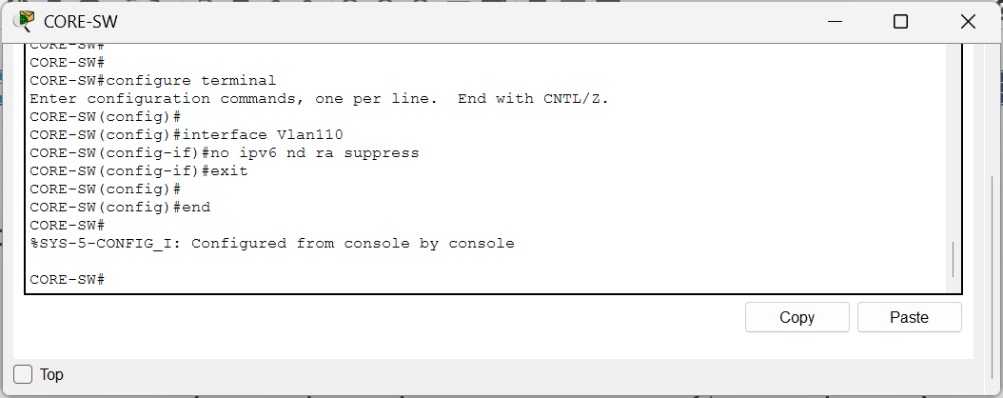  Figure 13c. After: RA suppression removed. | 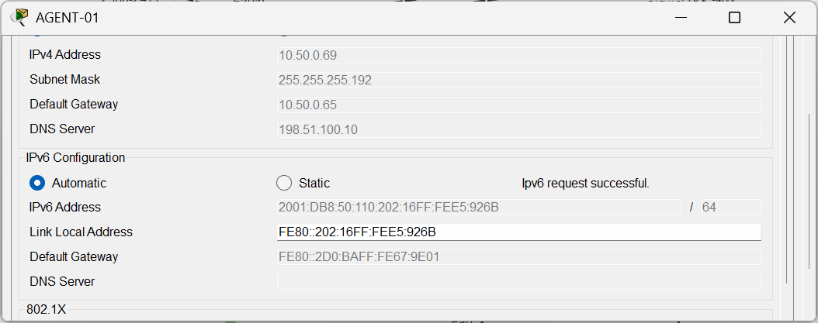  Figure 13d. After: global IPv6 and gateway restored.

4.2 Fault 2 — Phones in the Wrong VLAN
Before: removing switchport voice vlan 150 from Fa0/1-2 on ACCESS-2 left 'Voice VLAN: none', while data VLAN 110 remained configured. The two affected phones displayed Configuring IP after being restarted, and CME showed registrations lost/DOWN for some extensions. Repair: restore switchport voice vlan 150 on both interfaces. Verification again displayed Voice VLAN: 150, the phones showed internal numbers, and a subsequent show ephone output listed all extensions 2101-2104 as REGISTERED. Thus the issue was access-port voice segmentation, not CME numbering. The screenshots do not show the phones receiving addresses specifically from the agent data DHCP pool, as mentioned in the assignment symptom.
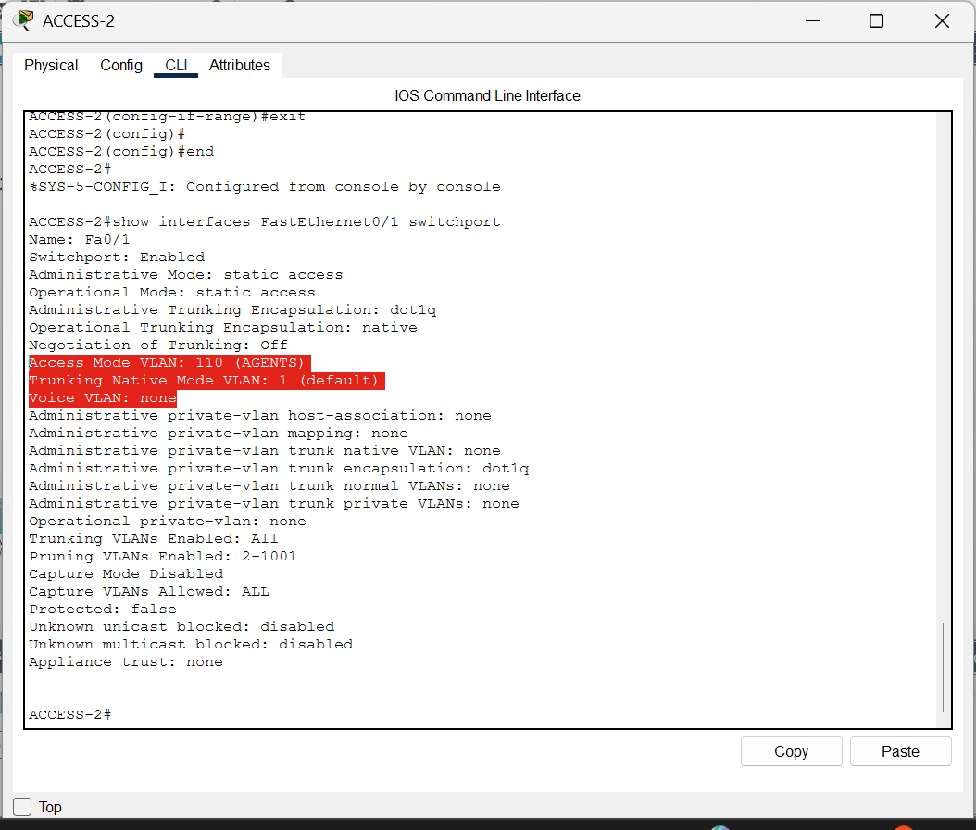  Figure 14a. Before: Voice VLAN none. | 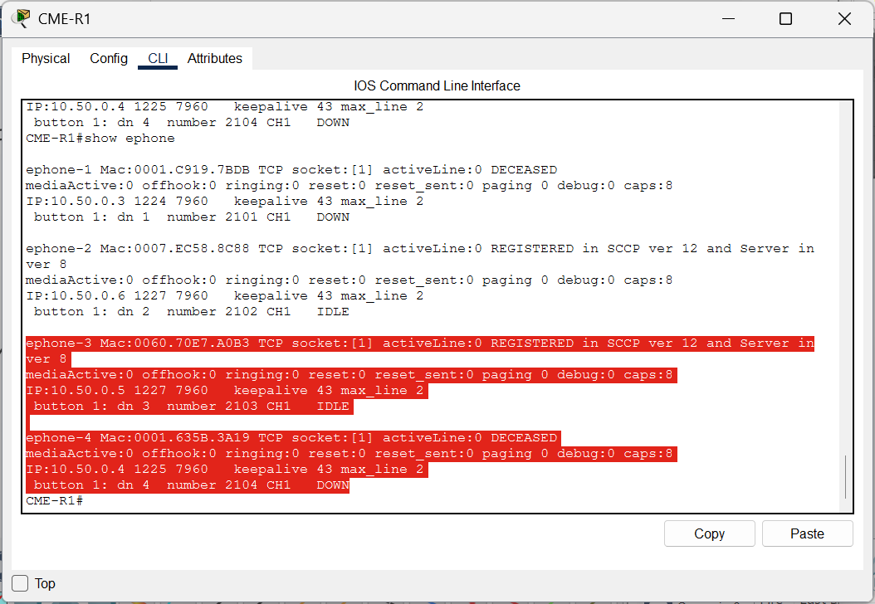  Figure 14b. Before: CME shows dropped registrations.

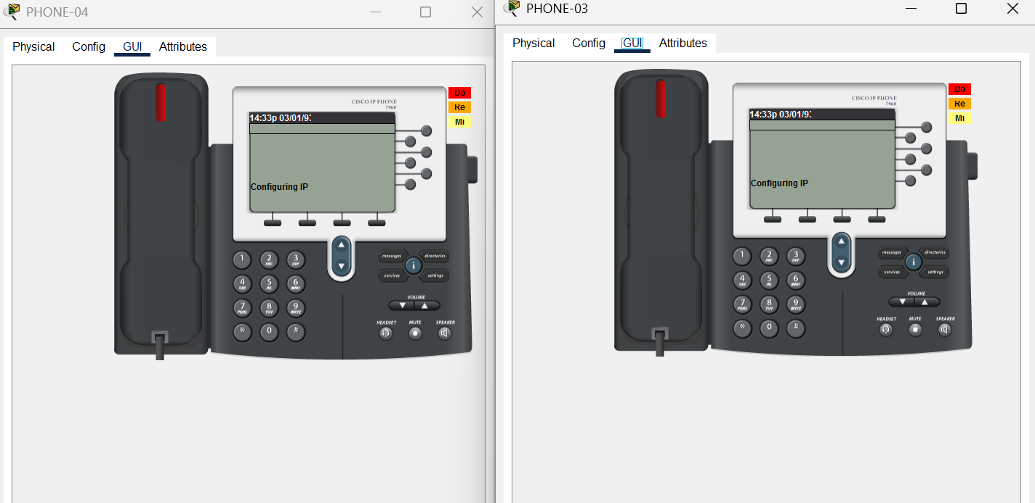
Figure 14e. Before repair: PHONE-03 and PHONE-04 display Configuring IP after Voice VLAN removal.
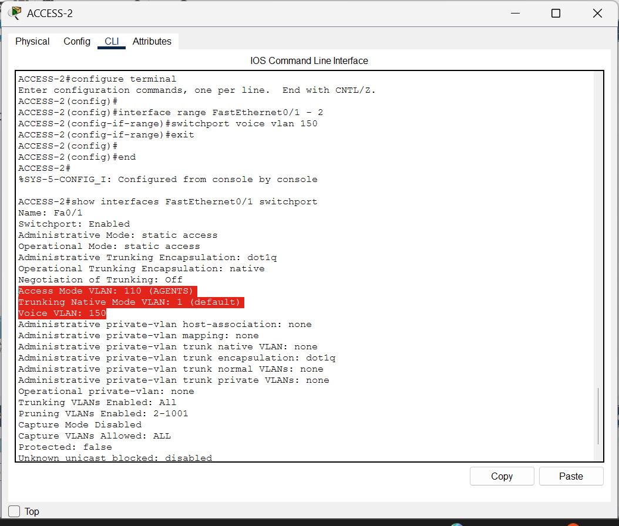  Figure 14c. After: Voice VLAN 150 restored. | 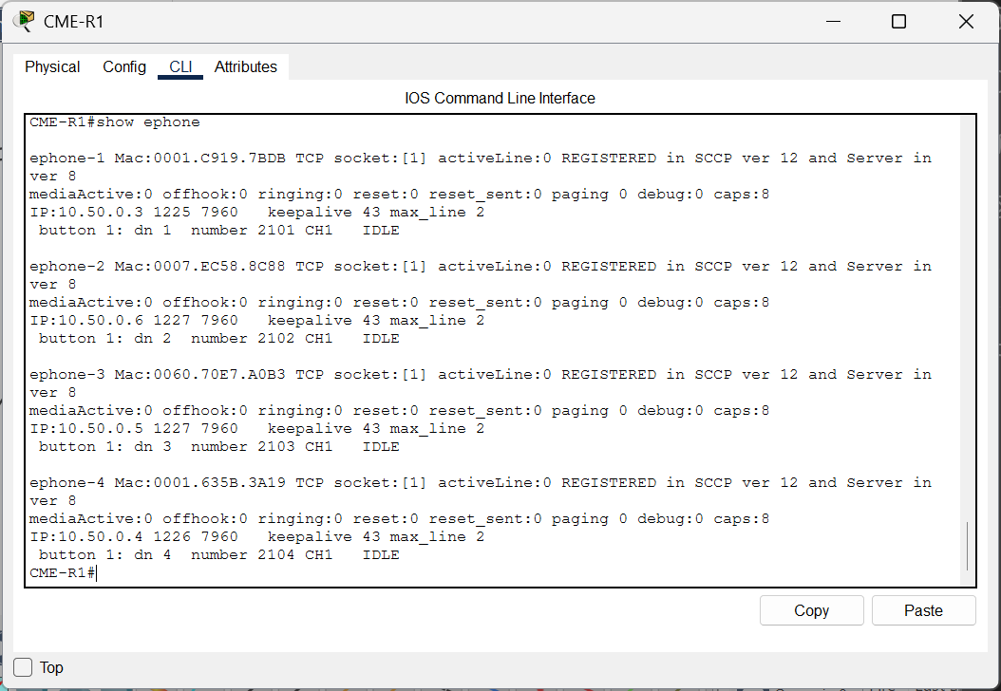  Figure 14d. After: four phones REGISTERED.

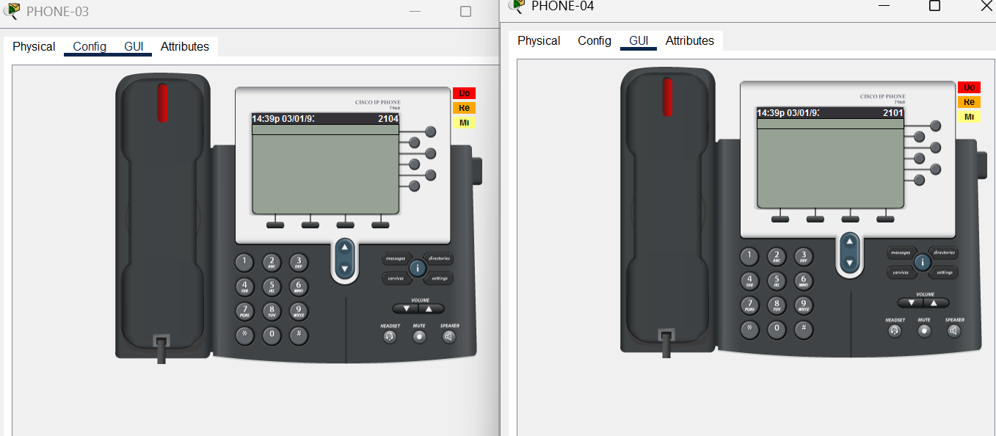
Figure 14f. After repair: both phones display assigned extensions again; CME confirms registration of all four.

4.3 Fault 3 — IPv6 Internet Failure (Missing Default Route)
Before: CORE-SW's IPv6 default route was deleted using no ipv6 route ::/0 2001:DB8:50:210::2. The command show ipv6 route then showed 13 entries, with no S ::/0 route. AGENT-01 could not ping the external IPv6 address 2001:DB8:FFFF:20::10; all four packets were lost and the gateway reported the destination unreachable. IPv4 routing was not intentionally changed. Repair: restore ipv6 route ::/0 2001:DB8:50:210::2. The default route reappeared, and the agent received all four IPv6 replies with 0% loss. This is exactly the routing failure designated Fault 3 in the assignment brief.
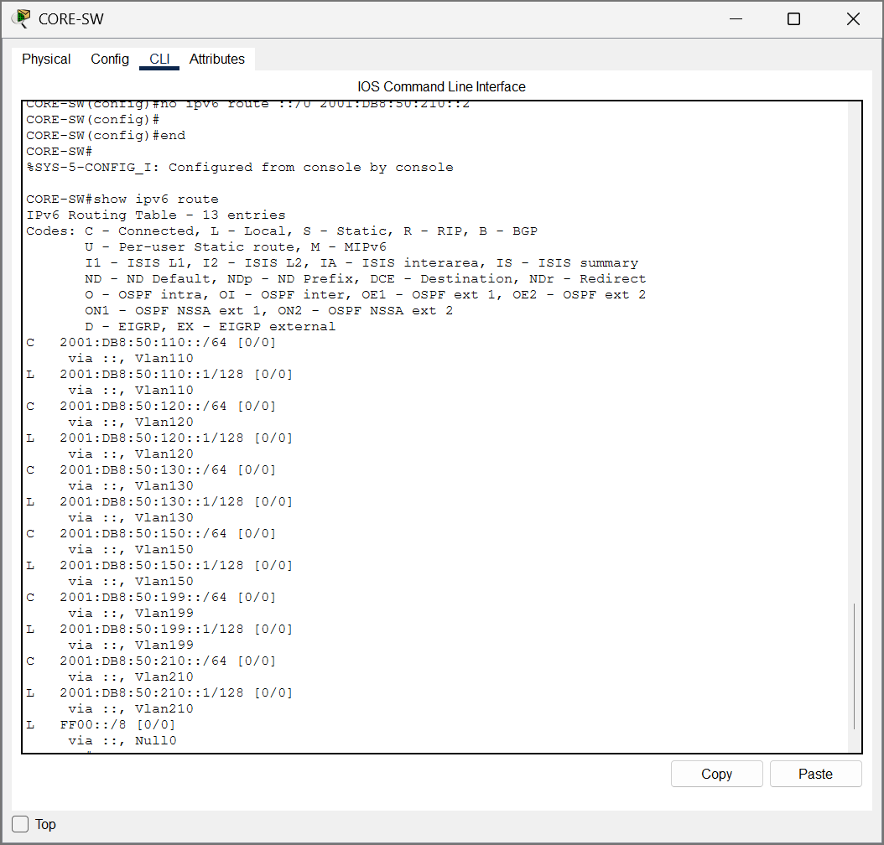  Figure 15a. Before: no IPv6 ::/0 route. | 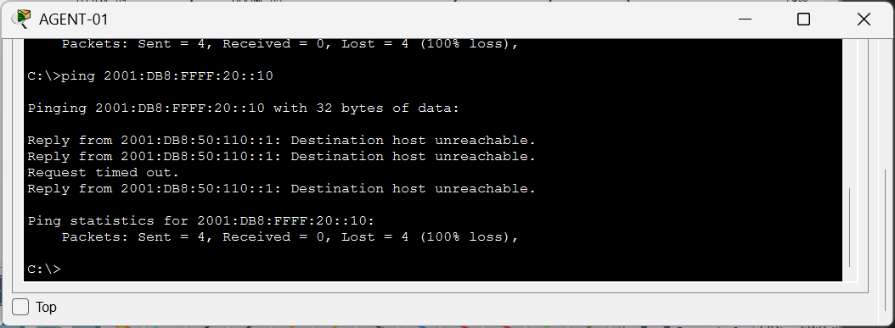  Figure 15b. Before: external IPv6 ping fails.

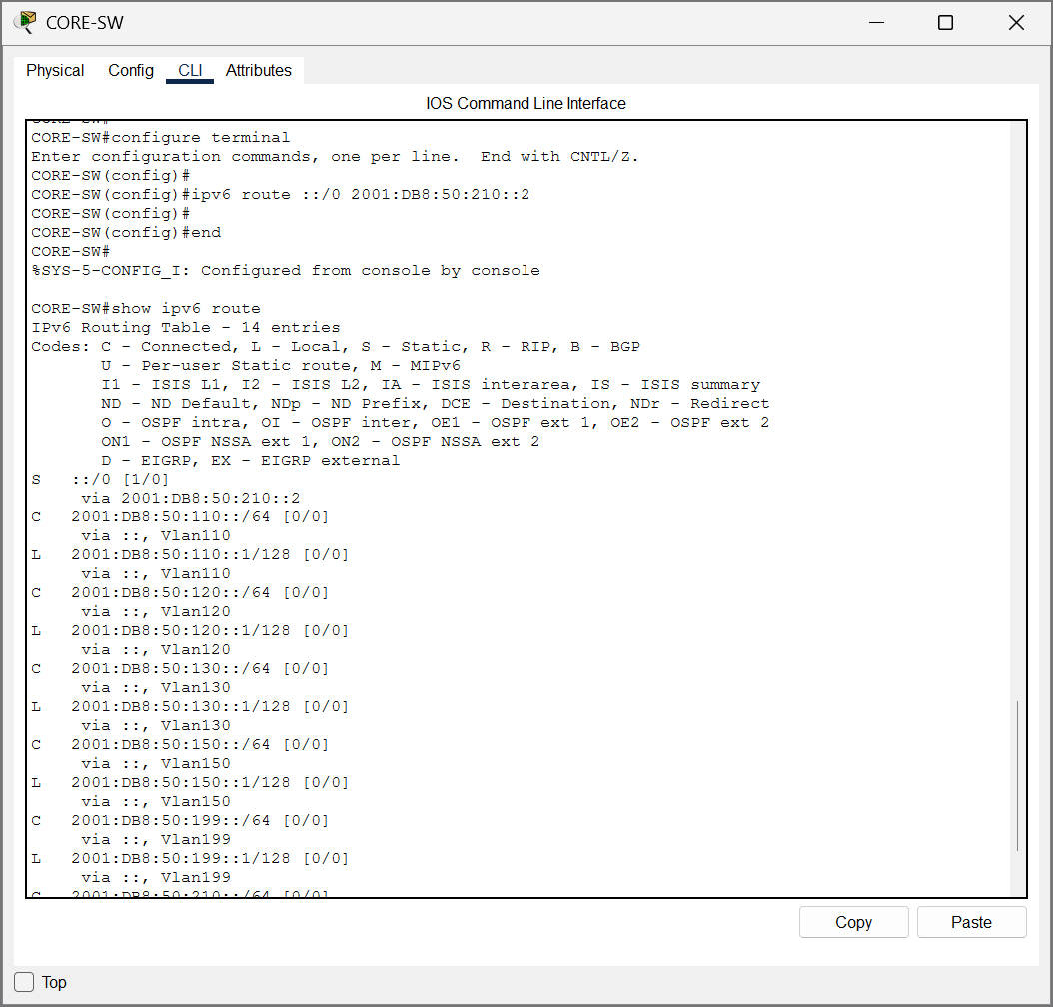  Figure 15c. After: ::/0 route restored. | 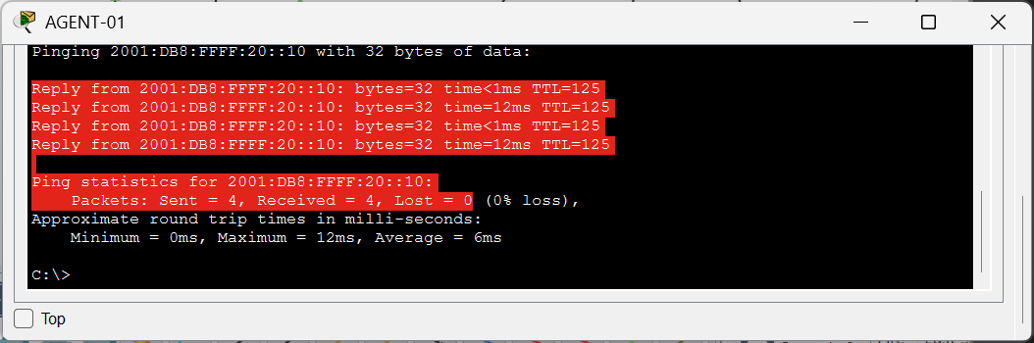  Figure 15d. After: IPv6 ping replies 4/4.

4.4 Fault 4 — CRM Blocked over IPv6
Before: both IPv6 TCP/443 permit entries for agent and supervisor prefixes were removed from CRM-IPv6, leaving the deny entry to 2001:DB8:50:130::/64. The ACL counter showed matched denied packets, and the HTTPS browser request to the CRM IPv6 address displayed Request Timeout. Repair: rebuild the ACL rules in the correct order, placing two TCP 443 permits ahead of deny ipv6 any to the CRM prefix, followed by permit ipv6 any any. After correction, the four rules appeared in show ipv6 access-list, and the CRM page loaded over HTTPS from AGENT-01. A separate supervisor-originated HTTPS result was not captured.
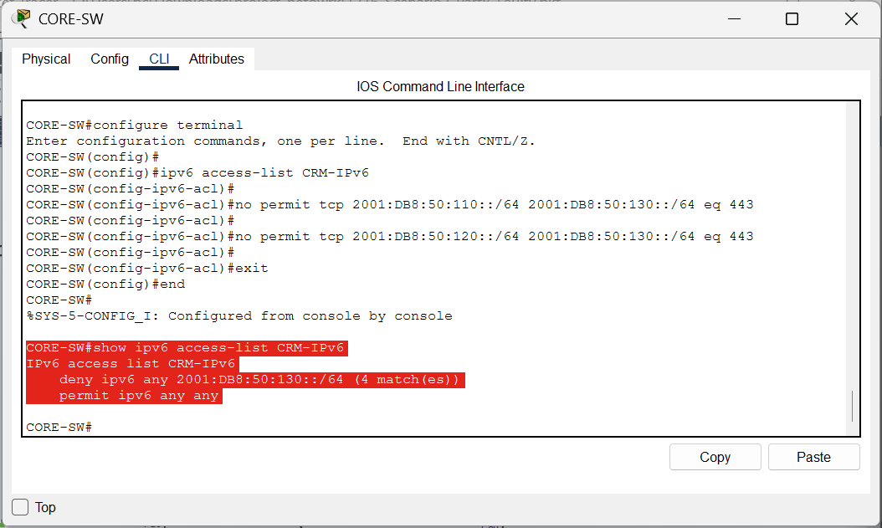  Figure 16a. Before: TCP/443 permits removed. | 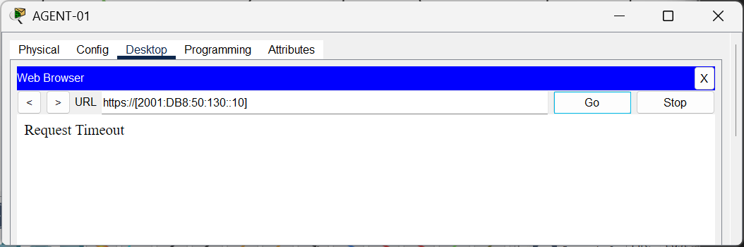  Figure 16b. Before: CRM HTTPS timeout.

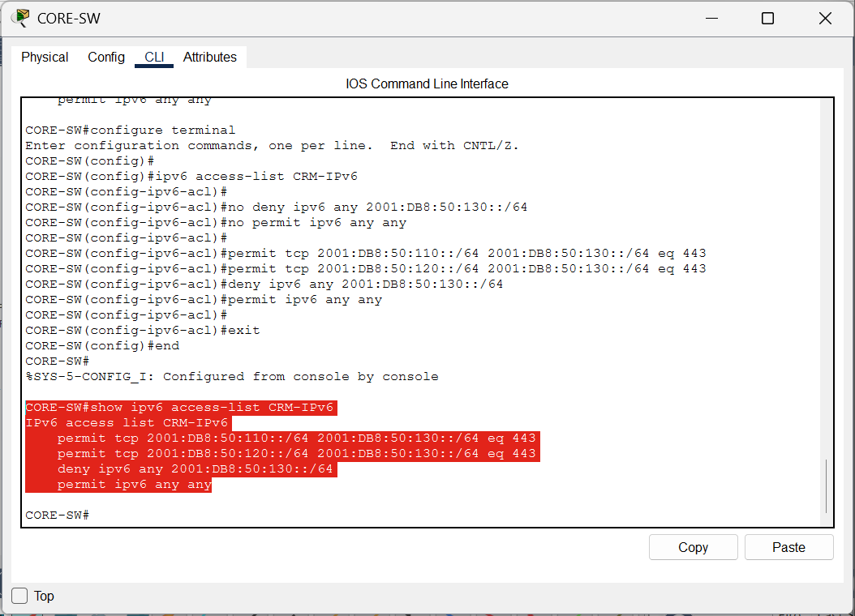  Figure 16c. After: IPv6 ACL permits restored. | 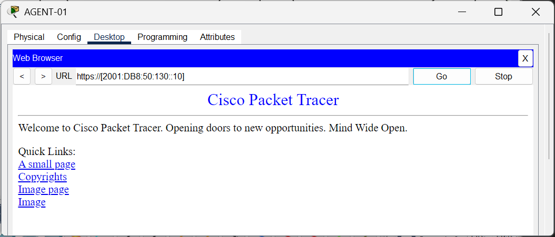  Figure 16d. After: CRM HTTPS page loads.

4.5 Fault 5 — BPDU Guard Err-Disabled Port
Before: a spare ACCESS-1 user port Fa0/6 was configured with PortFast and BPDU Guard and connected to an unauthorized ROGUE-SW. The switch marked Fa0/6 err-disabled, demonstrating a spanning-tree edge-port security violation. Repair: remove the unauthorized switch cable, then use shutdown and no shutdown under Fa0/6 while leaving BPDU Guard configured. The subsequent show interfaces status output changed to notconnect, the expected recovered state for an unplugged interface. This confirms port protection and recovery. However, the original incident specifies an occupied agent desk where both its phone and PC go offline; the spare-port demonstration did not separately measure that endpoint outage.
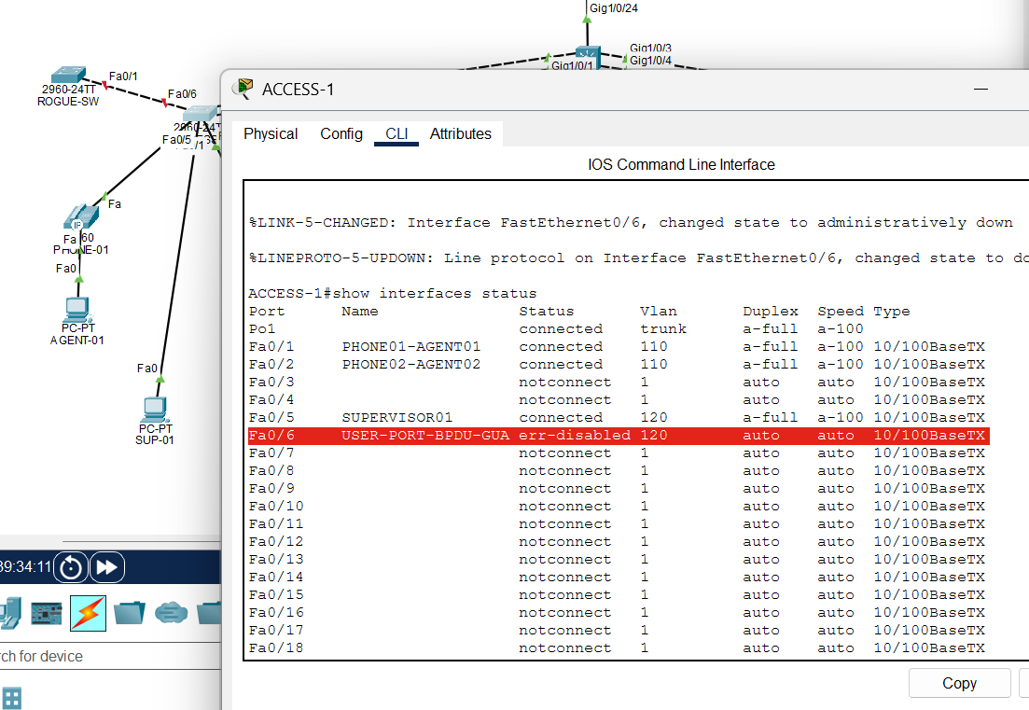  Figure 17a. Before: Fa0/6 err-disabled. | 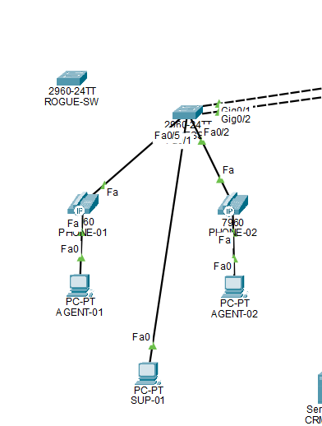  Figure 17b. After: rogue link disconnected.

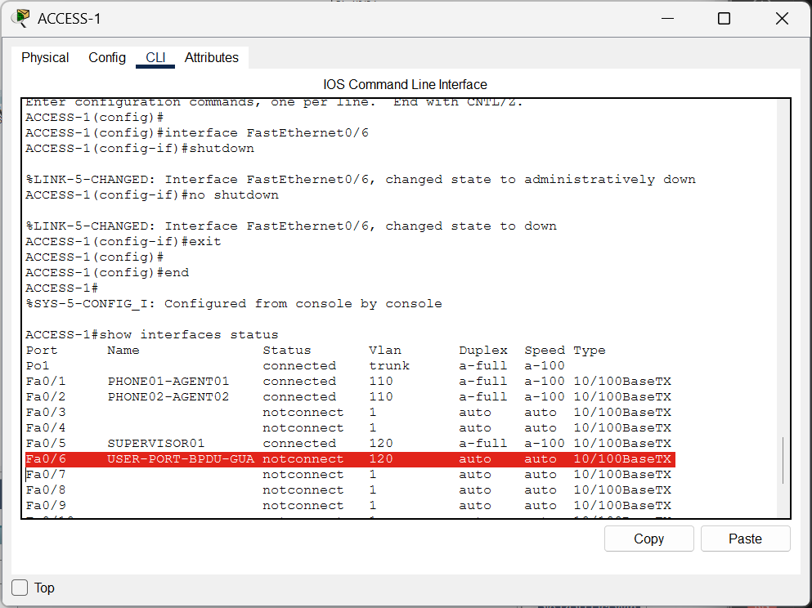
Figure 17c. After: protected port recovers to notconnect.

5. Network Analysis: IPv6 Transition, DHCPv6 and QoS (~500 words)

5.1 IPv6 Transition Methods
IPv6 transition planning has three widely discussed approaches. Dual-stack runs IPv4 and IPv6 simultaneously on hosts and routed interfaces; applications can continue using IPv4 while IPv6 services are introduced. Tunnelling transports IPv6 packets across an underlying IPv4 network and can join IPv6 sites without converting the entire intermediate path. Translation, such as stateful NAT64 combined with DNS64, lets IPv6-only clients contact IPv4-only servers by rewriting protocol headers and addresses [1,4]. In this contact centre dual-stack was the practical choice: the CRM, agents and management equipment could be given predictable IPv4 addresses and parallel IPv6 prefixes, while existing Cisco phone services continued operating over the tested IPv4 voice network. The separate IPv4 PAT service provided connectivity to the simulated ISP without converting IPv6 traffic. The cost is maintaining two routing, DNS and access-control policy sets, so the IPv4 and IPv6 ACLs must be reviewed together.

5.2 IPv6 Address Assignment
SLAAC, stateless DHCPv6 and stateful DHCPv6 solve different parts of host configuration. SLAAC uses Router Advertisements (RAs) to advertise a prefix and default-router information; the client constructs a global address, ordinarily checking for duplicates [2]. With stateless DHCPv6, the client still creates its address through SLAAC but obtains other settings such as DNS servers and domain-search information from DHCPv6 [3]. Stateful DHCPv6 may allocate addresses and additional options from a server, so the address assignment is managed centrally. The RA Managed (M) flag signals that stateful address assignment should be used, whereas the Other (O) flag signals availability of non-address configuration information. In this lab VLAN 110 used SLAAC and VLAN 120 used the O flag with the SUPERVISOR-DNS6 pool. SUP-01 therefore had a global IPv6 address and the configured DNS address. A key operational point is that DHCPv6 by itself does not replace the default-router information delivered through RAs. If core IPv6 routing or RA behaviour failed, clients could retain link-local FE80:: connectivity but lose global IPv6 autoconfiguration; this is why the official first fault explicitly tests IPv6 RAs.

5.3 Voice VLAN and Trust Boundary
The voice VLAN separates latency-sensitive phone packets from workstation traffic, supports a different IPv4 DHCP pool with option 150, and enables voice-specific access and QoS policies. Voice isolation also limits accidental access from phone endpoints to the CRM service. At Layer 2, IEEE 802.1p Class of Service (CoS) provides markings within VLAN-tagged frames; Cisco 7960 phones generally mark voice traffic with priority value 5 [6]. At Layer 3, Differentiated Services can mark expedited voice forwarding with DSCP EF, whose per-hop behaviour aims at low delay, low jitter and low loss [5]. The trust boundary matters because an unmanaged PC should not be allowed to claim high voice priority. A Cisco phone can mark its own voice packets, while the access-switch trust configuration should validate or accept the intended tag from the phone, not blindly trust every end device. Here both 2960 switches showed trust cos on the phone-facing ports, but no active CORE-SW queueing policy appeared in show policy-map interface. Therefore this project verified CoS recognition, not end-to-end QoS scheduling. In a real contact centre, the next tasks would include validating DSCP preservation on uplinks, configuring hardware queues where supported, measuring latency, jitter and loss under traffic load, and comparing call performance before and after congestion [5,7].

6. Evidence Limitations and Submission Status
The five documented incidents now match the assignment's named fault categories, and the newly captured SLAAC failure and recovery replace the earlier supplementary SSH-ACL experiment in the official Part B section. The incorrect SSH ACL was repaired before the final faulty-file preparation and is documented only as part of normal SSH validation. There are remaining distinctions between some rubric symptoms and the directly observed evidence: the Voice VLAN fault showed 'Configuring IP' and registration failures but no screenshot of an agent-pool DHCP lease on a phone; the BPDU Guard violation used spare Fa0/6, rather than disconnecting an occupied phone-and-PC desk port. The supplied tests do not independently demonstrate the Voice-to-CRM denied case or a supervisor-originated CRM HTTPS success case. A core egress-queueing QoS policy was not verified. The user confirmed saving the two .pkt files, but they were not uploaded for inspection. These points should not be described as successful tests without additional screenshots.

7. References
[1] E. Nordmark and R. Gilligan, Basic Transition Mechanisms for IPv6 Hosts and Routers, RFC 4213, Oct. 2005. https://www.rfc-editor.org/rfc/rfc4213.html
[2] S. Thomson et al., IPv6 Stateless Address Autoconfiguration, RFC 4862, Sept. 2007. https://www.rfc-editor.org/rfc/rfc4862.html
[3] T. Mrugalski et al., Dynamic Host Configuration Protocol for IPv6 (DHCPv6), RFC 8415, Nov. 2018. https://www.rfc-editor.org/rfc/rfc8415.html
[4] M. Bagnulo et al., Stateful NAT64: Network Address and Protocol Translation from IPv6 Clients to IPv4 Servers, RFC 6146, Apr. 2011. https://www.rfc-editor.org/rfc/rfc6146.html
[5] B. Davie et al., An Expedited Forwarding PHB (Per-Hop Behavior), RFC 3246, Mar. 2002. https://www.rfc-editor.org/rfc/rfc3246.html
[6] Cisco Systems, Configuring Voice VLANs: Catalyst 2960, Cisco IOS 15.2(2)E Configuration Guide. https://www.cisco.com/c/en/us/td/docs/switches/lan/catalyst2960/software/release/15-2_2_e/configuration/guide/b_1522e_2960_2960c_2960s_2960sf_2960p_cg/m_1522e_vlan_voice_2960s_cg.html
[7] Cisco Systems, Configuring QoS: Catalyst 3650, Cisco IOS XE Consolidated Configuration Guide. https://www.cisco.com/c/en/us/td/docs/switches/lan/catalyst3650/software/release/37e/consolidated_guide/b_37e_consolidated_3650_cg/b_37e_consolidated_3650_cg_chapter_0110010.html
[8] Cisco Packet Tracer screenshots and configuration outputs, author-generated simulation evidence, Nov. 2026.

