Testing Tutorial 2
Question 1
The example procedure below shows how the algorithm statements are mapped into graph nodes, numbered on the left.
public double calculate(int amount)
{
-1- double rushCharge = 0;
-1- if (nextday.equals("yes") )
{
-2- rushCharge = 14.50;
}
-3- double tax = amount * .0725;
-3- if (amount >= 1000)
{
-4- shipcharge = amount * .06 + rushCharge;
}
-5- else if (amount >= 200)
{
-6- shipcharge = amount * .08 + rushCharge;
}
-7- else if (amount >= 100)
{
-8- shipcharge = 13.25 + rushCharge;
}
-9- else if (amount >= 50)
{
-10- shipcharge = 9.95 + rushCharge;
}
-11- else if (amount >= 25)
{
-12- shipcharge = 7.25 + rushCharge;
}
else
{
-13- shipcharge = 5.25 + rushCharge;
}
-14- total = amount + tax + shipcharge;
-14- return total;
} //end calculate
Step 1: Draw the flow graph for the algorithm.
Solution
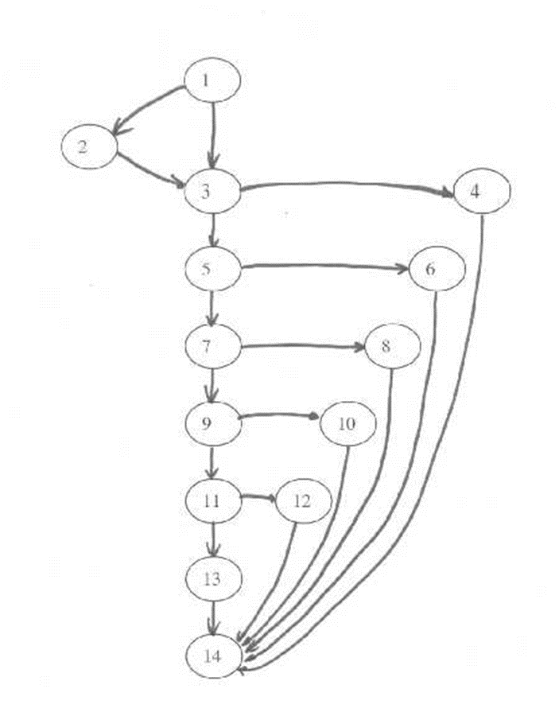

Step 2: Determine the cyclomatic complexity of the flow graph.
V(G) = E - N + 2
= 19 - 14 + 2
= 7
This tells us the upper bound on the size of the basis set. That is, it gives us the number of independent paths we need to find.

Step 3: Determine the basis set of independent paths.
Path 1: 1 - 2 - 3 - 5 - 7 - 9 - 11 - 13 - 14
Path 2: 1 - 3 - 4 - 14
Path 3: 1 - 3 - 5 - 6 - 14
Path 4: 1 - 3 - 5 - 7 - 8 - 14
Path 5: 1 - 3 - 5 - 7 - 9 - 10 - 14
Path 6: 1 - 3 - 5 - 7 - 9 - 11 - 12 - 14
Path 7: 1 - 3 - 5 - 7 - 9 - 11 - 13 - 14
Note: This basis set is not unique. There are several different basis sets for the given algorithm. You may have derived a different basis set.
Question 2
1: WHILE NOT EOF LOOP
2: Read Record;
2: IF field1 equals 0 THEN
3: Add field1 to Total
3: Increment Counter
4: ELSE
4: IF field2 equals 0 THEN
5: Print Total, Counter
5: Reset Counter
6: ELSE
6: Subtract field2 from Total
7: END IF
8: END IF
8: Print "End Record"
9: END LOOP
9: Print Counter

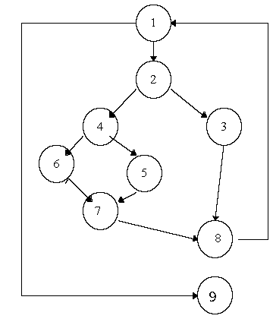

Example has:
- Independent Paths:
  - 1, 9
  - 1, 2, 3, 8, 1, 9
  - 1, 2, 4, 5, 7, 8, 1, 9
  - 1, 2, 4, 6, 7, 8, 1, 9
- Cyclomatic Complexity of 4; computed using any of these 3 formulas:
  - #Edges - #Nodes + #terminal vertices (usually 2)
  - #Predicate Nodes + 1
  - Number of regions of flow graph.
Cyclomatic complexity provides upper bound for number of tests required to guarantee coverage of all program statements.

