## **What is Logistic Regression?**

As previously stated, Logistic Regression is used to solve classification problems. **Models are trained on historical labelled datasets** and aim to predict which category new observations will belong to.

Logistic regression is well suited when we need to predict a binary answer (only 2 possible values like yes or no,0 or 1) and this type we did project about

The term logistic regression comes from “**Logistic Function,**” which is also known as “**Sigmoid Function”.** Let us learn more about it.

## **Logistic/Sigmoid Function**

The sigmoid function, commonly known as the logistic function, predicts the likelihood of a binary outcome occurring. **The function takes any value** **and converts it to a number between 0** **and 1**. The Sigmoid Function is a machine learning activation function that is used to introduce non-linearity to a machine learning model.

The formula of Logistic Function is:

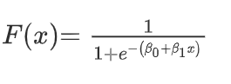

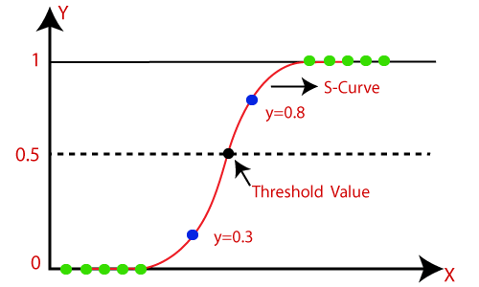

The key point from the above graph is that no matter what value of x we use in the logistic or sigmoid function, the **output** along the vertical axis will always be **between 0 and 1**.

When the result of the sigmoid function is greater than 0.5, we classify the label as class 1 or positive class; if it’s less than 0.5, we can classify it as a negative class or 0.

## Assumptions for Logistic Regression:

* The dependent variable must be categorical in nature.
* The independent variable should not have multi-collinearity

Let’s understand the **mathematics behind the sigmoid function**.

## Logistic Regression Equation:

The Logistic regression equation can be obtained from the Linear Regression equation. The mathematical steps to get Logistic Regression equations are given below:

  
In Logistic Regression y can be between 0 and 1 only, so for this let's divide the above equation by (1-y):

  
But we need range between -[infinity] to +[infinity], then take logarithm of the equation it will become:

