Softmax Classifier 1D - rev.02

Device used: cpu

Dataset plot:

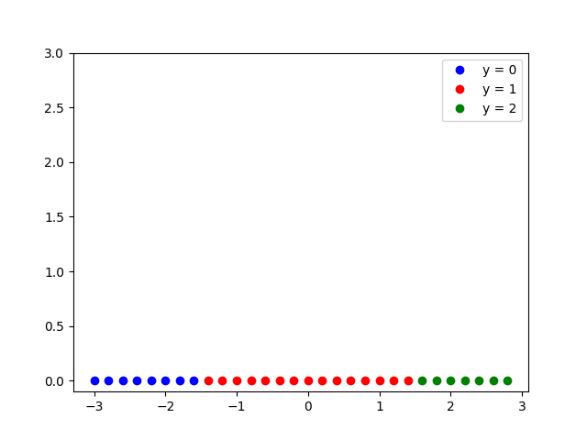

Model output at epoch 0

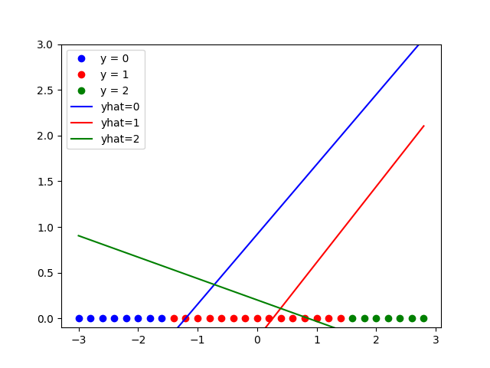

Model output at epoch 40

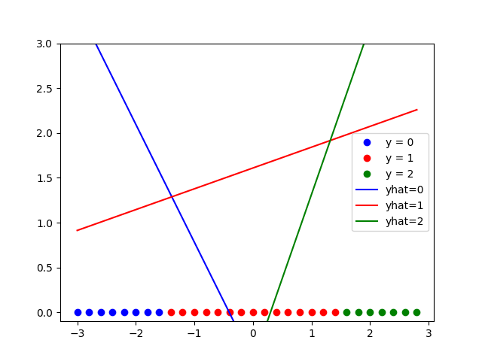

Model output at epoch 80

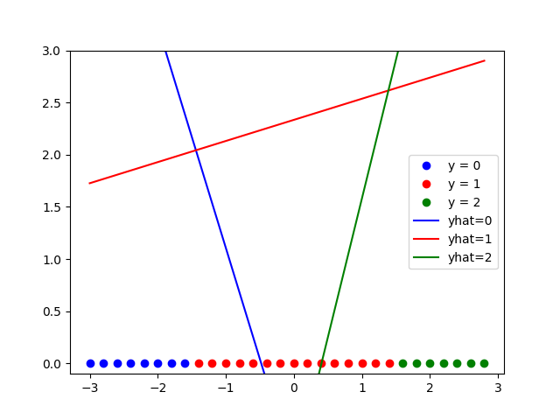

Model output at epoch 120

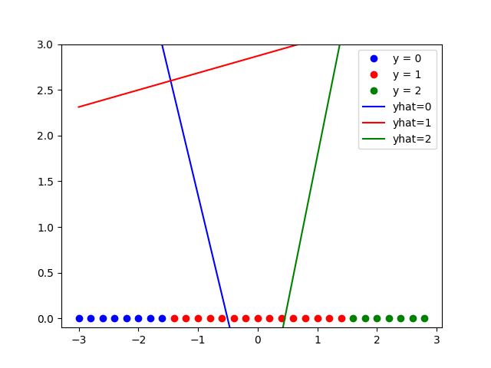

Model output at epoch 160

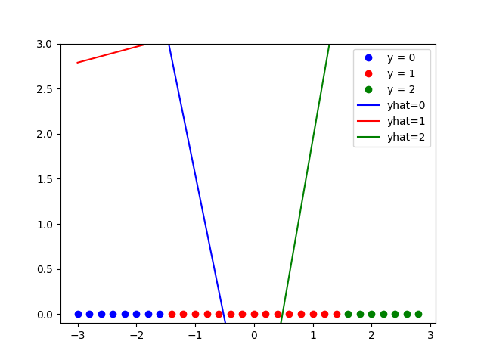

Loss curve:

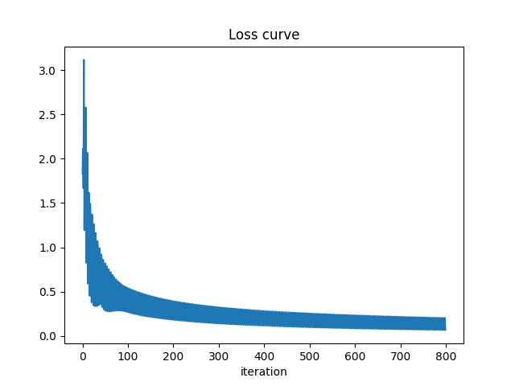

The prediction: [0 0 0 0 0 0 0 0 1 1 1 1 1 1 1 1 1 1 1 1 1 1 1 2 2 2 2 2 2 2]

The accuracy: 1.0

probability of class 0 for first sample: 0.9970580339431763

probability of class 1 for first sample: 0.00294197048060596

probability of class 2 for first sample: 4.829827510155482e-11