Softmax Classifier MNIST - rev.02

Device used: cpu

Initial model parameters:

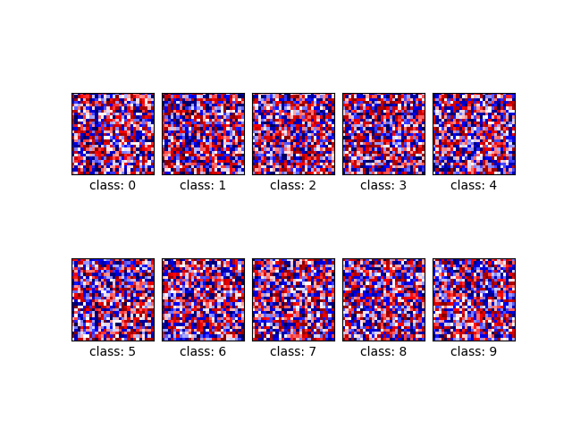

Loss and accuracy at epoch 1:

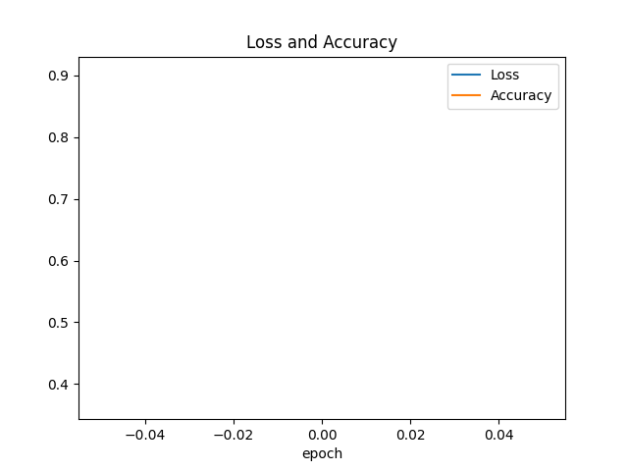

Loss and accuracy at epoch 2:

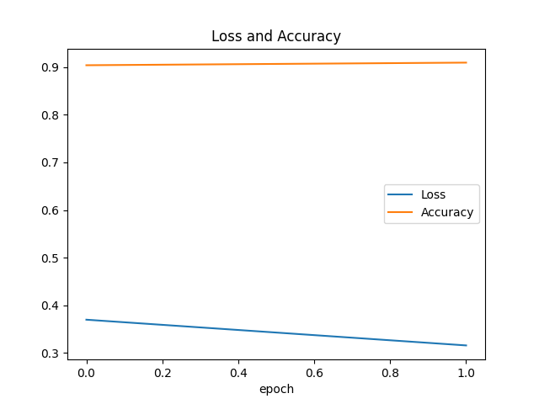

Loss and accuracy at epoch 3:

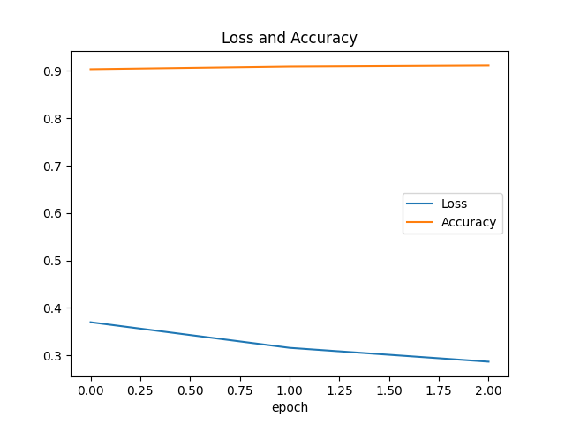

Loss and accuracy at epoch 4:

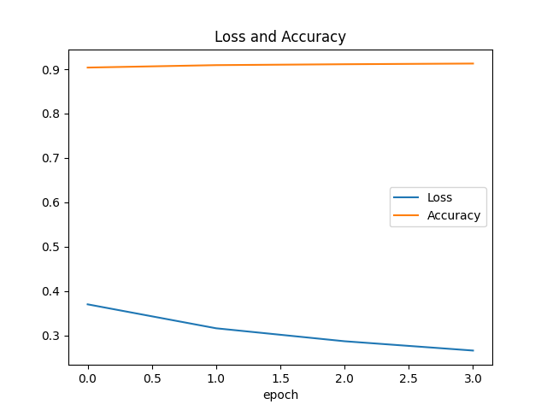

Loss and accuracy at epoch 5:

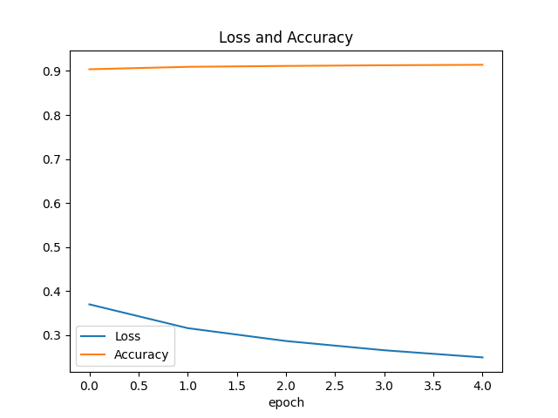

Final model parameters:

