Simple One Hidden Layer Neural Network - GPU Version

Device used: gpu

# Training with Cross Entropy Loss

Model output at epoch 0

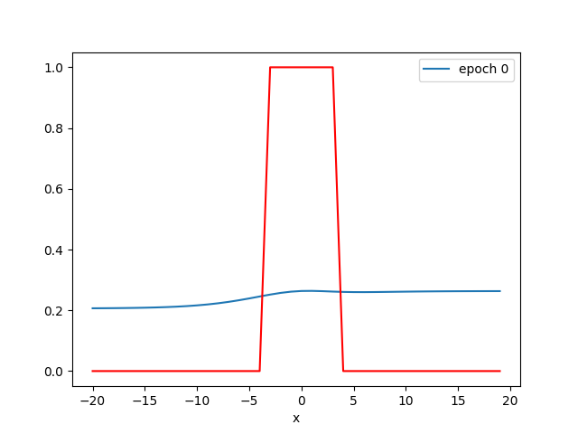

Activations at epoch 0

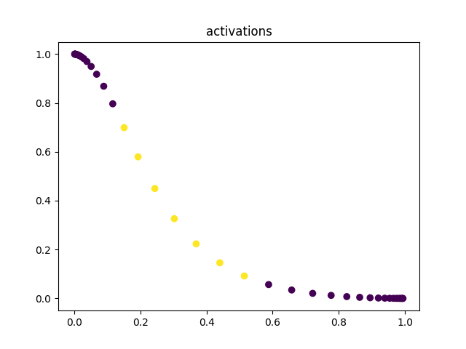

Model output at epoch 300

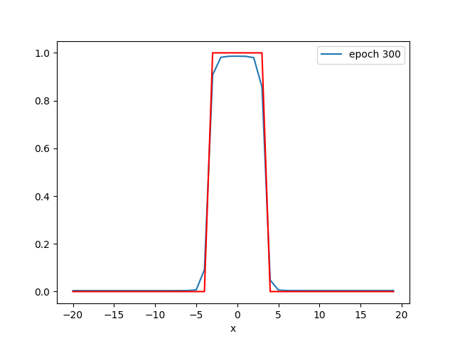

Activations at epoch 300

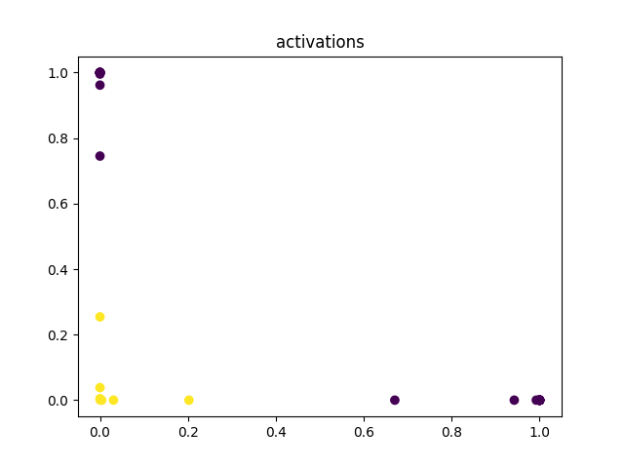

Model output at epoch 600

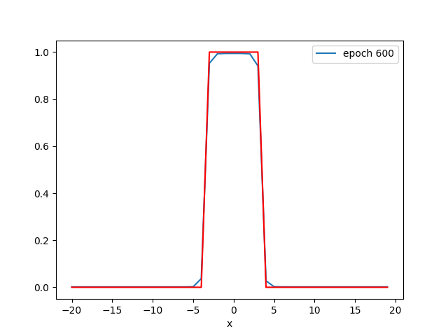

Activations at epoch 600

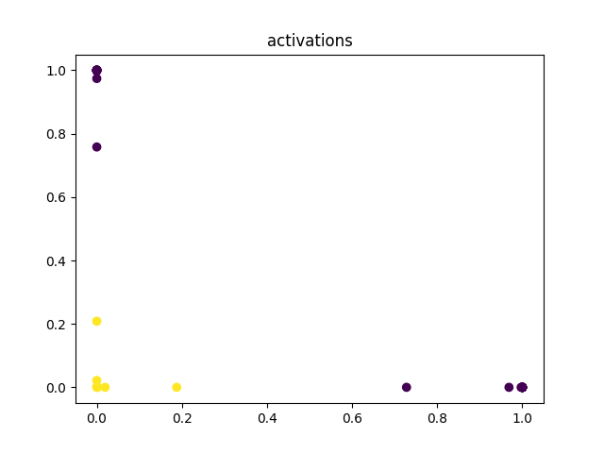

Model output at epoch 900

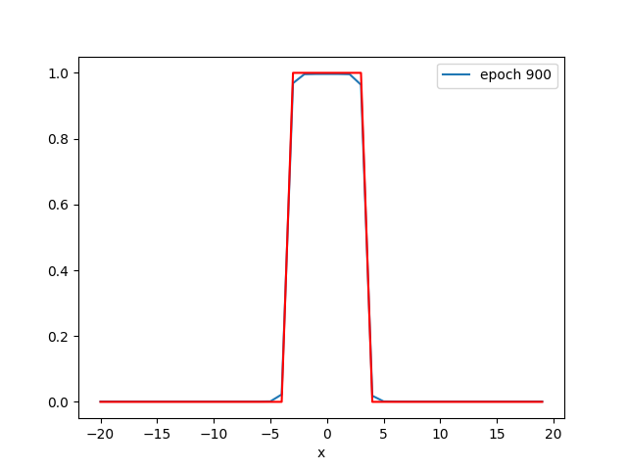

Activations at epoch 900

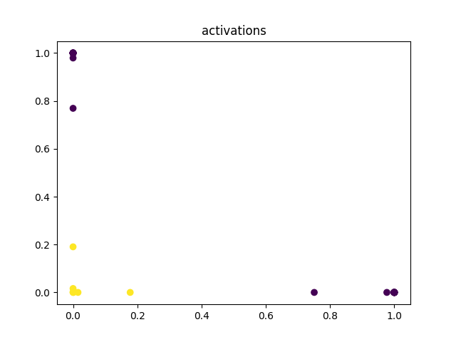

Loss curve:

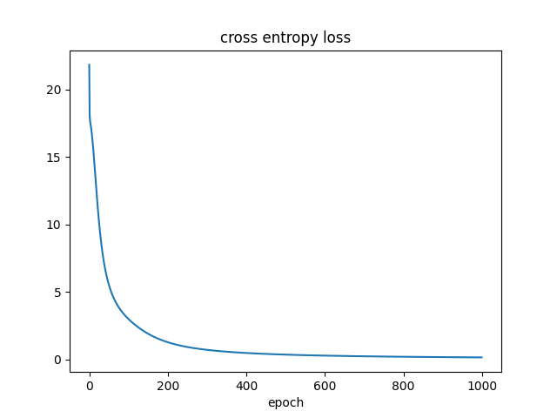

Prediction for x=0.0: [0.99694246]

Predictions for X_: [[0.99694246]  
 [0.99629384]  
 [0.96796924]]

Thresholded predictions: [[ True]  
 [ True]  
 [ True]]