Simple One Hidden Layer Neural Network - GPU Version (Different Params)

Device used: cpu

# Training with Cross Entropy Loss (Different Params)

Model output at epoch 0

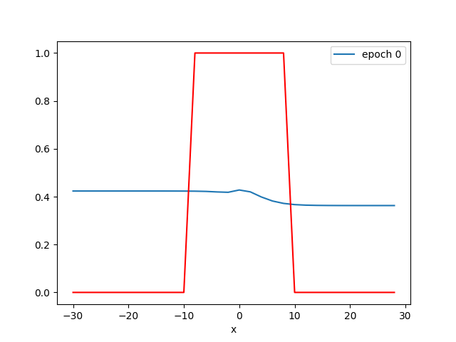

Activations at epoch 0

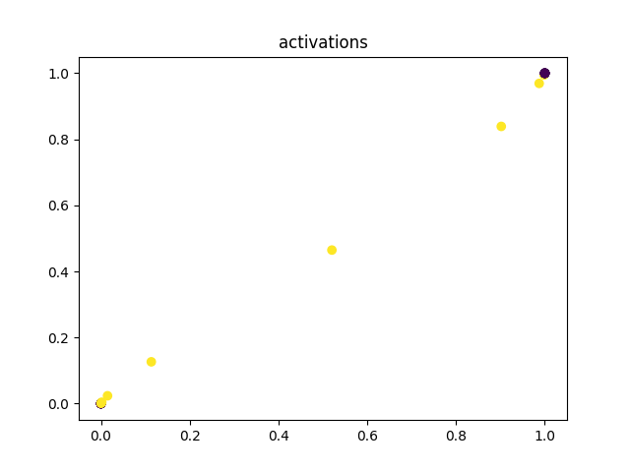

Model output at epoch 200

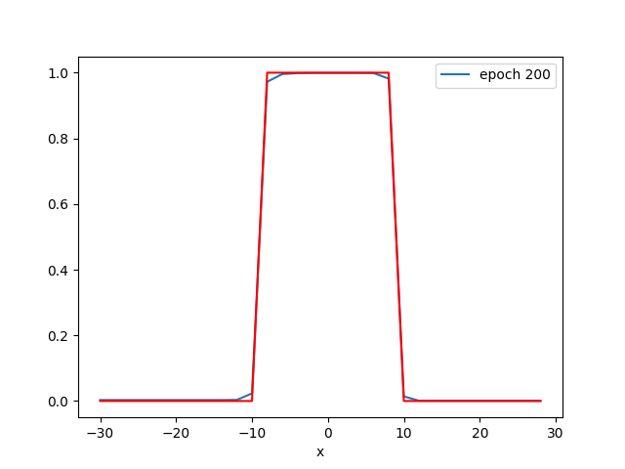

Activations at epoch 200

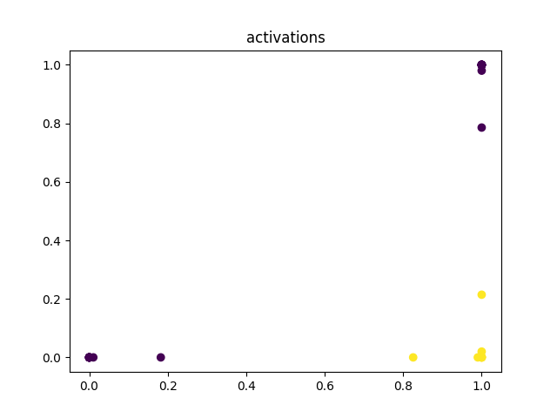

Model output at epoch 400

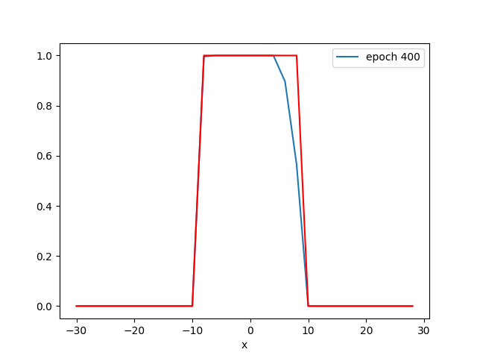

Activations at epoch 400

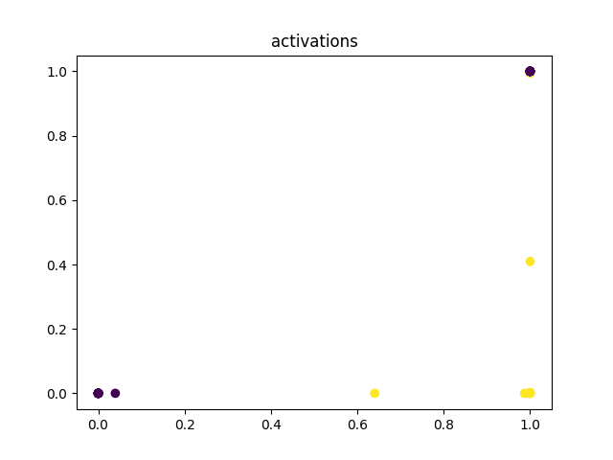

Model output at epoch 600

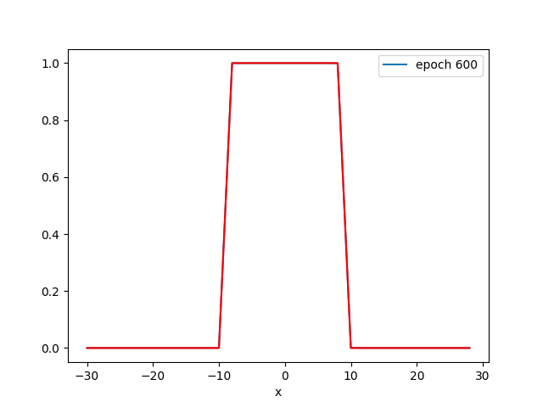

Activations at epoch 600

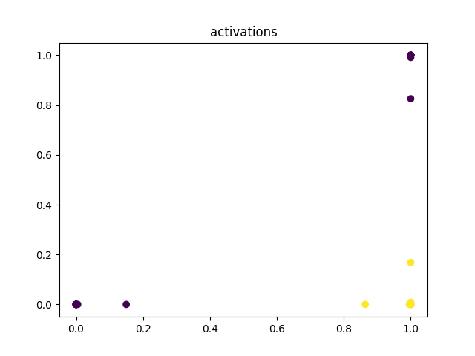

Loss curve:

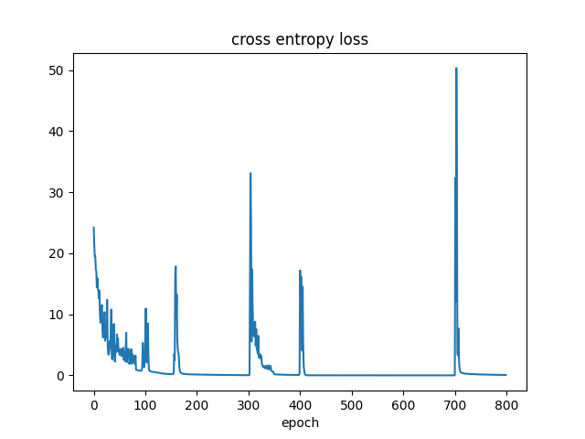

Prediction for x=5.0: [0.9999883]

Predictions for X_: [[9.999883e-01]  
 [8.031130e-04]  
 [5.081289e-04]]

Thresholded predictions: [[ True]  
 [False]  
 [False]]