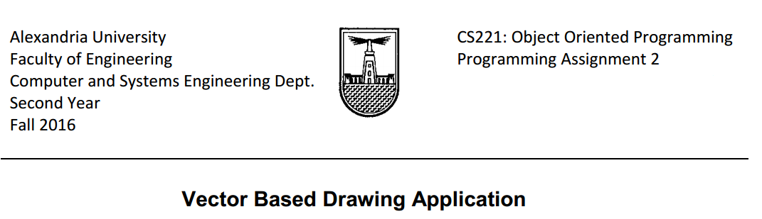

**Team:**

**Name: Omar Ahmed Fouad Hassan Wasfy.**

**Id: 42**

**Name: Shaban Sheta.**

**Id: 38**

**Description of the design:**

We have an abstract class “AllShapes” which is the super class for other shapes

As Uml class diagram shows that square class inherit from Rectangle class and circle class inherit from elipse class

On the other hand, we have a 2 classes for the paint application one for the static buttons and interfaces and the other one as a panel for drawing and detecting any mouse event which may occur by the user we have a 2 classes for saving and loading in json format and another 2 classes for xml format.

We have a class for the undo and redo task.

We Have used MVC design Pattern

**User Guide:**

The interface of the paint Application

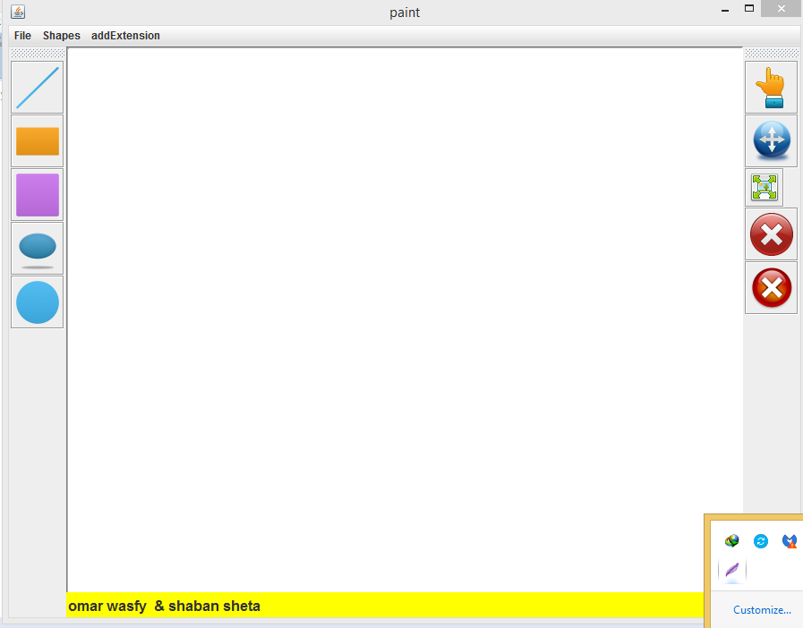

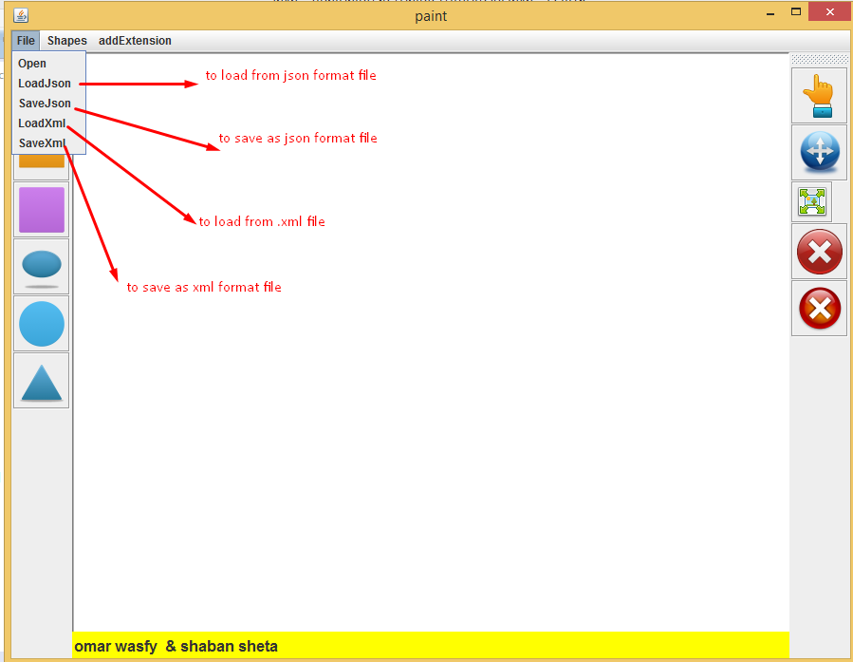

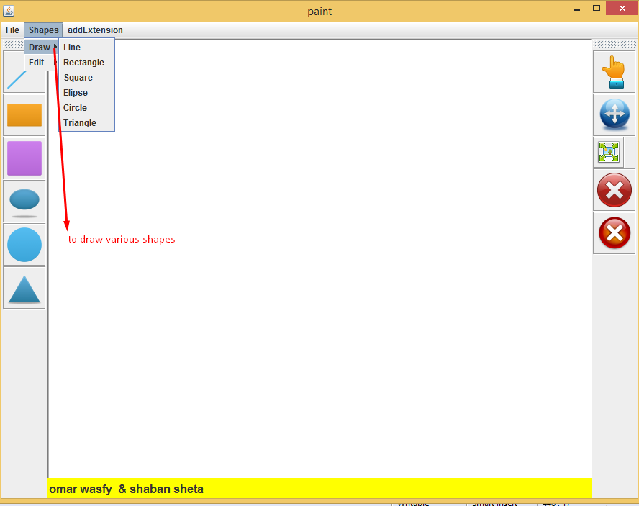

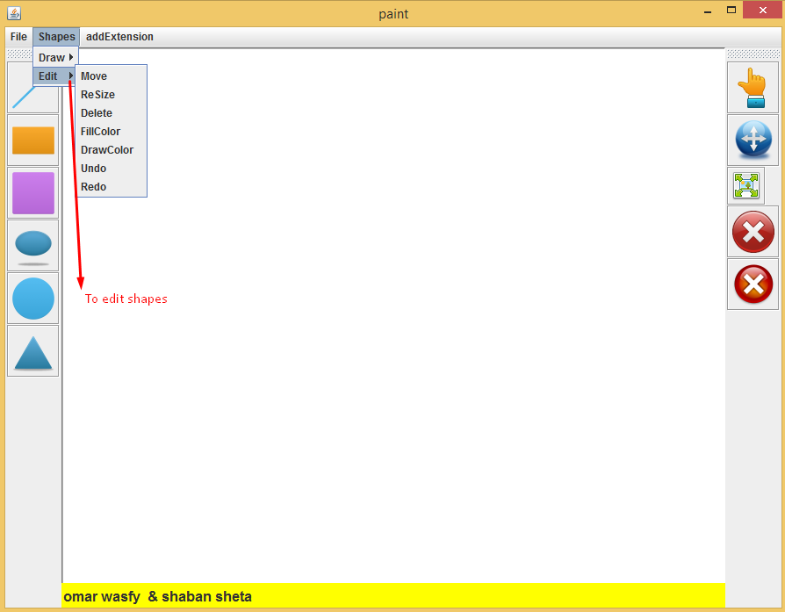

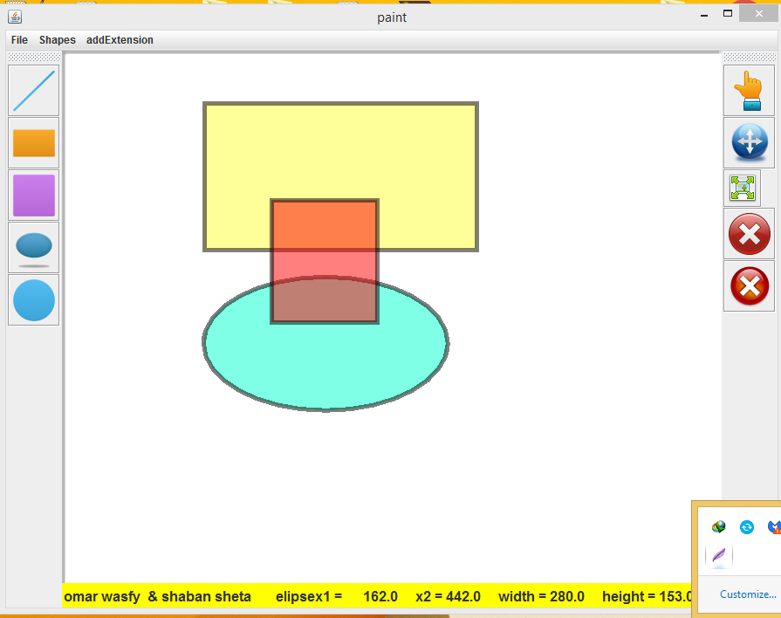

When you select the shape it will have a dotted selection rectangle and you can move it

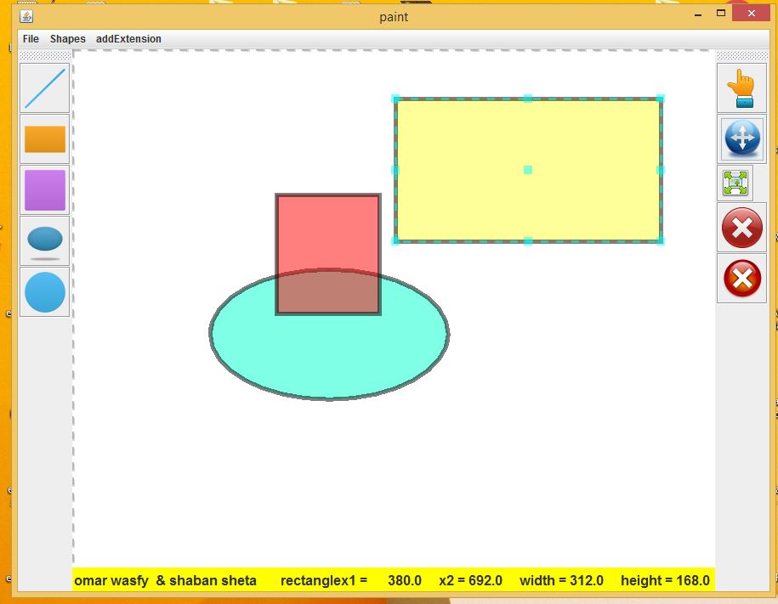

When you select the shape it will have a dotted selection rectangle and you can resize it.

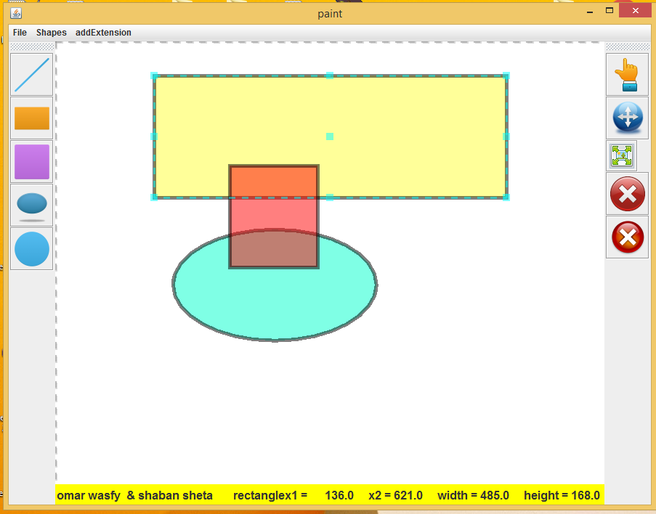

You can select many shapes with click in point which shape you want to select it contain this point.

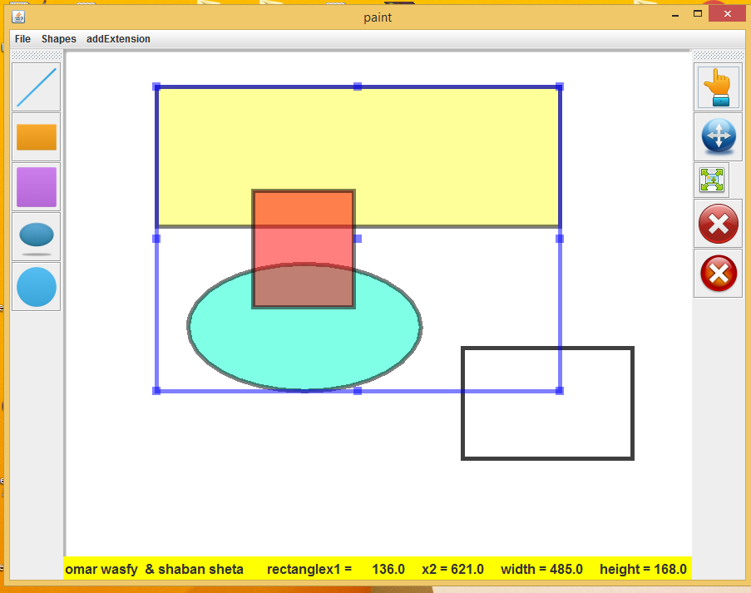

You can add extension shape by choose the folder which contain the binary class of the shape

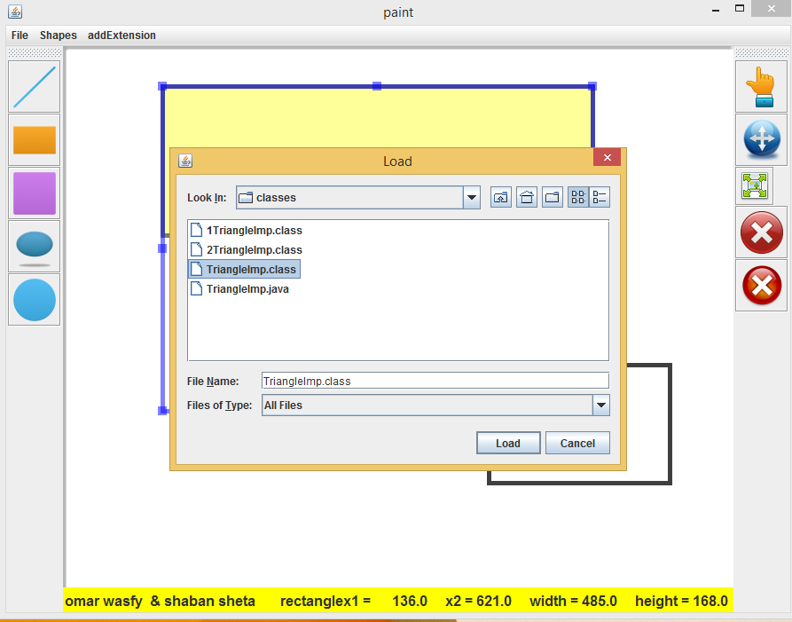

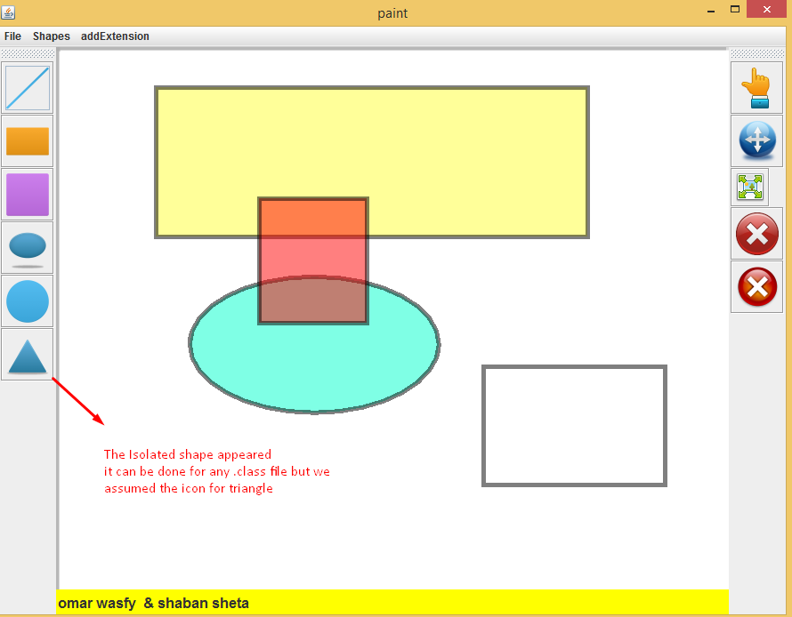

**UML Class Digram:**

