AICFD
AI-ASSISTED CFD FOR DATA CENTRE COOLING
TECHNICAL REPORT · STEADY-STATE ANALYSIS
CFD Analysis of the hall-double-gallery Data Hall
Ascenty
AICFD
September 2026
Case hall-double-gallery · solved to iteration 1700 · 275,400 cells · all checks passed

Contents

1 Summary
Scope, objectives, basis of design and headline results
2 Methodology
Geometry, mesh, models and boundary conditions
3 Results
Verification, temperature and airflow fields, unit by unit
4 Conclusions
Findings and what they do and do not support
5 Limitations
What this model cannot be asked

1 Summary

Overview
- This report presents the modelling approach and the results of a steady-state CFD simulation of the hall-double-gallery data hall under the IT load described in its case specification.
- The simulation resolves the temperature and airflow fields through the room, to identify where the air entering the IT equipment is warmest and to establish whether the cooling plant removes the heat the equipment releases.
- The hall carries 440 rack positions in 20 row segments and 14 fan wall units, against an installed IT load of 5,100 kW.
Objectives
- Establish the temperature of the air entering each rack, and check it against the ASHRAE class A1 recommended range of 18 °C to 27 °C.
- Confirm that the air loop closes: that the fan walls move the mass they are given, that nothing leaks through a wall or reverses through an intake, and that the return air carries the installed load.
- Quantify the resistance the room presents to the units, against the external static pressure their datasheet offers.
- Size the plant against the design office's rules — installed capacity in kilowatts and installed airflow at the design CFM/kW — before any CFD result is quoted.
Basis of design — fan wall selection point
Quantity | Value
Units installed | 14
Airflow per unit | 104,181 m³/h
Total airflow to the room | 1,458,533 m³/h
Supply air temperature | 21.9 °C
Net sensible capacity per unit | 432.6 kW
Electrical input per unit | 21.4 kW
External static pressure | 131 Pa
Site elevation | 750 m
Operating pressure | 92.6 kPa
Supply air density | 1.094 kg/m³
The solve runs at the site's operating pressure, so the airflow and the mass flow agree with the unit's selection at that elevation.
Results summary
Quantity | Value | Against what
Warmest rack intake (top of rack) | 22.43 °C | rack F5B2-04, against the 27 °C ASHRAE recommended limit
Mixed return air temperature | 33.35 °C | 11.45 K above the supply
Energy closure | 100.0 % | heat carried out by the return air, against the installed load
Rise across the most loaded unit | 56.1 Pa | of 131 Pa available
Plant against the design rules | 119 % capacity · 106 % airflow | installed against the load in kW and against the racks' demand at 158 CFM/kW

All physical checks pass. The numbers below may be quoted.

2 Methodology

Geometry
The room is derived from the case specification, not drawn: every dimension below follows from the equipment sizes, the aisle widths and the clearances the engineer typed. The arrangement is a mechanical gallery at each end of the hall, 14 units shared between them, with hot-aisle containment and a ceiling-plenum return.
The false ceiling covers the whole hall and stops at each dividing wall, so the return plenum above it is one continuous volume: it collects from every hot aisle and opens into both galleries. Two supplies, one return — which is what allows a block whose own gallery is short of capacity to be drawn on by the other.
Feature | As built in the model
Hall, internal | 33.0 × 32.4 m
Floor to slab | 7.5 m
False ceiling | 5.5 m
Mechanical galleries | 2 × 9.0 m deep
Rack rows | 20 row segments — 10 rows in 2 blocks
Rack positions | 440
Contained hot aisles | 5 in plan, 10 separate containment volumes
Cold aisles | 6
Fan wall units | 14

Computational mesh
A single structured hexahedral block of 275,400 cells, 0.60 × 0.30 × 0.25 m, with every internal surface cut into it afterwards as a two-sided baffle: the containment panels, the false ceiling, the row ends and tops, the return grilles and the fan walls. The room's air loop closes inside the box, so none of those surfaces is a domain boundary.
The cell sizes differ by axis on purpose. In plan the cell is one rack wide, which is the resolution a conceptual study needs and no more. In the vertical it is fine enough that the false ceiling, the fan wall top and the rack tops land on cell faces — a plane that falls mid-cell produces a ragged surface that leaks silently.
What this resolution supports: the ranking of racks, the aisle-to-aisle temperatures and the hall-scale pressure field. What it does not: signing off ASHRAE compliance rack by rack, since a single rack's intake carries 1 to 2 K of uncertainty at this cell size.
Dimensions that did not land on the mesh and were snapped:
- fan wall width: 3.960 m is not on the 0.30 m grid; the mesh will use 3.90 m (-60 mm).
- rack height: 2.200 m is not on the 0.25 m grid; the mesh will use 2.25 m (+50 mm).
- fan wall edge: 3.670 m is not on the 0.25 m grid; the mesh will use 3.75 m (+80 mm).
- rack top position: 2.200 m is not on the 0.25 m grid; the mesh will use 2.25 m (+50 mm).
- row end edge: 2.200 m is not on the 0.25 m grid; the mesh will use 2.25 m (+50 mm).
Boundary conditions and models
Feature | How it is modelled
Fan wall | A pair of patches on the same internal faces: air leaves the gallery through the intake and re-enters the cold aisle through the supply. Both are set by MASS flow, not volume — the air leaving is warmer and thinner than the air arriving, and in a closed loop a 1 % mismatch has nowhere to go.
Rack | Darcy–Forchheimer porous block with a volumetric enthalpy source. The rack has no fan: what passes through it is an outcome of the room's pressure field, so the temperature rise across a rack is a result and not an input.
Return grille | Cyclic pair carrying the datasheet's loss coefficient as a pressure jump, then checked against the field.
Containment, false ceiling, row ends | Two-sided adiabatic wall baffles. A row not closed on five sides leaks most of its air sideways.
Building envelope | No-slip, adiabatic. Conservative for sizing the plant: no heat is assumed to leave through it.
Turbulence | Steady RANS, k-epsilon, with buoyancy (buoyantSimpleFoam, OpenFOAM v1912).

How the airflow per unit is obtained
Step | Value
1 — the unit's airflow, from the datasheet | 104,181 m³/h
2 — units installed | 14
3 — total delivered to the room | 1,458,533 m³/h
4 — at the supply density | 1.094 kg/m³
5 — mass flow imposed at each unit | 31.65 kg/s
Every unit is given the same duty. A unit that is really on a pressure boundary would draw more or less than this and is not modelled here; see section 5.

3 Results

3.1 Verification — the checks the field has to pass
A steady solver's residuals say how much the last iteration moved, not whether the answer means anything. Every run is therefore judged against identities the physics has to satisfy. All of them have to pass before a temperature is quoted.
Check | Result | What it would have caught
mass_balance | PASS — fan supplies 443.12804 kg/s and draws 443.12799 kg/s (0.000% apart) | the fan walls supplying and drawing different masses
sealed_envelope | PASS — every wall and baffle carries zero flow | any wall or baffle passing air
no_backflow | PASS — 0.00000 kg/s reverses through the fan intakes (14 units), 0.0% of the 443.128 kg/s they move | air reversing through a fan intake
energy_closure | PASS — the return air carries 5099.62 kW of the 5099.60 kW installed (100%) | the return air not carrying the installed load
return_path | PASS — nothing heats or cools the air between the rack outlet and the fan intake, so these have to agree: hot_aisle 33.5, plenum 33.2, fan_back 33.3 degC (0.29 K apart) | a volume still filling — the plenum, usually
rack_resistance | PASS — the field drops 29.4 Pa across the rows where the rack curve at 1,458,534 m3/h asks for 28.4 Pa (104%) (rows 29.2 to 30.0 Pa) | the porous zones not delivering the pressure drop given
grille_resistance | PASS — the field drops 8.99 Pa across the return grilles where their K at 1,458,534 m3/h asks for 8.59 Pa (105%) | the same, for the ceiling grilles
fan_capacity | PASS — the most loaded unit (fan5) costs 56.1 Pa, the least 52.8 Pa, and the fan wall's datasheet offers 131 Pa at 104,181 m3/h per unit (43%); uncontrolled at full speed it would run at 128,854 m3/h and 85.9 Pa | the room costing more than the unit's datasheet offers
settled | PASS — the places moved at most 0.00 K since the previous sample (settled below 0.25 K) | a field still moving between samples
ashrae_inlet | PASS — warmest rack inlet 22.4 degC at the top of F5B2-04 -- within ASHRAE recommended (18.0-27.0 degC) | a rack breathing air above the recommended band
plausible_velocity | PASS — peak 5.47 m/s against a plausible 11.99 m/s (peak air 38.4 degC) | a velocity field no fan or buoyancy could produce

3.2 Convergence
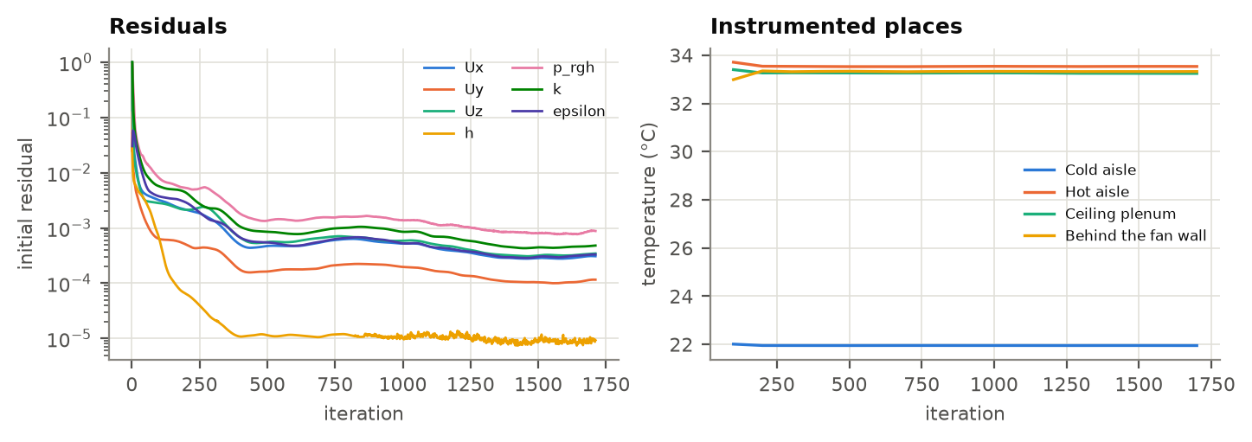
Left: initial residuals per iteration. Right: the instrumented places — cold aisle, hot aisle, ceiling plenum and behind the fan walls — recorded while the field settled.
3.3 Temperature field
All maps share one fixed colour band, 10 °C to 40 °C in 2,5 K contours, with the ASHRAE limits marked on the bar. Fixed rather than fitted to each field: a scale stretched to a field's own extremes answers a different question in every picture.
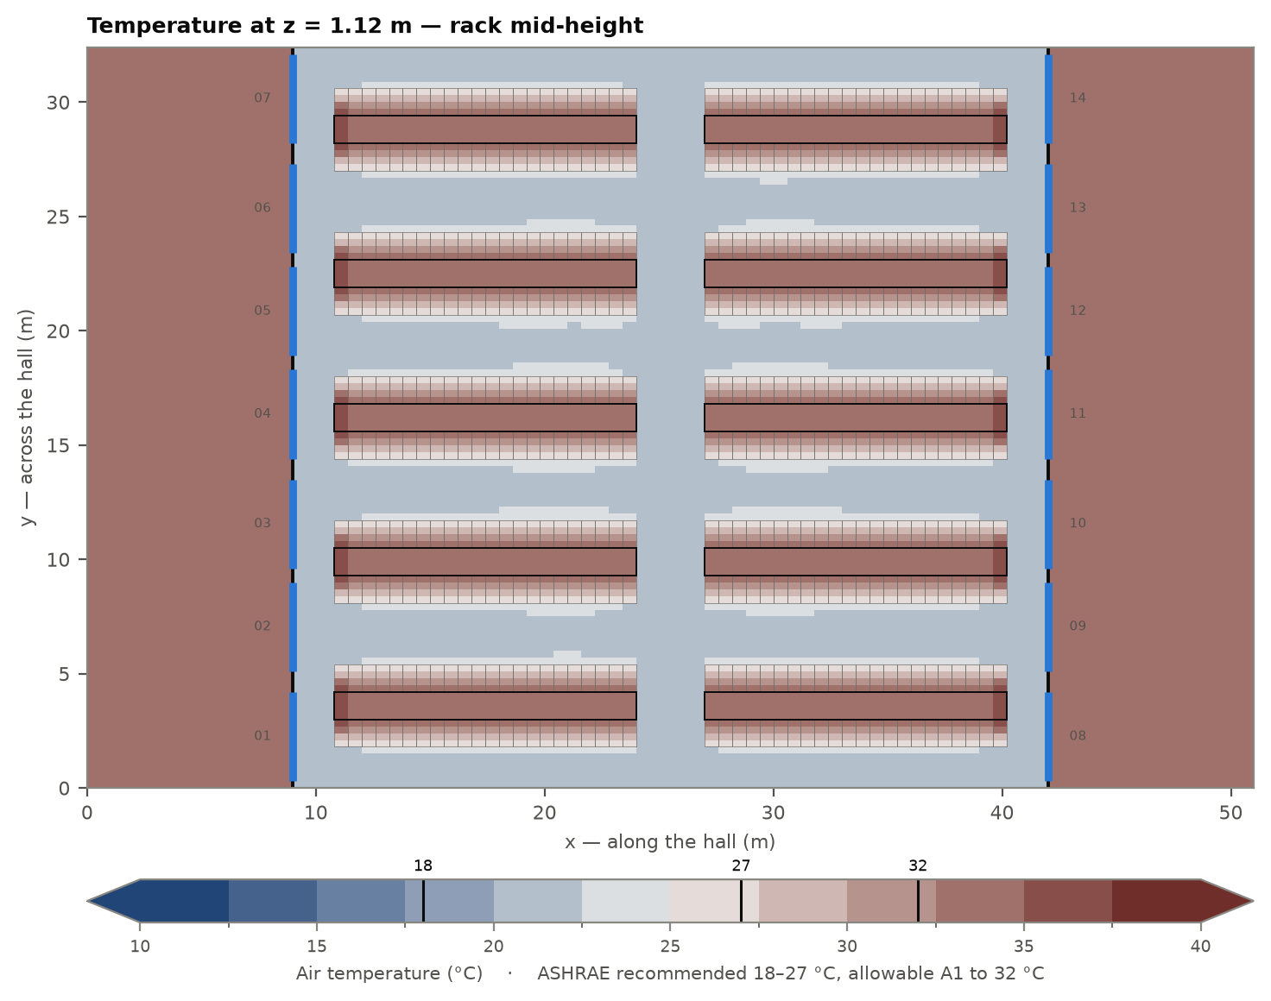
Plan at rack mid-height — the plane that governs the intake condition of the IT equipment. Each outlined rectangle is one rack; the heavy lines are the containment and the dividing walls; the blue bars in the dividing walls are the fan wall units.
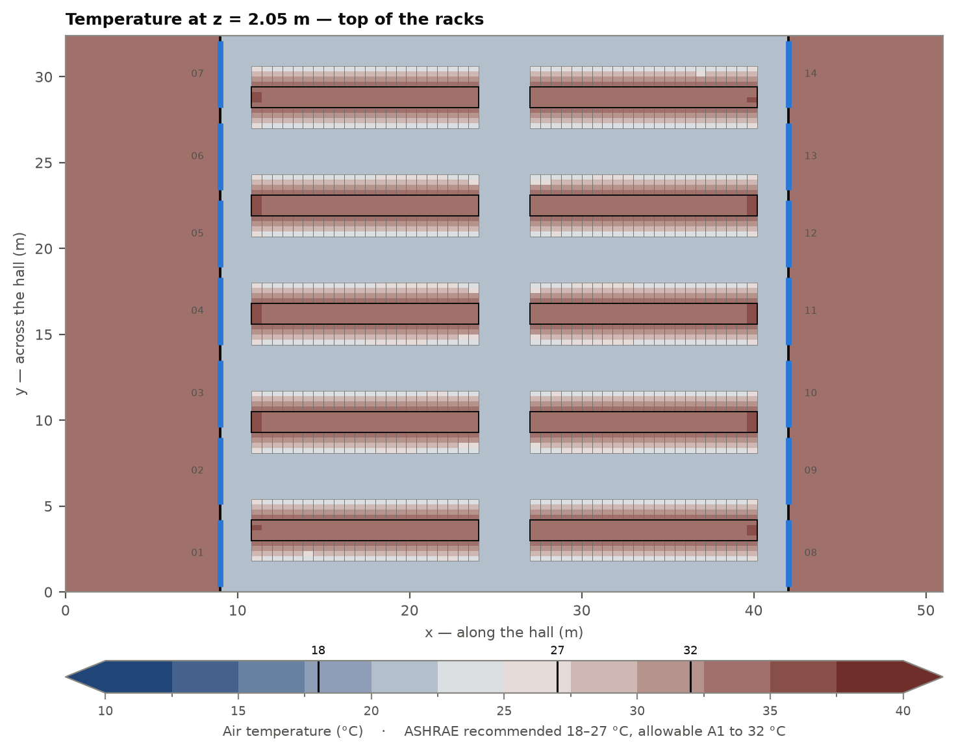
Plan just below the top of the racks, at the mouth of the contained hot aisles — where recirculating or leaking air arrives first.
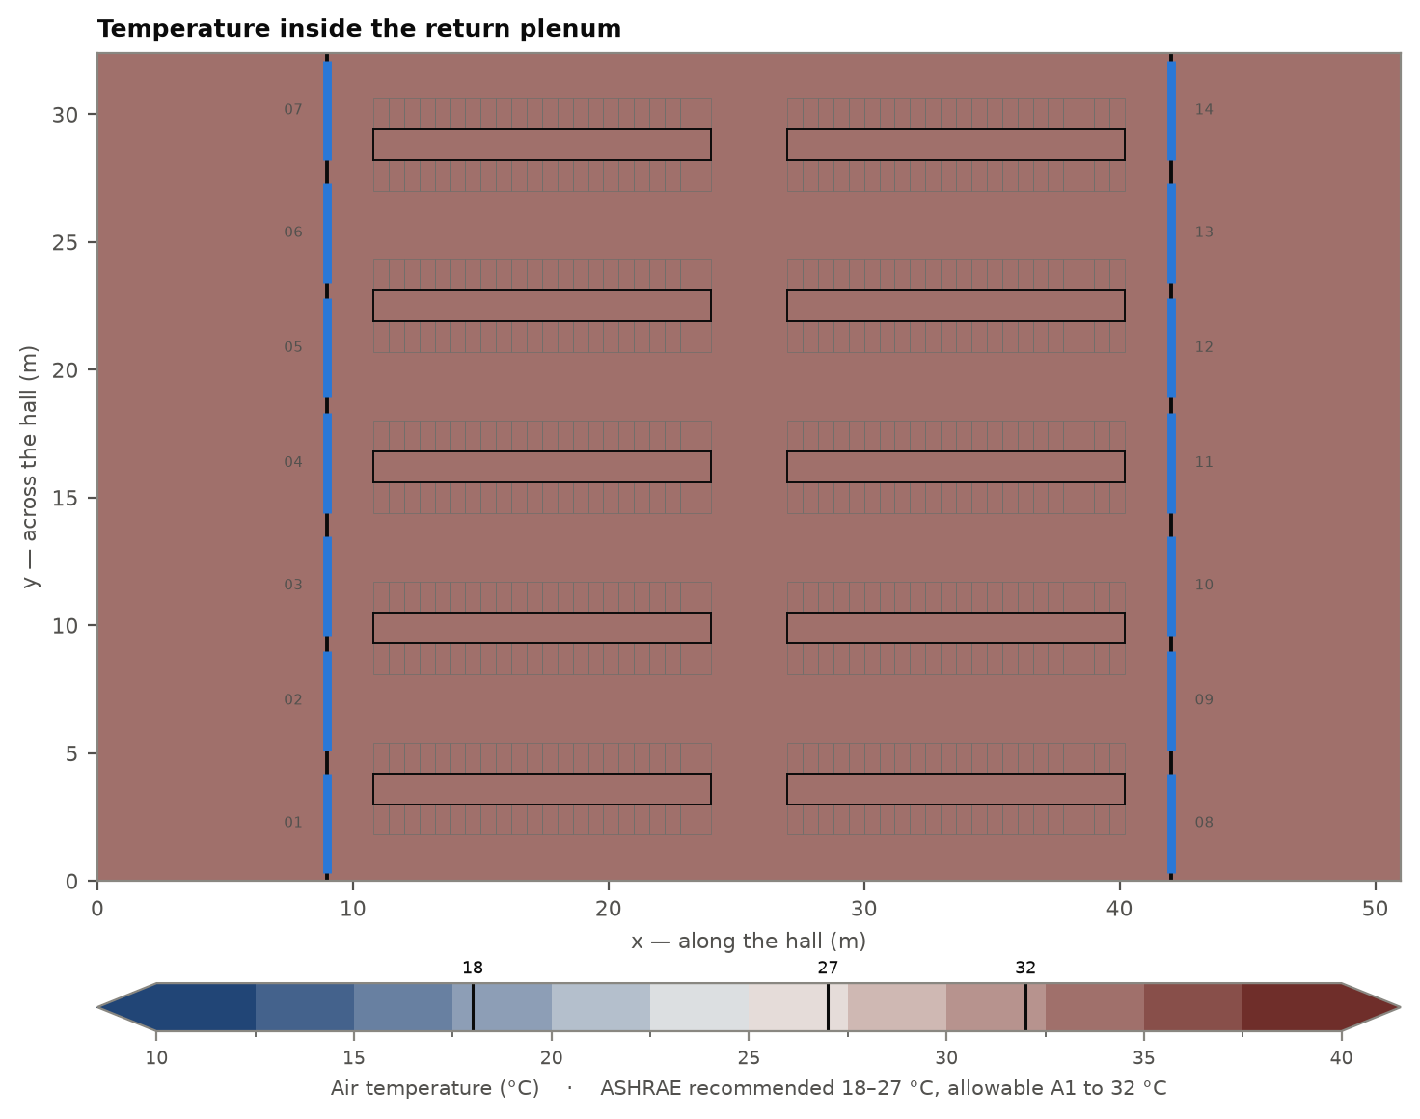
Plan inside the return plenum, above the false ceiling. One volume across the whole hall, feeding every gallery.
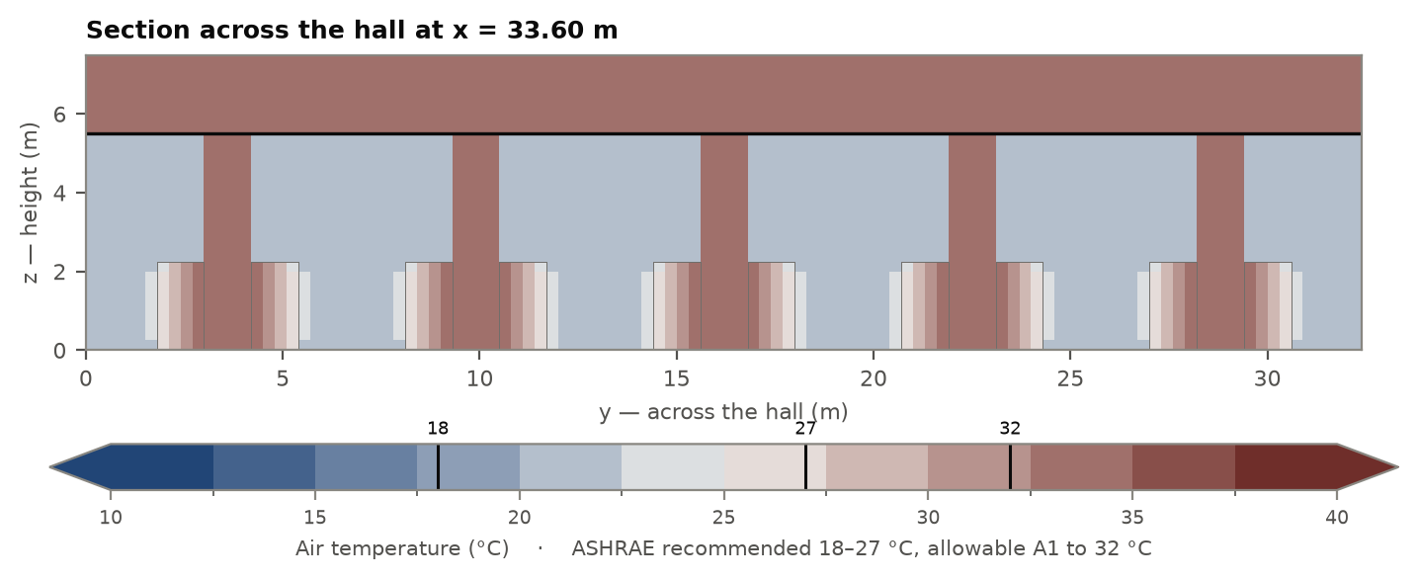
Section across the hall, through a rack block: cold aisle, rack row, contained hot aisle and the chimney up to the false ceiling.
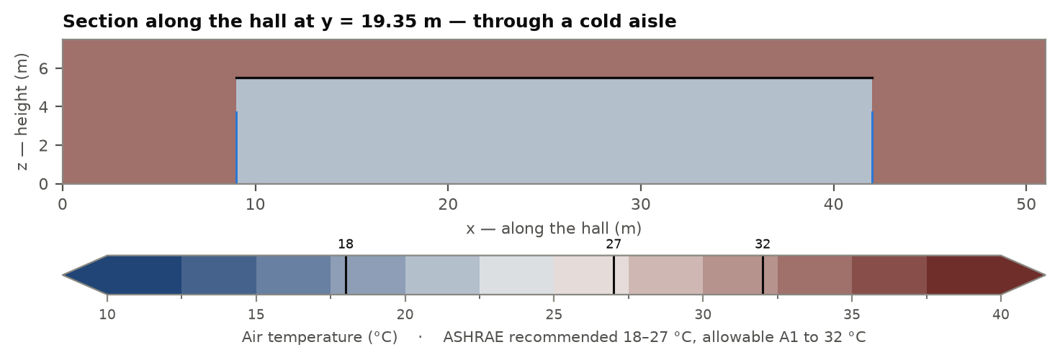
Section along the hall, through a cold aisle: the supply air leaving the units, the length it has to travel, and the mechanical gallery behind each dividing wall.
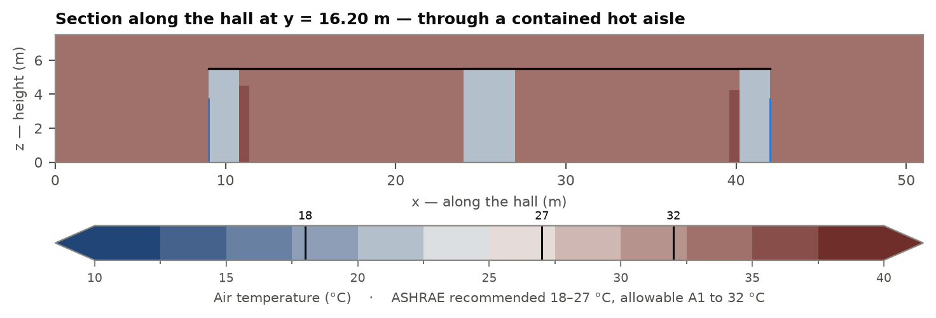
The same section through a contained hot aisle. The containment is doing its job when this plane is hot from floor to ceiling and the one above is not — the cold plane is where a containment leak shows first.
3.4 Rack intake temperature
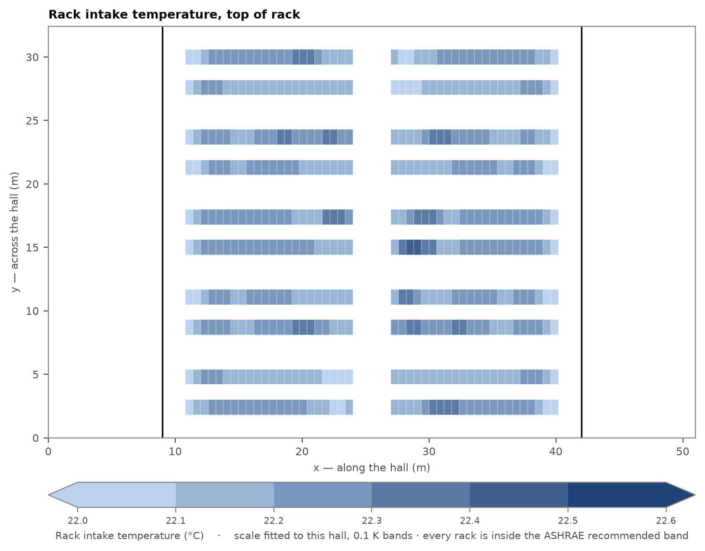
Every rack coloured by the temperature of the air it breathes, measured at the top of the rack. The scale here is FITTED to this hall, not the fixed band used for the field maps above: on the fixed band every rack in a healthy hall falls inside one 2,5 K step, which says they are all acceptable and nothing about which is worst. Read this figure for the ranking and the figure below for the absolute judgement.
Rack | Row | Intake, top of rack | Intake, face mean | Exhaust | Rise | ASHRAE
F5B2-04 | F5B2 | 22.43 °C | 23.18 °C | 33.73 °C | 10.55 K | within ASHRAE recommended (18.0-27.0 degC)
F5B2-03 | F5B2 | 22.41 °C | 23.01 °C | 33.67 °C | 10.66 K | within ASHRAE recommended (18.0-27.0 degC)
F5B2-05 | F5B2 | 22.40 °C | 23.21 °C | 33.73 °C | 10.52 K | within ASHRAE recommended (18.0-27.0 degC)
F6B1-20 | F6B1 | 22.38 °C | 23.06 °C | 33.70 °C | 10.64 K | within ASHRAE recommended (18.0-27.0 degC)
F3B1-15 | F3B1 | 22.37 °C | 23.11 °C | 33.61 °C | 10.50 K | within ASHRAE recommended (18.0-27.0 degC)
F3B1-16 | F3B1 | 22.37 °C | 23.15 °C | 33.64 °C | 10.49 K | within ASHRAE recommended (18.0-27.0 degC)
F6B1-21 | F6B1 | 22.36 °C | 22.86 °C | 33.64 °C | 10.78 K | within ASHRAE recommended (18.0-27.0 degC)
F6B2-05 | F6B2 | 22.36 °C | 23.17 °C | 33.75 °C | 10.58 K | within ASHRAE recommended (18.0-27.0 degC)
F6B2-04 | F6B2 | 22.35 °C | 23.14 °C | 33.72 °C | 10.58 K | within ASHRAE recommended (18.0-27.0 degC)
F3B1-17 | F3B1 | 22.34 °C | 23.16 °C | 33.65 °C | 10.49 K | within ASHRAE recommended (18.0-27.0 degC)
F1B2-07 | F1B2 | 22.33 °C | 22.88 °C | 33.57 °C | 10.69 K | within ASHRAE recommended (18.0-27.0 degC)
F3B2-03 | F3B2 | 22.33 °C | 23.01 °C | 33.66 °C | 10.65 K | within ASHRAE recommended (18.0-27.0 degC)
The twelve warmest of 440 rack positions, by the air arriving at the top of the rack. The complete table is exported as CSV from the results page.
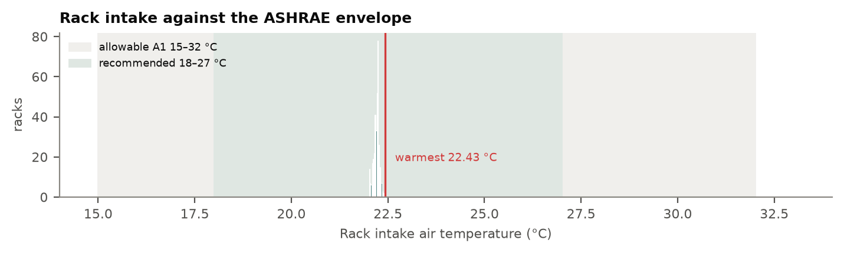
Distribution of rack intake temperature against the ASHRAE class A1 envelope.
3.5 Unit by unit
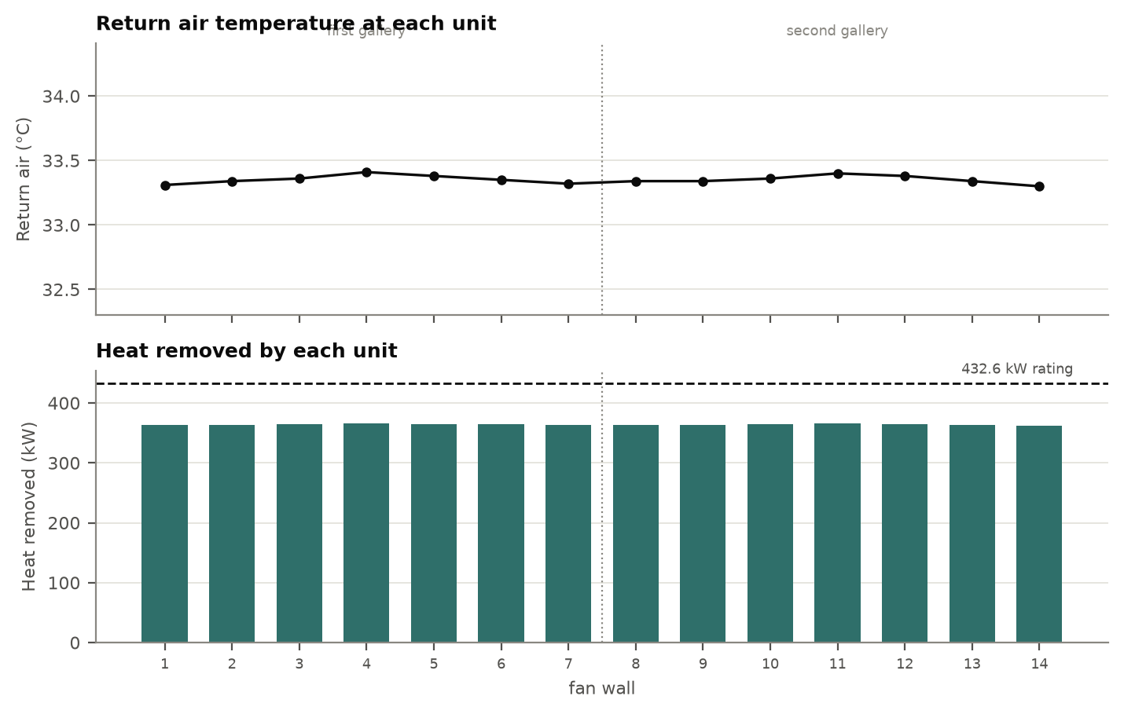
Return air temperature and heat removed, unit by unit. The units are numbered along the gallery wall, in gallery order.
Unit | Return air | Mass flow | Heat removed | Of the rating | Rise across the unit
1 | 33.31 °C | 31.7 kg/s | 363 kW | 84 % | 55.5 Pa
2 | 33.34 °C | 31.7 kg/s | 364 kW | 84 % | 53.3 Pa
3 | 33.36 °C | 31.7 kg/s | 365 kW | 84 % | 55.4 Pa
4 | 33.41 °C | 31.7 kg/s | 366 kW | 85 % | 53.1 Pa
5 | 33.38 °C | 31.7 kg/s | 365 kW | 84 % | 56.1 Pa
6 | 33.35 °C | 31.7 kg/s | 364 kW | 84 % | 53.0 Pa
7 | 33.32 °C | 31.7 kg/s | 363 kW | 84 % | 55.6 Pa
8 | 33.34 °C | 31.7 kg/s | 364 kW | 84 % | 54.7 Pa
9 | 33.34 °C | 31.7 kg/s | 364 kW | 84 % | 53.2 Pa
10 | 33.36 °C | 31.7 kg/s | 365 kW | 84 % | 53.3 Pa
11 | 33.40 °C | 31.7 kg/s | 366 kW | 85 % | 54.9 Pa
12 | 33.38 °C | 31.7 kg/s | 365 kW | 84 % | 54.6 Pa
13 | 33.34 °C | 31.7 kg/s | 364 kW | 84 % | 52.8 Pa
14 | 33.30 °C | 31.7 kg/s | 363 kW | 84 % | 55.5 Pa
Heat removed is the enthalpy the air carries out of each unit, mass flow × cp × (return − supply). 'Of the rating' compares it with the unit's CATALOGUE net sensible capacity at its selection point; the capacity a coil actually has at the return temperature it receives is lower, and AICFD does not yet compute it — see section 5.

4 Conclusions

- The air delivered to the IT equipment is within the ASHRAE class A1 recommended range. The warmest rack intake is 22.43 °C at rack F5B2-04, measured at the top of the rack, leaving 4.57 K of margin against the 27 °C recommended limit.
- The cooling plant is thermally uniform in this configuration: the return air temperature spans 0.11 K across the 14 units, from 33.30 °C to 33.41 °C.
- The plant removes 5,100 kW. No unit exceeds its catalogue rating of 432.6 kW; the most loaded is at 85 % of it.
- The room costs the most loaded unit 56.1 Pa of the 131 Pa its datasheet offers (43 %), and the least loaded 52.8 Pa.
- The energy balance closes at 100.0 %: the heat the return air carries out matches the load the racks put in. Every physical check passes, so the temperatures above may be quoted.
5 Limitations

These results are valid only for the boundary conditions listed in section 2. CFD gives an approximate solution to the equations of fluid motion, given the simplifications required to model a real room; the model, the mesh and the inputs all carry uncertainty.
- Steady state only. A unit failing, a door opening or a load step are transients and are outside this model.
- One operating scenario. A failure case — units out of service, the surviving units sharing the same total airflow — is not modelled, so this report cannot state how much reserve the plant has when a unit is lost.
- The unit's catalogue capacity, not the capacity it actually has. A chilled-water coil delivers its rating only at the return temperature it was selected for, and a real hall returns cooler air than that. Comparisons here are against the catalogue figure and are therefore optimistic.
- One load per rack. Unloaded positions and a real per-rack load map are not represented, and where the empty positions sit changes how evenly the units load.
- Heat released outside the racks — PDU and other ancillary losses, typically about 2 % of the IT load — is not included.
- Containment is modelled as perfect. Real containment leaks, and the leak is what decides the top-of-rack temperature in a marginal design.
- A conceptual-design mesh. One rack per cell in plan: trust the ranking of racks and the hall-scale fields, not a single rack's intake to better than 1 to 2 K.
- No comparison against measurement. Every validation in section 3.1 is an identity the physics must satisfy. That class of check catches wrong models; it cannot promise the built room behaves this way.
The case specification, the generated OpenFOAM case, the solver log and the exported result together reproduce this document exactly. Nothing in it was typed in by hand.

