**TEST#1**

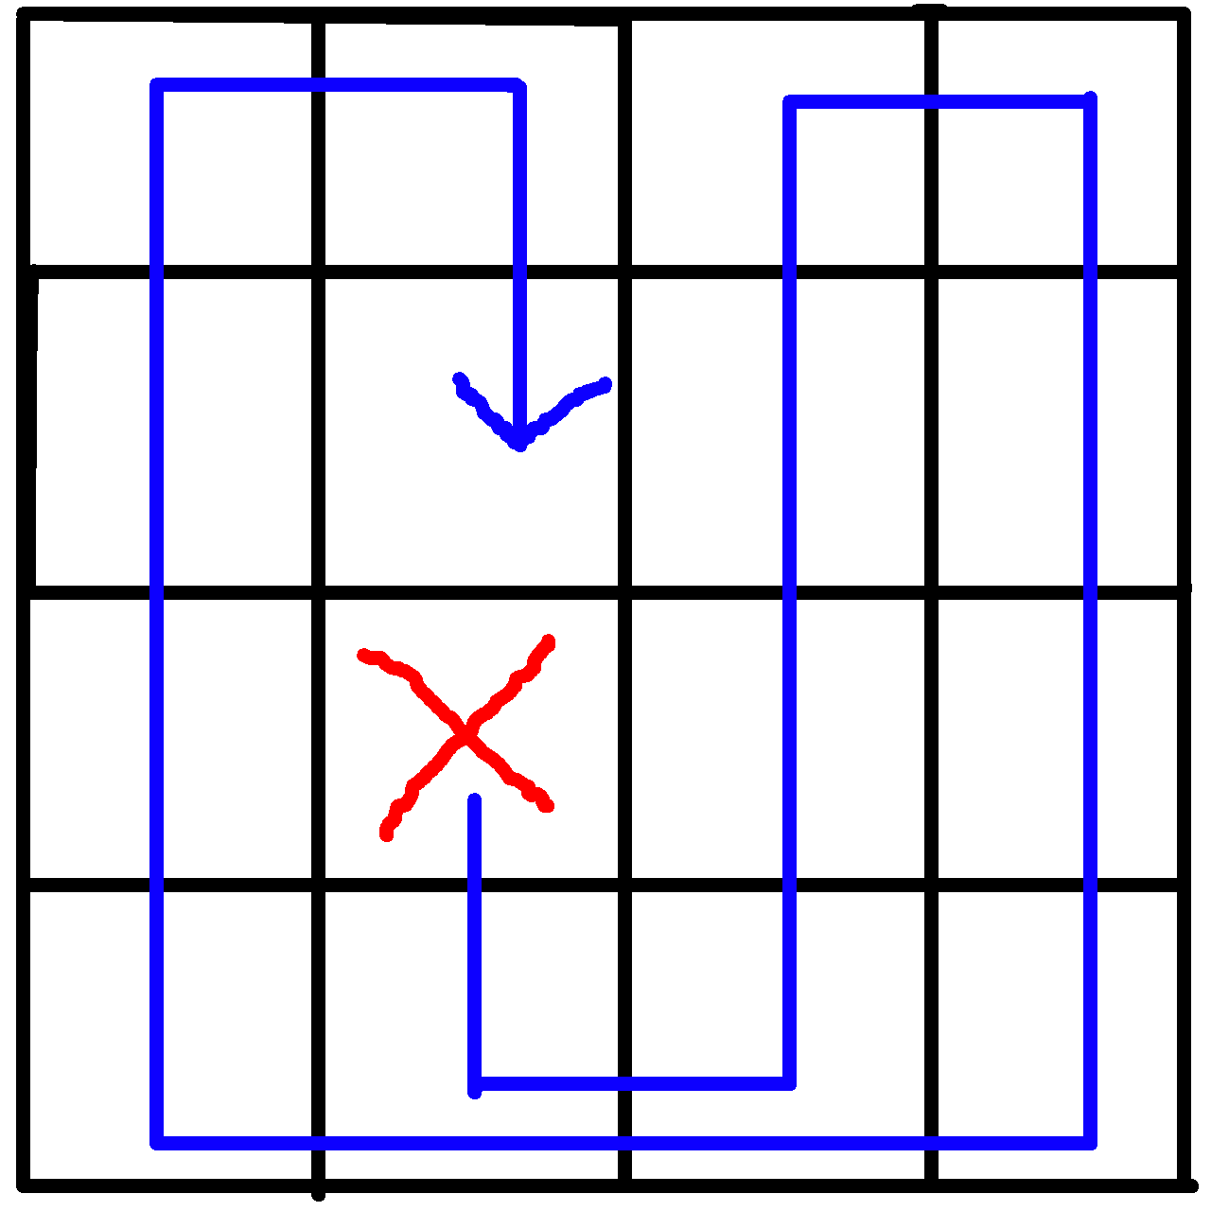**EnvMap = [[0,0,1,0],**

**[1,1,0,0],**

**[0,1,0,0],**

**[1,0,0,1]]**

**Percept = [2,1,1]**

**Elapsed time : 0.0028655012533489004 s**

**Total actions (include sucks): 24**

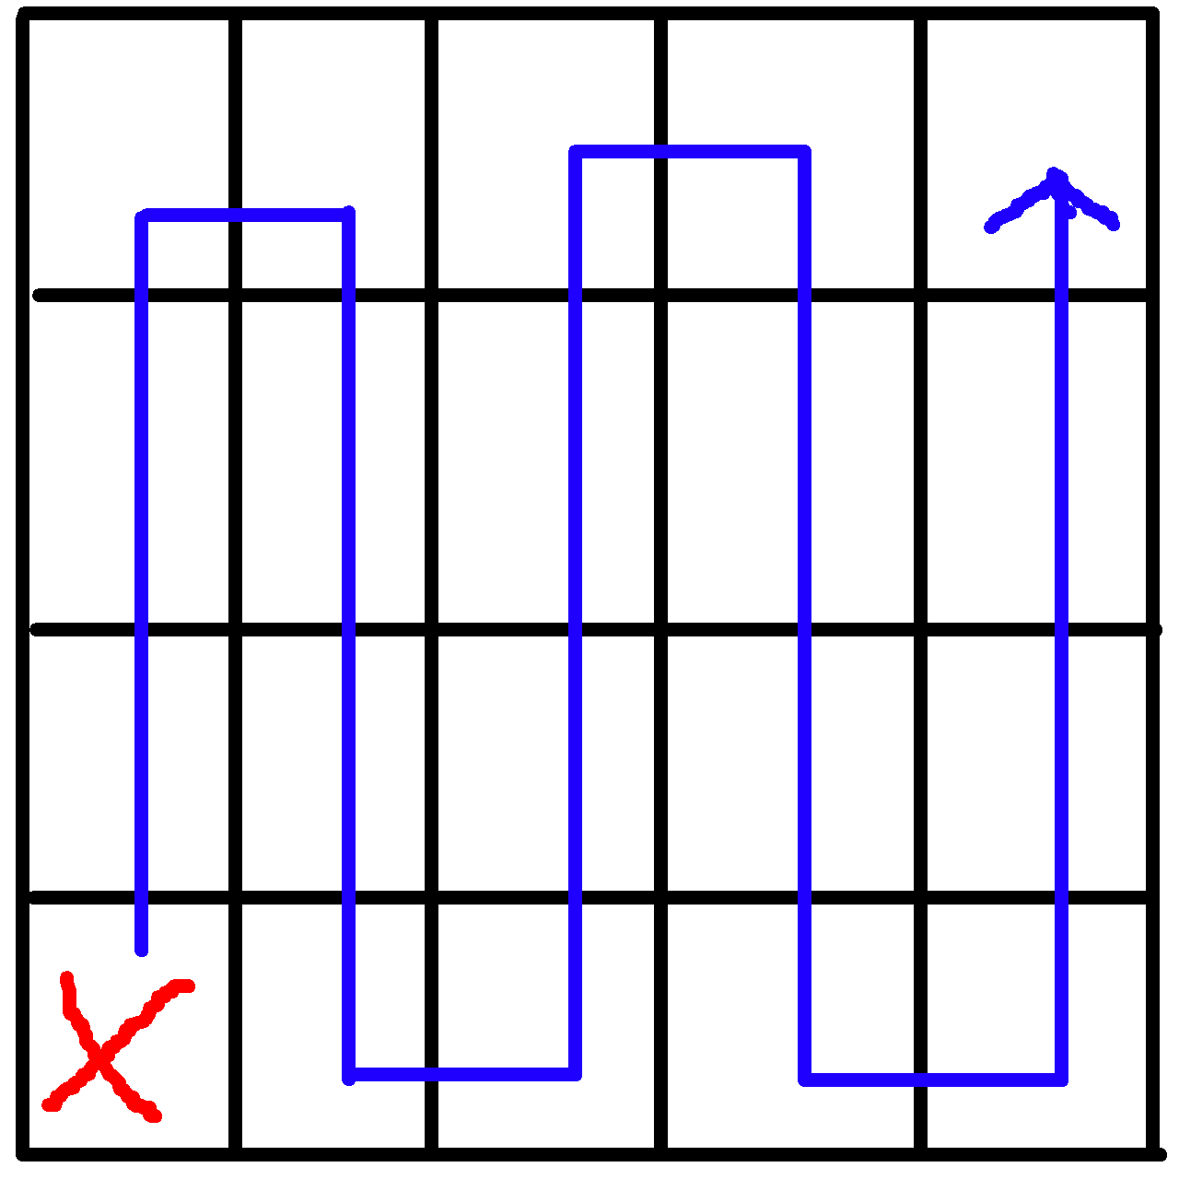

**TEST#2**

**EnvMap = [[0,0,1,0,0],**

**[1,1,0,0,1],**

**[0,1,0,0,1],**

**[1,0,0,1,0]]**

**Percept = [3,0,1]**

**Elapsed time : 0.003672193225101134 s**

**Total actions (include sucks) : 28**

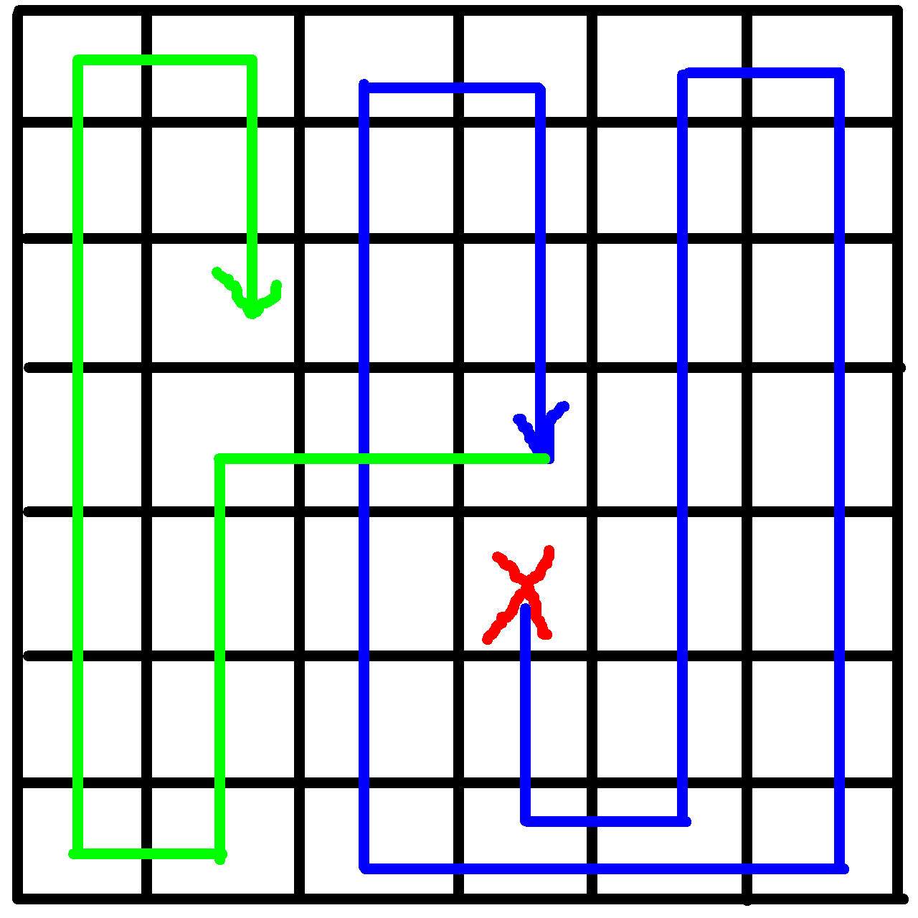**TEST#3**

**EnvMap = [[0,0,1,0,0,1],**

**[1,1,0,0,1,1],**

**[0,1,0,0,1,0],**

**[1,0,0,1,0,0],**

**[0,1,0,0,1,0],**

**[1,1,1,0,1,1],**

**[0,0,1,0,0,0]]**

**Percept = [4,3,0]**

**Elapsed time : 0.010458669044457964 s**

**Total actions (include sucks) : 63**