Firmware Flashing & Setup Guide
1st june 2026

Important safety note
Do not power the LED boards from the USB programming port. Use the correct external LED power supply for the PCB/LED assembly and keep the ESP32 ground and LED power ground common. Do not connect raw vehicle signals directly to ESP32 GPIO pins; use the PCB signal-conditioning circuit only.

1. Purpose and Scope
This document explains how to prepare a fresh computer and flash the Tail Light firmware onto the ESP32-S3 based PCB. It is intended for firmware re-installation, future maintenance, and basic verification after programming.

2. Firmware and Hardware Overview
The firmware controls a four-board automotive tail light assembly using an ESP32-S3 N16R8 controller. It drives four SK6812 RGBW LED PCBs, handles brake/turn/hazard priority states, and supports BLE-controlled show animations when vehicle signal inputs are idle.
Item | Project Value
Controller | ESP32-S3 N16R8
LED Type | SK6812 RGBW addressable LEDs
LED Boards | Four boards: L1, L2, R1, R2
LED Count | 78 RGBW LEDs per PCB
Firmware File | Tail_Light_Firmware.ino
Custom Flash Layout | partitions.csv for 16 MB flash
BLE Device Name | Tail Light
Serial Monitor Baud Rate | 115200

Operating priority
Vehicle lighting states override decorative BLE animations. The firmware priority order is: hazard + brake, hazard, turn + brake, turn, brake, BLE animation, then normal running light.

3. Required Software and Resources

Resource | Purpose | Link / Source
Arduino IDE 2.x | Compile and upload the sketch | https://www.arduino.cc/en/software
ESP32 Arduino Core | Adds ESP32-S3 board support to Arduino IDE | https://espressif.github.io/arduino-esp32/package_esp32_index.json
Adafruit NeoPixel Library | Required LED driver library for SK6812 RGBW LEDs | Install from Arduino Library Manager

4. Downloading and Preparing the Firmware Folder
Extract the shared Fimrware files in any storage partition for example D drive.
Place the extracted folder inside the Arduino sketchbook folder, for example:
D/Tail_Light_Firmware
Confirm that the folder contains Tail_Light_Firmware.ino and partitions.csv in the same top-level folder.
Open Tail_Light_Firmware.ino from Arduino IDE. Do not copy only the .ino file by itself; keep the complete project folder together.
Tail_Light_Firmware/
|-- Tail_Light_Firmware.ino
|-- partitions.csv
|-- Docs/

5. Installing Arduino IDE
Go to the official Arduino software download page: https://www.arduino.cc/en/software
Download Arduino IDE 2.x for the operating system being used: Windows, macOS, or Linux.
Install Arduino IDE using the default installer options.
Launch Arduino IDE once after installation so it creates the default sketchbook folder.

6. Installing ESP32-S3 Board Support
Open Arduino IDE.
Go to File > Preferences.
In Additional boards manager URLs, add the stable Espressif package URL:
https://espressif.github.io/arduino-esp32/package_esp32_index.json
Click OK.
Open Tools > Board > Boards Manager.
Search for esp32 and install esp32 by Espressif Systems.
Restart Arduino IDE after the board package is installed.
Recommended package selection
Use the latest stable ESP32 package unless a locked release is provided with the project. Avoid development/nightly board packages unless specifically required.

7. Installing Required Libraries
The firmware uses one external Arduino library and several ESP32-core libraries. Install only the external library manually; the rest come with the ESP32 board package.
Library / Header | Required Action | Reason
Adafruit_NeoPixel.h | Install from Arduino Library Manager | Controls SK6812 RGBW LED strips
BLEDevice.h | No manual install | Included with ESP32 Arduino core
Preferences.h | No manual install | Included with ESP32 Arduino core for NVS storage
esp_idf_version.h / esp_task_wdt.h | No manual install | Included through ESP32/ESP-IDF toolchain
freertos/FreeRTOS.h / freertos/queue.h | No manual install | Included through ESP32 Arduino core

Install Adafruit NeoPixel
Open Arduino IDE.
Go to Sketch > Include Library > Manage Libraries.
Search: Adafruit NeoPixel.
Install the library named Adafruit NeoPixel by Adafruit.
After installation, close and reopen Arduino IDE if the library is not detected immediately.
Avoid conflicting BLE libraries
Do not install ArduinoBLE for this project. The firmware uses ESP32 BLEDevice.h from the ESP32 Arduino core, not the generic ArduinoBLE library.

8. Recommended Arduino IDE Board Settings
Connect the PCB to the computer using a known-good USB data cable, then configure Arduino IDE before compiling or uploading.
Arduino IDE Menu | Recommended Setting | Notes
Tools > Board | ESP32S3 Dev Module | Use this for a custom ESP32-S3 PCB unless a dedicated board profile is supplied.
Tools > Port | Detected COM/USB port | Port appears only after the PCB is connected and drivers are working.
Tools > USB CDC On Boot | Enabled it its important | It’s important that you enable this because without you won’t be able to flash properly
Tools > CPU Frequency | 240 MHz | Default ESP32-S3 performance setting.
Tools > Flash Size | 16MB | Required for ESP32-S3 N16R8 and project partition layout.
Tools > PSRAM | Leave it as it is | N16R8 includes PSRAM; firmware does not heavily depend on it.
Tools > Partition Scheme | Custom / project partitions.csv | Keep partitions.csv in the sketch folder. Use Custom if shown by the ESP32 core.
Tools > Upload Speed | 921600 or 460800 | Use 460800 if upload is unstable.
Tools > Core Debug Level | None | Use default for client flashing.
Tools > Erase All Flash Before Sketch Upload | Enabled for first install, Disabled for later updates | First flash erase clears old NVS/settings and avoids stale behavior.

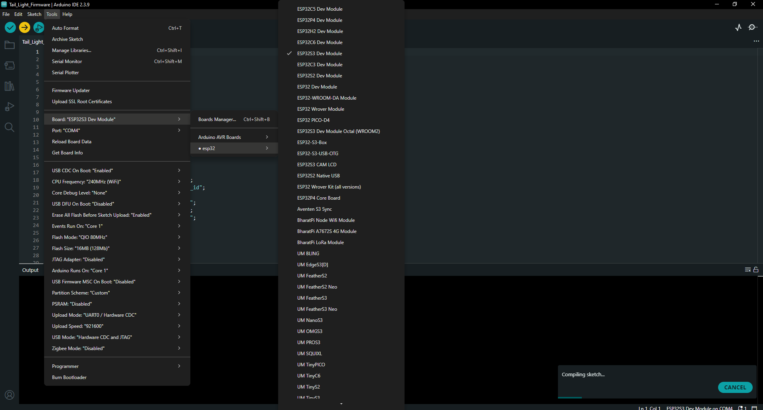

Make sure that highlighted options are properly set

Partition scheme note
The repository includes partitions.csv for a 16 MB flash layout. Keep this file beside Tail_Light_Firmware.ino. If the Arduino IDE does not show a Custom partition option, update the ESP32 board package or use an available 16 MB partition profile only after confirming that the sketch compiles and uploads correctly.

9. PCB Connection and Safety Checks
Check | Requirement
USB cable | Must be a data-capable USB cable, not charge-only.
PCB power | Use correct PCB input supply as defined by hardware design.
LED power | Use external LED power supply sized for LED current. Do not power LEDs from USB.
Ground reference | ESP32 ground, LED supply ground, and signal-conditioning ground must be common.
Vehicle inputs | Brake, left turn, and right turn must pass through the PCB conditioning stage.
Signal level | ESP32 GPIO expects safe logic-level input. Idle should be LOW and active should be HIGH.
USB port | Connect to the ESP32 programming/USB-UART port on the PCB.
BOOT/EN buttons | Locate BOOT and RESET/EN pads/buttons before flashing in case manual bootloader entry is needed.

10. Flashing the Firmware
Open Tail_Light_Firmware.ino in Arduino IDE.
Confirm the correct board and settings from Section 8.
Connect the PCB to the PC using USB.
Select the correct serial port from Tools > Port.
Click Verify/Compile. Resolve any library or board errors before uploading.
Click Upload.
If the IDE shows connecting... for a long time or fails to enter bootloader, use manual boot mode: hold BOOT, press and release EN/RESET, then release BOOT after upload starts.
Wait until Arduino IDE reports done uploading.
Press EN/RESET or power-cycle the PCB after upload.
First installation recommendation
For the first flash, enable Erase All Flash Before Sketch Upload. This removes old NVS values and guarantees the running-light mode and BLE settings start cleanly.

11. First Power-On Verification
Verification Step | Expected Result
Serial Monitor | Set baud rate to 115200. Firmware prints: Tail light Arduino firmware started.
Startup LED Check | LEDs clear, run the startup color/light check, then switch to the running-light state.
Running State | With brake and turn inputs idle, LEDs show the configured red running light mode.
Brake Input | Brake signal forces all four boards to full brake red.
Left Turn Input | L1 and L2 animate together in amber; right side remains in base state unless brake/hazard is active.
Right Turn Input | R1 and R2 animate together in amber; left side remains in base state unless brake/hazard is active.
Hazard Input | Left and right activity together flashes all boards’ amber.
BLE Scan | Mobile BLE scanner should show device name Tail Light when signals are idle.

12. BLE Command Test
You can use the mobile application to test the LED animations

13. Troubleshooting
Problem | Likely Cause | Fix
Board/COM port not visible | USB cable is charge-only, driver missing, or wrong USB port | Use a data cable, try another USB port, install CP210x/CH340 driver if the PCB uses that chip.
Upload fails at Connecting... | Auto-reset circuit did not enter bootloader | Hold BOOT, press/release EN or RESET, and then release BOOT after upload begins.
Compilation error: Adafruit_NeoPixel.h not found | NeoPixel library not installed | Install Adafruit NeoPixel from Library Manager and restart Arduino IDE.
Compilation error: BLEDevice.h not found | ESP32 board package not installed/selected | Install esp32 by Espressif Systems and select ESP32S3 Dev Module.
Upload succeeds but LEDs do not turn on | No external LED power, missing common ground, wrong LED data connection, or LED supply issue | Verify external LED supply, common GND, and data GPIO mapping.
Only USB works but external power fails | Board power path or regulator issue | Check PCB input voltage, regulator output, and ESP32 3.3 V rail.
BLE device not visible | Vehicle input active, BLE not initialized, phone cache issue | Set all inputs idle, reset PCB, rescan BLE, or toggle phone Bluetooth.
Wrong colors or flickering LEDs | Incorrect LED type/order or unstable power | Confirm SK6812 RGBW/GRBW configuration, short data wire, stable 5 V LED supply, and common GND.
Unexpected saved running mode | Old NVS settings retained | Enable Erase All Flash Before Sketch Upload once, then re-upload.

14. Final Client Checklist
- Arduino IDE installed successfully.
- ESP32 board package installed using the stable Espressif board manager URL.
- ESP32S3 Dev Module selected in Arduino IDE.
- Flash size set to 16MB.
- Partitions.csv kept with Tail_Light_Firmware.ino.
- Adafruit NeoPixel library installed.
- PCB detected on the correct COM/USB port.
- Firmware compiles without errors.
- Firmware uploads successfully.
- Serial monitor prints firmware start message at 115200 baud.
- Running, brake, turn, hazard, and BLE modes verified.

Appendix A: Pin Map and Partition Table

A.1 Firmware Pin Map
Function | GPIO
Brake input | GPIO 1
Left turn input | GPIO 2
Right turn input | GPIO 38
LED strip L1 | GPIO 4
LED strip L2 | GPIO 16
LED strip R1 | GPIO 12
LED strip R2 | GPIO 14
Ready status LED | GPIO 17
Heartbeat status LED | GPIO 8

A.2 Custom 16 MB Partition Table
Name | Type | Subtype | Offset | Size
nvs | data | nvs | 0x9000 | 0x5000
otadata | data | ota | 0xE000 | 0x2000
app0 | app | ota_0 | 0x10000 | 0x640000
app1 | app | ota_1 | 0x650000 | 0x640000
spiffs | data | spiffs | 0xC90000 | 0x370000

Appendix B: Useful Links
Arduino IDE Download: https://www.arduino.cc/en/software
ESP32 Arduino Core Installation Guide: https://docs.espressif.com/projects/arduino-esp32/en/latest/installing.html
ESP32 Stable Board Manager URL: https://espressif.github.io/arduino-esp32/package_esp32_index.json
Adafruit NeoPixel Library: https://github.com/adafruit/Adafruit_NeoPixel

