PERSONAL INFORMATION | Junaid Ahmad
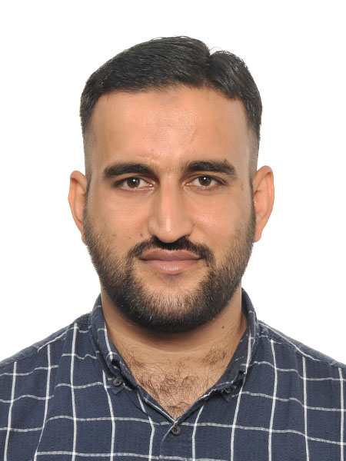 |   Ghala, Katlang, Mardan, KPK, Pakistan.
 |  +923431234567

abscde@gmail.com
 | Sex: Male | Date of birth 10/04/1988 | Nationality | Pakistani

EDUCATION AND TRAINING

2018-2020  Institution  CGPA  Thesis Title  Thesis Abstract  2014-2018  Institution  CGPA  Thesis Title  Thesis Abstract | Master of Science (MS) in Disaster Management  Asian Institute of Technology, Thailand (www.ait.ac.th)  CGPA 3.42/4.0  Assessment of Earthquake Induced Health Risks and Vulnerabilities in Khyber-Pakhtunkhwa Area of Pakistan  The research was undertaken in the most severely affected districts of Khyber Pakhtunkhwa. The study implemented mix-method study design. A cross-sectional survey was carried out in the KPK province of Pakistan. The research in this dissertation has attempted to contribute to disaster health risk reduction by providing a baseline assessment and giving an insight that what domains of public health may have high risks of devastating impacts in the aftermath of an earthquake. The other significant contribution of this dissertation is the selection and highlighting of key public health indicators for rapid need assessment in post-earthquake scenarios.  Bachelor of Science in Public Health  Asian Institute of Technology, Thailand (www.ait.ac.th)  3.58 out of 4.0  Health Risks Assessment of Internally-Displaced People and Refugees Living in the Camps of Khyber-Pukhtunkhwah in Pakistan  The focus of this research study is the assessment of health risks and vulnerabilities of population displaced by disasters. The study aim at displacement as result of natural disaster as well as man-made disaster. It is explorative type of study and based on secondary data. Data from secondary sources that include the most reliable in terms of accuracy and reliability has been considered. The first objective is to assess health care’s services coverage of the study population, while the second objective is to assess risks and vulnerabilities in the context of health.

Peer-Reviewed Publications
- Junaid Ahmad., Ahmad, M. M., Su, Z., Rana, I. A., Rehman, A., & Sadia, H. (2022). A systematic analysis of worldwide disasters, epidemics and pandemics associated mortality of 210 countries for 15 years (2001-2015). IJDRR, 76, 103001. https://doi.org/10.1016/j.ijdrr.2022.103001
International Journal of Disaster Risk Reduction (Elsevier – Q1 - Impact Factor 4.30)

- Junaid Ahmad, Mokbol Mosrshed Ahmad. "Assessing the public health impacts of disasters: A retrospective study of the October 2015 Hindu Kush earthquake in Pakistan.” https://doi.org/10.1016/j.ijdrr.2018.01.004
International Journal of Disaster Risk Reduction (Elsevier – Q1 - Impact Factor 4.30)

Work Experience

Designation | Researcher
Timeline | 6/2019- 4/2020
Organization | Department of Disaster Management,  Asian Institute of Technology, Thailand
Achievements | I worked with my team to implement secure and quality healthcare services in Rawalpindi/Islamabad, Pakistan. I ensured a secured accessible and quality maternal and child healthcare among marginalised communities, especially for widows, single mothers and orphans. Provide inputs and participate in the mid and end Year reviews, detail planning and contingency Planning. Advocate for the inclusion of the refugees in public health services with DoH and other key stakeholders including other development INGOs/ NGOs, CSO, welfare trusts, donors’ partners and UN agencies; Work as a member of multi-functional team (MFT) with Protection, Programme, Education, Livelihood and Islamic Relief field staff to monitor activities and conduct participatory assessment. Coordinate with other health partners including the Department of Health at provincial and district levels, UN agencies and other development partners at provincial level to ensure that refugees are included in their programmes and plans.
Related Skills |  | - Modelling with DSSAT software  Good experience of Models development using Decision Support System of Agrotechnology Transfer (DSSAT), learnt during my master studies.  - Statistix 10  Full command on Statistix 10 software for statistical analysis of data sets.  - Cropstat7.2  Good command on crop stat7.2 for statistical analysis of data sets.  - Demonstrated experience of field and lab work during my postgraduate and undergraduate research.
Awards |  | - Awarded the Laptop for highest achiever in class by Higher Education Commission of Pakistan.  - Awarded HEC (Higher Education commission) of Pakistan Merit and Need Based Scholarship for undergraduate program.
Languages |  | - Pashto (Mother language),  - Urdu (National language),  - English (IELTS)
References |  | - ABC  - XYZ

