Users are required to register themselves on footprints as a one-time activity
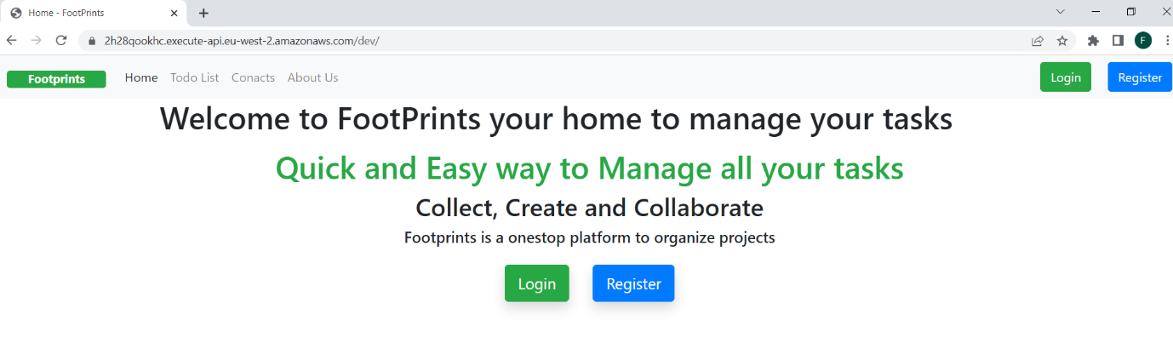
Registration screen
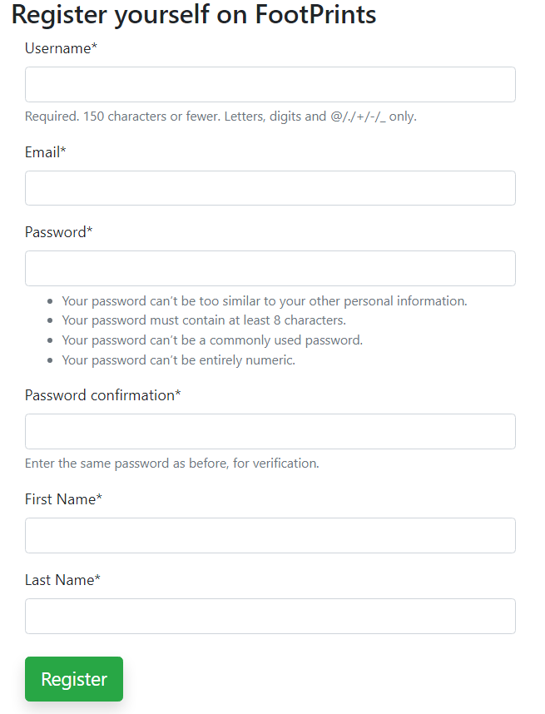

Post registration, user will be able to Login using username and password

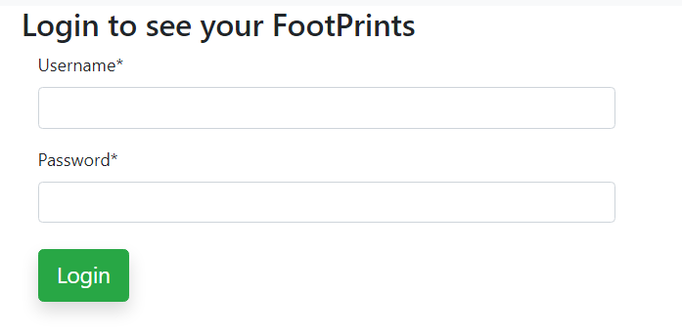

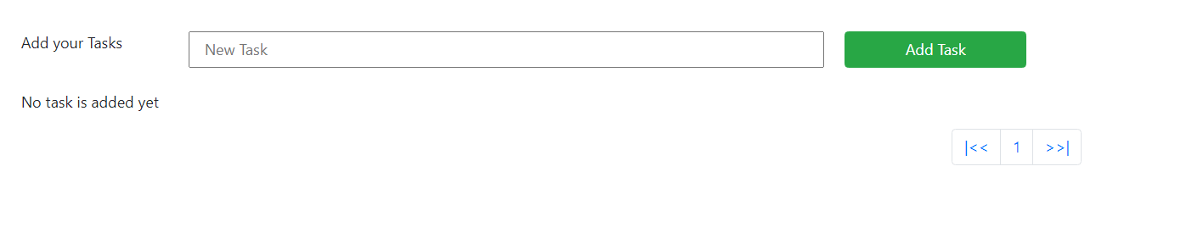

once the login is successful, user will be able to see the TODO list. Very first time, the list is blank

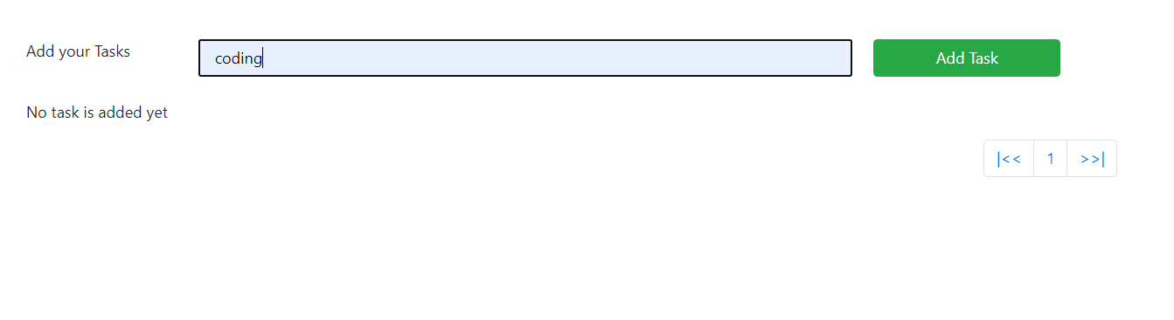

User can enter the task in the new task field and press "Add Task" button
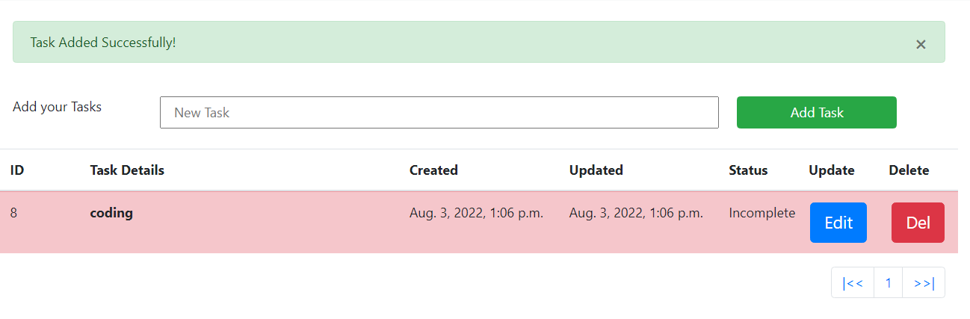

User can enter the task in the new task field and press "Add Task" button

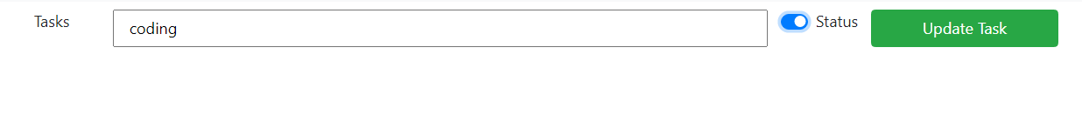
When the task is updated, it's shown as completed
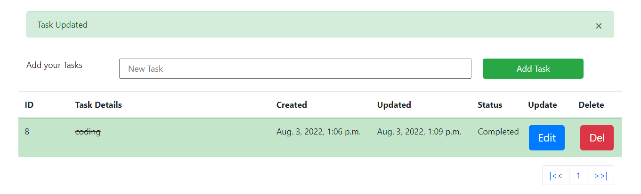
Upon adding a blank task, system responds with a message to add a valid task

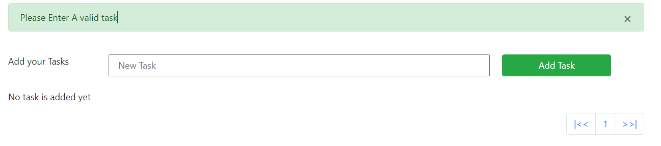

Another example of invalid task when the user enters more than 512 characters
