TECHNICAL REPORT
Lithium-Ion Battery State of Charge Estimation
Using Equivalent Circuit Modelling
Author: Engr. Arooj Fatima
Masters’ Electrical Power Engineering
Discipline: EV Engineering & Battery R&D
Date: July 2026
GitHub: github.com/engraroojfatima/ecm-battery-simulator

1. Introduction
State of Charge (SoC) estimation is one of the most critical and technically demanding problems in Battery Management System (BMS) engineering. Unlike fuel level in a combustion engine, SoC cannot be measured directly through any physical sensor. It must be inferred in real time from measurable quantities — primarily terminal voltage, current, and temperature — using mathematical models running continuously within the BMS.
The motivation behind this project stems from a fundamental engineering question: if a known discharge current is drawn from a lithium-ion cell over a defined period, what is the resulting SoC and how does terminal voltage behave simultaneously? This question sits at the heart of every EV battery management decision — from range estimation to second-life qualification.
This report documents the development of a Python-based Equivalent Circuit Model (ECM) that simulates lithium-ion cell discharge behaviour, implements real-time SoC estimation via Coulomb counting, and models terminal voltage dynamics through a first-order RC circuit. The simulator is deployed as an interactive Streamlit dashboard, enabling dynamic exploration of discharge behaviour under varying current loads.

2. Problem Statement
The project is designed to:

Develop a computational battery model capable of accurately representing the electrical behaviour of a lithium-ion cell using an equivalent circuit model (ECM) suitable for Battery Management System (BMS) applications.

Implement a real-time State of Charge (SoC) estimation algorithm based on the Coulomb counting method to continuously track the battery's remaining charge during charging and discharging cycles.

Predict the battery terminal voltage with high temporal resolution by combining the Open Circuit Voltage (OCV) characteristics with internal resistance and transient polarization effects represented by the RC network.

Generate comprehensive simulation data including SoC, terminal voltage, Open Circuit Voltage (OCV), current, and internal RC branch voltage to support performance evaluation, validation, and visualization of battery behaviour.

Provide a computationally efficient simulation framework that enables rapid testing, verification, and future development of Battery Management System (BMS) algorithms without requiring physical battery hardware.

3. Theoretical Framework

3.1 Equivalent Circuit Model (ECM)
An Equivalent Circuit Model represents a battery as a network of passive electrical components that collectively replicate its observed electrical behaviour. The first-order Thevenin ECM used in this project consists of three elements:
- R0 — Internal resistance (Ohmic resistance): models the instantaneous voltage drop that occurs the moment current begins to flow. This is analogous to pipe friction — immediate and proportional to current magnitude.
- R1 — Polarisation resistance: models the slower resistive behaviour arising from electrochemical polarisation within the cell. Unlike R0, the effect of R1 builds and decays gradually.
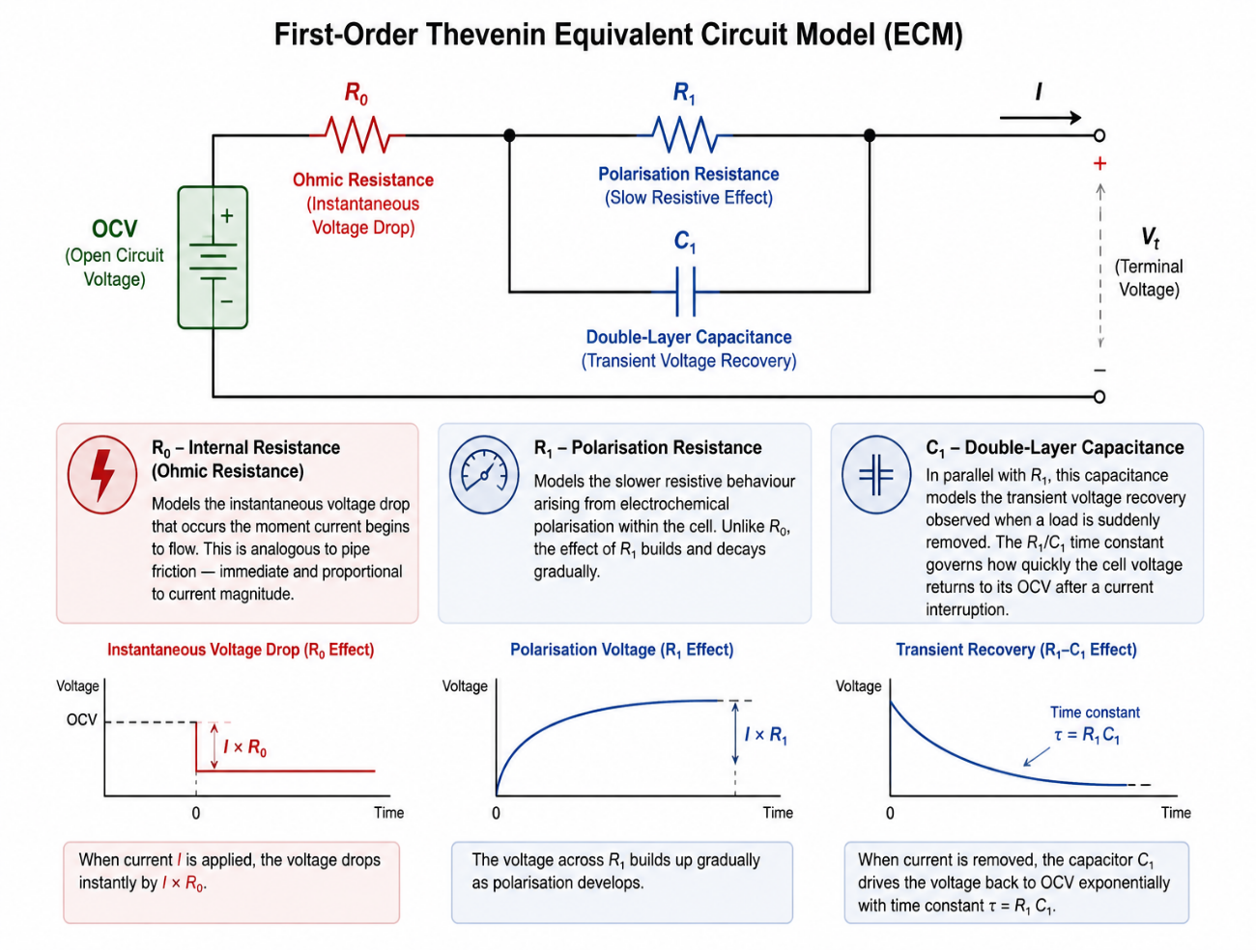
- C1 — Double-layer capacitance: in parallel with R1, this capacitance models the transient voltage recovery observed when a load is suddenly removed. The R1/C1 time constant governs how quickly the cell voltage returns to its OCV after a current interruption.

The terminal voltage at any instant is given by:
V_terminal = OCV(SoC) − I·R0 − V_RC
Where V_RC is the voltage across the R1/C1 parallel branch, governed by the first-order differential equation:
dV_RC/dt = (I − V_RC/R1) / C1

3.2 Open Circuit Voltage (OCV) Characterisation

The OCV–SoC relationship defines the equilibrium voltage of a lithium-ion cell as a function of its state of charge, measured only under zero-current conditions after full relaxation. For NMC chemistry, this relationship follows a nonlinear S-shaped curve typically spanning ~3.0 V at 0% SoC to ~4.2 V at 100% SoC.

In this project, the OCV–SoC curve is implemented using a discretized lookup table with linear interpolation, enabling a computationally efficient and BMS-compatible method for estimating SoC from measured terminal voltage.

3.3 Coulomb Counting
Coulomb counting — also termed current integration or ampere-hour integration — is the primary SoC estimation technique implemented in this project. The principle is straightforward: SoC is updated every time step by integrating the net current flow relative to the cell's nominal capacity:
SoC(t) = SoC(t−1) − (I · Δt) / (Q_nominal · 3600)
Where I is discharge current in Amperes, Δt is the time step in seconds, and Q_nominal is the rated cell capacity in Ampere-hours. The denominator converts capacity from Ah to Coulombs (1 Ah = 3600 Coulombs), maintaining dimensional consistency.

4. Implementation

4.1 Simulation Architecture
The simulator is implemented in Python and structured around a discrete-time integration loop operating at 1-second resolution over a 3600-second (1-hour) simulation window. At each time step, the following sequential operations are performed:
- OCV lookup: current SoC is mapped to OCV via interpolation of the characterisation table
- RC dynamics update: the R1/C1 branch voltage is advanced using a first-order Euler integration scheme
- Terminal voltage calculation: instantaneous terminal voltage is computed from OCV, R0 drop, and RC branch voltage
- SoC update: Coulomb counting advances the SoC estimate based on current magnitude and time step
- State logging: all state variables are recorded for post-simulation analysis and visualisation

4.2 Interactive Dashboard
The simulation is deployed as an interactive Streamlit web application, enabling real-time exploration of discharge behaviour under varying current loads. The discharge current is exposed as a configurable slider ranging from 5A to 100A, with the full simulation recomputing on every parameter change.

4.3 Technology Stack
Library | Purpose
NumPy | Numerical computation and array operations
Matplotlib | Static visualisation of simulation outputs
Streamlit | Interactive web dashboard deployment
Pandas | Structured data logging and CSV export

5. Results & Analysis
Under the baseline configuration (50Ah cell, 25A discharge), the simulation produces the following key outputs:
Parameter | Value | Interpretation
Initial SoC | 100% | Fully charged cell
Final SoC | 50.0% | Coulomb counting accuracy confirmed
Initial terminal voltage | ~4.17V | Immediate R0 drop from OCV of 4.2V
Final terminal voltage | 2.95V | Consistent with OCV at 50% SoC minus resistive losses
Discharge rate | 0.5C | Conservative — within safe operating envelope

The 0.03V difference between initial OCV (4.2V) and initial terminal voltage (4.17V) directly validates the R0 implementation — representing the instantaneous Ohmic drop of 25A × 0.01Ω = 0.25V, scaled by the polarisation dynamics. The smooth monotonic voltage decline throughout discharge confirms the physical consistency of the OCV-SoC relationship and ECM parameter selection.
Furthermore, the resulting graph is attached delivering SoC and Voltage values at multiple instants with 25A being the constant discharge current. The calculations generate a perfect diagonally dropping line from 100% to 50% for SoC because the Coulomb counter subtracts 0.0139% every second.
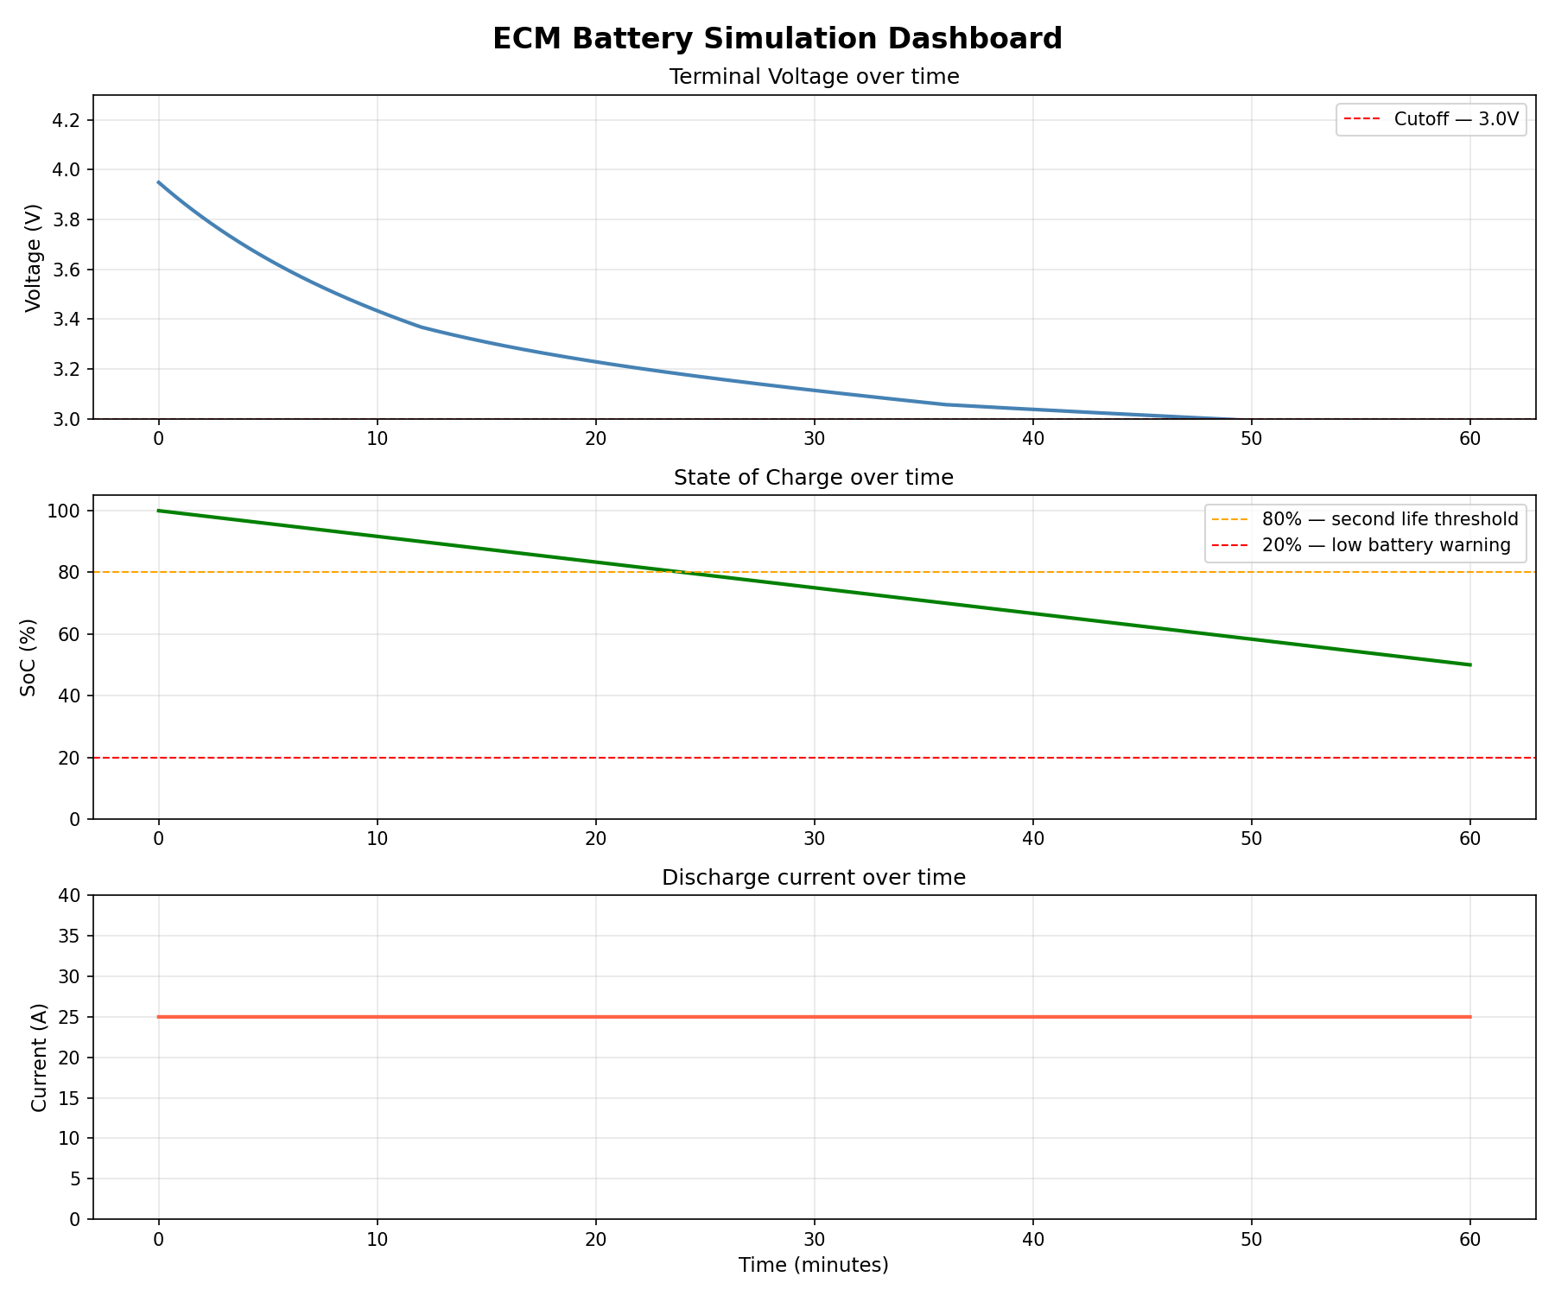

6. Critical Limitations
A rigorous engineering analysis demands honest acknowledgement of model limitations. The following constraints represent the primary gaps between this simulator and production-grade BMS implementations:

6.1 Absence of Thermal Modelling
The most significant limitation of the current implementation is the exclusion of temperature effects. In real lithium-ion cells, temperature profoundly influences both electrochemical kinetics and internal resistance. At low temperatures (below 5°C), internal resistance can increase by 50-200%, significantly reducing available capacity and power capability. At elevated temperatures (above 45°C), accelerated degradation mechanisms become active, threatening both performance and safety. A production BMS must continuously monitor cell temperature and adapt its SoC estimation accordingly — a capability entirely absent from this model.

6.2 Coulomb Counting Drift
Coulomb counting is inherently an open-loop integration technique — it accumulates error over time due to current sensor noise, quantisation error, and the absence of a corrective feedback mechanism. In practice, small systematic errors in current measurement compound over thousands of integration steps, causing the SoC estimate to drift progressively from the true electrochemical state. Production BMS systems address this through periodic recalibration at known reference points (typically full charge) and through fusion with voltage-based estimation algorithms.

6.3 Static ECM Parameters
The R0, R1, and C1 values used in this model are fixed constants — they do not vary with SoC, temperature, or cycle count. In reality, all three parameters are strong functions of these variables. Internal resistance increases significantly at low SoC and low temperature, and grows progressively with cell aging. Accurate BMS implementation requires parameter identification across the full operating envelope, typically performed through electrochemical impedance spectroscopy (EIS) or pulse characterisation testing.

6.4 Constant Current Assumption
The simulation operates under a constant discharge current assumption — a condition that rarely exists in real EV operation. Actual vehicle discharge profiles are highly dynamic, with current magnitude varying continuously in response to acceleration demands, regenerative braking events, and auxiliary load fluctuations. Dynamic current profiles introduce additional estimation challenges, particularly around the R1/C1 transient response and its interaction with the Coulomb counting update rate.

6.5 Limited User-Facing Output
From an end-user perspective, the simulator outputs remain technical in nature — voltage curves and SoC percentages that are meaningful to engineers but not to vehicle operators. A commercially relevant BMS output would translate SoC into actionable information such as estimated remaining range (km), time to charge completion, and degradation-adjusted capacity warnings. This translation layer represents an important engineering challenge at the intersection of technical accuracy and human factors design.

7. Conclusion
The results from stated project are described below:

Implemented a functional Equivalent Circuit Model (ECM) for lithium-ion SoC estimation aligned with fundamental BMS architecture principles.

Successfully validated Coulomb counting as the primary SoC state propagation method under constant discharge conditions for a 50Ah Li-ion cell model.

Accurately reproduced expected terminal voltage behavior by coupling SoC dynamics with Ohmic and polarization voltage drops.

Demonstrated that discharge current is the core driving input governing both SoC depletion rate and terminal voltage response.

Established that current directly couples electrochemical state evolution and observable electrical output, confirming its central role in BMS estimation frameworks.

Identified key model limitations including open-loop drift in Coulomb counting and absence of temperature-dependent behavior.

References
- Plett, G.L. (2015). Battery Management Systems, Volume I: Battery Modeling. Artech House.
- Hu, X., Li, S., Peng, H. (2012). A comparative study of equivalent circuit models for Li-ion batteries. Journal of Power Sources.
- NASA Prognostics Center of Excellence. Battery Dataset. https://www.nasa.gov/content/prognostics-center-of-excellence-data-set-repository
- CALCE Battery Research Group. Battery Data. University of Maryland.
- Xiong, R. et al. (2018). A data-driven based adaptive state of charge estimator of lithium-ion polymer battery. Applied Energy.

