CONDUTO
Project Intelligence
Minimum viable product: complete documentation
Product guide · Method · Connectors · Technical reference · Operation
Version 1.0 · 29 September 2026 · Prepared by Zenthic

About the data. Every project, client, person and figure in this demo is synthetic. The data was generated to follow the formats Conduto really uses (Excel cost-control workbooks, Microsoft Project schedules, PDF contracts and reports, Dynamics GP exports) and to illustrate the method. The application says so on every screen.

Contents
1. Summary 4
What it demonstrates 4
Key figures of the demo 4
Access 4
2. The problem and the approach 5
2.1 Where Conduto starts 5
2.2 What the solution does 5
2.3 Design principles 5
3. What the demo discovers 6
4. Screen guide 7
4.1 Portfolio 7
4.2 Project page 7
4.3 Bids in progress 8
4.4 Data and quality 9
4.5 Connectors 10
4.6 Load data 12
4.7 Project assistant 12
4.8 Benchmarks 13
4.9 Methodology 14
5. Connectors 15
5.1 Why connectors 15
5.2 How a connector works 15
5.3 Catalog 15
5.4 What “Sync now” does on the three working connectors 16
5.5 What is needed to switch on the others 16
6. How the numbers are calculated 17
6.1 Earned value, in plain words 17
6.2 Estimated final cost and forecast margin 17
6.3 Alerts and project health 17
6.4 Automatic checks 17
6.5 Spending without progress 18
6.6 Historical benchmarks 18
6.7 Bid check 18
7. Local intelligence and the assistant 19
How an answer is built 19
8. Technical architecture 20
8.1 Components 20
8.2 Data model 20
8.3 Interface reference 20
8.4 Code structure 21
9. Deployment and operation 22
9.1 On Vercel (free plan) 22
9.2 How it behaves 22
9.3 Running locally 22
9.4 Before a meeting 22
10. Security and data 23
11. Limitations of the demo 23
12. Roadmap and what we need 24
What we need for discovery 24
13. Questions to confirm in discovery 24
Appendix A. Meeting script (about 25 minutes) 25
Appendix B. Glossary 25

1. Summary
Conduto builds pipelines and civil works for oil pipelines in Ecuador, Peru and Brazil. Its project information lives in Excel workbooks, Microsoft Project schedules, PDF documents and the Dynamics GP accounting system. Project control exists as a process, but it is done by hand in Excel and pivot tables, so profitability is known late and the experience of past projects cannot be queried.
This minimum viable product shows, with realistic sample data, how that information can be brought into one traceable source and turned into project-control and profitability insight, without waiting for the decision on the new accounting system (SAP or Dynamics 365).

What it demonstrates
- Consolidation with traceability. 151 source files become 11,735 records for 18 projects in 3 countries. Every value points to the exact Excel cell, PDF page, schedule task or accounting row it came from.
- Automatic checks that find real problems. An invoice in accounting that is missing from the Excel, a duplicated accounting entry, a monthly report quoting an old figure, and spending with no documented reason.
- Margin analysis per project. EC-2503 fell from a 17.0% bid margin to a 4.5% forecast margin. The system shows where the margin went and that USD 3.4 million in pending change orders would recover part of it.
- Connectors. Read-only links to the programs Conduto already uses (project folders, Dynamics GP and a sales system). The dashboards do not depend on the accounting system, so the move from Dynamics GP changes one connector, not the solution.
- Bid check. Every open bid from the sales system is compared with what similar closed jobs really cost. One open bid, for the same client and terrain as EC-2503, is priced below history.
- A project assistant that answers questions in Spanish, English and Portuguese, cites its sources and works without any paid artificial-intelligence service.

Key figures of the demo
Figure | Value
Projects | 18 (6 active, 12 closed) in Ecuador, Peru and Brazil
Source files consolidated | 151 (Excel, Microsoft Project, PDF, Dynamics GP, sales system)
Records | 11,735, of which 100% traceable to their source
Active contract value | USD 281.3 million
Forecast margin of active projects | 10.1%, against 15.5% at bid
Pending change orders | USD 6.3 million in 6 orders; 5 older than 90 days
Open bids | USD 300.6 million in 8 bids; 1 below history, 3 tight
Automated tests | 42, all passing

Access
- Website: [add the website's Vercel address here]
- Application programming interface: https://conduto-demo.vercel.app (health check at /api/health)
- Languages: Spanish, English and Portuguese, switched at the top right of every screen. Adding ?lang=en to any address opens it in English.

2. The problem and the approach

2.1 Where Conduto starts
From the first meeting with Oscar (Head of Technology, Ecuador):
- Conduto uses Microsoft Dynamics GP and is evaluating a move to SAP or Dynamics 365 because Dynamics GP is reaching the end of its support. The decision has been open for more than a year.
- There is no dedicated project-control software. Project control is handled in Excel and pivot tables, with different formats per country.
- Historical and project data is spread across Excel, Microsoft Project and PDF files, so costs, schedules and documents are not connected.
- The main gap: no centralized system or process for project control and global information management.
Oscar asked to see real examples and a method, not a generic artificial-intelligence pitch. The demo answers with working screens on data in Conduto's own formats, and the Methodology screen explains how it would be built with their real data.

2.2 What the solution does
- Reads the files and systems that already exist, through read-only connectors and a guided loading screen.
- Organizes everything into one common model (projects, activities, costs, progress, change orders, events, bids), with a person confirming anything uncertain.
- Checks that sources that should agree actually agree, and flags what does not.
- Shows margins, risks, findings and bids, with every number linked to its source, and answers questions about them.

2.3 Design principles
Principle | What it means in practice
Numbers are calculated, never guessed | Figures come from calculations on the database. Artificial intelligence, when used, only reads documents, recognizes formats and writes answers; it never produces a number.
Every number is traceable | Each value keeps its source file and exact location. Auditing is one click.
Works with any accounting system | Screens and indicators run on the common model. Changing from Dynamics GP to SAP or Dynamics 365 replaces one connector.
A person stays in control | Nothing is imported without review. A new format is learned once and reused.
In Conduto's cloud | Installed in Conduto's own cloud account (for example Microsoft Azure). Data stays under Conduto's control.
Read-only access | Connectors and queries only read, with time and volume limits.

3. What the demo discovers
The sample data contains realistic problems on purpose. The system finds each one automatically; none is hard-coded into the screens.
Finding | Where | What the system shows
Margin erosion | EC-2503 Oleoducto Amazonía – Tramo B | Bid margin 17.0% → forecast 4.5%. Causes by activity: river crossings by directional drilling done without an approved change order, rain standby, rock excavation. USD 3.4 million in 3 pending change orders would recover 5.1 points.
Invoice missing from the Excel | EC-2503, August 2026, subcontracts | Invoice FAC-004471 (USD 185,000) is in Dynamics GP but not in the cost-control workbook.
Cost not yet in accounting | PE-2410, June 2026, equipment | The Excel has a cost (about USD 66,500) that accounting has not recorded yet, probably an accrual.
Duplicated accounting entry | BR-2501, July 2026, materials | The same invoice (FAC-001894) is recorded twice in Dynamics GP (about USD 87,700).
Outdated monthly report | EC-2503, April 2026 | The PDF report quotes a cumulative cost of 43.8 million; the Excel says 48.1 million.
Spending with no documented reason | BR-2501 (June 2026, stringing and bending) and PE-2410 (November 2025, indirect costs) | Cost well above what the progress justifies, with no event or change order to explain it.
Bid priced below history | OPP-2026-014 Oleoducto Napo – Tramo C | Same client and terrain as EC-2503. At the cost of similar jobs, the margin left is 0.6% instead of 15%. The price would need to be USD 51.7 million instead of 44.2 million.
Bid renegotiated below history | OPP-2026-019 Ducto Selva Central – Tramo 2 | After “Sync now” on the sales connector, the client's 6% discount leaves 4.8% margin at historical cost.

4. Screen guide
Common to every screen: the language switch (Spanish, English, Portuguese) at the top right; filters at the top right wherever the data can be filtered; and numbers that open the records behind them. Any source link opens the original file at the exact cell, page or task. “Reset demo” in the sidebar restores the clean dataset.

4.1 Portfolio
Why it exists. One view of every project, so management sees margin, risk and pending money without opening a workbook.
What you see
- What matters today: the project losing the most margin, change orders waiting for approval, and what history says about terrain.
- Cards: active projects, contract value, forecast margin, pending change orders and project health.
- Charts of bid versus forecast margin and contract value by country, and the project table with alerts.
What you can do
- Filter by status, country, terrain and health; every card, chart and table follows the filters.
- Click any card to see its list (projects, contracts, margins, each pending change order with its PDF).
- Click a bar, a country or a row to open that project or filter by it.
- Download the consolidated Excel.
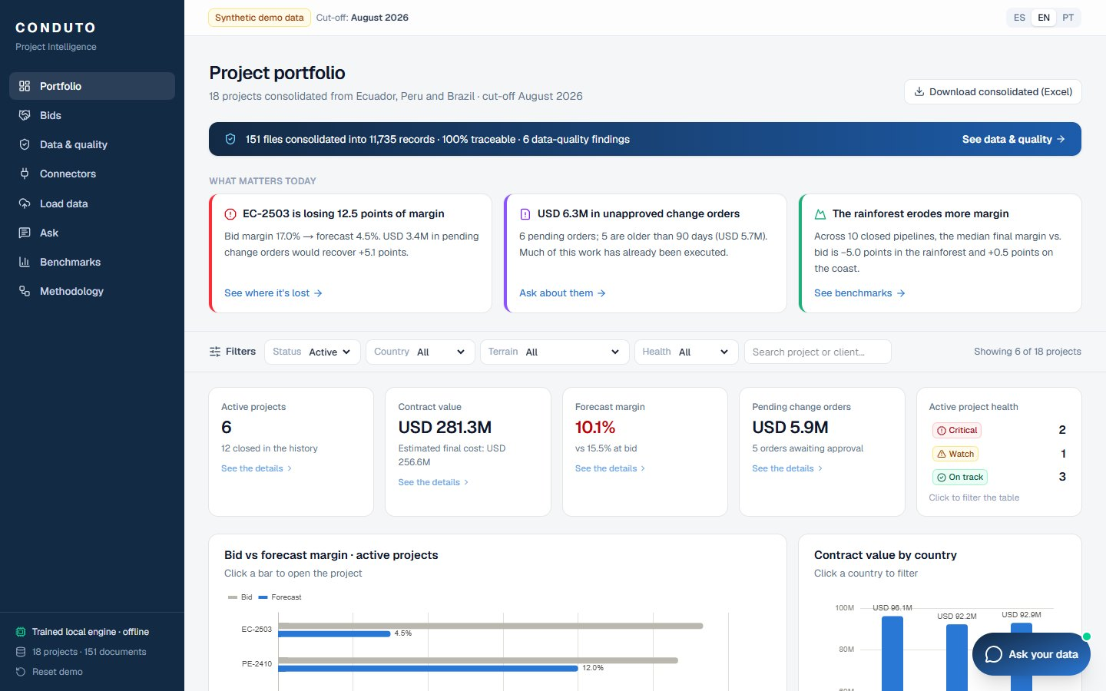
Figure 1. Portfolio with filters at the top and the highlights of the day.

4.2 Project page
Why it exists. Explains a single project: where the margin is going and why.
What you see
- Tiles for contract, estimated final cost, forecast margin, cost efficiency, schedule efficiency and pending change orders.
- “Where is the margin going?”: a waterfall from bid margin to forecast margin, by activity, with its main causes.
- Cost curve over time, schedule against baseline, cost by activity, spending without progress, the accounting check, change orders, events and welding production.
What you can do
- Click an efficiency tile for an activity-by-activity explanation.
- Click an activity to see the exact Excel cells its figures come from.
- Switch between local currency and US dollars.
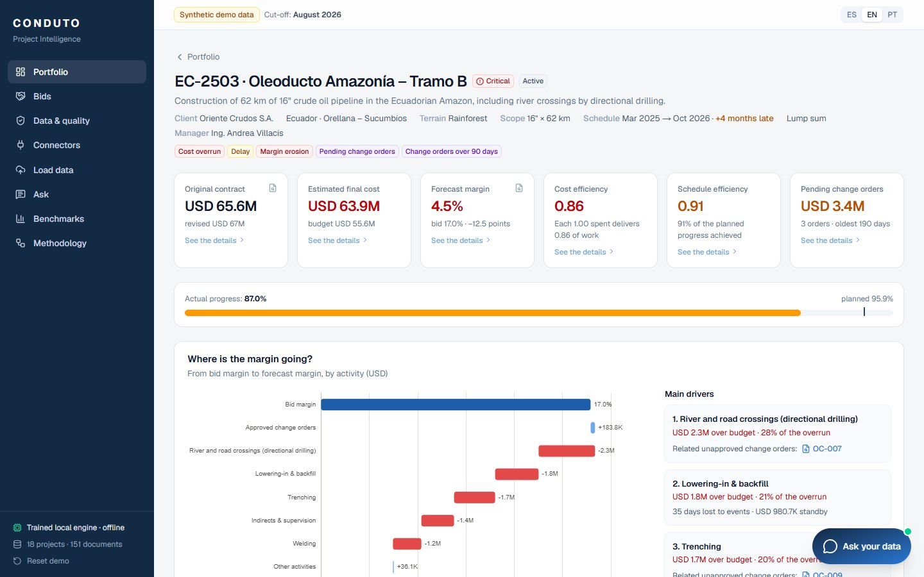
Figure 2. Project EC-2503: tiles, margin waterfall and its causes.

4.3 Bids in progress
Why it exists. Stops Conduto from bidding below cost, by checking every open bid against what similar jobs really cost.
What you see
- Open bids, weighted value by probability, bids below history, tight bids and bids won.
- Each open bid with its planned margin next to the margin left if the job costs what history says.
- Won bids linked to the project they became; lost bids with their reason.
What you can do
- Filter by country, stage and check result.
- Open a bid to compare what it assumes with what history says, see the price needed to keep the planned margin and the comparable projects, and open its row in the copy of the sales system.
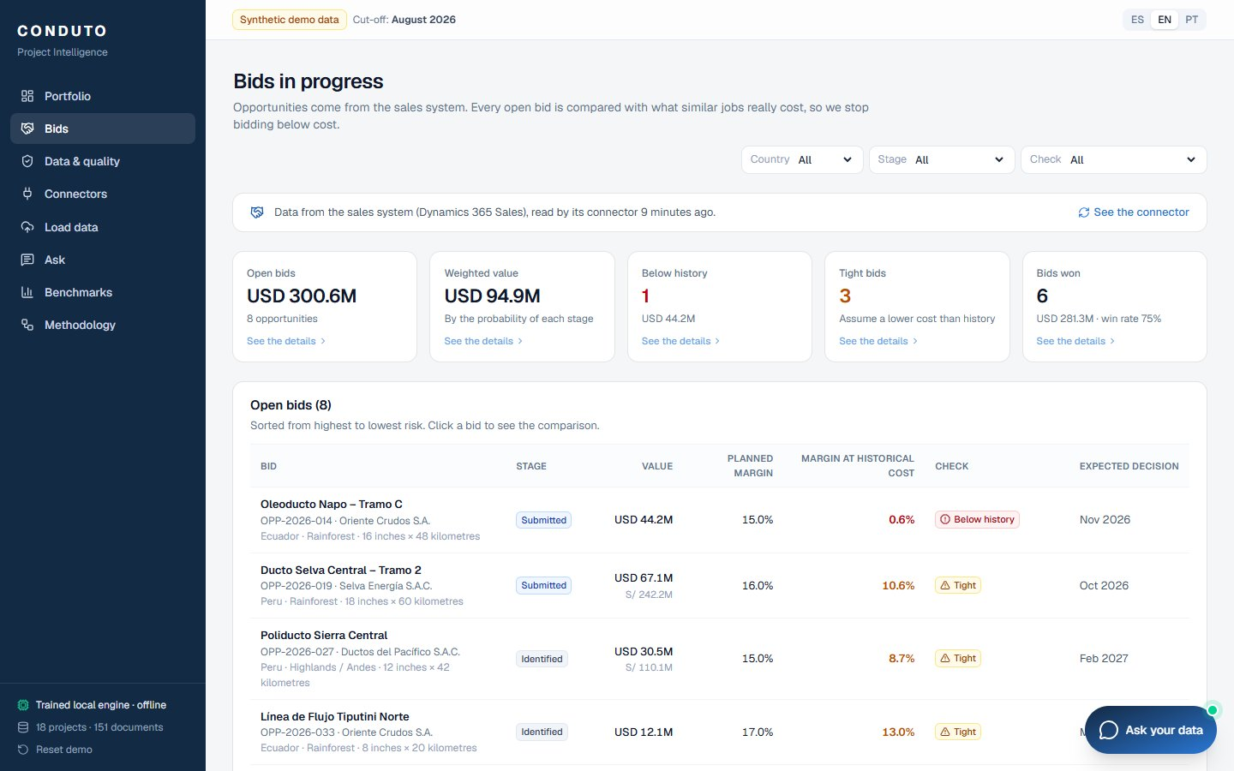
Figure 3. Bids in progress, sorted from highest to lowest risk.
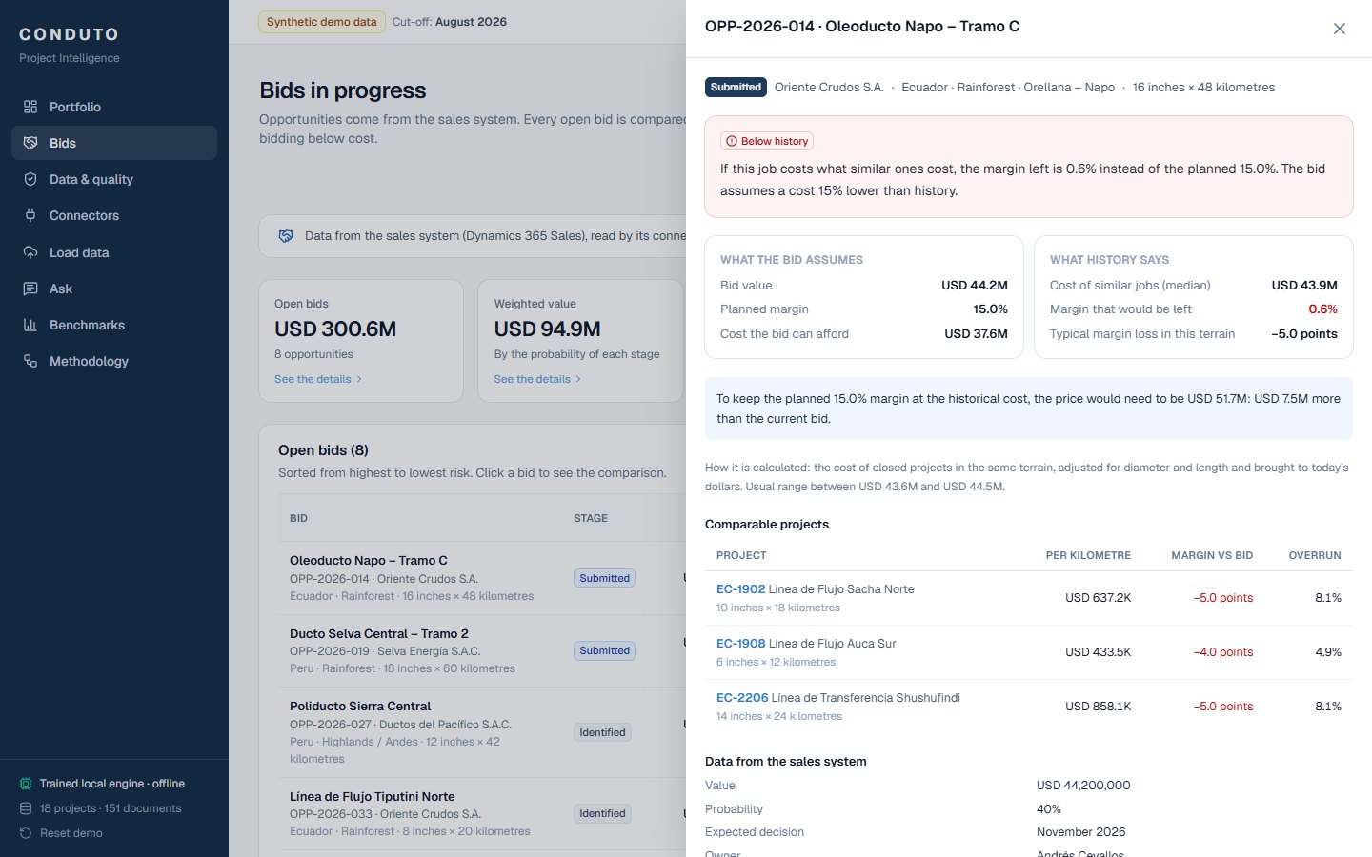
Figure 4. The comparison for OPP-2026-014: the bid assumes a cost 15% below history.

4.4 Data and quality
Why it exists. Shows that the consolidated data can be trusted, and what it found that needs action.
What you see
- From scattered files to one source of truth: files, records, projects and traceability.
- Four automatic checks: traceability, Excel against its own totals, monthly reports against Excel, accounting against Excel.
- Findings that need action, spending without progress, the trained models with their measured accuracy, learned formats and document coverage per project.
What you can do
- Click any counter, file type, check or coverage cell to see the files or records behind it.
- Filter the findings by country.
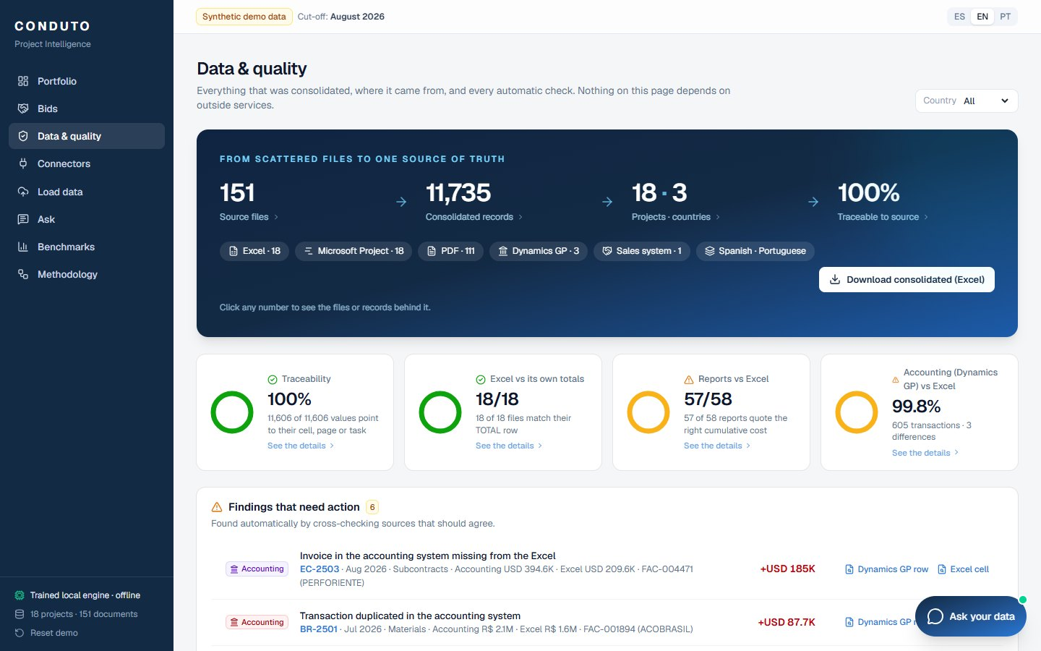
Figure 5. Data and quality: consolidation, checks and findings.

4.5 Connectors
Why it exists. Explains how data arrives by itself from Conduto's programs, and makes the point that the accounting system can change without changing the dashboards.
What you see
- How the data arrives: programs → connectors → common model → screens.
- Three connectors working in the demo, six available for the pilot or after the accounting decision, one planned.
- For each: what it reads, how often, the last read and anything to review.
What you can do
- Open a connector to see what it reads, how it maps to the common model and how it is set up.
- Press “Sync now” or “Test the connection” on a working connector, and review its history of reads.
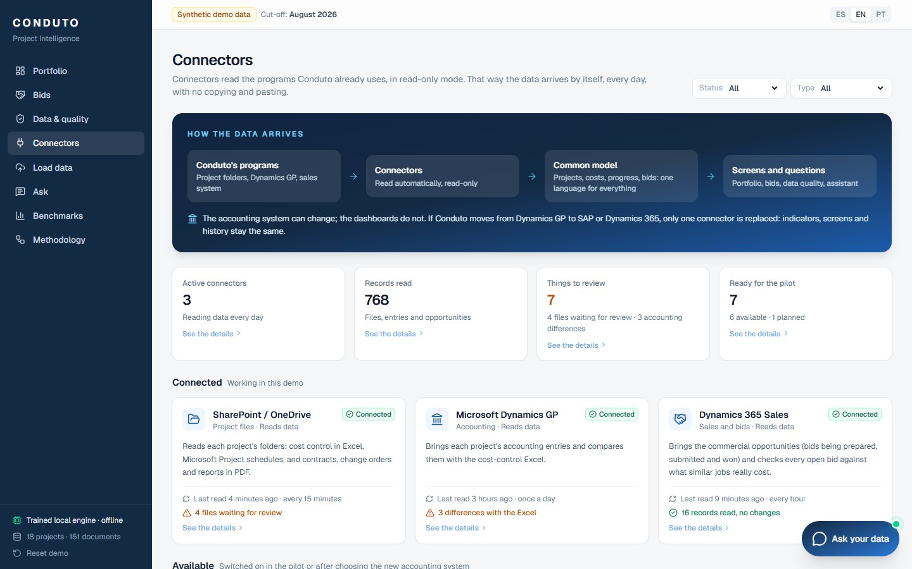
Figure 6. Connectors, grouped by status.
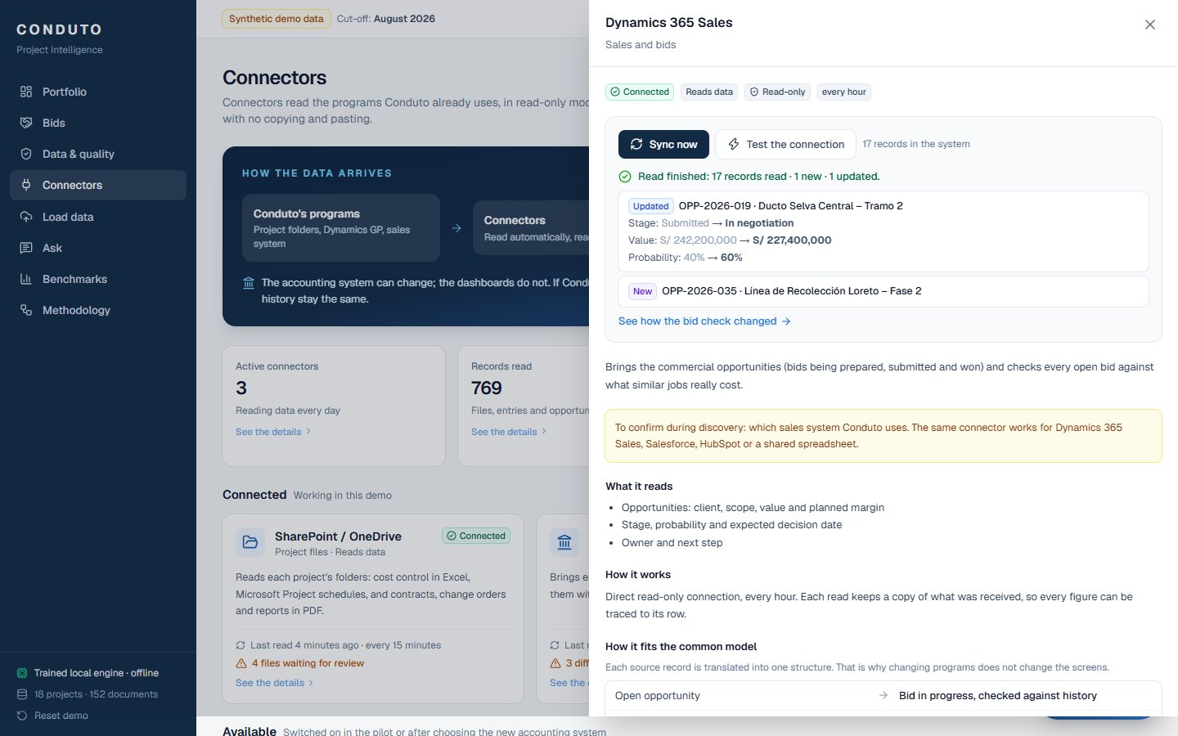
Figure 7. “Sync now” on the sales connector: one bid renegotiated and one new opportunity.

4.6 Load data
Why it exists. Shows how a new file enters the system: it is read, checked and only saved after a person confirms.
What you see
- Four steps: choose a file, the system reads it, you check, saved and traceable.
- A panel explaining why the screen exists.
- Example files, each showing a different situation (an old format never seen before, a change order PDF, a scanned PDF, a new schedule version).
What you can do
- Read an example or upload your own file (Excel, PDF or Microsoft Project, up to 4 megabytes).
- Correct anything marked as uncertain, then confirm and save; see what changed in the project.
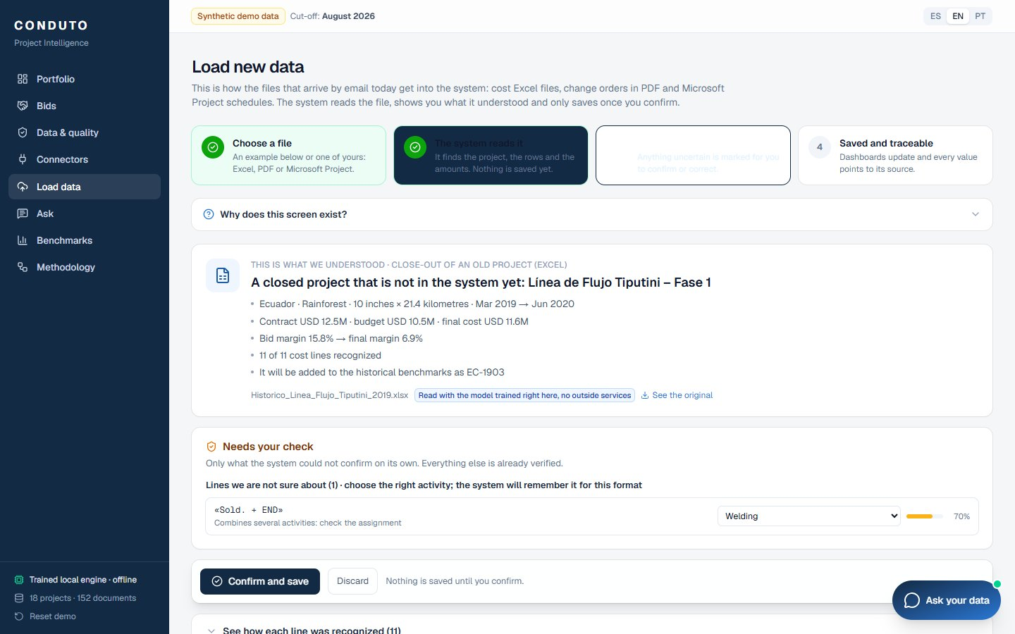
Figure 8. Load data: what was understood and the one line that needs a person's check.

4.7 Project assistant
Why it exists. Lets anyone ask about the projects in their own words and get an answer with its sources.
What you see
- Available on every screen as a floating chat, and as the full Ask screen.
- Suggested questions that change with the screen you are on.
What you can do
- Ask in Spanish, English or Portuguese; follow-up questions keep the context.
- Open “How this answer was built” to see the calculation or query behind it, and click a source to open the original file.
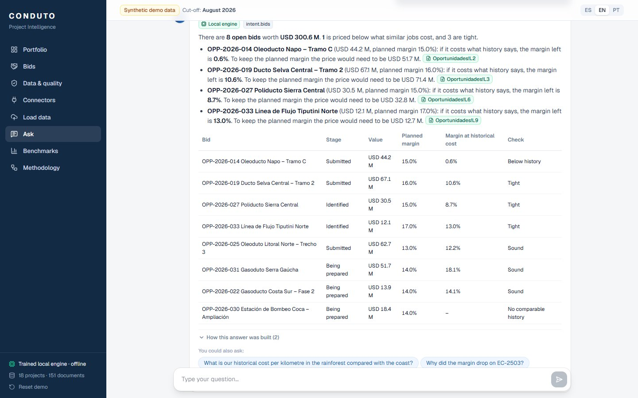
Figure 9. The assistant answering which open bids are priced below history, with its sources.

4.8 Benchmarks
Why it exists. Makes the history of closed projects usable when preparing new bids.
What you see
- Cost per inch of diameter and kilometre, and per kilometre, by terrain; margin lost against the bid; overrun by activity and terrain; a bid estimator.
What you can do
- Filter by terrain, open the projects behind each terrain, and estimate a bid from its scope and target margin.
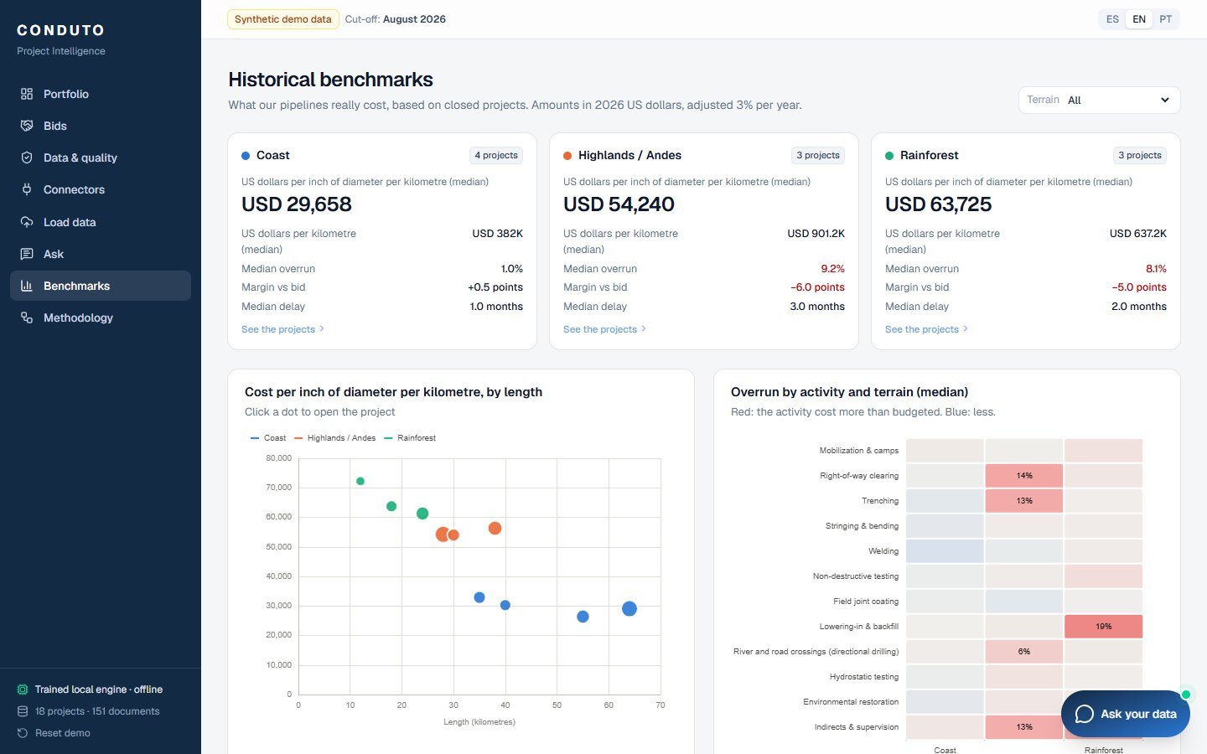
Figure 10. Historical benchmarks by terrain.

4.9 Methodology
Why it exists. The other screens show what the system does with example data. This one explains how it would be built with Conduto's real data: the starting point, the architecture, the design principles, the proposed roadmap and what is needed for the discovery phase.

5. Connectors

5.1 Why connectors
Today someone copies and pastes data from each program into Excel to see the portfolio. A connector reads a program automatically and in read-only mode, and translates what it reads into the common model. Every screen, indicator and check works on the common model, never directly on a program.
The accounting system can change; the dashboards do not. If Conduto moves from Dynamics GP to SAP or Dynamics 365, only the accounting connector is replaced. Indicators, screens and history stay the same, and the consolidated history makes the migration easier.

5.2 How a connector works
- Read-only. A connector never writes to the source program.
- On a schedule. Each connector reads at a fixed frequency (every 15 minutes, every hour or once a day), and a person can start a read at any time with “Sync now”.
- Mapped to the common model. Each source record is translated into one structure; the mapping is shown for every connector.
- Traceable. Each read of the sales system keeps a copy of what was received, so every figure points to its row. Files and accounting rows keep their file and location.
- Observable. Every read is recorded with its time, records read, new and updated records, and anything to review. “Test the connection” checks the link without reading data.

5.3 Catalog
Connector | Type | Status | What it brings | Frequency
SharePoint / OneDrive | Project files | Connected | Cost-control workbooks, Microsoft Project schedules, contracts, change orders and reports | Every 15 minutes
Microsoft Dynamics GP | Accounting | Connected | General-ledger entries with a project account, invoices and vendors | Once a day
Dynamics 365 Sales | Sales and bids | Connected | Opportunities: client, scope, value, planned margin, stage, probability, decision date, owner | Every hour
SAP S/4HANA | Accounting | Available after the decision | Project structure, posted costs, purchase orders | Once a day
Dynamics 365 Finance | Accounting | Available after the decision | Projects, cost categories, accounting entries, vendor invoices | Once a day
Microsoft Project Online | Schedules | Available in the pilot | Tasks, baseline and actual dates, progress | Every hour
Oracle Primavera P6 | Schedules | Available in the pilot | Activities, dates and progress | Once a day
Microsoft Outlook | Email | Available in the pilot | Attachments sent to a project mailbox, sent to Load data | Every 15 minutes
Power BI | Reporting (sends data) | Available in the pilot | The consolidated model, for finance's own reports | Once a day
Daily site reports | Site | Planned | Daily progress, welds and repairs, events with photos from a mobile app | Every hour

5.4 What “Sync now” does on the three working connectors
Connector | What a read does | What the demo shows
SharePoint / OneDrive | Scans the project folders and the incoming folder; reports files not yet reviewed. | 151 files read; 4 files waiting for review in Load data.
Microsoft Dynamics GP | Re-reads the accounting exports and compares accounting with the Excel by project, month and cost type. | 605 transactions; 261 of 264 combinations match; 3 differences.
Dynamics 365 Sales | Reads the opportunities, keeps a copy, inserts new ones and updates changed ones; the bid check recalculates. | 17 read, 1 new, 1 updated; the renegotiated bid moves from tight to below history. A second read finds no changes.

5.5 What is needed to switch on the others
Connector | Needed
SharePoint / OneDrive | A read-only account; the list of project folders per country.
Microsoft Dynamics GP | A scheduled SmartList report per country (or a read-only database user); the rule saying which account segment is the project.
Sales system | A read-only user; three fields on each opportunity: diameter, length and terrain.
SAP S/4HANA or Dynamics 365 Finance | The accounting-system decision; a read-only user; the mapping between Dynamics GP and new accounts to keep the history.
Microsoft Project Online | Confirm whether Conduto uses Project Online or only desktop files.
Oracle Primavera P6 | Know which projects or clients use Primavera.
Microsoft Outlook | A dedicated mailbox (for example projects@conduto).
Power BI | A Conduto Power BI workspace.
Daily site reports | A pilot project and its supervisors.
To confirm during discovery: the meeting brief does not mention a sales system. The demo uses Dynamics 365 Sales as an example because it fits Conduto's Microsoft environment. The same connector works for Salesforce, HubSpot or a shared spreadsheet.

6. How the numbers are calculated
Every calculation runs on the database, with the same rules for every project and country. Local currencies (US dollars, Peruvian soles, Brazilian reais) are converted to US dollars with monthly exchange rates.

6.1 Earned value, in plain words
Term | Meaning
Budget | What each activity was expected to cost, including approved change orders.
Actual cost | What has been spent so far, from the cost-control workbook.
Earned value | The work actually done, valued at budget: progress × budget. If a 100 activity is 40% done, its earned value is 40, whatever was spent.
Planned value | The work that should be done by now according to the plan, valued at budget.
Cost efficiency | Earned value ÷ actual cost. 1.00 means spending exactly as budgeted; 0.86 means each 1.00 spent produced 0.86 of work.
Schedule efficiency | Earned value ÷ planned value. Below 1.00 means behind schedule.

6.2 Estimated final cost and forecast margin
- Per activity: estimated final cost = actual cost + remaining work ÷ cost efficiency, with the efficiency kept between 0.5 and 1.5.
- Activities under 10% progress: the remaining work is estimated at budget, because it is too early to measure efficiency. Finished or closed activities: the actual cost.
- Revised contract = original contract + approved change orders. Forecast margin = (revised contract − estimated final cost) ÷ revised contract.
- Margin erosion = bid margin − forecast margin, in percentage points.

6.3 Alerts and project health
Alert | Rule
Cost overrun | Cost efficiency below 0.95 (active projects)
Schedule delay | Schedule efficiency below 0.92, or forecast finish 3 or more months late
Margin erosion | Forecast margin at least 3 points below the bid margin
Pending change orders | Pending change orders worth 3% or more of the contract
Change orders waiting too long | A change order pending for more than 90 days
Welding quality | Weld repair rate above 5%
Health: critical | Margin erosion of 8 points or more, or 3 or more alerts
Health: watch | Any alert, or margin erosion of 3 points or more
Health: on track | No alerts

6.4 Automatic checks
Check | How it works
Traceability | Counts the records that keep their file and exact location. The demo reaches 100%.
Excel against its own totals | After reading a workbook, the rows are added up and compared with the workbook's own TOTAL row and budget total, so no row is lost or counted twice.
Monthly reports against Excel | Each PDF report quotes the cumulative cost; it is compared with the Excel total up to that month (tolerance 0.05%).
Accounting against Excel | Dynamics GP entries and Excel costs are compared by project, month and cost type. Each difference is classified as missing in the Excel, missing in accounting or duplicated, with the invoice that explains it.

6.5 Spending without progress
For each activity, the expected cost of a month is the progress gained × the activity budget × the activity's typical cost rate (its median across months). A month is flagged when the excess is above 4 robust deviations and above 0.3% of the project budget. The system then looks for an explanation: an event in that month's report (rain, community stoppage, permits) or a work-related change order. Anything left is marked as unexplained. The demo finds 17 such months, 2 of them unexplained.

6.6 Historical benchmarks
- Uses closed pipeline projects. Final costs are converted to US dollars and brought to 2026 values at 3% per year.
- Costs are compared per inch of diameter and kilometre, adjusted for length and diameter (longer and wider pipelines cost less per unit).
- Medians by terrain (coast, highlands, rainforest), so one extreme project cannot distort them. The suggested contingency is the overrun that only 1 in 4 similar projects exceeded.

6.7 Bid check
Step | Calculation
Cost the bid can afford | Bid value × (1 − planned margin)
Cost of similar jobs | Median cost of comparable closed pipelines (same terrain, adjusted for diameter and length, in today's dollars)
Margin left at historical cost | 1 − cost of similar jobs ÷ bid value
Price needed | Cost of similar jobs ÷ (1 − planned margin): the price that keeps the planned margin if the job costs what history says
Below history (red) | Margin left at historical cost under 6%
Tight (amber) | The bid assumes a cost more than 3% below history
Sound (green) | Otherwise
No comparable history | Civil works, until enough closed projects exist

7. Local intelligence and the assistant
The demo works completely without an internet connection to any artificial-intelligence service. Two small models are trained on the server itself, and their accuracy is measured on examples that were never used for training and shown on the Data and quality screen.
Model | What it does | Measured accuracy
Cost-line mapper | Translates Excel labels (abbreviated, misspelled, in Spanish, Portuguese or English) into the 18 standard activities. | 96.3% on 82 hand-written labels (3,213 training examples)
Question understanding | Understands what is being asked, among 20 question types, in three languages. | 87.5% on 72 hand-written questions

How an answer is built
- Understand the question and find the project, country, terrain or year it mentions.
- Run a read-only calculation or database query for data questions; use the knowledge base for concepts and questions about the system; search the documents otherwise.
- Write the answer with its sources (Excel cells, PDF pages, accounting rows, sales-system rows) and show how it was built.
- Suggest follow-up questions; follow-ups keep the conversation's context.
When the system is unsure, it searches the documents instead of guessing, and it says clearly when a question is outside what it can answer.
Optional: with a Claude key configured, open questions go to Claude and scanned PDFs are read as images. If Claude is unreachable during a meeting, the assistant falls back to the local engine automatically.

8. Technical architecture

8.1 Components
Part | Technology | Role
Website | Next.js 16, React 19, Tailwind CSS 4, ECharts | All screens, in three languages; retries automatically while the server starts
Application programming interface | Python 3.13, FastAPI | Calculations, checks, connectors, loading, assistant
Database | SQLite | Common model with traceability; regenerated from the dataset on each deployment
File reading | openpyxl, pypdf, an XML reader for Microsoft Project | Excel, PDF and schedule files
Models | scikit-learn | Cost-line mapper and question understanding
Optional | Anthropic software development kit (Claude) | Open questions and scanned PDFs, only with a key

8.2 Data model
Table | Content | Traced to
projects, project_kpis | Projects and their calculated indicators | Contract PDF and workbook
budget_lines, cost_actuals, progress, production | Budget, monthly cost, progress and welding by activity | Workbook cells
change_orders, issues | Change orders and site events | PDF pages
schedule_tasks | Tasks with baseline and actual dates | Schedule tasks
erp_transactions | Dynamics GP entries by project | Export rows
opportunities | Bids from the sales system | Rows of the sales-system copy
documents, document_chunks | Every source file and its text, for search | The file itself
sync_runs | Every connector read | The copy kept by the read
mapping_templates, ingestion_jobs | Learned formats and loaded files | The uploaded file
Every fact row keeps a document reference and a locator, for example “Costos mensuales!F23”, “p.1”, “Task UID 12” or “Oportunidades!L2”. That is what makes every figure open its source.

8.3 Interface reference
Method and path | Purpose
GET /api/health, /api/meta | Status and reference data (countries, activities, labels)
GET /api/portfolio | Portfolio summary, projects and highlights
GET /api/projects/{code} | Project detail, waterfall, curves, anomalies, accounting check
GET /api/change_orders, /api/documents | Lists behind the clickable numbers
GET /api/datahub | Consolidation, checks, findings, models
GET /api/lineage, /api/documents/{id}/file | Source preview and original file
GET /api/benchmarks, POST /api/benchmarks/estimate | Historical benchmarks and bid estimator
GET /api/connectors, /api/connectors/{key} | Connector catalog, detail and read history
POST /api/connectors/{key}/sync, /test | Read now; test the connection
GET /api/bids, /api/bids/{id} | Bid pipeline and bid check
POST /api/ask, GET /api/ask/suggestions | Assistant
/api/ingest/… | Load data: examples, upload, review, confirm, history
GET /api/export/consolidated.xlsx | Consolidated Excel with the source of every value
POST /api/admin/reset | Restore the clean dataset

8.4 Code structure
Folder | Content
backend/app/seed | Synthetic data in real formats: workbooks, schedules, PDFs, accounting exports, sales-system data
backend/app/ml | Cost-line mapper, question understanding, entities, knowledge base, training
backend/app/services | Indicators, anomalies, reconciliation, quality, benchmarks, bids, connectors, search, assistant, loading, export
backend/app/api | The interface routes
backend/tests | 42 automated tests
frontend/src/app | One folder per screen
frontend/src/components, lib | Shared components, chat, translations (Spanish, English, Portuguese), formatting

9. Deployment and operation

9.1 On Vercel (free plan)
The repository deploys as two Vercel projects from the same GitHub repository.
- Interface: import the repository with Root Directory backend. Vercel detects FastAPI. Its build runs build.py (declared in backend/pyproject.toml), which generates the demo data and trains the models so they ship with the deployment.
- Website: import the same repository again with Root Directory frontend and the setting NEXT_PUBLIC_API_URL = the interface's address.
- Use the projects' main .vercel.app addresses: Vercel protects preview addresses with a login.
Setting | Project | Value
NEXT_PUBLIC_API_URL | Website | https://conduto-demo.vercel.app (read at build time: redeploy after changing it)
CORS_ORIGINS | Interface (optional) | The website address; the default * also works
ANTHROPIC_API_KEY | Interface (optional) | Only to switch on Claude; not needed for the demo

9.2 How it behaves
- Start after a quiet period: a few seconds. The website shows “the server is starting” and retries on its own for about two minutes, so nobody has to refresh.
- Storage: the deployed code is read-only. Each server instance copies the shipped dataset to its temporary folder. Imports, connector reads and resets last while that instance is running; afterwards the demo returns to its clean state.
- Uploads: Vercel accepts requests up to 4.5 MB, so Load data accepts files up to 4 megabytes.

9.3 Running locally
- Backend: create a Python environment, install requirements-dev.txt, optionally run build.py, then start the server on port 8000.
- Frontend: copy .env.example to .env.local, install packages and start on port 3000.
- Tests: 42 automated tests cover the interface, file loading, the models, the checks, the read-only query guard, the optional Claude paths (simulated), connectors and bids.

9.4 Before a meeting
- Open the website a few minutes before, so the server is warm.
- Press “Reset demo” in the sidebar to start from the clean dataset.
- Check that the language is the one the audience expects.

10. Security and data
- All access to Conduto's systems is read-only; connectors never write to a source program.
- The assistant's database queries are checked before running: only reading is allowed, with time and size limits.
- In production the solution is installed in Conduto's own cloud account, and the local engine needs no internet connection. With the optional Claude service, only the question and the needed context leave the system.
- Every figure keeps its source, which makes any number auditable.
- The demo contains synthetic data only.

11. Limitations of the demo
- No login or user roles yet.
- Accounting data comes from exports, not a live connection to Dynamics GP (planned for the pilot). The sales system is simulated.
- SQLite instead of a server database; each Vercel instance keeps its own copy, so imports do not persist across restarts.
- Keyword search over documents instead of meaning-based search.
- Microsoft Project is read from its XML export; native .mpp files would need an additional reader.
- Civil works have no bid check yet, because there is no comparable closed history.
- The local assistant covers 20 question types; broader questions need the optional Claude service.

12. Roadmap and what we need
Phase | Duration | Content
Phase 0 · Today | – | This demo with synthetic data, to validate the use case.
Phase 1 · Discovery | 2–4 weeks | Inventory of real sources, 2–3 sample projects processed, indicators agreed with project controls and finance, connectors confirmed.
Phase 2 · Ecuador pilot | 6–8 weeks | Real Ecuador data, read-only connection to Dynamics GP, dashboard and questions live for management.
Phase 3 · Group rollout | – | Peru and Brazil, per-country templates, and the connector for the new accounting system (SAP or Dynamics 365).

What we need for discovery
Source | Minimum | Ideal
Cost control (Excel) | 2–3 projects: at least one closed and one active | All projects from the last 5 years
Schedules (Microsoft Project) | The schedule files for those projects | Baseline and monthly updates
Contracts and change orders (PDF) | Contract and change orders for the sample projects | Full history of change orders and claims
Monthly reports | Last 6 reports of an active project | All reports and close-out reports
Dynamics GP | General-ledger export by project (Excel or text file) | Read-only access to the accounting database
Sales system | An export of open and closed opportunities | A read-only user
People | 2 hours with project controls, 1 hour with technology, 1 hour with finance | One data owner per country

13. Questions to confirm in discovery
- Which sales system Conduto uses for bids and opportunities, if any.
- How Dynamics GP identifies the project in each account (which segment), per country.
- Whether schedules are kept in Microsoft Project desktop files, Project Online or Primavera.
- How project folders are organized in SharePoint or file servers, per country.
- Which indicators project controls and finance already use, and their exact definitions.
- The timeline of the accounting-system decision, to plan the new connector.

Appendix A. Meeting script (about 25 minutes)
- Problem (2 minutes). Methodology, “Where we start”.
- Data and quality (3 minutes). 151 scattered files consolidated, 100% traceable; then the findings: an invoice missing from the Excel, a duplicated entry, an outdated report, unexplained spending.
- Portfolio → EC-2503 (5 minutes). The margin waterfall from 17.0% to 4.5%; open change order OC-007 to show its PDF; click an activity to show the exact Excel cell.
- Load data (4 minutes). “Why does this screen exist?”; the old 2019 workbook: 11 of 11 lines recognized, one flagged for review, totals reconciled, saved; benchmarks grow from 10 to 11 projects. Then the change order PDF and the scanned PDF (“we don't guess”).
- Connectors → Bids (3 minutes). The banner about the accounting system; “Sync now” on Dynamics 365 Sales; the renegotiated bid turns below history, next to OPP-2026-014, same client and terrain as EC-2503.
- Assistant (3 minutes). Two suggested questions in Spanish and one of the audience's own; open “How this answer was built”.
- Benchmarks (2 minutes). Rainforest against coast; the estimator.
- Next step (1 minute). Roadmap and what we need; hand over the consolidated Excel.

Appendix B. Glossary
Term | Meaning
Bid margin | The margin calculated when the bid was prepared.
Forecast margin | The margin expected at the end, based on actual costs so far.
Change order | A document that modifies the contract: extra work, a design change or a claim. While pending, the cost may be spent but not yet paid.
Common model | The single structure all data is translated into, so screens do not depend on any particular program.
Connector | A read-only link that reads a program automatically and translates its data into the common model.
Traceability | The link from every figure to the exact place in the source file where it came from.
Benchmark | A reference value from closed projects, such as the median cost per kilometre in a terrain.
Median | The middle value when values are sorted; one extreme project cannot pull it.
Directional drilling | A method to cross rivers and roads by drilling underneath them.
Accrual | A cost recorded in project control before it reaches accounting.
SmartList | The Dynamics GP feature used to export reports.

