Cruise Control System in Simulink: A Short Report
What is cruise control?
Cruise control is a system that allows a driver to maintain a constant speed without having to press the accelerator pedal. This can be very useful on long stretches of highway where the speed limit is constant. Cruise control can also help to improve fuel economy, as it can prevent the driver from accelerating and decelerating unnecessarily.

Advantages:
Improved fuel economy: Cruise control can help to improve fuel economy by preventing the driver from accelerating and decelerating unnecessarily.
Reduced driver fatigue: Cruise control can help to reduce driver fatigue by taking the burden of maintaining a constant speed off of the driver.
Increased safety: Cruise control can help to increase safety by preventing the driver from speeding or drifting out of their lane.
Improved comfort: Cruise control can help to improve comfort by allowing the driver to relax and enjoy the ride.
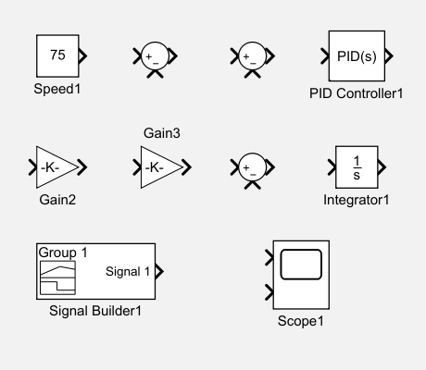
COMPONENTS USED IN SIMULATION:

System Modeling
The Simulink model comprises the following key components:
Vehicle Dynamics: This block represents the vehicle's behavior, considering factors like mass, inertia, and aerodynamic drag. It translates the throttle input into vehicle acceleration and speed.
Controller: This block implements the control logic, typically a PID controller, to adjust the throttle based on the difference between the desired speed and the actual speed.
Input: This block provides the desired speed set by the driver.
Output: This block displays the actual vehicle speed and other relevant parameters.

SIMULATION MODEL

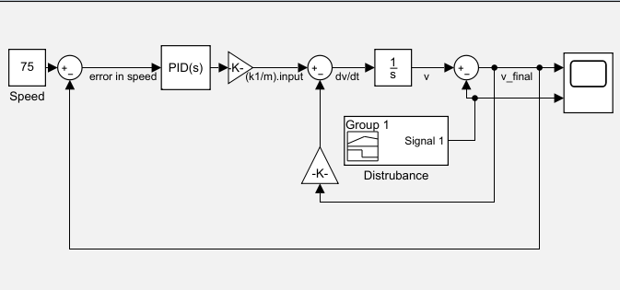

TUNNING OF PID Controller
We use built-in Auto tuning ( PID TUNER App) to tune the PID controller according to our desire.
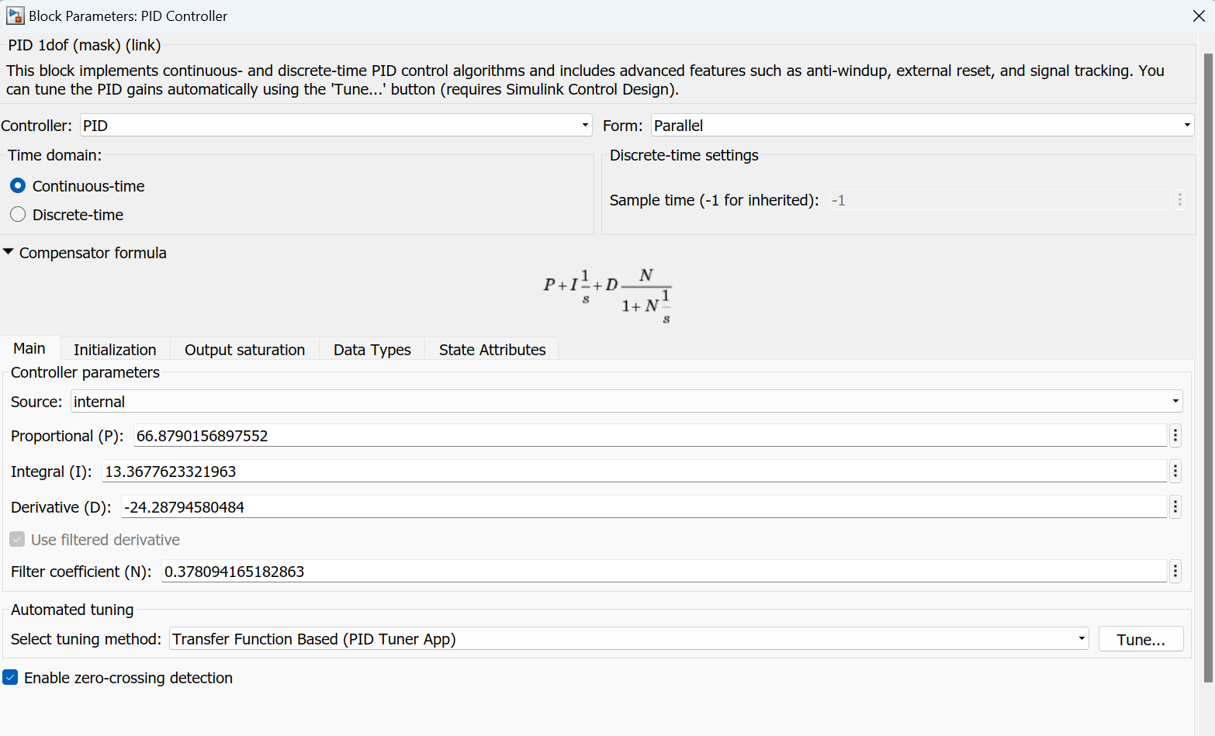

Signal Builder ( Disturbance/Slope):
We use signal builder as a disturbance/slope to final output to check if the system is working properly.
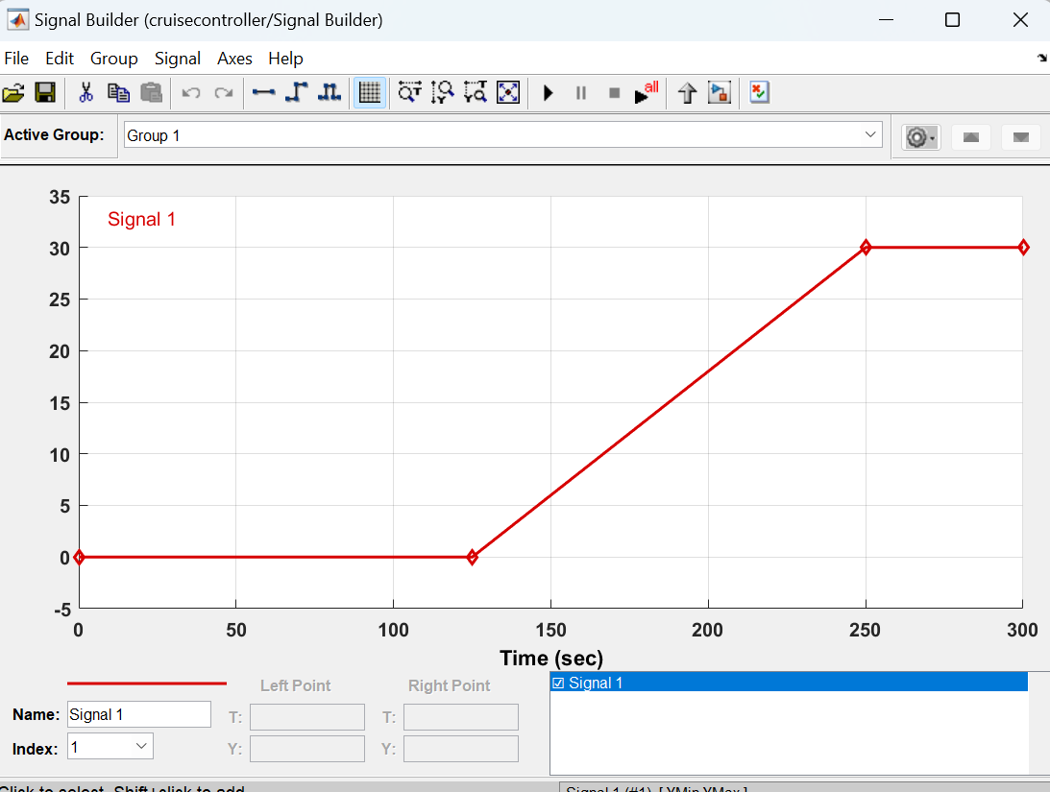

Simulation and Analysis
The simulation involves running the model with various scenarios, such as different desired speeds and road conditions. The results are analyzed to evaluate the system's performance, including:
Rise Time: How quickly the vehicle reaches the desired speed.
Overshoot: How much the vehicle speed exceeds the desired speed before settling.
Steady-State Error: The difference between the desired speed and the actual speed after the system stabilizes.
Disturbance Rejection: The system's ability to maintain the desired speed despite external disturbances like road slope changes.

SIMULATION RESULT:

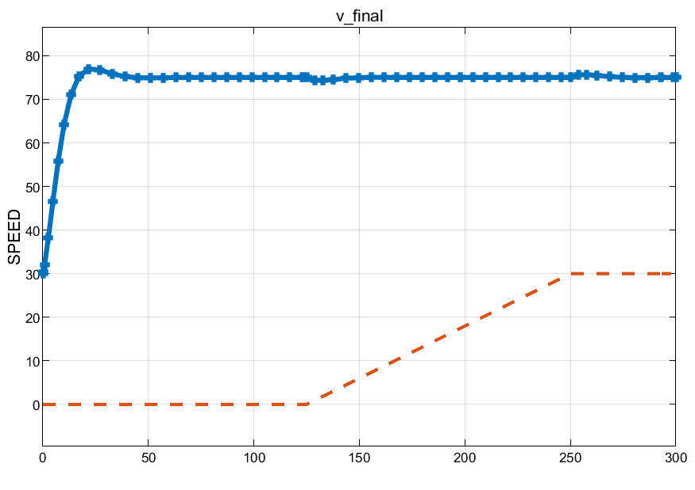
Results and Conclusion
As the disturbance add to the system , we can see that the speed of vehicle remains same
The simulation results demonstrate the effectiveness of the cruise control system in maintaining the desired speed under various conditions. The analysis provides insights into the system's performance characteristics and potential areas for improvement. This model serves as a foundation for further development, such as incorporating adaptive cruise control features or optimizing the controller parameters for enhanced performance.

