Mitigating Frequency Instability in Hybrid Renewable Energy Systems (HRES) Connected to Weak Grids: A Case Study of the Jhampir Wind Corridor
M.Huzaifa¹
Department of Automation & Control Engineering, QUEST Nawabshah
Sakrand Road Nawabshah Sindh, Pakistan
22ace06@quest.edu.pk

Abstract—
This paper investigates the stability challenges associated with integrating large-scale Hybrid Renewable Energy Systems (HRES) into weak grids, with a specific focus on the Jhampir Wind Corridor in Pakistan. As the penetration of inverter-based resources (IBRs) like wind and solar increases, the effective system inertia decreases, leading to severe frequency excursions during disturbances. We model a 500 MW HRES (Wind + Solar) and analyze the impact of simultaneous generation loss on the Rate of Change of Frequency (RoCoF). Furthermore, we propose a battery sizing methodology for Synthetic Inertia support to maintain grid stability.

I. INTRODUCTION
The global shift towards renewable energy has introduced significant technical challenges for power systems. In Pakistan, the Jhampir and Gharo Wind Corridors are critical hubs for wind generation [1]. However, these areas are often remote, characterized by "weak grid" connections with low Short Circuit Ratios (SCR) [2].
The primary risk explored in this paper is the Loss of Inertia. Traditional synchronous generators provide physical inertia $(H$) that resists frequency changes. Renewable sources, being inverter-based, decouple the generation from the grid frequency, leading to faster and deeper frequency drops (Nadir) during faults [3].
II. SYSTEM MODELING & METHODOLOGY
2.1 Hybrid Plant Configuration
We consider a hypothetical 500 MW HRES plant connected to the NTDC network:
- Wind Farm: 300 MW (Doubly-Fed Induction Generators - DFIG).
- Solar PV: 200 MW (Grid-Following Inverters).
- Grid Connection: 132 kV double-circuit line.
2.2 The Disturbance Scenario
To stress-test the system, we simulate a "Worst-Case Scenario" at peak generation $(t=0$):
- Cloud Cover: Rapid solar ramp-down (loss of 150 MW in 60s).
- Wind Gust Cut-Out: Simultaneous trip of 120 MW wind capacity due to high wind speeds $(>25 m/s)$.
III. MATHAMETICAL FRAMEWORK
To quantify the risk, we analyze the Swing Equation, which governs the rotor dynamics of synchronous machines and, by extension, the grid frequency:
$$\frac{2H}{ ω_{s}}\frac{d^{2}}{dt^{2}}= P_{m}-P_{e}$$

Where:
- $H$ is the inertia constant (s).
- $P_{m}$ is mechanical power (p.u.).
- $P_{e}$ is electrical power (p.u.).
The Rate of Change of Frequency (RoCoF) immediately following a disturbance ($\Delta P$) is calculated as:
$$RoCoF=\frac{df}{dt} = \frac{-∆P.f_{0}}{2.H_{sys}.S_{Base}}$$
Constraint: The NTDC Grid Code requires $|RoCoF|≤0.5 Hz/s$ to prevent cascading trips [4].
IV. STABILITY ANALYSIS
1. The "Duck Curve" Phenomenon
The integration of solar PV creates a steep ramping requirement for the grid.
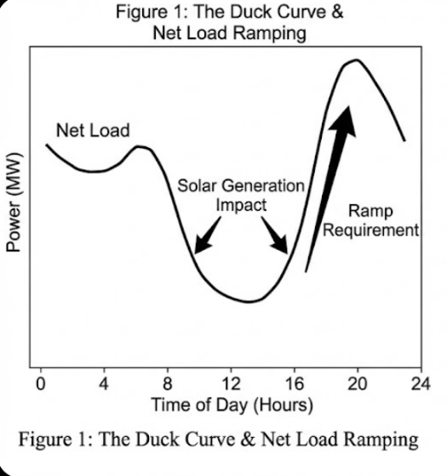

2. Frequency Response Calculation
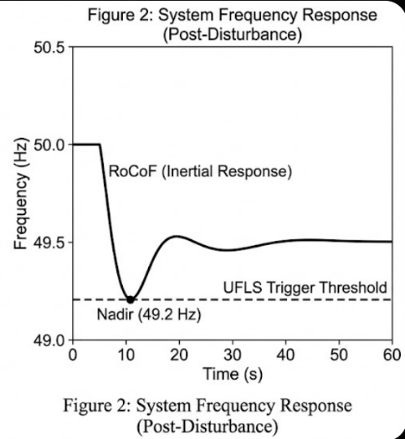
During the simultaneous wind and solar loss event, the system inertia is insufficient.

V. PROPOSED MITIGATION; BATTERY ENERGY STORAGE (BESS)
To counteract the low inertia, a Lithium-Ion BESS is proposed to provide Synthetic Inertia.
5.1 BESS Sizing Calculation
We must reduce the $RoCoF$ from$0.857 Hz/s$ to a safe target of $0.4 Hz/s$.
First, we calculate the Required System Inertia ${(H}_{req})$to achieve this target:
$$H_{req}=\frac{-∆P.f_{0}}{2.{RoCoF}_{target}}$$
$$H_{req}=\frac{0,12 ×50}{2×0.4}=7.5s$$
The Missing Inertia ${(H}_{missing})$that the battery must emulate is:
$$H_{missing}=H_{req}-H_{sys}=7.5s-3.5s=4.0s$$
The Active Power Capacity ${(P}_{BESS})$ required for the battery is derived from the power deficit needed to arrest the slope:
$$P_{BESS}={∆P}_{total}-{∆P}_{allowed}$$
$$P_{BESS}≈64MW$$
VI. CONCLUSION
This study highlights the vulnerability of the Jhampir Wind Corridor to frequency instability due to the displacement of synchronous generation. Our analysis confirms that without auxiliary support, a simultaneous renewable dropout violates grid codes. The integration of a 64 MW BESS providing synthetic inertia is critical for maintaining the reliability of Pakistan's evolving grid.
VII. REFEERENCES
- M. H. Baloch et al., "Current scenario of the wind energy in Pakistan challenges and future perspectives: A case study," Energy Reports, vol. 2, pp. 201–210, 2016.
- NTDC, "Grid Code 2023 (Draft)," National Transmission & Dispatch Company, Pakistan, 2023. [Online]. Available: https://nepra.org.pk
- A. U. Rehman et al., "Power System Stability With High Penetration of Renewable Energy Sources," IEEE Access, vol. 11, pp. 1-15, 2025.
- NEPRA, "Operating Reserves Policy 2023," National Electric Power Regulatory Authority, Islamabad, Pakistan, 2023.
- UN-ESCAP, "Review of Climate Ambition in Asia and the Pacific: Weak grid threatens renewable energy transition in Pakistan," United Nations Report, 2025.

