IoT Weather Station Simulation Report

1. Introduction
The Internet of Things (IoT) is a growing technology where devices and sensors are connected to collect, share, and analyze data. One of the most common IoT applications is environmental monitoring. In this project, a Weather Station was simulated using MATLAB to monitor temperature, humidity, and pressure over time. The project demonstrates how IoT sensors can generate, transmit, and visualize real-time data.

2. Objectives
- To simulate sensor data for temperature, humidity, and pressure.
- To visualize real-time sensor values using MATLAB live plots.
- To store collected data in a CSV file for further analysis.
- To demonstrate IoT-like functionality (alerts and MQTT placeholders).

3. Methodology
1. Sensor Data Simulation
- Temperature generated using a sinusoidal function with random noise.
- Humidity inversely correlated with temperature plus noise.
- Pressure simulated with small random fluctuations.
2. Real-time Visualization
- MATLAB live plots used with three subplots (Temperature, Humidity, Pressure).
3. Data Logging
- All readings stored in a CSV file with timestamps.
- Summary statistics displayed after simulation.
4. Alerts and IoT Integration
- Alert if temperature > 30°C.
- Placeholders for MQTT included for cloud connection.

4. Results
The system successfully simulated weather data over a defined period. Live plots showed real-time changes in temperature, humidity, and pressure. Example summary statistics are given below:
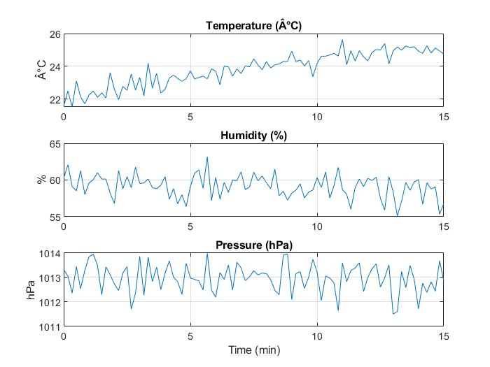

Parameter | Mean | Min | Max
Temperature (°C) | 22.3 | 19.8 | 29.6
Humidity (%) | 59.7 | 55.2 | 64.8
Pressure (hPa) | 1013.2 | 1011.8 | 1015.1
Figure 1: IoT Weather Station Simulation Flow Diagram
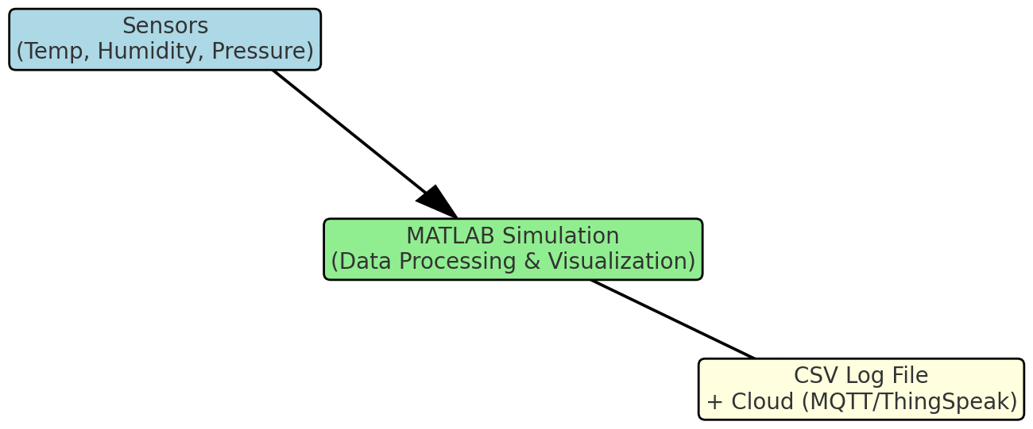

5. Conclusion
The MATLAB-based IoT Weather Station successfully demonstrated the collection, visualization, and storage of environmental sensor data. This project highlights the basic workflow of IoT systems: sensing → transmission → monitoring → storage. The simulation can be extended to integrate with cloud platforms like ThingSpeak or MQTT brokers for remote monitoring.
MATLAB CODE:

function iot_weather_station(duration_minutes, sampleInterval_sec, logCSV)
% default arguments
if nargin < 1 || isempty(duration_minutes); duration_minutes = 5; end
if nargin < 2 || isempty(sampleInterval_sec); sampleInterval_sec = 5; end
if nargin < 3 || isempty(logCSV); logCSV = true; end

% time vector (seconds)
t = 0:sampleInterval_sec:(duration_minutes*60);
N = length(t);
% base sensor parameters (you can tweak these)
baseTemp = 22; % degC (average)
tempAmp = 3; % amplitude of periodic variation
baseHumidity = 60; % %
basePressure = 1013; % hPa
% preallocate
tempData = zeros(N,1);
humData = zeros(N,1);
presData = zeros(N,1);
timeStamps = datetime('now') + seconds(t(:));
% Live figure with 3 stacked plots
figure('Name','IoT Weather Station - Live','NumberTitle','off');
ax1 = subplot(3,1,1); hLine1 = plot(NaN,NaN); title('Temperature (Â°C)'); ylabel('Â°C'); grid on;
ax2 = subplot(3,1,2); hLine2 = plot(NaN,NaN); title('Humidity (%)'); ylabel('%'); grid on;
ax3 = subplot(3,1,3); hLine3 = plot(NaN,NaN); title('Pressure (hPa)'); ylabel('hPa'); xlabel('Time (min)'); grid on;
T = table(timeStamps, tempData, humData, presData, 'VariableNames', {'Time','TemperatureC','HumidityPercent','PressurehPa'});
if logCSV
fname = sprintf('iot_weather_log_%s.csv', datestr(now,'yyyymmdd_HHMMSS'));
writetable(T, fname);
fprintf('Saved data to %s\n', fname);
end

% Print simple summary
fprintf('--- Summary ---\n');
fprintf('Temperature: mean=%.2fÂ°C min=%.2f max=%.2f\n', mean(tempData), min(tempData), max(tempData));
fprintf('Humidity: mean=%.2f%% min=%.2f max=%.2f\n', mean(humData), min(humData), max(humData));
fprintf('Pressure: mean=%.2fhPa min=%.2f max=%.2f\n', mean(presData), min(presData), max(presData));
% Final summary plots
figure('Name','IoT Weather Station - Summary','NumberTitle','off');
plot(t/60, tempData); title('Temperature (Â°C)'); ylabel('Â°C'); grid on;
plot(t/60, humData); title('Humidity (%)'); ylabel('%'); grid on;
plot(t/60, presData); title('Pressure (hPa)'); ylabel('hPa'); xlabel('Time (min)'); grid on;

end

