Speed Control Analysis of DC Motor Drive under Variable Load Conditions Using PID Controller
M.Huzaifa^{1,} Huzefa Shakeel²
Department of Automation & Control Engineering, QUEST Nawabshah
Sakrand Road Nawabshah Sindh, Pakistan
22ace06@quest.edu.pk
huzefashakeelahmed@gmail.com

Abstract—
This paper presents a comprehensive analysis of the speed control of a Direct Current (DC) motor drive subjected to variable load conditions. The primary control strategy employed is a Proportional-Integral-Derivative (PID) controller. The system is modeled and simulated using the MATLAB Simulink environment. The performance of the PID controller is evaluated based on transient response characteristics, including rise time, settling time, and steady-state error, as well as its ability to reject load disturbances. Simulation results demonstrate the effectiveness of the proposed control scheme in maintaining reference speed despite dynamic load variations.
Keywords—DC Motor, Speed Control, PID Controller, MATLAB Simulink, Variable Load.

I. INTRODUCTION
DIRECT Current (DC) motors are widely used in industrial applications such as robotic manipulators, electric vehicles, and conveyor belts due to their precise speed control and high starting torque. However, the performance of a DC motor is often affected by nonlinearities and external load disturbances. To ensure stability and precision, a robust control mechanism is required.
The Proportional-Integral-Derivative (PID) controller remains one of the most popular control strategies in industrial automation due to its simplicity and effectiveness. This paper focuses on the design and tuning of a PID controller to regulate the speed of a separately excited DC motor.

The primary objective is to analyze the system's behavior when the load torque varies dynamically. The mathematical model of the motor is derived, and the control loop is implemented in MATLAB Simulink.
II. MATHEMATICAL MODELING
To analyze the speed control, the dynamic model of the DC motor must first be established. The motor is controlled by the armature voltage $V_{a}$, while the field current is kept constant.
A. Electrical System Equation
Applying Kirchhoff’s Voltage Law (KVL) to the armature circuit yields the following equation:
$$V_{a}\left(t\right)=R_{a}i_{a}\left(t\right)+L_{a}\frac{di_{a}\left(t\right)}{dt}+E_{b}\left(t\right)$$
Where $V_{a}$ is the armature voltage, $R_{a}$ is the armature resistance, $L_{a}$ is the inductance, $i_{a}$ is the current, and $E_{b}$ is the back EMF.
B. Mechanical System Equation
The torque equation for the motor shaft is given by Newton’s second law:
$$T_{m}\left(t\right)=J\frac{dω\left(t\right)}{dt}+Bω\left(t\right)+T_{L}\left(t\right)$$Where $T_{m}$ is the motor torque, $J$ is the moment of inertia, $B$ is the viscous friction coefficient, $ω$ is the angular velocity, and $T_{L}$ is the load torque.
C. Transfer Function
By taking the Laplace transform of the electrical and mechanical equations, the open-loop transfer function relating the speed $ω(s)$ to the input voltage$V_{a}(s)$ is derived as:
$$G(s)=\frac{ω(s)}{V_{a}(s)}=\frac{K_{t}}{(L_{a}s+R_{a})(Js+B)+K_{t}K_{b}}$$

III. CONTROLLER DESIGN
The PID controller minimizes the error signal $e\left(t\right)$, which is the difference between the reference speed $ω_{ref}$and the actual speed $ω$.
A. PID Control Law
The control signal $u\left(t\right)$ generated by the PID controller is expressed as:
$$u\left(t\right)=K_{p}e\left(t\right)+K_{i} \int{e\left(t\right)dt}+ K_{d}\frac{de\left(t\right)}{dt}$$
Where $K_{p}$, $K_{i}$, and$K_{d}$ are the proportional, integral, and derivative gains, respectively.
B. Tuning Method
The gains were tuned using MATLAB PID Tuner App method to achieve an optimal balance between fast transient response and minimal overshoot.
IV. SIMULATION AND RESULTS
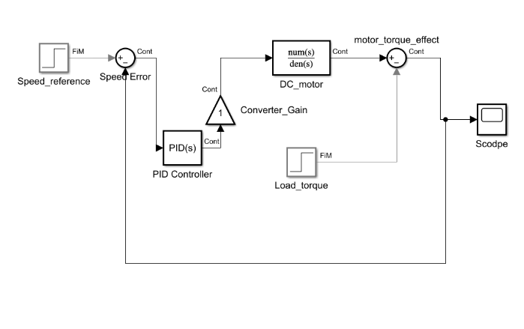
The proposed system was simulated using MATLAB Simulink. The block diagram consists of the DC Motor subsystem, the PID controller block, and a step input for the reference speed.

Fig A. Block Diagram

A. Simulation Parameters
The DC motor parameters used for this study are listed in Table I.
Parameter | Value | Unit
Armature Resistance $R_{a}$ | 0.5 | Ω
Armature Inductance $L_{a}$ | 0.01 | H
Moment of Inertia $J$ | 0.01 | kg-m²
Friction Coefficient $B$ | 0.1 | N.m.s
Torque Constant $K_{t}$ | 0.01 | N·m/A
Back EMF Constant $K_{b}$ | 0.01 | V·s/rad

B, No-Load Performance
Initially, the motor was simulated under no-load conditions. The system response showed a rise time of 2 seconds and a settling time of 5 seconds. As shown in Fig. 1, the PID controller successfully tracks the reference speed with zero steady-state error.
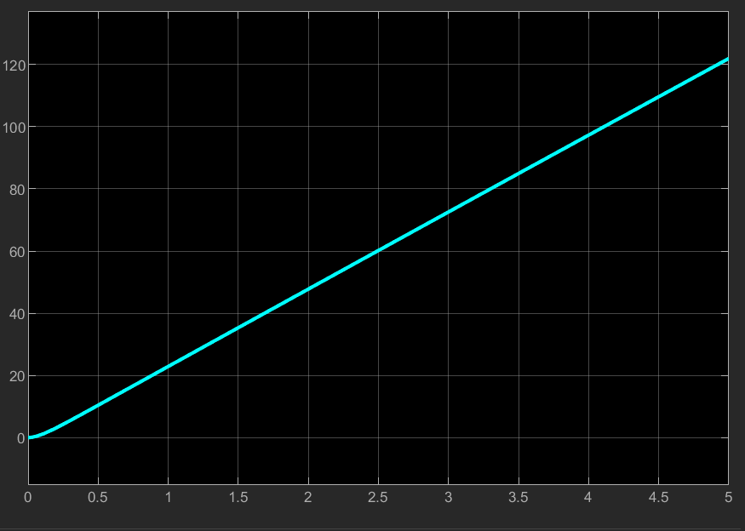

Fig 1.

C. Variable Load Analysis
To test robustness, a load torque $T_{L}$was introduced at $t$ =2 seconds.
- Effect of Load Step: Upon applying the load, a momentary dip in speed was observed.
- Recovery: The PID controller reacted to the error, increasing the armature voltage to compensate. The speed returned to the reference value within 2 seconds, demonstrating effective disturbance rejection.

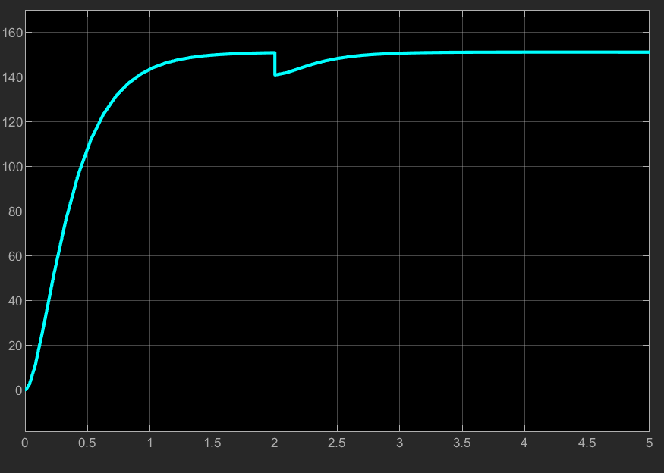

Fig 2.
V. CONCLUSION
This paper analyzed the speed control of a DC motor using a PID controller within the MATLAB Simulink environment. The simulation results confirm that the PID controller provides a stable and fast response. Furthermore, the system demonstrated robustness by recovering the reference speed quickly after the application of a variable load torque. Future work may involve implementing adaptive control techniques such as Fuzzy Logic to further improve performance under parameter uncertainty.
REFERENCES [1] K. Ogata, Modern Control Engineering, 5th ed. Upper Saddle River, NJ, USA: Prentice Hall, 2010. [2] "DC Motor Speed Control using PID," MATLAB Central File Exchange, 2024. [Online]. [3]

