Object : 550w solar (PV) module simulation in Maltab Simulink.

Introduction:
Solar photo-voltaic (PV) technology has gained significant attention as a sustainable and renewable energy source. Designing an efficient solar PV module is crucial for maximizing energy generation. MATLAB SIMULINK provides a versatile platform for simulating and analyzing various aspects of PV systems. This report outlines the steps involved in designing a 550 Watt solar PV module using MATLAB SIMULINK software.

Components:
Components that are used in this project

- Solar PV panel
- Resistors
- Voltage measurement meter
- Current measurement meter
- Grounds
- Display meter to show V,I & P
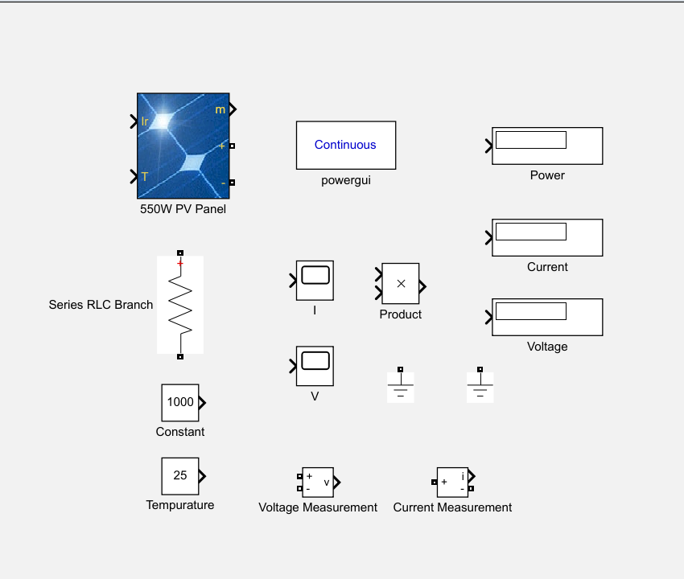

1. System Modeling:
- Define the solar PV module specifications including the rated power (550 Watts), voltage, and current characteristics.
- Utilize MATLAB SIMULINK blocks to model the behavior of the solar PV module.

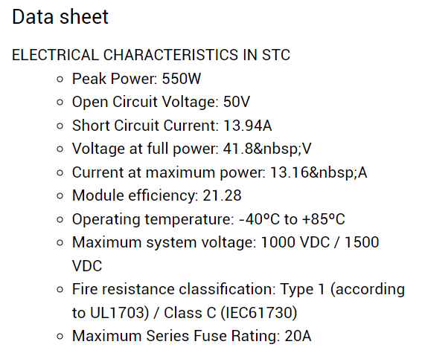

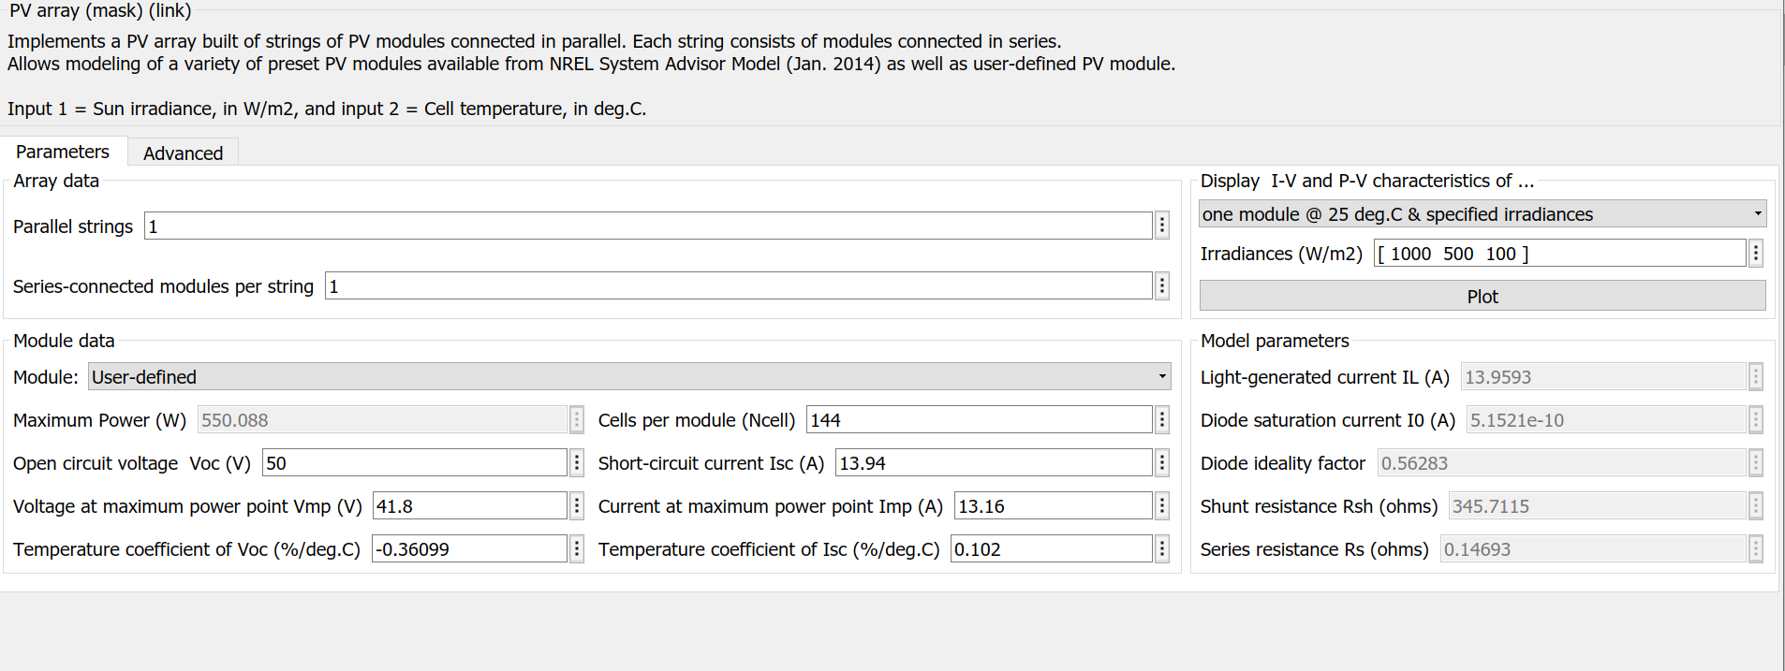

- Performance Analysis:
- Conduct simulations to analyze the performance of the designed 550 Watt solar PV module.
- Evaluate key parameters including efficiency, output power, voltage, and current characteristics.
- Compare simulation results with theoretical calculations and experimental data to validate the model's accuracy.

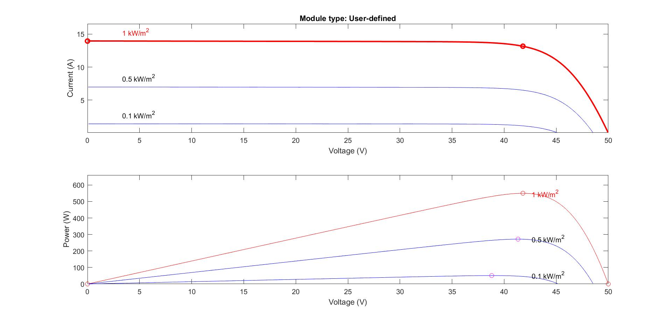

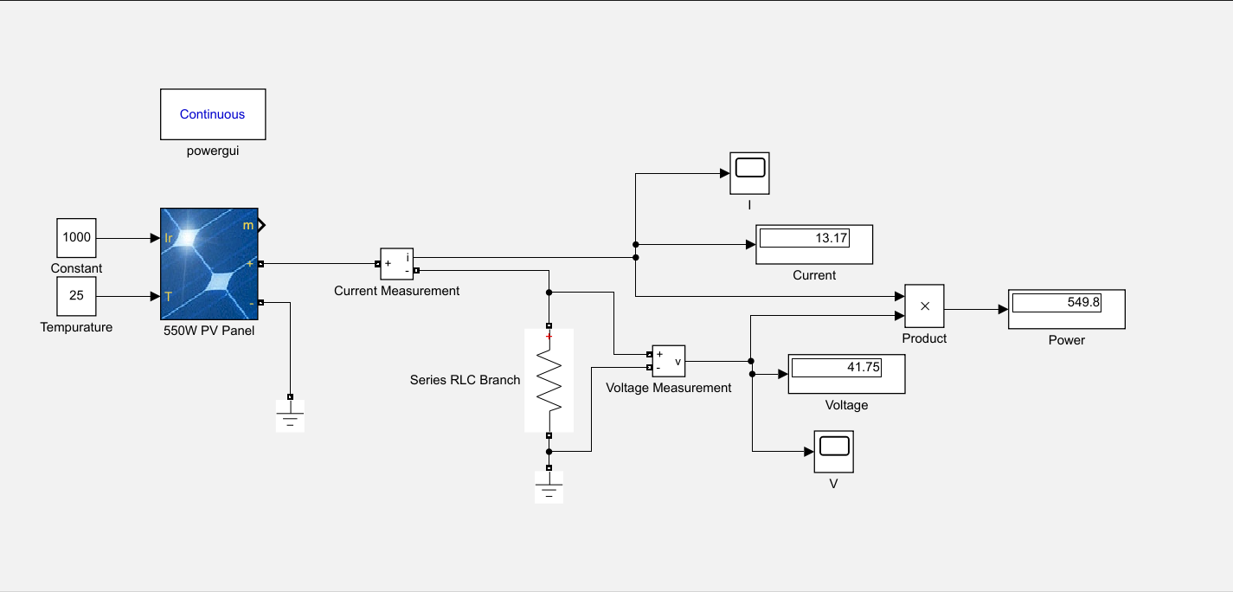

- Conclusion
Designing a 550 Watt solar PV module using MATLAB SIMULINK software involves modeling various aspects such as solar irradiance, temperature effects, MPPT algorithms, and performance analysis. By accurately simulating real-world conditions and optimizing design parameters, it is possible to develop efficient and reliable solar PV systems for renewable energy applications.

- Applications:
1. Residential Solar Power Systems: The solar PV module can be integrated into residential rooftops to generate electricity for household consumption. It can power lighting, appliances, and other electrical devices, reducing reliance on grid-supplied electricity and lowering utility bills.

2. Off-Grid Power Solutions: In remote areas or locations without access to the power grid, the solar PV module can serve as a primary source of electricity. It can power off-grid cabins, remote telecommunications equipment, water pumping systems, and other standalone applications.

3. Solar Street Lighting:The solar PV module can be utilized in solar street lighting systems to illuminate streets, pathways, parks, and other outdoor spaces. It provides sustainable and energy-efficient lighting solutions, reducing carbon emissions and operating costs.

4.Portable Solar Chargers: The compact and portable nature of the solar PV module makes it suitable for designing solar chargers for mobile phones, tablets, laptops, and other portable electronic devices. It enables users to harness solar energy for charging their devices on the go, ideal for outdoor activities, camping, and emergencies.

5. Solar-Powered Water Pumping Systems: The solar PV module can be integrated into water pumping systems for agricultural irrigation, livestock watering, and remote water supply applications. It offers a sustainable and cost-effective alternative to diesel-powered pumps, particularly in areas with abundant sunlight.

6. Educational Demonstrations: The designed solar PV module can be used for educational purposes in schools, colleges, and universities to demonstrate the principles of solar energy conversion, MPPT algorithms, and system optimization. It provides hands-on learning opportunities for students interested in renewable energy technologies.

These applications demonstrate the versatility and potential impact of the designed 550 Watt solar PV module across various sectors, contributing to sustainable development and energy independence.

