OBJECT: Efficiency of Transformers
Transformers are highly efficient devices used to step up or step down electrical voltage. Their primary function is to transfer electrical power from one circuit to another without changing the frequency.

Efficiency Definition
The efficiency of a transformer is the ratio of its output power to its input power. In ideal conditions, a transformer would have 100% efficiency, meaning all the input power would be converted to output power. However, in reality, some energy is lost due to various factors.

Factors Affecting Efficiency
- Copper Losses: These are caused by the resistance of the transformer's windings. As current flows through the windings, heat is generated due to this resistance.
- Iron Losses: These are also known as core losses and are divided into two types:
  - Hysteresis Loss: This occurs due to the magnetization and demagnetization of the core material as the magnetic flux changes.
  - Eddy Current Loss: These are circular currents induced in the core material due to the changing magnetic field.
- Stray Load Losses: These are due to leakage fluxes that do not contribute to the useful output power.
- Dielectric Losses: These occur in the insulating materials used in the transformer.

COMPONENTS

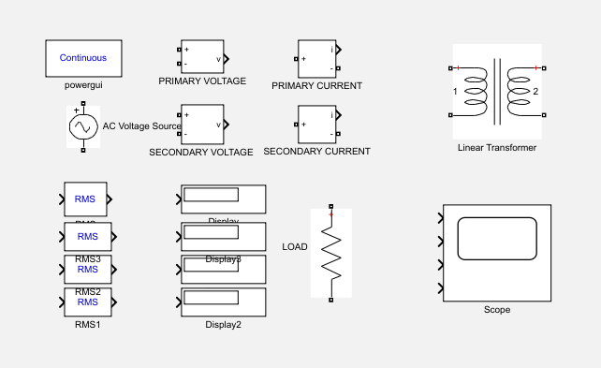

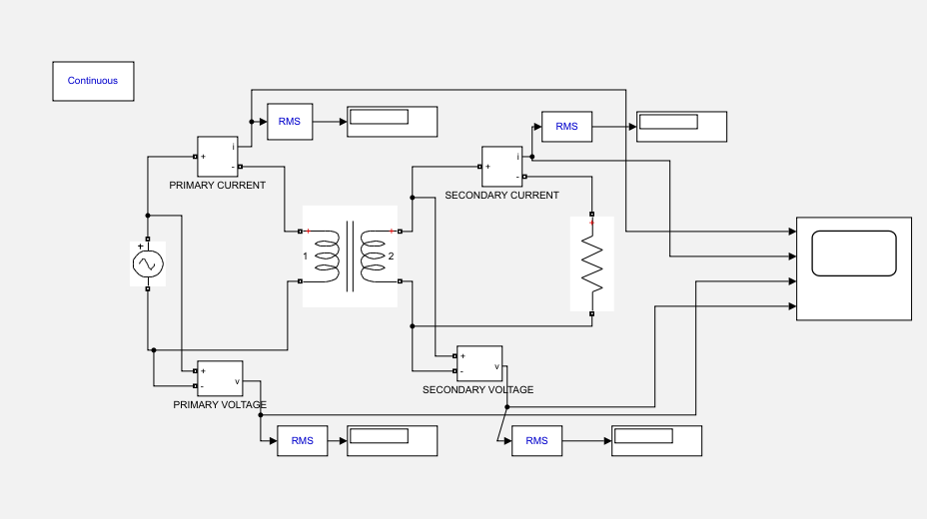
Circuit

SIMULATION

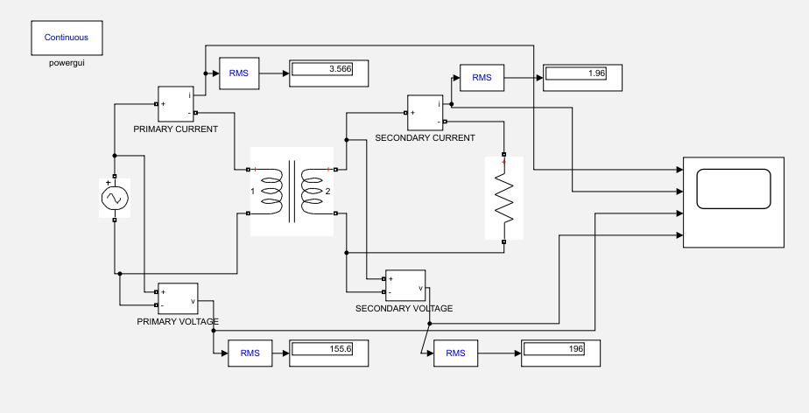

GRAPH
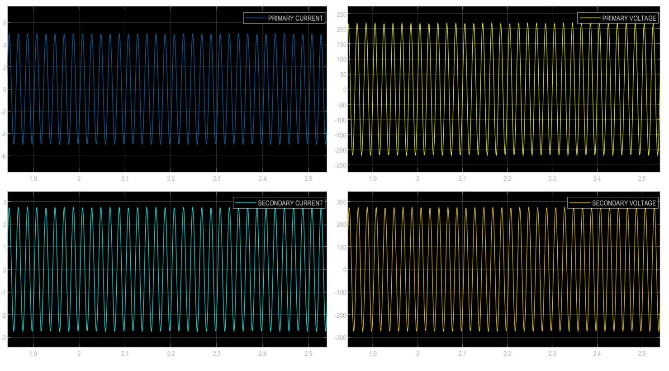

EQUATIONS & CALCULATIONS
• Efficiency (η) = (Output Power) / (Input Power)
• Output Power (Po) = (Vo * Io)
• Input Power (Pi) = (Vi * Ii)

Input Power = P₁ = V₁ * I₁= 155.6 x 3.556 = 553.31 W

Output Power = P₂= V₂ * I₂ = 196 x 1.96 = 384.16 W

Efficiency (η) = (Output Power) / (Input Power)

= P₂/P₁

= 384.16 / 553.31

= 0.69 x 100

= 69 %

Improving Efficiency
To improve the efficiency of a transformer, engineers employ various techniques:
- Using high-quality core materials with low hysteresis and eddy current losses.
- Optimizing the design of the windings to reduce copper losses.
- Using efficient cooling methods to dissipate heat generated by the losses.
- Minimizing stray load losses through careful design and construction.

Efficiency Importance
Transformers are essential components in power distribution systems. High efficiency is crucial to minimize energy losses and reduce operating costs. Additionally, efficient transformers contribute to a more sustainable and environmentally friendly power grid.
In conclusion, transformers are highly efficient devices that play a vital role in electrical power systems. By understanding the factors that affect their efficiency and implementing appropriate measures, engineers can ensure that these devices operate at their optimal performance levels.

