Simple Open‑Loop Offline UPS (1–2 kW) — Student Report
Course: Power Electronics | Complex Engineering Problem (CEP) Assignment
Fill the following and keep this cover on top:
Student Name | - Huzaifa | Roll No. | 22EL(ACE)06
Program / Semester | B.E/ 6th Semester | Course / Section | EL(ACE)/ (B)
Teacher Name | Dr. Waqar Adil Chohan | Date | 30.06.2025
Chosen Power Rating (kW) | 1.75 kW | Backup Time (hours) | 10 hours
Battery System Voltage | 48 V | Switching Frequency fs (kHz) | 15000

CEP Assignment Statement — Design & Simulation of a Residential Offline UPS (1–2 kW)
Problem Statement: Perform a residential load survey, choose a UPS rating (1–2 kW) and backup time, size the DC‑DC boost converter (L, C, device ratings) and battery bank, implement timed transfer logic (break‑before‑make), and demonstrate operation by plotting AC input, boost stage, and inverter stage in SIMULINK. Present calculations and resulting waveforms in the attached template.
Constraints and Considerations:
• Electrical: 230 V, 50 Hz system;
• Practical: Use standard component values; realistic battery configuration (24 V/48 V).
• Societal/Economic: Balance cost (battery size), simplicity of model; justify choices.
Deliverables:
1) Completed report template with load survey, specs, pre‑design calculations, and simulation plots.
2) Simulink model file with your parameter settings.
3) One‑page reflection on trade‑offs and limitations (fixed load with already tuned duty cycle).

1. Introduction
This assignment demonstrates the design and simulation of an open‑loop offline UPS for residential use. An offline UPS normally powers the load from the utility grid; when a grid outage occurs, it transfers the load to an inverter fed by a battery through a DC‑DC boost stage. The goals are to (i) survey household loads to select a 1–2 kW rating, (ii) size the DC‑DC boost converter passives using basic ripple constraints, (iii) run the provided Simulink model to simulate the transfer with dead‑time, and (iv) Include the key waveforms and calculated values.

2. Residential Load Survey (enter your house calculated values)
List your own appliances and usage. Compute power and daily energy, then pick a UPS power rating between 1 and 2 kW.
Appliance | Rated Power (W) | Qty | Use (h/day) | Rated×Qty (W) | Energy/day (Wh)
Fan | 80 | 2 | 10 | = 80 × 2 | =160×10
Bulbs | 12 | 6 | 10 | = 12 x 6 | = 72 x 10
Air Conditioner | 1200 | 1 | 10 | = 1200 x 1 | = 1200 x 10
Refrigerator | 300 | 1 | 10 | = 300 x 1 | = 300 x 10
Totals (compute and fill):
Total Coincident Power (W): 1732 W | Total Energy (Wh/day): 1732 x 10

3. Design Specifications (fill)
AC Input (Vrms, Hz) | 220–230 V, 50 Hz | UPS Output (Vrms, Hz) | 220–230 V, 50 Hz
Chosen UPS Rating (kW) | 1.75 kW | Backup Time (hours) | 10
Battery Chemistry | Lead‑acid / Li‑ion | Battery System Voltage | 48 V
DC Bus Target Vdc (V) | 325.27 | Boost fs (kHz) | 15000

4. Boost Converter Pre‑Design (fill)
4.1 Duty Cycle (ideal): D = 1 − Vin/Vout → D = 0.79
4.2 Inductor (CCM): L _{min} → L = 3.038e-05 (choose std: µ)
4.3 Output Capacitor: C → C = 1.00e-09 (choose std: n )

5. How to Run the Model
1) Open the Simulink model. 2) Set t_outage, t_restore, t_transfer in Model Workspace. 3) Enter your load (Power rating in kW). 4) Set fs in the boost PWM/Pulse Generator. 5) Run 1 s simulation. 6) Use Scopes to display and include the waveforms below.
SIMULATION MODEL:
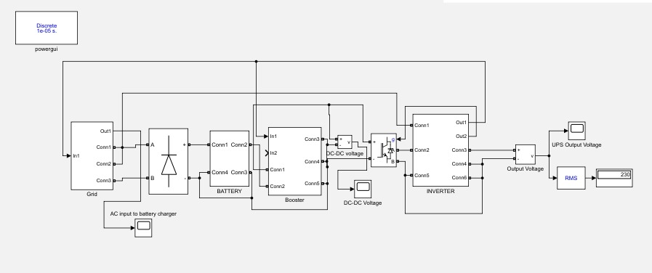

6. Simulation Results (paste figures and fill)

6.1 AC Input (Grid) — Voltage
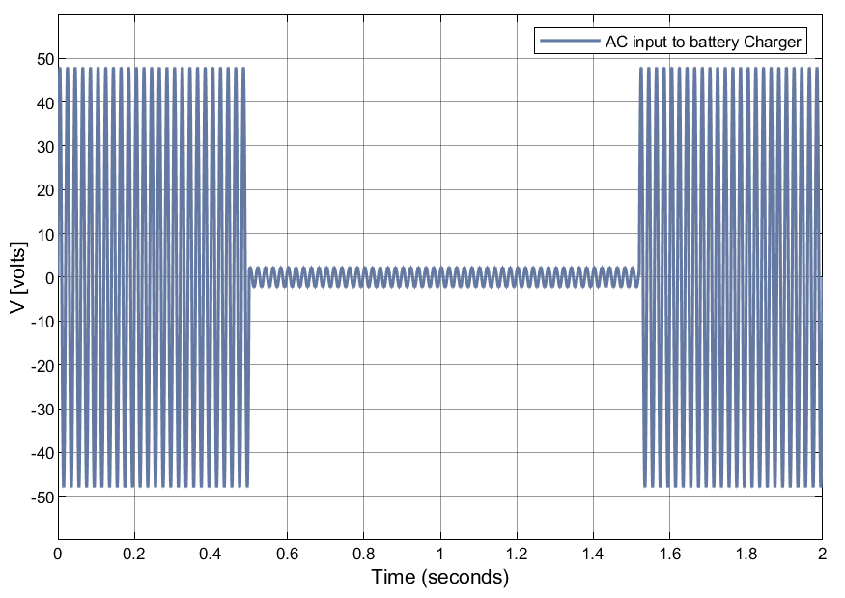
Observation (2–3 lines): As we can see that grid voltage is disconnected at 0.5s so the voltage becomes zero as you can see on the graph and then grid voltage is reconnected at 1.5s.

6.2 DC‑DC Boost Stage — Vin, Vout.
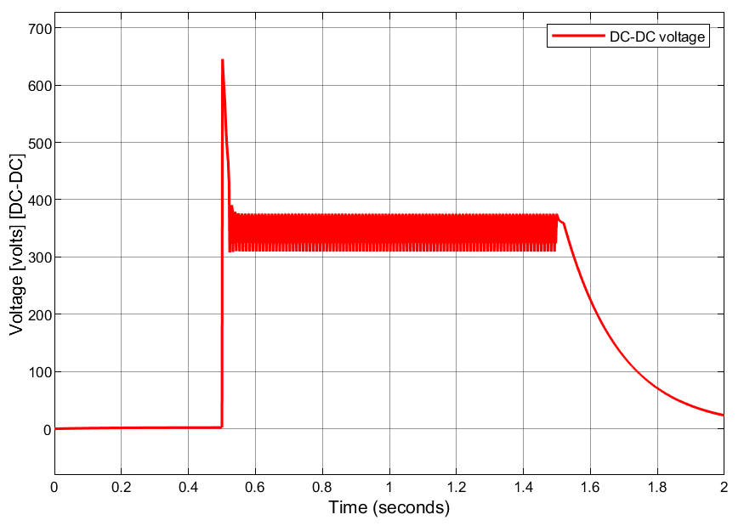
 | Min | Max | Avg / RMS
V_out (V) | 310 | 380 | 50
Comment (1–2 lines): When the grid voltage is cut-off at 0.5s so you see that the UPS is on and the DC booster step up the voltage suddenly to 650V but take 380V as Vmax cause the output is max at steady state and when the grid is connected at 1.5s, then the voltage is decreased to 50V as per requirement.

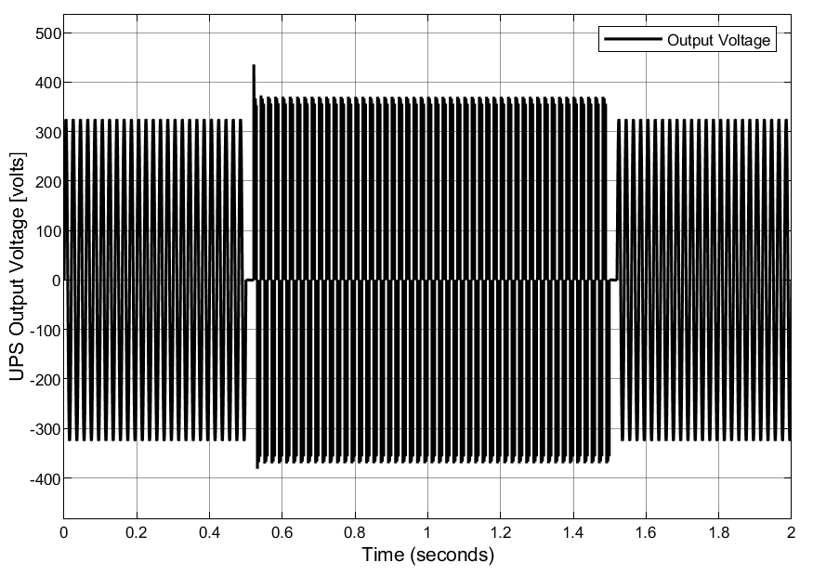
6.3 DC‑AC Inverter — Output Voltage & Load Current

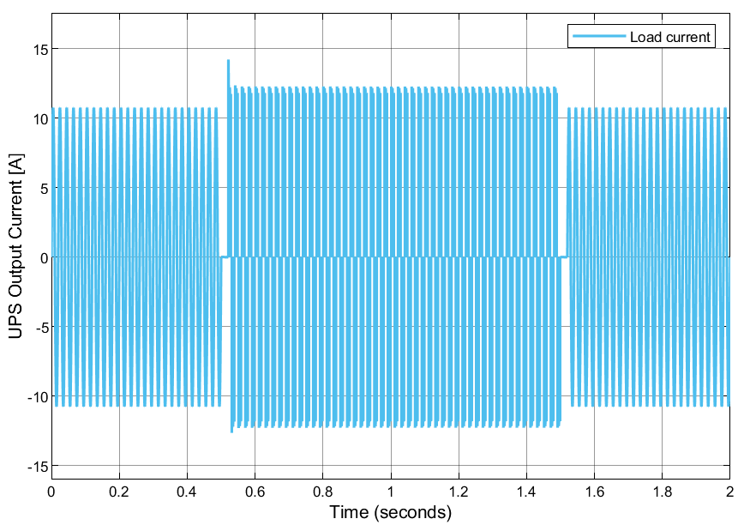
 | Peak | RMS | Notes
V_out (V) | 380 | 230 | ___
I_load (A) | 12 | 7.6 | ___

7. Discussion (4–6 lines)
Comment on transfer behavior (dead‑time, no overlap), boost regulation (difference between calculated value and manually tuned value), inverter output quality.
The transfer behavior of the UPS is 0.1ms. And there is no overlapping in the conversion of voltage , so it ensures the safety and power quality.
The difference between calculated and manually valued must be very low. A closer match indicates good design and accurate modeling, while larger differences suggest stronger parasitic or control issues.

8. Assumptions & Safety Notes
• Ideal switches used; snubbers/high‑R bleeders added for numerical stability.
• Battery always connected to inverter; charger disconnected during outage.
• Component ratings exceed calculated stresses with ≥30% margin.
• Thermal/protection design out of scope for this open‑loop study.

9. Conclusion (2–3 lines)
Thus, the UPS design met the requirement for my residential load. And its work perfectly. Transfer behavior was stable, with short dead-time and no overlap, ensuring smooth changeover without damaging overlap currents.
If my load consumption increases in future so I’ll have to planned to built a UPS using Feedback controlled because it has great stability , efficiency, reliability over different load conditions.

10. Student Declaration
I, M.Huzaifa , confirm that this work reflects simulation and calculations of my own home load.

Roll Number: 22EL(ACE)06
Signature: ______________________

