I’ve had this wireless digital thermometer/hygrometer for a while now – we keep it in our kitchen so we can quickly see the temperature outside and know how to dress the kids if they need snow pants or just a light jacket, or if it is warm enough to run around in the sprinklers as was the case today. The device came with 3 sensors which I have located in a few places throughout the house.

I have also had a software defined radio (RTL-SDR) dongle laying around that I experimented with a few years ago. I had fun trying to listen in on ham radio communications and a few shortwave stations. I was able to pick up a broadcast in New Zealand once with a long string of garage door opener wire strung across the house.

Earlier this week after coffee time, I was wondering if I could see the signal coming from my cheap weather station. It turns out that 433Mhz is a standard frequency for these and many other devices.

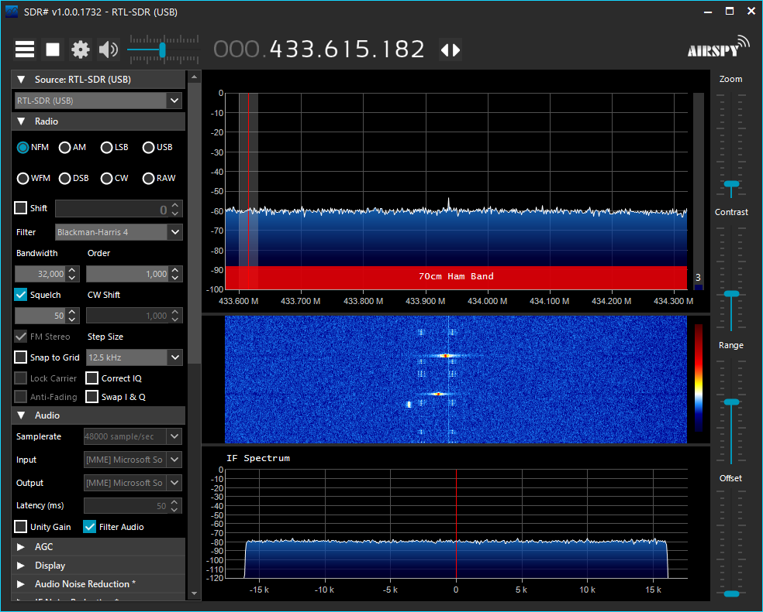

So then I started wondering if it would be possible to decode such signals and it turns out that there is a really awesome command line utility that does exactly this: RTL_433.