* **Network**: A *network* is a collection of computers and other devices that can send data to and receive data from one another, more or less in real time.
* All modern computer networks are *packet-switched* networks: data traveling on the network is broken into chunks called *packets* and each packet is handled separately.

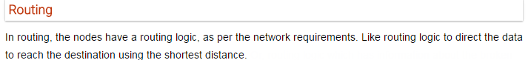



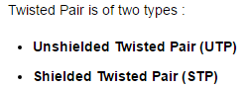



ISO: International Organization for Standardization

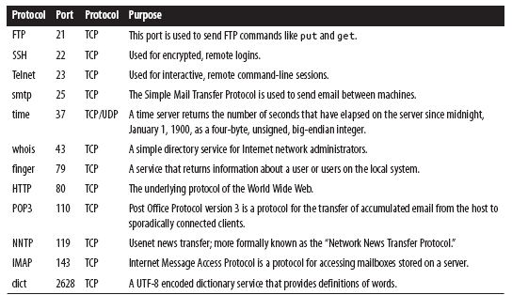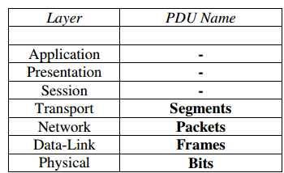

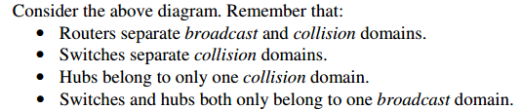

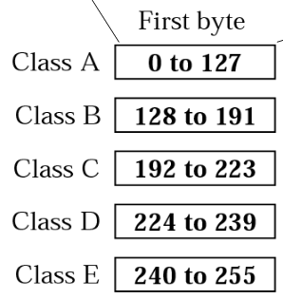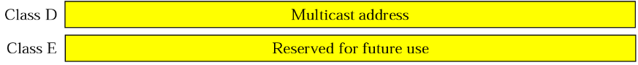

* **Usability** is the effectiveness, efficiency and satisfaction with which specific users can achieve a specific set of tasks in a particular environment
* Port numbers range from 0 to 65,535 because ports are represented by 16-bit numbers. The port numbers ranging from 0 - 1023 are restricted; they are reserved for use by well-known services such as HTTP and FTP and other system services. These ports are called *well-known ports*

Data Structures

* **Bubble sort:** O(n square)
* **Insertion sort:** Worst Case Time Complexity : **O(n2),**Best Case Time Complexity : **O(n),** Average Time Complexity : **O(n2)**
* **Selection Sort:** Worst Case Time Complexity : **O(n2),** Best Case Time Complexity : **O(n2),** Average Time Complexity : **O(n2**)
* **Quick Sort:** Worst Case Time Complexity **: O(n2),** Best Case Time Complexity : **O(n log n),** Average Time Complexity : **O(n log n)**
* **Merge Sort:** Worst Case Time Complexity : **O(n log n),** Best Case Time Complexity : **O(n log n),** Average Time Complexity : **O(n log n)**
* **Heap Sort:** Worst Case Time Complexity : **O(n log n),** Best Case Time Complexity : **O(n log n),** Average Time Complexity : **O(n log n)**

**Operating System:**

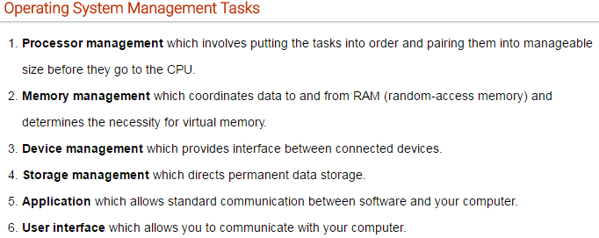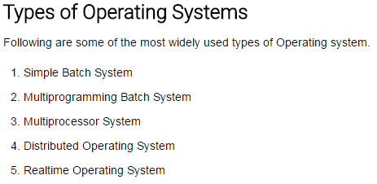



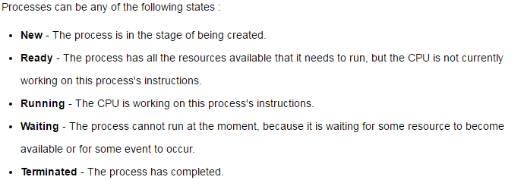



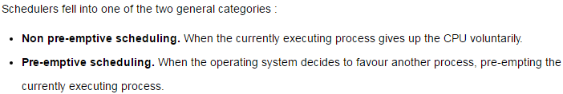

**CPU SCHEDULING ALGORITMS**

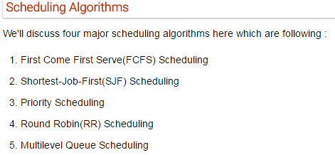

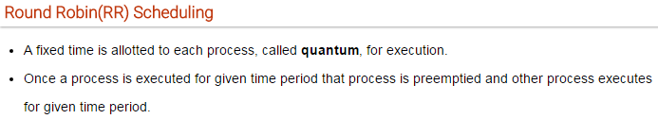

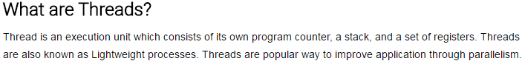



* **Mutual Exclusion**
* **Hold and Wait**
* **No Preemption**
* **Circular Wait**



* **Preemption**
* **Rollback**
* **Kill one or more processes**



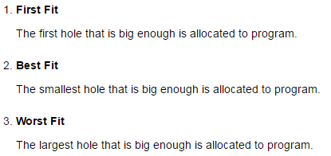

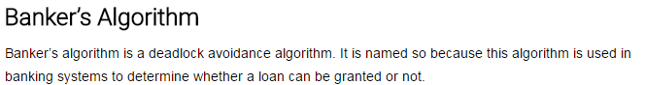

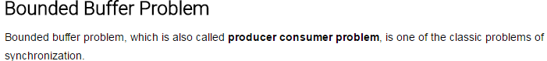

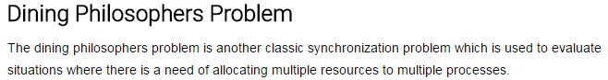

**Linux commands:**

* **grep** ­ print lines matching a pattern
* **wc** ­ print the number of newlines, words, and bytes in files
* **df**– report filesystem disk space usage
* **scp**– secure copy (remote file copy program)
* **ssh** – SSH client (remote login program) ssh – SSH client (remote login program)
* **ps** – report a snapshot of the current processes
* **chown** – change file owner and group

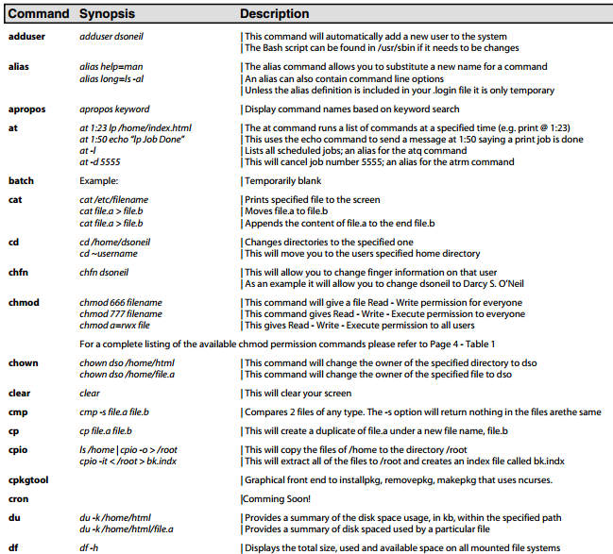

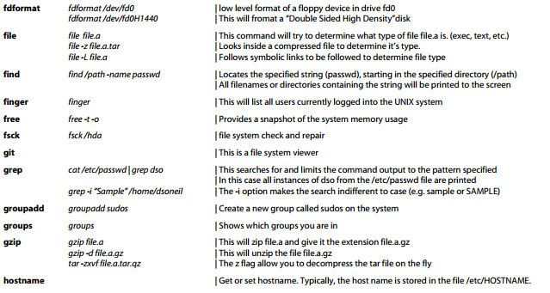

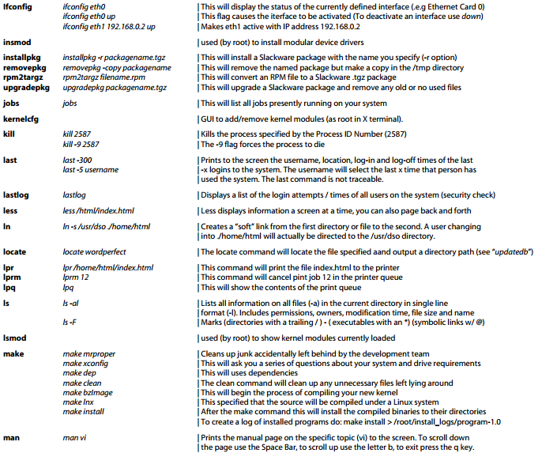

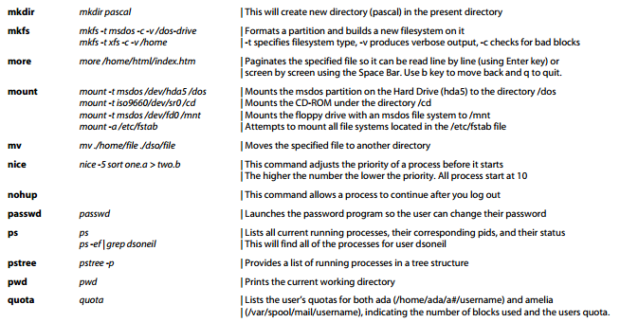

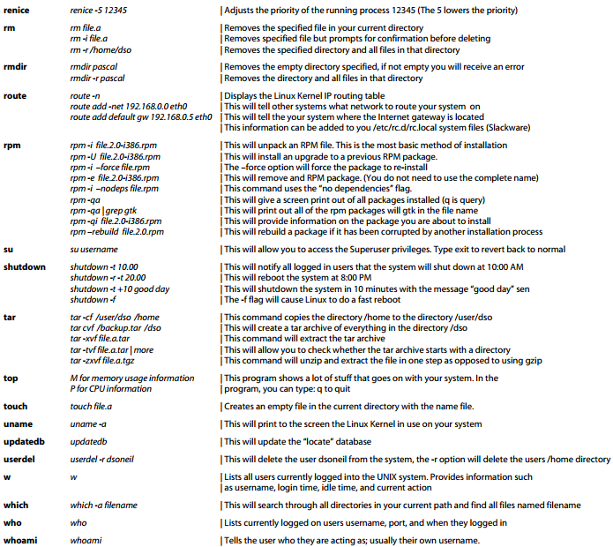

C++

* typedef int feet; can create new name for an existing type using typedef
* sizeof(int,Bool,char etc.) will produce correct size
* **#define LENGTH 10//** use #define preprocessor to define a constant
* **const int LENGTH** **= 10;**//use **const** prefix to declare constants with a specific type
* **strcpy(s1, s2);//**Copies string s2 into string s1.
* **strcat(s1, s2);** //Concatenates string s2 onto the end of string s1.
* **strlen(s1);** //Returns the length of string s1.
* **strcmp(s1, s2);** //Returns 0 if s1 and s2 are the same; less than 0 if s1<s2; greater than 0 if s1>s2.
* **strchr(s1, ch);** //Returns a pointer to the first occurrence of character ch in string s1
* **strstr(s1, s2);** //Returns a pointer to the first occurrence of string s2 in string s1.
* A C++ class can inherit members from more than one class
* Class derived-class: access baseA, access baseB....

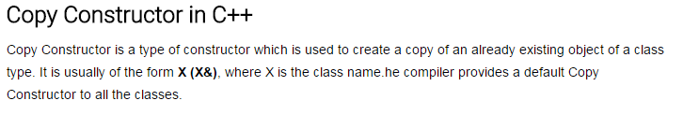

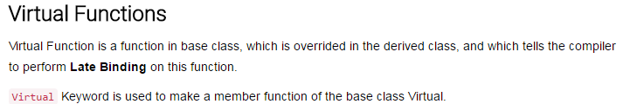

**C**

* A **pointer** is a variable whose value is the address of another variable
* int *ip; // pointer to an integer

**Switch Statement: 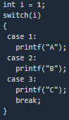 Structure:** 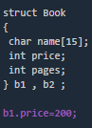

**Arrays:** 