**Computer Architecture:**

Introduction to modern machine Architecture,

Storage Hierarchy: registers->L1 cache -> L2 Cache-> RAM-> secondary mem

Main / Virtual / Cache / Secondary memory: A **Cache memory** is a high-speed memory which is used to reduce the access time for data. On the other hands, **Virtual memory** is not exactly a physical memory it is a technique which extends the capacity of the main memory beyond its limit.

CPU:

ALU,

Peripheral communication,

Designing of instruction set,

Stored programmer concept,

Introduction to parallel computing,

SIMD / MIMD

**Operating system**:

Functions / Types of operating systems: An operating system (OS) is a software, that manages the computer hardware, and provides common services for execution of various programs

Processes:

Inter-processes Communication / Synchronization / Coordination,

Process Scheduling Policies: First Come, First served (FCFS)(FIFO), Round Robin (RR), Shortest Process Next (SPN) (Shortest Job First (SPF)), Preemptive Shortest Process Next (PSPN), Multiple-level Feedback (FB)

Visual Memory Management Techniques: Memory management is part of an operating system which allocates memory among competing processes, maximizing memory utilization and system throughput.

Base and limit registers, Virtual memory, Swapping (A process can be swapped temporarily), Segmentation (partition an address space into logical units • stack, code, heap, subroutines. Breaking up the memory into smaller chucks increases chances of finding free memory), Paging (Sometimes the available memory is broken up into lots of little pieces, none of which is big enough to satisfy the next memory requirement, although the sum total could. Paging divides physical memory into a number of equal sized blocks called frames and divides a process’s logical memory space into equal sized blocks called pages)

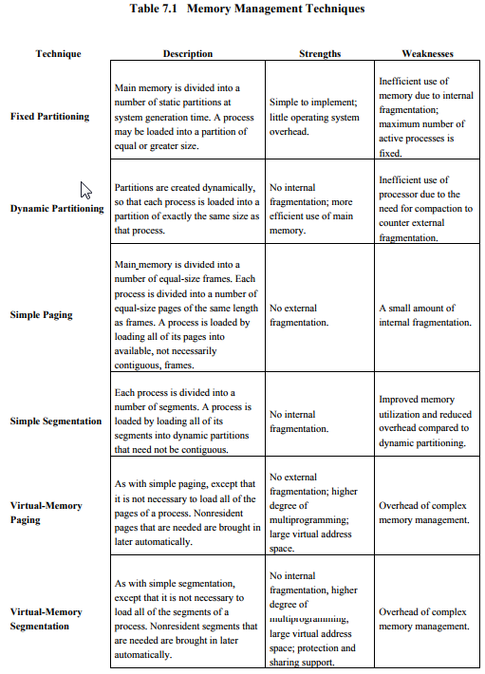

Paging / Segmentation:

File Management Systems

**Computer Networks:**

LAN / WAN / MAN,

Communication channels,

Internetworking,

Internet,

Network layer structure,

ISO Internet Protocol,

OSI / TCP / IP reference model

Structured and Object Oriented Programming Basics of C/C++ environment,

Memory concepts,

Operators,

Control structures,

Selection structures,

Array & functions / methods,

Classes & data abstractions,

Inheritance and polymorphism Data Structures and Algorithms Pseudo language,

Functions,

Iteration,

Recursion,

Time / complexity analysis,

Stacks queue,

Hashing,

Linked list,

Searching,

Sequential,

Binary Trees: A **full binary tree** is a binary tree in which each node has exactly zero or two children. A **complete binary tree** is a binary tree, which is completely filled, with the possible exception of the bottom level, which is filled from left to right.

 BST is a binary tree where nodes are ordered in the following way:

* each node contains one key (also known as data)
* the keys in the left subtree are less then the key in its parent node, in short L < P;
* the keys in the right subtree are greater the key in its parent node, in short P < R;
* duplicate keys are not allowed.

Sorting algorithms,

Graphic algorithms,

Tree algorithms,

Trees,

ADTs,

Implementation using structured / object oriented languages

**Software Engineering:**

Introduction to software engineering,

Software life cycle,

Software design methodologies,

Structured / object oriented,

Software documentation and management,

Introduction to CASE tools

**Database Management**

Data,

Models,

E R Models,

Relational Database concepts,

SQL normalization,

Database Design

Web Programming

HTML, CGI, PERL, JAVA, Applet / Script, WWW, Web based interface design

Computer Graphics

Fundamentals of input,

Display and hard copy devices,

Scan conversion of geometric primitives,

2D and 3D geometric transformations,

Clipping and windowing,

Scene modeling and animation,

Algorithms for visible and surface determination

