1.What are the two values of the Boolean data type? How do you write them?

* The two Boolean data types are **True** and **False** .
* It isvery important to captilise the letter ‘T”as in True and ‘F” as in False. Any expression can be evaluated using Boolean values. Once the expression is evaluated, python returns the Boolean values.

2. What are the three different types of Boolean operators?

* The three operators are and , or , not

They are used to compare the values . Once evaluates the expression and returns Boolean values .

3. Make a list of each Boolean operator's truth tables (i.e. every possible combination of Boolean values for the operator and what it evaluate ).

Truth table with example

|  |  |  |  |  |  |  |  |
| --- | --- | --- | --- | --- | --- | --- | --- |
| = = Truth table | | AND Truth Table | | OR Truth Table | | NOT Truth Table | |
| 3 ==3 | True | 5>3 and 5 == 5 | True | 5 >3 or 5 == 5 | True | not 5<3 | True |
| 3==2 | False | 5< 3 and 5 == 5 | False | 5 > 3 or 5 != 5 | True | not 5>3 | False |
| 2==(5>4) | False | 5==3 and 5<3 | False | 5<3 or 5 == 5 | True |  |  |
| (2>4)==(5>6) | True | 5==3 and 3>5 | False | 5<3 or 5 != 5 | False |  |  |

4. What are the values of the following expressions?

(5 > 4) and (3 == 5)

False

not (5 > 4)

False

(5 > 4) or (3 == 5)

True

not ((5 > 4) or (3 == 5))

False

(True and True) and (True == False)

False

(not False) or (not True)

True

5. What are the six comparison operators?

|  |  |  |
| --- | --- | --- |
| Symbol | Bool | Operation |
| 5>3 | False | Greater than |
| 5<3 | True | Less than |
| 3>=5 | False | Greater than or equal to |
| 3=<5 | True | Less than or equal to |
| 3==5 | False | Equal to |
| 3!=5 | True | Not equal |

6. How do you tell the difference between the equal to and assignment operators?Describe a condition and when you would use one.

The equal to “=” is an assignment operator is used to assign the value on the right to the variable on the left.

The assignment ‘==’ operator checks whether the two given operands are equal or not. If so, it returns true. Otherwise it returns false.

7. Identify the three blocks in this code:

spam = 0

if spam == 10:

print('eggs')

if spam > 5:

print('bacon')

else:

print('ham')

print('spam')

print('spam')

ham

spam

spam

8. Write code that prints Hello if 1 is stored in spam, prints Howdy if 2 is stored in spam, and prints Greetings! if anything else is stored in spam.

spam = 1

if spam == 1:

print('Hello')

spam = 2

if spam == 2:

print('Howdy')

else:

print('Greetings')

9.If your programme is stuck in an endless loop, what keys you’ll press?

Use **ctrl+C** to end the loop

10. How can you tell the difference between break and continue?

Break command is used for sudden termination of the loop.

Continue command is used for stopping a particular iteration in a loop. After the code is skipped, the iteration still continues.

11. In a for loop, what is the difference between range(10), range(0, 10), and range(0, 10, 1)?

range(10), range(0, 10), and range(0, 10, 1) gives

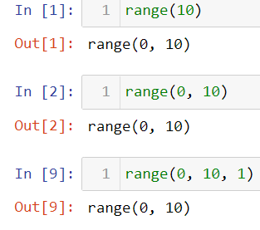

range(stop) -> range object

range(start, stop[, step]) -> range object

In all these cases, 0 is the start, 10 is the stop and the step by default is by 1. But in no case range object stops before the specified number. Here range object stops at 9.

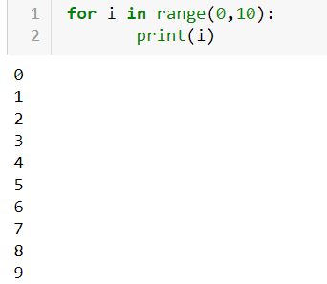

12. Write a short program that prints the numbers 1 to 10 using a for loop. Then write an equivalent program that prints the numbers 1 to 10 using a while loop.

For loop

print('Numbers from 1 to 10')

for N in range(1,11):

print(N)

while loop

print('Numbers from 1 to 10')

N=1

while N<=10:

print(N)

N=N+1

13. If you had a function named bacon() inside a module named spam, how would you call it after importing spam? Spam.bacon()