1. What does an empty dictionary's code look like?

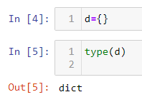

2. What is the value of a dictionary value with the key 'foo' and the value 42?

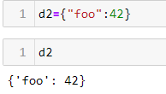

3. What is the most significant distinction between a dictionary and a list?

We can not add two dictionaries

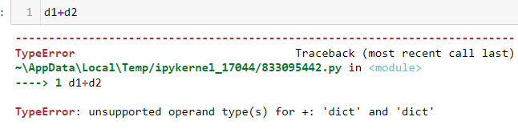

We can add two lists

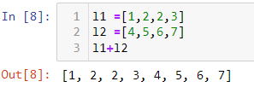

4. What happens if you try to access spam['foo'] if spam is {'bar': 100}?

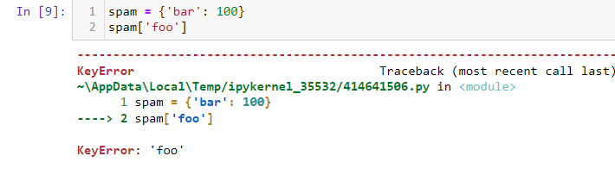

It throws a Key Error.

5. If a dictionary is stored in spam, what is the difference between the expressions 'cat' in spam and 'cat' in spam.keys()?

'cat' in spam.keys()

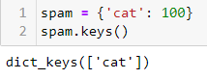

'cat' in spam



6. If a dictionary is stored in spam, what is the difference between the expressions 'cat' in spam and 'cat' in spam.values()?

'cat' in spam.values()

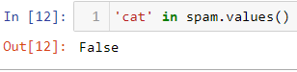



7. What is a shortcut for the following code?

if 'color' not in spam:

spam['color'] = 'black'

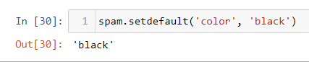

8. How do you "pretty print" dictionary values using which module and function?

pprint()