1. What are escape characters, and how do you use them?

The escape character allows you to use double quotes when you normally would not be allowed. Example –



2. What do the escape characters n and t stand for?

\n - Newline

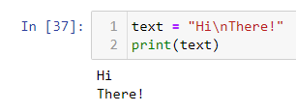

\t- tab

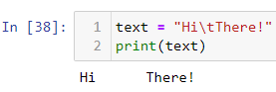

3. What is the way to include backslash characters in a string?

It can be included as shown below



4. The string "Howl's Moving Castle" is a correct value. Why isn't the single quote character in the word Howl's not escaped a problem?

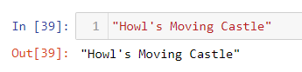

String is within double quotes

5. How do you write a string of newlines if you don't want to use the n character?

Mutlilines, as shown below

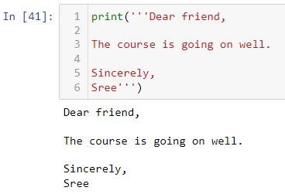

6. What are the values of the given expressions?

'Hello, world!'[1]

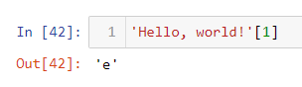

'Hello, world!'[0:5]



'Hello, world!'[:5]



'Hello, world!'[3:]

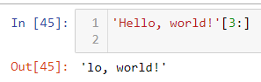

7. What are the values of the following expressions?

'Hello'.upper()

'HELLO'

'Hello'.upper().isupper()

True

'Hello'.upper().lower()

'hello'

8. What are the values of the following expressions?

'Remember, remember, the fifth of July.'.split()

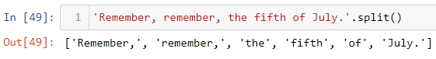

'-'.join('There can only one.'.split())

'There-can-only-one.'

9. What are the methods for right-justifying, left-justifying, and centering a string?

rjust()

ljust()

center()

10. What is the best way to remove whitespace characters from the start or end?

lstrip()

rslip()