1. Is the Python Standard Library included with PyInputPlus?

Yes. PyInputPlus is a Python module used for taking inputs with additional validation features. PyInputPlus will keep asking the user for text until they enter valid input.

2. Why is PyInputPlus commonly imported with import pyinputplus as pypi?

Because we can enter a shorter name when calling the module’s functions

3. How do you distinguish between inputInt() and inputFloat()?

When you want the user to type in a decimal use float(input()) , if you want the user to type in an integer use int(input()).

4. Using PyInputPlus, how do you ensure that the user enters a whole number between 0 and 99?

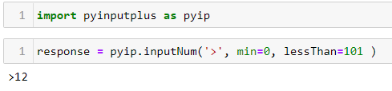

5. What is transferred to the keyword arguments allowRegexes and blockRegexes?

The allowRegexes and blockRegexes keyword arguments take a list of regular expression strings to determine what the PyInputPlus function will accept or reject as valid input.

6. If a blank input is entered three times, what does inputStr(limit=3) do?

it raises a RetryLimitException

7. If blank input is entered three times, what does inputStr(limit=3, default='hello') do?

Function returns the default value instead of raising an exception