18-SE-11
Muhammad Afzaal

Task 1
Program 9-1 accepts arguments list as from command line and then displays arguments count and arguments one by one

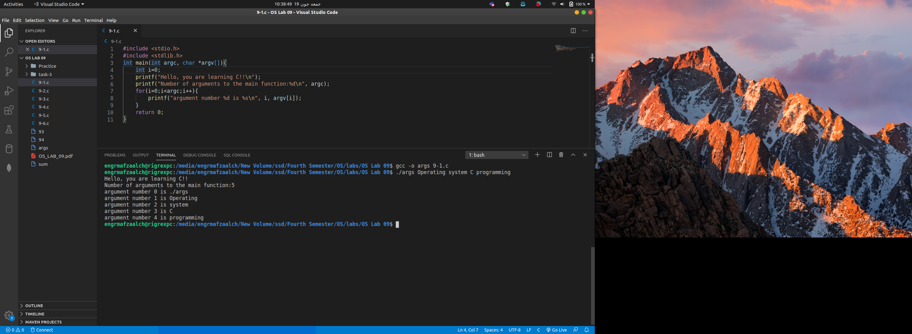

Program 9-2 accepts arguments list as from command line and built in environment variables list and then displays arguments count, arguments and environment variables one by one

Task 2
part 1

The difference b/w “program 9-3” and “program 9-4” is that
Program 9-3 prints the all files and folders in long listing form of current folder where as
Program 9-4 prints the all files and folders in long listing form of root( / ) folder because there we passed “/’ as an argument.

Program 9-3
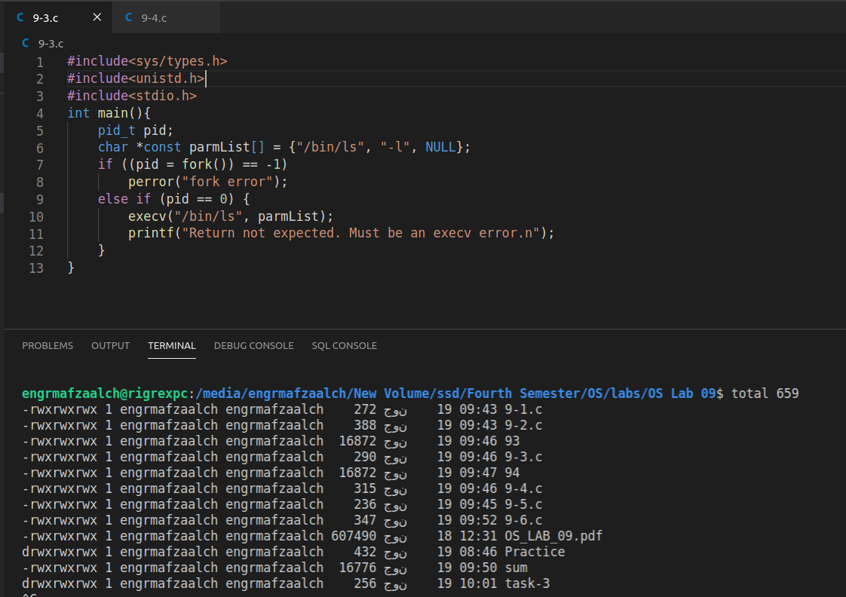

Program 9-4



