**PROJECTED TD REPORT (Automated)**

IMPORTANT!!

Unzip the “ProjectedTD.zip” file then put its content (ProjectedTD folder) on your **Desktop** folder.

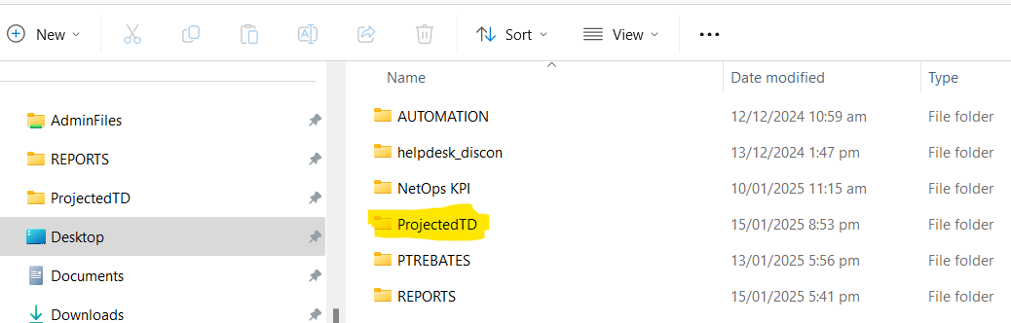

Step 1: CHECK IF THERE ARE INCOMPLETE DETAILS:

Go to 'scripts' folder. Run "incompletedetails.py" script. When the script has been executed, open the "ntr.xlsx" file inside ProjectedTD folder and go to sheet "INCOMPLETE DETAILS". Endorse to Netmon those with blank TS End, negative Duration, blank Category, blank Cause.

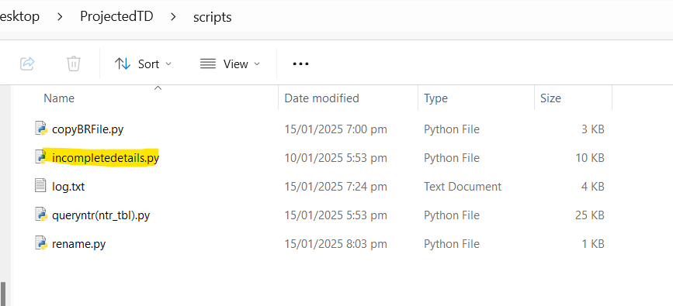

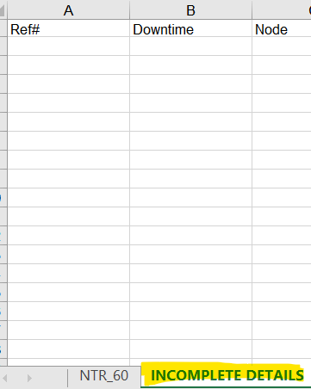

If the details are already complete or if there are no incomplete details, proceed to Step 2.

Step 2: Download the BR file from email. Put the BR file inside ProjectedTD folder.

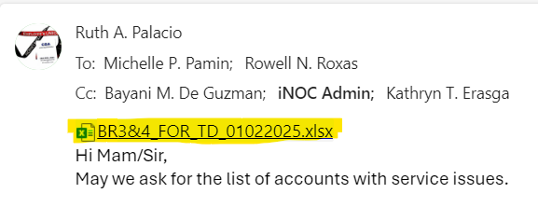

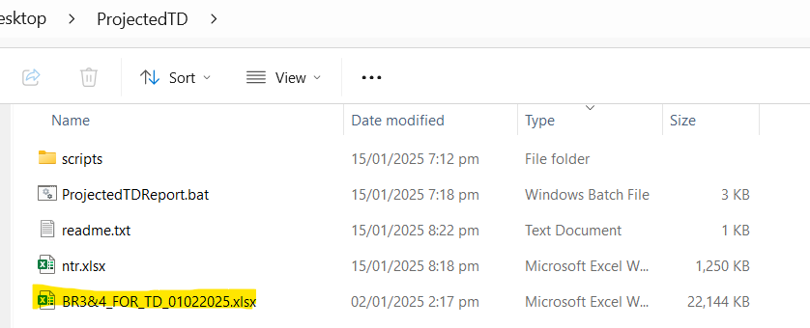

Step 3: Run "ProjectedTDReport.bat" file. Wait until the execution of scripts is done. It will then create a new file "TD_(currentdate).xlsx".

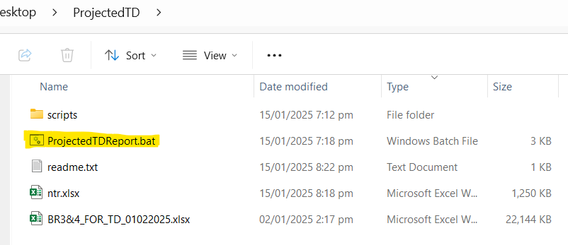

Step 4: Open the TD_(currentdate).xlsx file and check if there are errors or missing data. Once you’re done checking the file, rename it with ‘almost’ same filename as the original and email it.

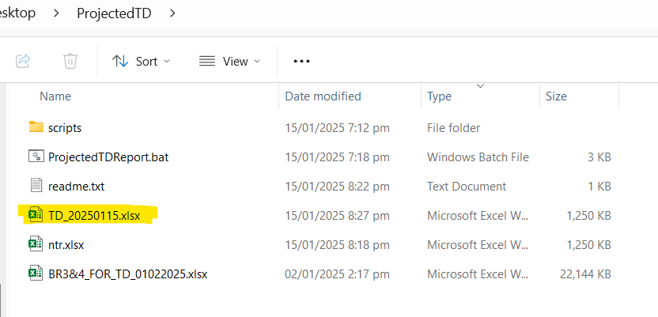

**Note: TD_20250115** was renamed to **BR3&4_FOR_TD 01022025**

