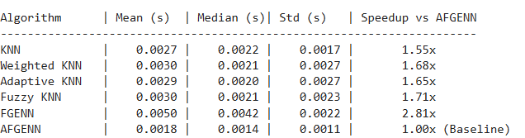

Algorithm | Mean (s) | Median (s)| Std (s) | Speedup vs AFGENN
----------------------------------------------------------------------
KNN | 0.0027 | 0.0022 | 0.0017 | 1.55x
Weighted KNN | 0.0030 | 0.0021 | 0.0027 | 1.68x
Adaptive KNN | 0.0029 | 0.0020 | 0.0027 | 1.65x
Fuzzy KNN | 0.0030 | 0.0021 | 0.0023 | 1.71x
FGENN | 0.0050 | 0.0042 | 0.0022 | 2.81x
AFGENN | 0.0018 | 0.0014 | 0.0011 | 1.00x (Baseline)

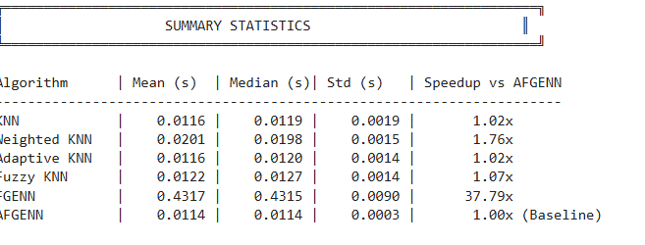 Algorithm | Mean (s) | Median (s)| Std (s) | Speedup vs AFGENN
----------------------------------------------------------------------
KNN | 0.0116 | 0.0119 | 0.0019 | 1.02x
Weighted KNN | 0.0201 | 0.0198 | 0.0015 | 1.76x
Adaptive KNN | 0.0116 | 0.0120 | 0.0014 | 1.02x
Fuzzy KNN | 0.0122 | 0.0127 | 0.0014 | 1.07x
FGENN | 0.4317 | 0.4315 | 0.0090 | 37.79x
AFGENN | 0.0114 | 0.0114 | 0.0003 | 1.00x (Baseline)

RESULTS - COVTYPE
==========================================================================
Algorithm HoldAcc CV Mean Macro-F1 Kappa Boundary Rank Time(s)
-----------------------------------------------------------------------------------------------
KNN 64.67% 64.20% 0.3672 0.4081 57.00% 4.00 0.1224
Weighted KNN 67.33% 68.40% 0.5776 0.4635 55.56% 2.20 0.1287
Fuzzy KNN 68.33% 69.10% 0.5779 0.4838 54.11% 1.60 0.1142
Adaptive KNN 64.00% 63.10% 0.3750 0.3983 56.04% 5.60 0.0948
FGENN 62.00% 67.80% 0.5099 0.3896 44.93% 5.00 0.0284
AFGENN 69.12% 69.60% 0.5818 0.4959 59.11% 1.00 17.4189 <-- AFGENN
-----------------------------------------------------------------------------------------------
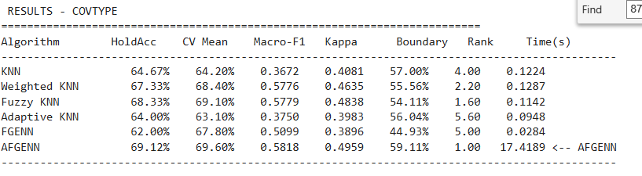

==========================================================================
RESULTS - IRIS DATASET
==========================================================================
Algorithm HoldAcc CV Mean Macro-F1 Kappa Boundary Rank Time(s)
-----------------------------------------------------------------------------------------------
KNN 91.11% 93.33% 0.9111 0.8667 50.00% 3.60 0.0114
Weighted KNN 93.33% 93.33% 0.9333 0.9000 50.00% 2.80 0.0117
Fuzzy KNN 95.56% 93.33% 0.9554 0.9333 50.00% 4.00 0.0106
Adaptive KNN 91.11% 94.67% 0.9111 0.8667 50.00% 4.80 0.0231
FGENN 97.78% 94.00% 0.9778 0.9667 75.00% 3.20 0.0250
AFGENN 97.78% 96.67% 0.9778 0.9667 75.00% 2.60 0.1224 <-- AFGENN
-----------------------------------------------------------------------------------------------
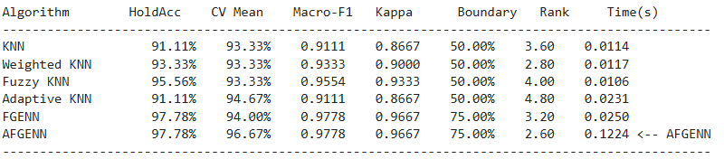
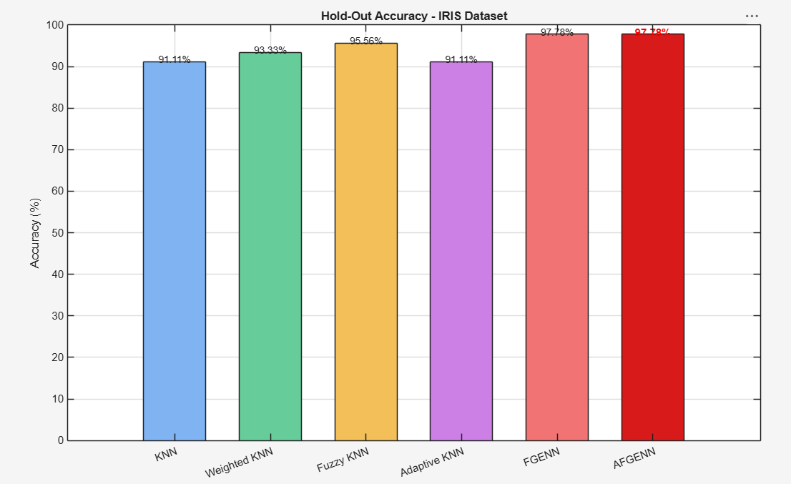

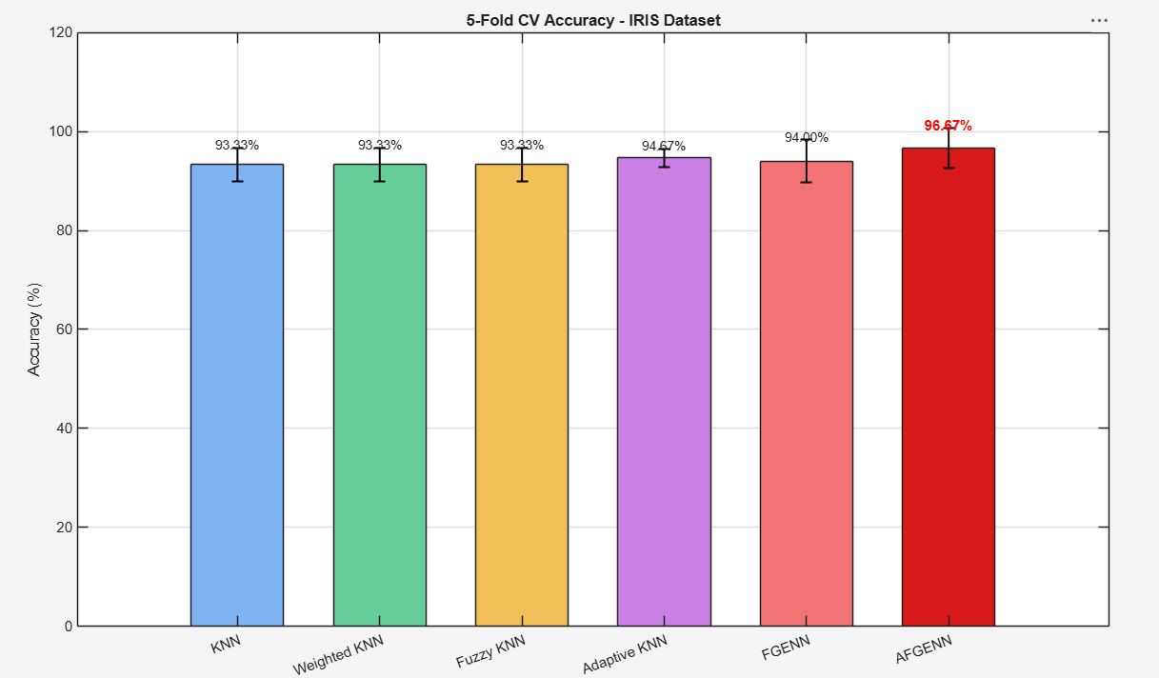

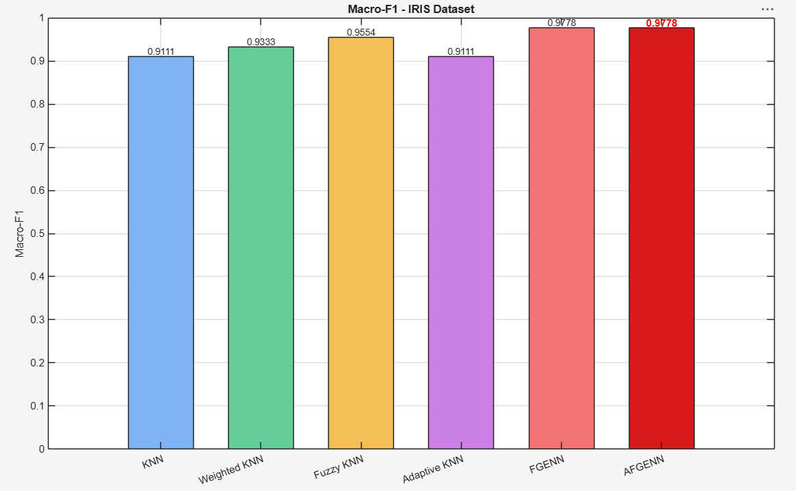

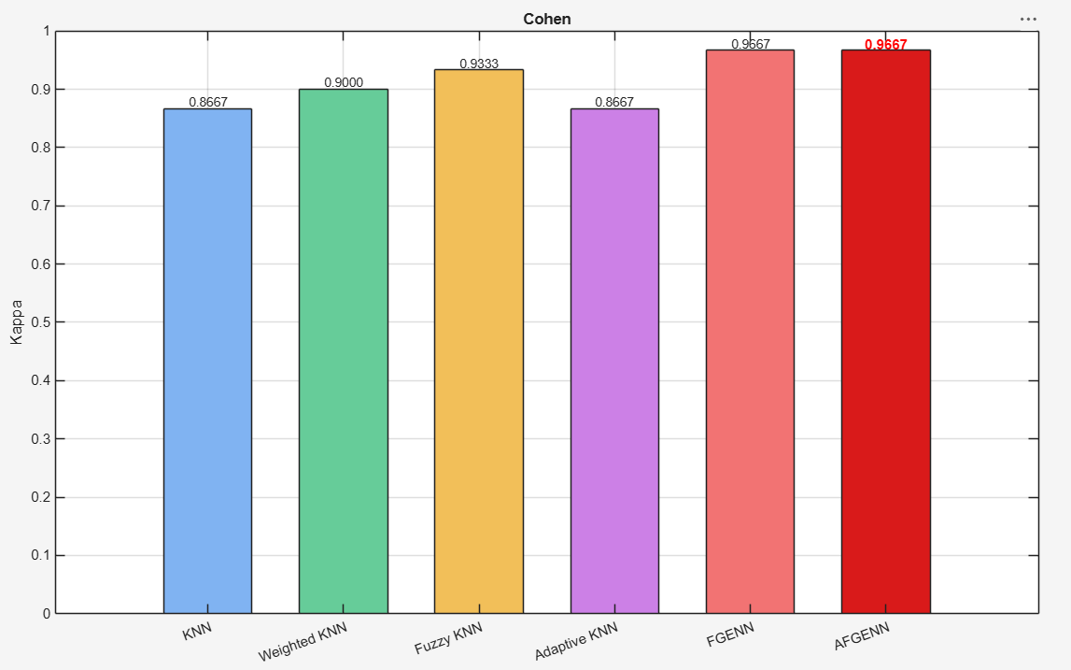

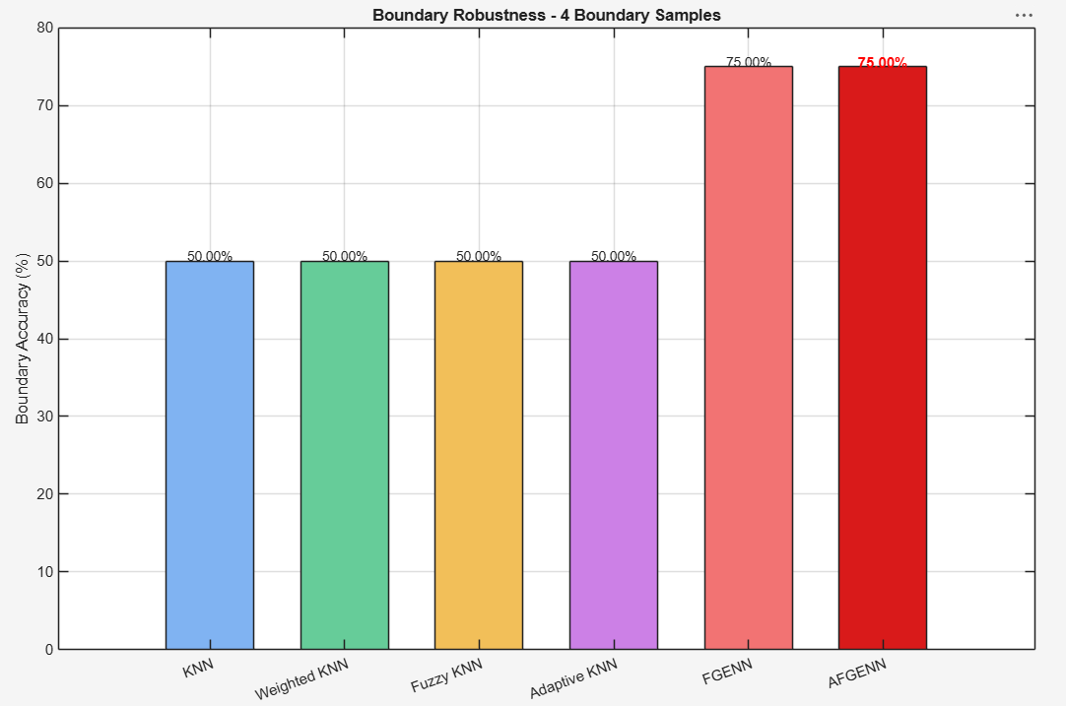

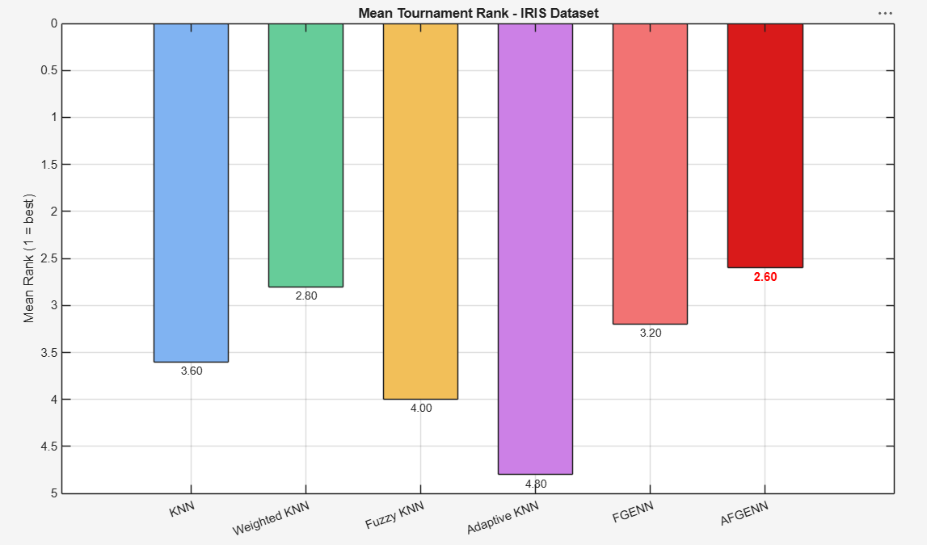

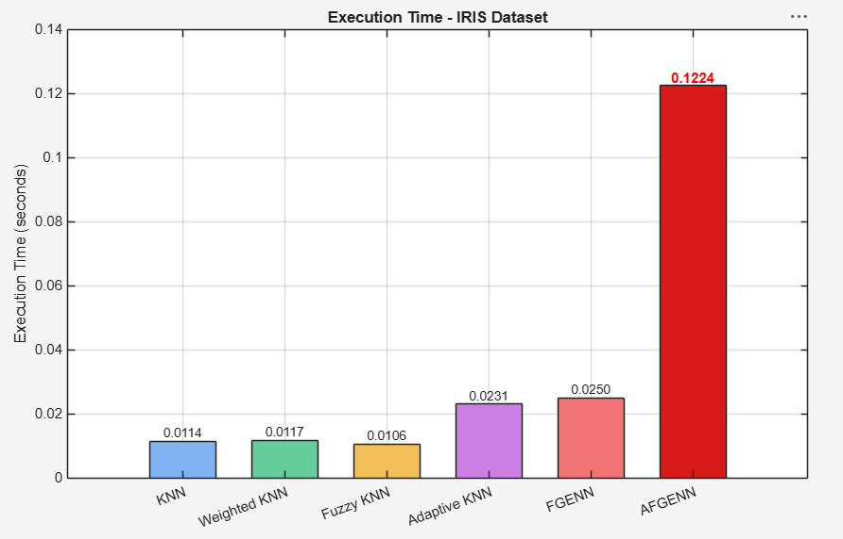

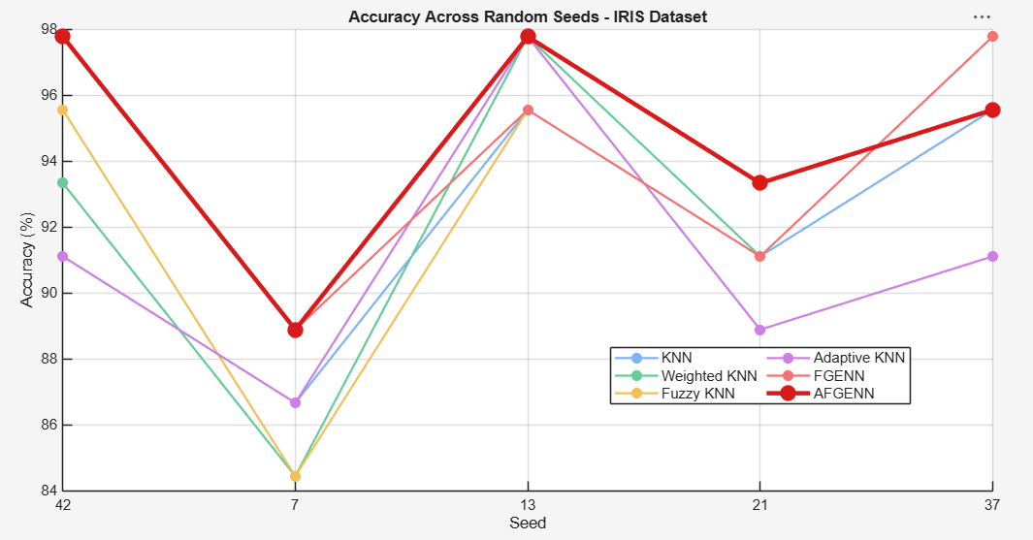
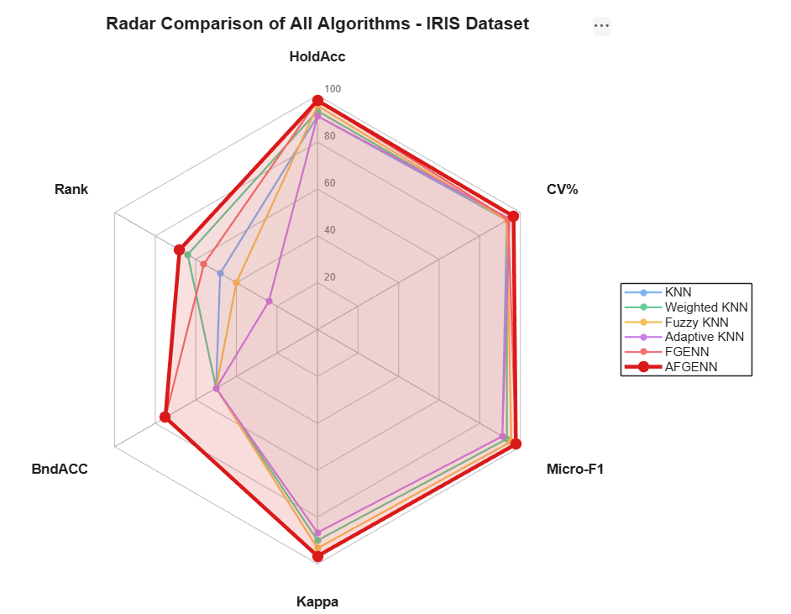

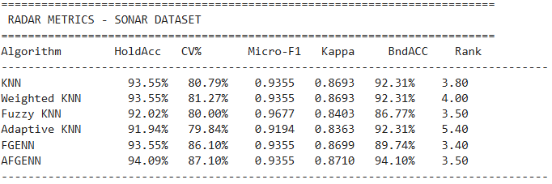

==========================================================================
RESULTS - SONAR DATASET
==========================================================================
Algorithm HoldAcc CV Mean Macro-F1 Kappa Boundary Rank Time(s)
-----------------------------------------------------------------------------------------------
KNN 93.55% 80.79% 0.9344 0.8693 92.31% 3.80 0.0116
Weighted KNN 93.55% 81.27% 0.9344 0.8693 92.31% 4.00 0.0215
Fuzzy KNN 92.02% 80.00% 0.9202 0.8403 86.77% 3.50 0.0161
Adaptive KNN 91.94% 79.84% 0.9176 0.8363 92.31% 5.40 0.0173
FGENN 93.55% 86.10% 0.9349 0.8699 89.74% 3.40 0.0176
AFGENN 94.09% 87.10% 0.9401 0.8710 94.10% 3.50 0.1161 <-- AFGENN
-----------------------------------------------------------------------------------------------

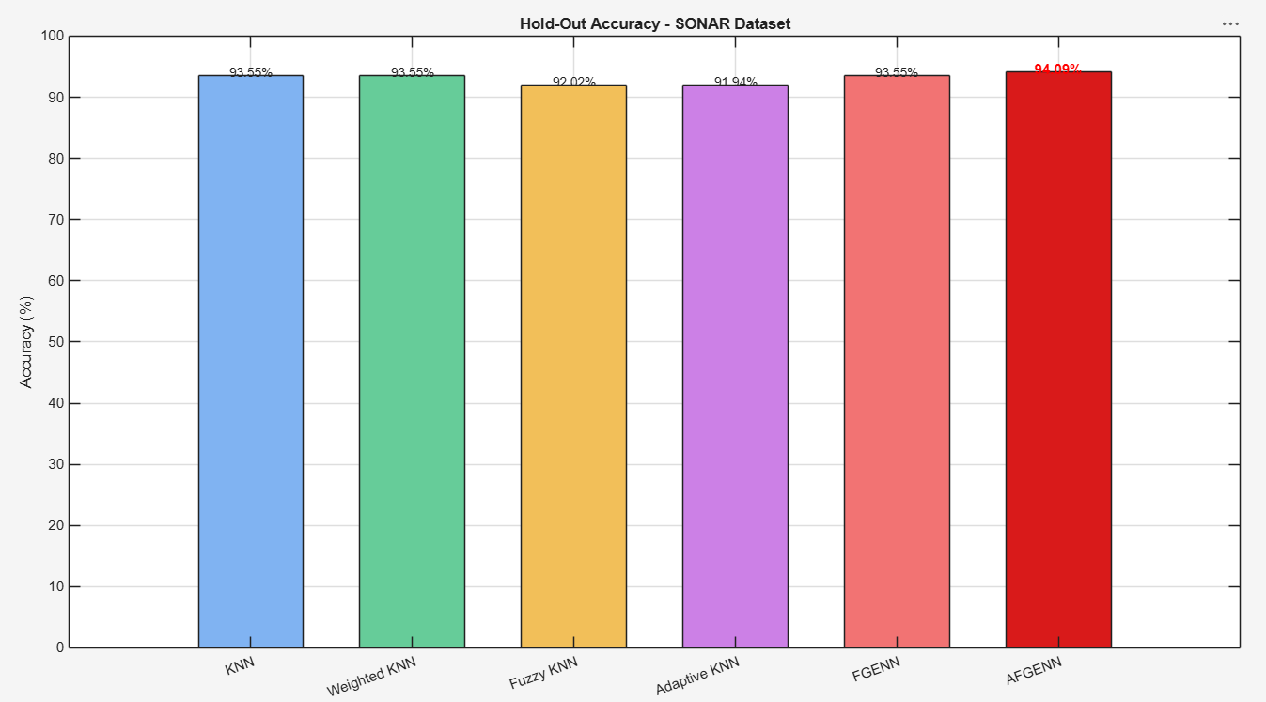

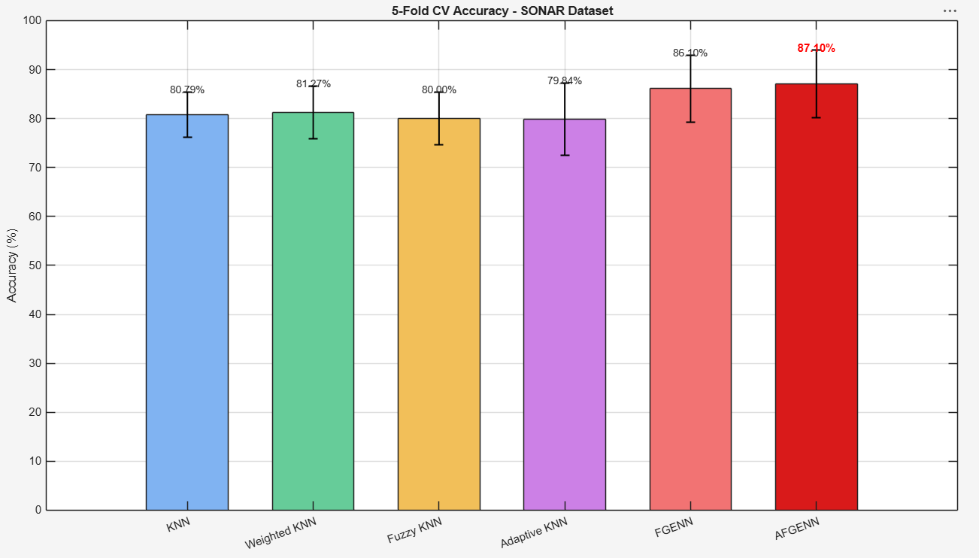

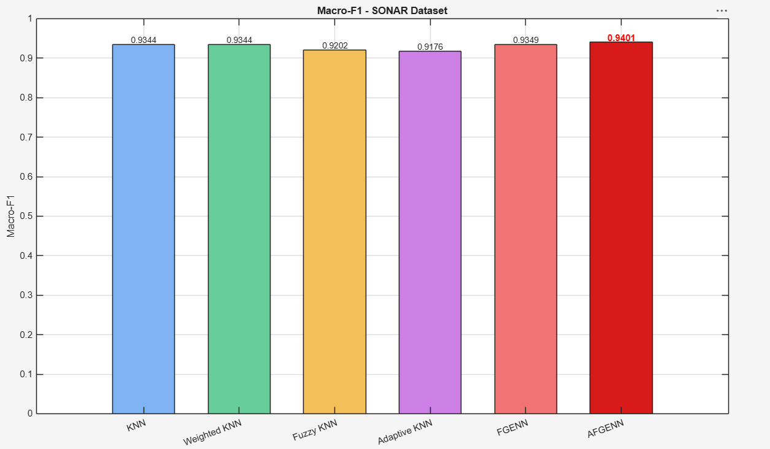

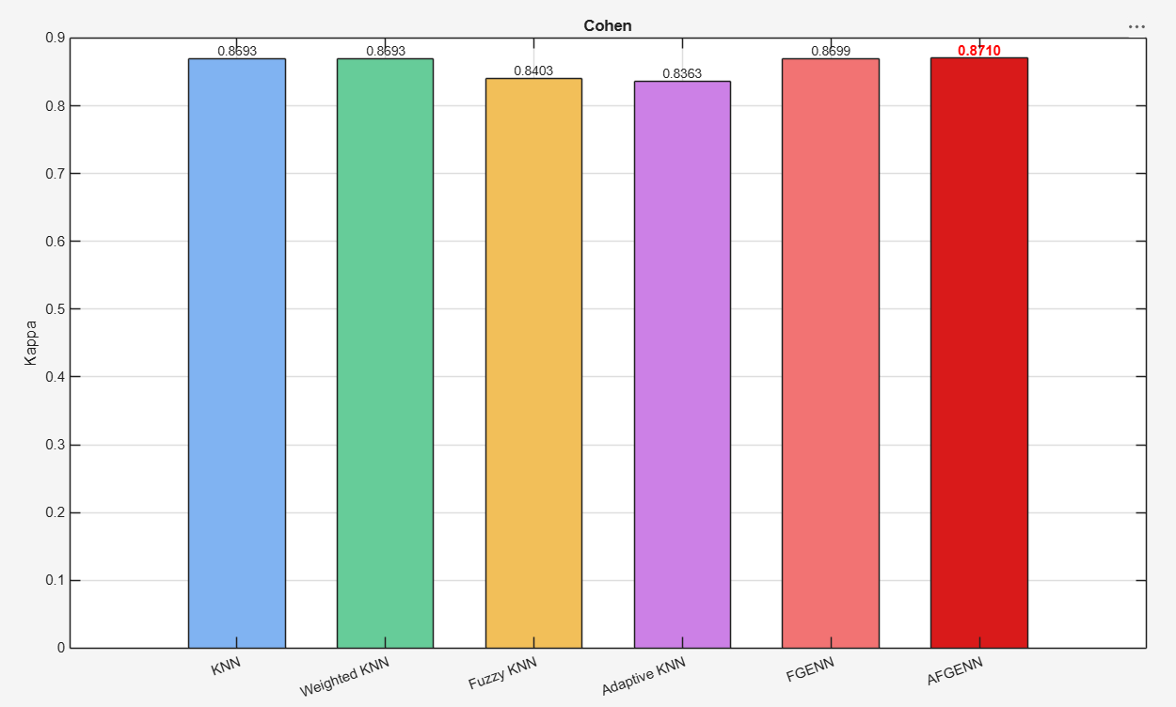

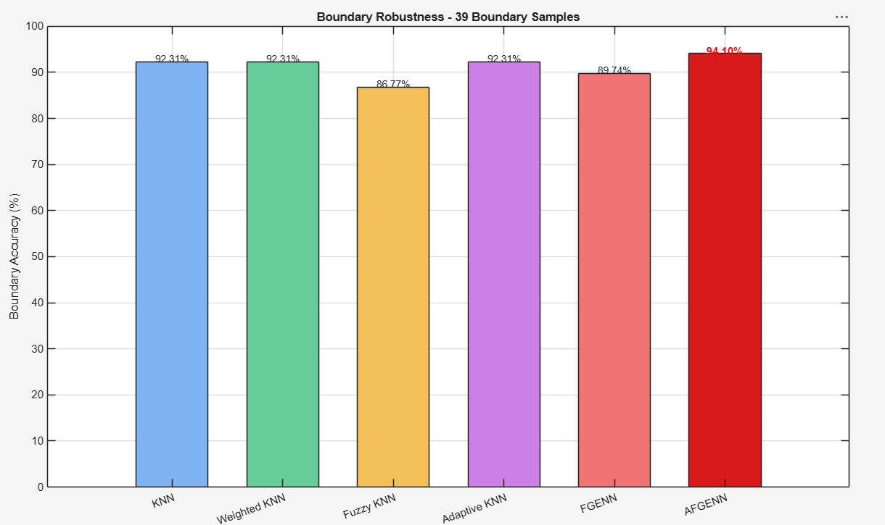

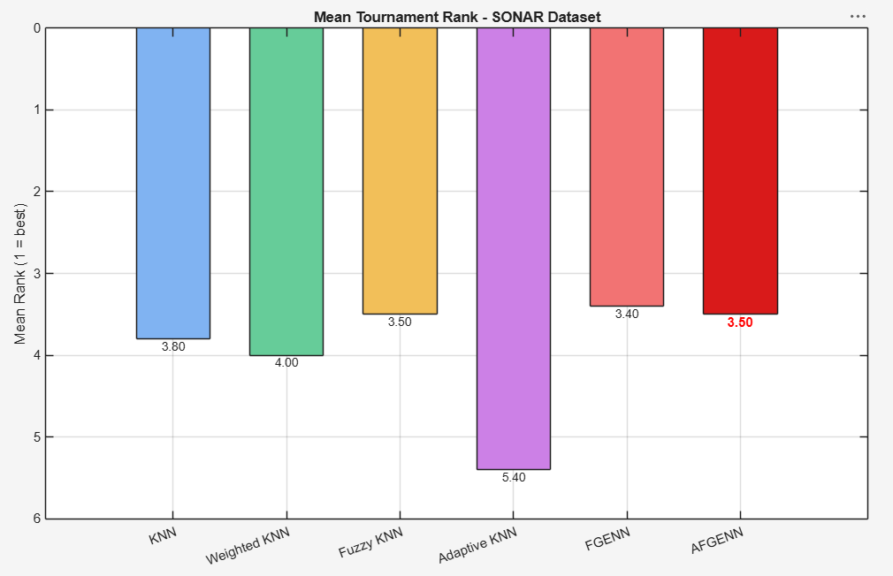

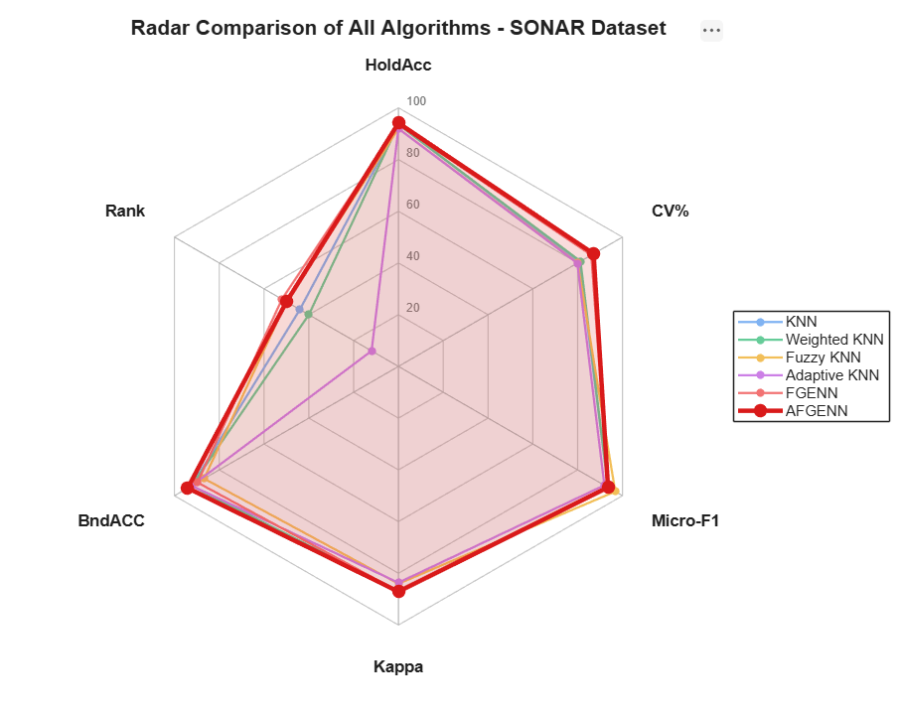

==========================================================================
RESULTS - COVTYPE DATASET
==========================================================================
Algorithm HoldAcc CV Mean Macro-F1 Kappa Boundary Rank Time(s)
-----------------------------------------------------------------------------------------------
KNN 64.67% 64.20% 0.3672 0.4081 57.00% 4.00 0.0929
Weighted KNN 67.33% 68.40% 0.5776 0.4635 55.56% 2.20 0.1215
Fuzzy KNN 68.33% 69.10% 0.5779 0.4838 54.11% 1.60 0.0873
Adaptive KNN 64.00% 63.10% 0.3750 0.3983 56.04% 5.60 0.0922
FGENN 62.00% 67.80% 0.5099 0.3896 44.93% 5.00 0.0340
AFGENN 69.12% 69.60% 0.5818 0.4959 59.11% 1.00 15.9124 <-- AFGENN
-----------------------------------------------------------------------------------------------
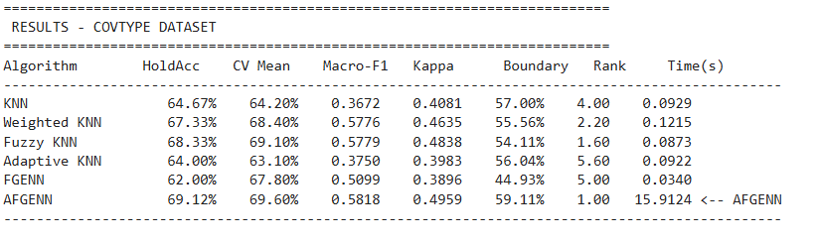

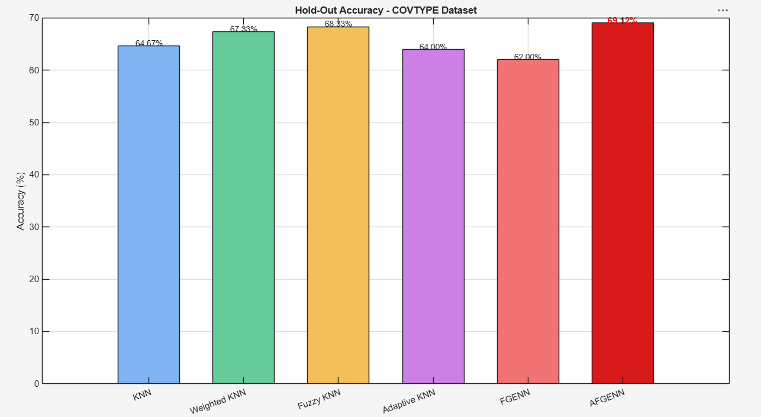

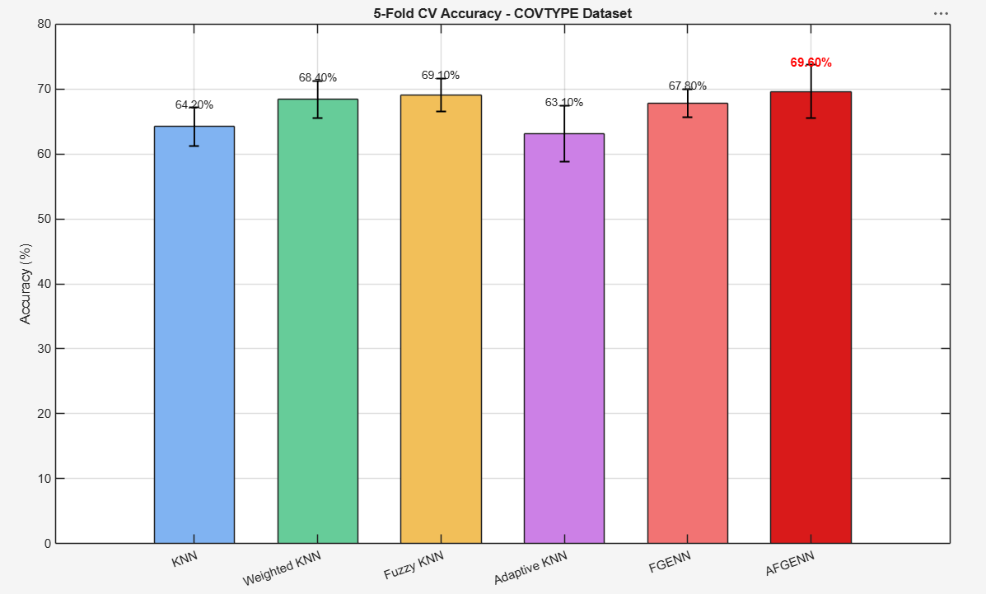
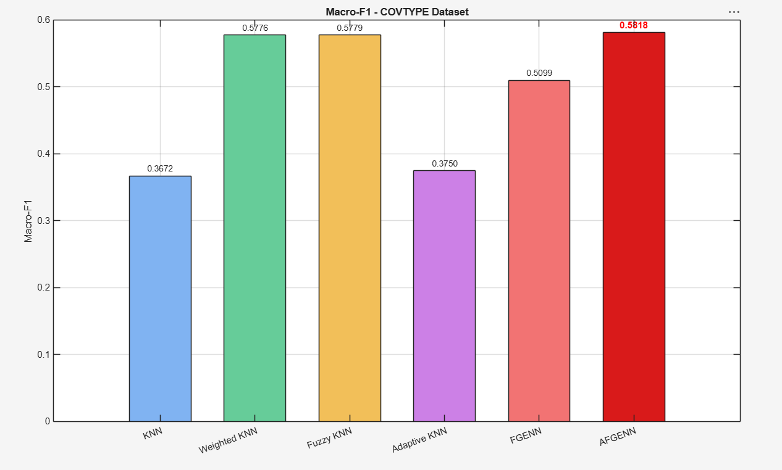

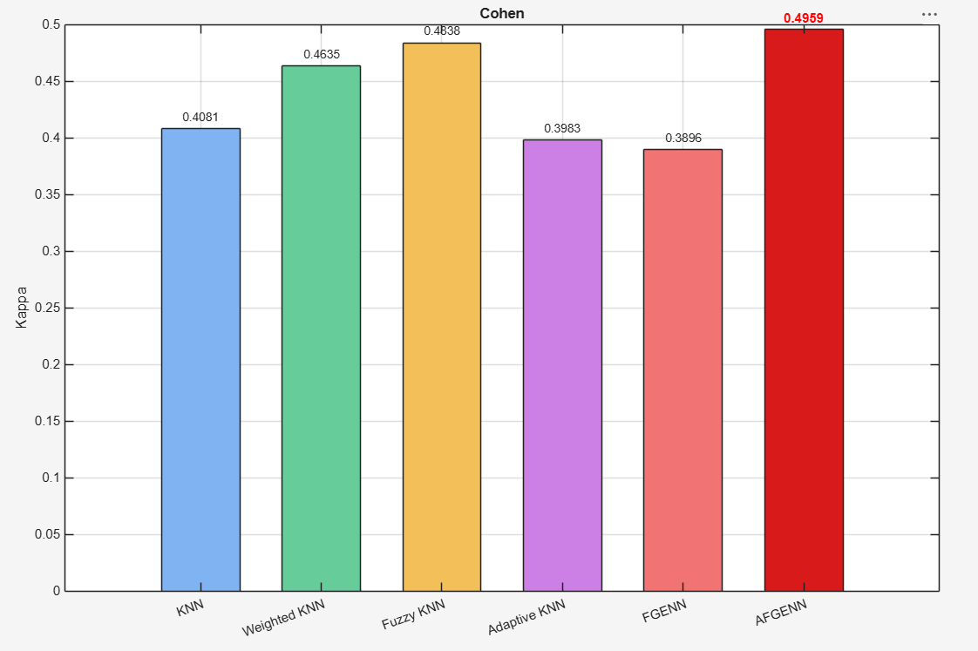

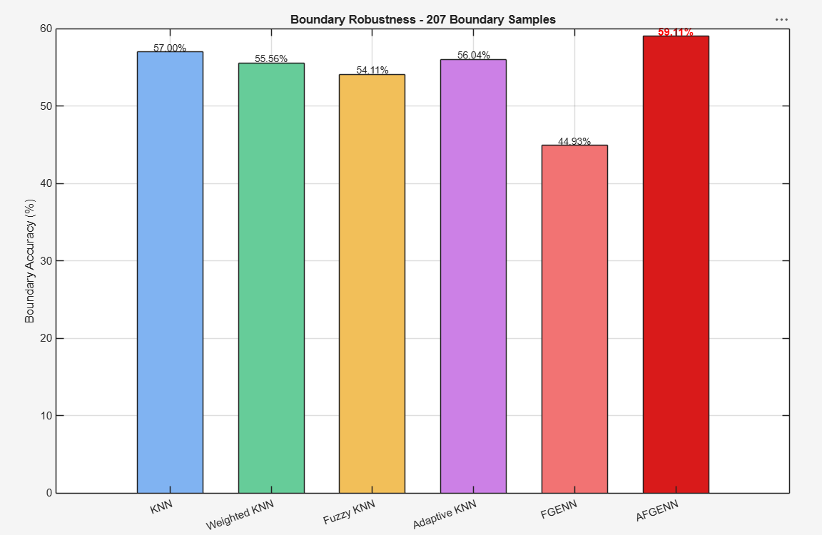

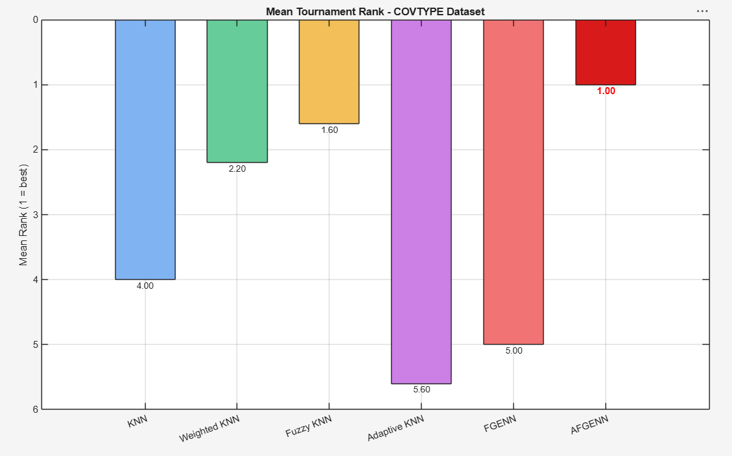

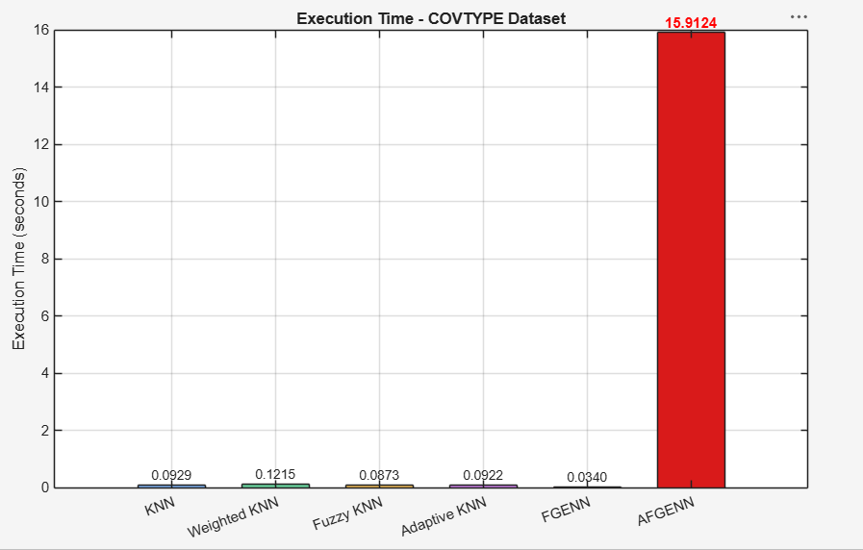

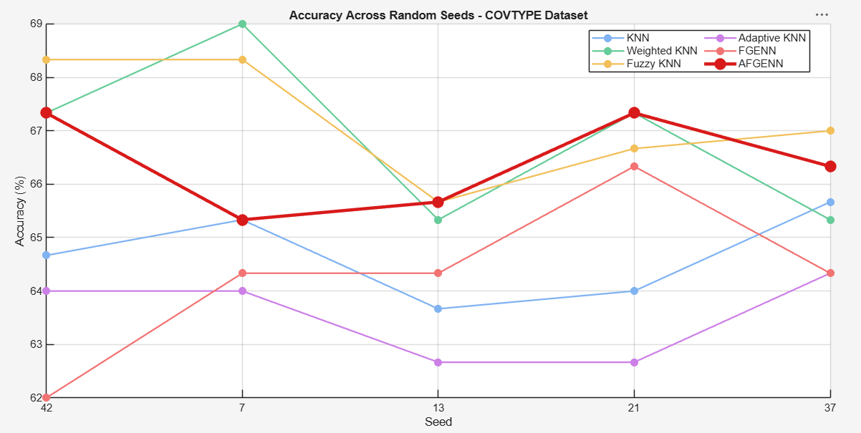

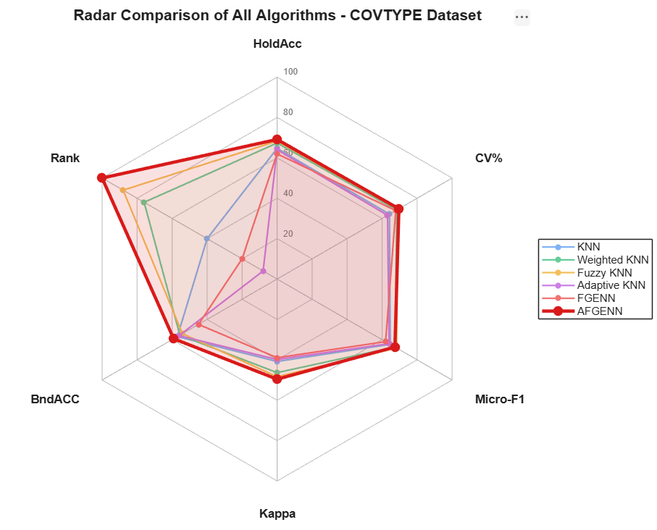

Quantization Function (4-bit)
IRIS
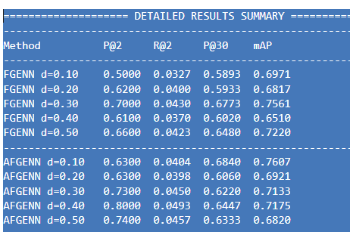
==================== DETAILED RESULTS SUMMARY ====================
--------------------------------------------------------------------
Method P@2 R@2 P@30 mAP
--------------------------------------------------------------------
FGENN d=0.10 0.5000 0.0327 0.5893 0.6971
FGENN d=0.20 0.6200 0.0400 0.5933 0.6817
FGENN d=0.30 0.7000 0.0430 0.6773 0.7561
FGENN d=0.40 0.6100 0.0370 0.6020 0.6510
FGENN d=0.50 0.6600 0.0423 0.6480 0.7220
--------------------------------------------------------------------
AFGENN d=0.10 0.6300 0.0404 0.6840 0.7607
AFGENN d=0.20 0.6300 0.0398 0.6060 0.6921
AFGENN d=0.30 0.7300 0.0450 0.6220 0.7133
AFGENN d=0.40 0.8000 0.0493 0.6447 0.7175
AFGENN d=0.50 0.7400 0.0457 0.6333 0.6820
--------------------------------------------------------------------

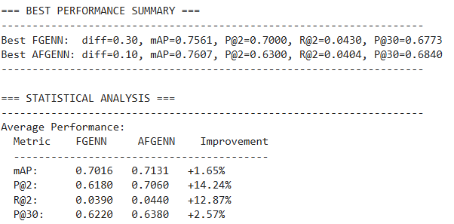
=== BEST PERFORMANCE SUMMARY ===
--------------------------------------------------------------------
Best FGENN: diff=0.30, mAP=0.7561, P@2=0.7000, R@2=0.0430, P@30=0.6773
Best AFGENN: diff=0.10, mAP=0.7607, P@2=0.6300, R@2=0.0404, P@30=0.6840
--------------------------------------------------------------------
=== STATISTICAL ANALYSIS ===
--------------------------------------------------------------------
Average Performance:
Metric FGENN AFGENN Improvement
-----------------------------------------
mAP: 0.7016 0.7131 +1.65%
P@2: 0.6180 0.7060 +14.24%
R@2: 0.0390 0.0440 +12.87%
P@30: 0.6220 0.6380 +2.57%
--------------------------------------------------------------------
=== Experiment Complete ===

SONAR Dataset
%% 4. Quantization Function (4-bit)

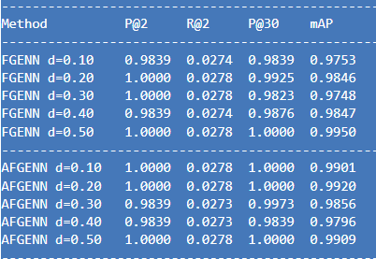
==================== DETAILED RESULTS SUMMARY ====================
--------------------------------------------------------------------
Method P@2 R@2 P@30 mAP
--------------------------------------------------------------------
FGENN d=0.10 0.9839 0.0274 0.9839 0.9753
FGENN d=0.20 1.0000 0.0278 0.9925 0.9846
FGENN d=0.30 1.0000 0.0278 0.9823 0.9748
FGENN d=0.40 0.9839 0.0274 0.9876 0.9847
FGENN d=0.50 1.0000 0.0278 1.0000 0.9950
--------------------------------------------------------------------
AFGENN d=0.10 1.0000 0.0278 1.0000 0.9901
AFGENN d=0.20 1.0000 0.0278 1.0000 0.9920
AFGENN d=0.30 0.9839 0.0273 0.9973 0.9856
AFGENN d=0.40 0.9839 0.0273 0.9839 0.9796
AFGENN d=0.50 1.0000 0.0278 1.0000 0.9909
--------------------------------------------------------------------

=== BEST PERFORMANCE SUMMARY ===
--------------------------------------------------------------------
Best FGENN: diff=0.50, mAP=0.9950, P@2=1.0000, R@2=0.0278, P@30=1.0000
Best AFGENN: diff=0.20, mAP=0.9920, P@2=1.0000, R@2=0.0278, P@30=1.0000
--------------------------------------------------------------------
=== STATISTICAL ANALYSIS ===
--------------------------------------------------------------------
Average Performance on SONAR Dataset:
Metric FGENN AFGENN Improvement
-----------------------------------------
mAP: 0.9829 0.9877 +0.49%
P@2: 0.9935 0.9935 +0.00%
R@2: 0.0277 0.0276 -0.11%
P@30: 0.9892 0.9962 +0.71%
--------------------------------------------------------------------

Covtype Dataset
%% 8. Quantization Function (4-bit)

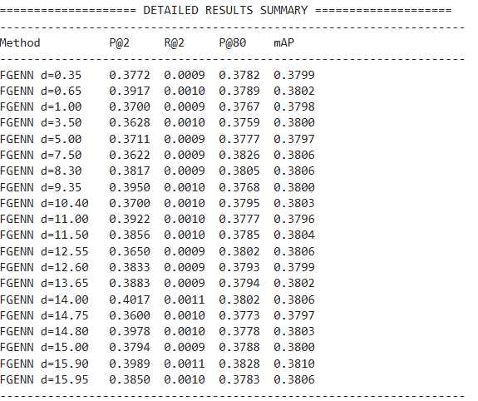
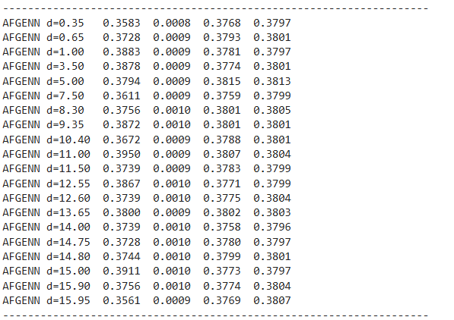
==================== DETAILED RESULTS SUMMARY ====================
--------------------------------------------------------------------
Method P@2 R@2 P@80 mAP
--------------------------------------------------------------------
FGENN d=0.35 0.3772 0.0009 0.3782 0.3799
FGENN d=0.65 0.3917 0.0010 0.3789 0.3802
FGENN d=1.00 0.3700 0.0009 0.3767 0.3798
FGENN d=3.50 0.3628 0.0010 0.3759 0.3800
FGENN d=5.00 0.3711 0.0009 0.3777 0.3797
FGENN d=7.50 0.3622 0.0009 0.3826 0.3806
FGENN d=8.30 0.3817 0.0009 0.3805 0.3806
FGENN d=9.35 0.3950 0.0010 0.3768 0.3800
FGENN d=10.40 0.3700 0.0010 0.3795 0.3803
FGENN d=11.00 0.3922 0.0010 0.3777 0.3796
FGENN d=11.50 0.3856 0.0010 0.3785 0.3804
FGENN d=12.55 0.3650 0.0009 0.3802 0.3806
FGENN d=12.60 0.3833 0.0009 0.3793 0.3799
FGENN d=13.65 0.3883 0.0009 0.3794 0.3802
FGENN d=14.00 0.4017 0.0011 0.3802 0.3806
FGENN d=14.75 0.3600 0.0010 0.3773 0.3797
FGENN d=14.80 0.3978 0.0010 0.3778 0.3803
FGENN d=15.00 0.3794 0.0009 0.3788 0.3800
FGENN d=15.90 0.3989 0.0011 0.3828 0.3810
FGENN d=15.95 0.3850 0.0010 0.3783 0.3806
--------------------------------------------------------------------
AFGENN d=0.35 0.3583 0.0008 0.3768 0.3797
AFGENN d=0.65 0.3728 0.0009 0.3793 0.3801
AFGENN d=1.00 0.3883 0.0009 0.3781 0.3797
AFGENN d=3.50 0.3878 0.0009 0.3774 0.3801
AFGENN d=5.00 0.3794 0.0009 0.3815 0.3813
AFGENN d=7.50 0.3611 0.0009 0.3759 0.3799
AFGENN d=8.30 0.3756 0.0010 0.3801 0.3805
AFGENN d=9.35 0.3872 0.0010 0.3801 0.3801
AFGENN d=10.40 0.3672 0.0009 0.3788 0.3801
AFGENN d=11.00 0.3950 0.0009 0.3807 0.3804
AFGENN d=11.50 0.3739 0.0009 0.3783 0.3799
AFGENN d=12.55 0.3867 0.0010 0.3771 0.3799
AFGENN d=12.60 0.3739 0.0010 0.3775 0.3804
AFGENN d=13.65 0.3800 0.0009 0.3802 0.3803
AFGENN d=14.00 0.3739 0.0010 0.3758 0.3796
AFGENN d=14.75 0.3728 0.0010 0.3780 0.3797
AFGENN d=14.80 0.3744 0.0010 0.3799 0.3801
AFGENN d=15.00 0.3911 0.0010 0.3773 0.3797
AFGENN d=15.90 0.3756 0.0010 0.3774 0.3804
AFGENN d=15.95 0.3561 0.0009 0.3769 0.3807
--------------------------------------------------------------------

AFGENN Best Results (Balanced):
Diff Value: 11.00
P@2: 0.3950 (vs FGENN: -0.97%)
R@2: 0.0009 (vs FGENN: -12.32%)
P@80: 0.3807 (vs FGENN: -0.56%)
mAP: 0.3804 (vs FGENN: -0.14%)
Best Individual AFGENN Metrics:
Best P@2: 0.3950 at diff=11.00
Best R@2: 0.0010 at diff=9.35
Best P@80: 0.3815 at diff=5.00
Best mAP: 0.3813 at diff=5.00
========================================

==================== DETAILED RESULTS SUMMARY 4bits====================
--------------------------------------------------------------------
Method P@2 R@2 P@80 mAP
--------------------------------------------------------------------
FGENN d=0.35 0.3967 0.0009 0.3752 0.3799
FGENN d=0.65 0.3928 0.0009 0.3766 0.3799
FGENN d=1.00 0.4161 0.0009 0.3778 0.3799
FGENN d=3.50 0.4156 0.0010 0.3767 0.3803
FGENN d=5.00 0.3944 0.0009 0.3743 0.3795
FGENN d=7.50 0.4000 0.0009 0.3737 0.3797
FGENN d=8.30 0.3894 0.0009 0.3732 0.3799
FGENN d=9.35 0.3539 0.0009 0.3772 0.3807
FGENN d=10.40 0.3833 0.0009 0.3742 0.3798
FGENN d=11.00 0.3783 0.0009 0.3772 0.3806
FGENN d=11.50 0.3728 0.0009 0.3763 0.3800
FGENN d=12.55 0.4228 0.0010 0.3782 0.3801
FGENN d=12.60 0.3922 0.0009 0.3759 0.3805
FGENN d=13.65 0.3606 0.0009 0.3808 0.3807
FGENN d=14.00 0.4250 0.0009 0.3772 0.3800
FGENN d=14.75 0.3950 0.0009 0.3752 0.3801
FGENN d=14.80 0.4050 0.0009 0.3776 0.3800
FGENN d=15.00 0.4322 0.0010 0.3732 0.3800
FGENN d=15.90 0.3622 0.0009 0.3772 0.3801
FGENN d=15.95 0.3939 0.0009 0.3770 0.3799
--------------------------------------------------------------------
AFGENN d=0.35 0.3994 0.0009 0.3754 0.3799
AFGENN d=0.65 0.4017 0.0009 0.3755 0.3799
AFGENN d=1.00 0.4044 0.0009 0.3760 0.3799
AFGENN d=3.50 0.4183 0.0009 0.3788 0.3803
AFGENN d=5.00 0.4183 0.0010 0.3770 0.3798
AFGENN d=7.50 0.4028 0.0010 0.3745 0.3798
AFGENN d=8.30 0.3978 0.0009 0.3758 0.3798
AFGENN d=9.35 0.4039 0.0009 0.3730 0.3798
AFGENN d=10.40 0.3878 0.0009 0.3721 0.3800
AFGENN d=11.00 0.3950 0.0011 0.3767 0.3802
AFGENN d=11.50 0.3967 0.0009 0.3745 0.3790
AFGENN d=12.55 0.3722 0.0009 0.3724 0.3796
AFGENN d=12.60 0.4056 0.0010 0.3749 0.3806
AFGENN d=13.65 0.3961 0.0009 0.3746 0.3800
AFGENN d=14.00 0.3944 0.0010 0.3773 0.3803
AFGENN d=14.75 0.3861 0.0009 0.3745 0.3795
AFGENN d=14.80 0.4150 0.0009 0.3767 0.3799
AFGENN d=15.00 0.4017 0.0010 0.3769 0.3799
AFGENN d=15.90 0.3922 0.0009 0.3740 0.3798
AFGENN d=15.95 0.4128 0.0010 0.3788 0.3803

AFGENN Best Results (Balanced):
Diff Value: 3.50
P@2: 0.4183 (vs FGENN: +18.21%)
R@2: 0.0009 (vs FGENN: -0.91%)
P@80: 0.3788 (vs FGENN: +0.43%)
mAP: 0.3803 (vs FGENN: -0.09%)
Best Individual AFGENN Metrics:
Best P@2: 0.4183 at diff=3.50
Best R@2: 0.0011 at diff=11.00
Best P@80: 0.3788 at diff=15.95
Best mAP: 0.3806 at diff=12.60
========================================

