Pipeline Pressurizing Test Documents
Common description:
Table 1 shows the specification of the pipeline used.
Contents | Value
Thickness | t > 4.85mm (-12.5% to INF.)
Length | 2m
Size | 150A
Notch size | 0.1mm x 10mm x 2.7mm  (width x length x depth)
Notch center position | 295mm (from a side)
Metal | SPP(KSD3507) C(-) MIN(-) P(0.040%) S(0.040%)
Design pressure | 25Bar
Out diameter | 6’’ (165.2mm)
Inner diameter | 155.5mm (not exactly)

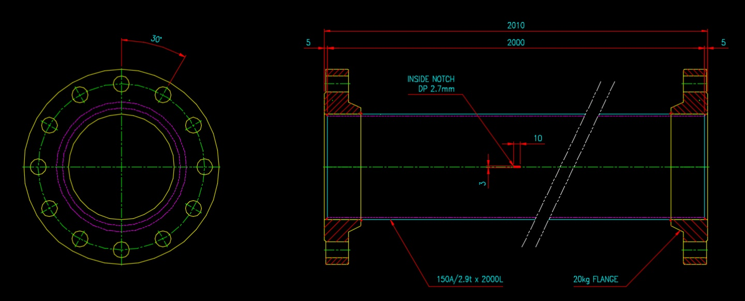
Fig. 1 Pipeline diagram
In this experiment, six pipes, one plain pipe and five notched pipes were used. The pipe was pressurized to 0 ~ 200 Bar by nine stages of pressurization. The first pressure is 0 Bar to check the background noise, the second is 50% of the design pressure, the third is 65%, the fourth is 80%, the fifth is 100%. And in 4 stages (50, 100, 150, 200) further pressurize. Data collection times are 30, 10, 10, 10, 30, 5, 5, 5, 5 min at each stage. Pressure data is stored in each folder "pressure.mat".
Sampling rate : 1M Hz
Sensor Type : R15I-AST
Sensor position :

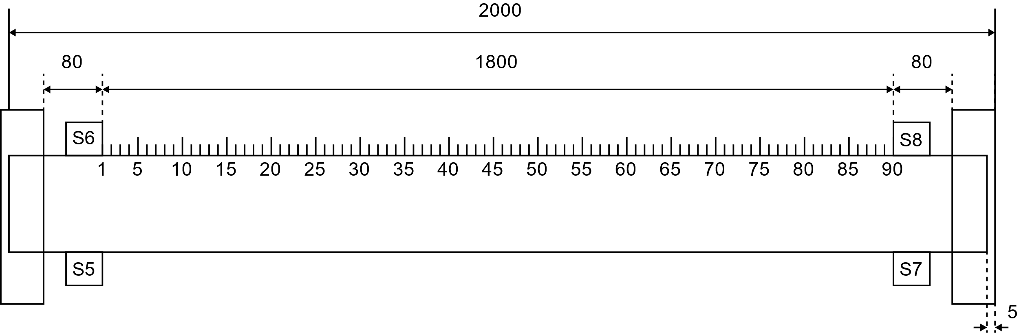
Fig. 2 Position of sensor mounter and points of pencil leak break
(20mm spacing for each position)

