**UNIVERSITY OF ENGINEERING & TECHNOLOGYMARDAN**

**DEPARTMENT OF COMPUTER SCIENCE**

FINAL YEAR PROJECT PROPOSAL



**TITLE OF THE PROJECT: Hostel Management System**

**Group Members:**

|  |  |  |
| --- | --- | --- |
| **Name** | **Registration #** | **Email** |
| Mumtaz Ali | 21MDBCS124 | Engrmumtazali01@gmail.com |
| Muhammad Maaz | 21MDBCS151 | maazkhan29456@gmail.com |
| Muhammad Abubakar | 21MDBCS169 | m.abubaakar755@gmail.com |

**Proposed Supervisor:**

**Name: _________________**

**Signature: ______________**

Contents

1. Introduction 2

2. Problem Statement 3

3. Objectives 3

4. Literature Review 3

5. Methodology for Implementation of Project 3

6. Budget Details 4

7. Project Implementation Schedule 5

8. Utilization of Project Results 5

9. FYP to SDG's Mapping 5

10. Undertaking 6

11. Proposed Supervisor's Comments 7

12. Comments of FYP Coordinator 7

13. Approval by the Chairman of Department 8

14. References 8

# **Introduction**

The Hostel Management System is a comprehensive software solution designed to automate and streamline hostel operations, addressing the challenges faced by traditional manual management methods [1]. This innovative system replaces outdated processes with a user-friendly interface that benefits hostel administrators, staff, and students alike [2]. By efficiently handling tasks such as room bookings, student registrations, and fee payments, the system not only saves time but also significantly reduces errors, ultimately enhancing the overall experience for all stakeholders involved in hostel life [1] [3].

Key features of the Hostel Management System include:

1. Centralized Database: Maintains accurate and up-to-date information on students, rooms, and financial transactions [2].
2. Automated Room Allocation: Streamlines the process of assigning rooms based on availability and student preferences [1].
3. Online Fee Management: Facilitates easy payment and tracking of hostel fees, reducing administrative burden [3].
4. Complaint Management: Provides a platform for students to register and track their complaints or maintenance requests [2].
5. Visitor Management: Enhances security by keeping track of visitors entering and leaving the hostel premises [1].

# **Problem Statement**

Managing hostel facilities manually is inefficient, error-prone, and lacks real-time data handling. The specific problem addressed by this system is to replace manual data entry, room allocation, and fee management with a computerized system that is faster, more accurate, and capable of handling various administrative tasks seamlessly.

# **Objectives**

* Improve Hostel Management Efficiency
* Optimize Room and Resource Allocation
* Automate Administrative and Billing Processes
* Enhance Communication and Student Clearance

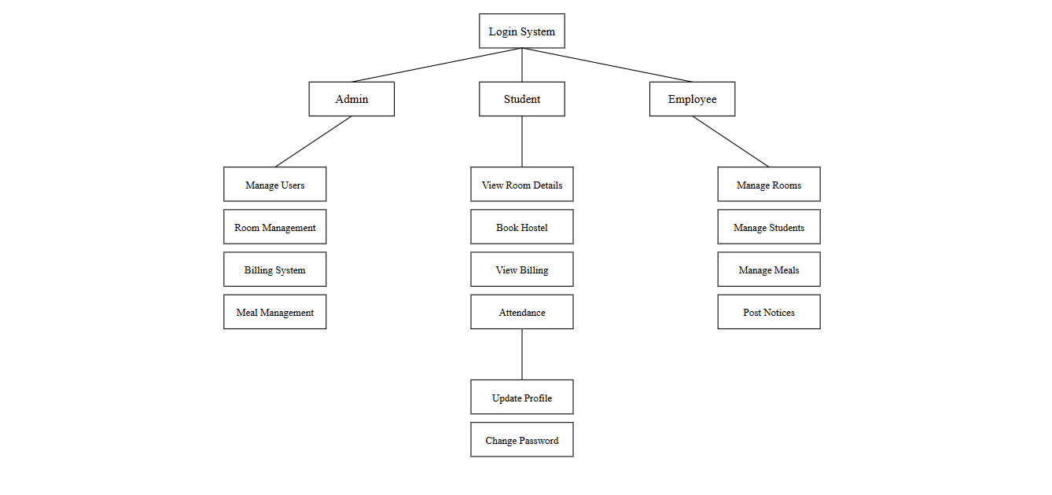

# **Literature Review**

In creating the Hostel Management System, we explored current solutions and practices in hostel management. Our research highlighted the limitations of traditional methods, which often rely on manual data entry and are time-consuming. The existing system requires significant effort, as while students can apply for hostel accommodations online, the allocation process is handled manually. This manual approach can lead to errors and potential corruption in room assignments and hostel fee calculations. Additionally, the current system does not manage mess calculations or allow for easy complaint registration.

By examining the latest advancements in software and data management, our proposed solution aims to leverage technology to automate these essential hostel management tasks. This system will utilize modern concepts from database management, user-friendly interface design, and automation to enhance efficiency and improve the overall user experience.

# **Methodology for Implementation of Project**

The Hostel Management System will be developed using a modular approach. Here's how we plan to build and implement the system:

* 1. Requirements Gathering and Analysis
  2. System Design
  3. Plan out how the whole system will work
  4. Design the database and user interfaces
  5. Create flowcharts for each part of the system

1. Development We will use the following technologies: Front-end:
   1. HTML: To create the structure of web pages
   2. CSS: To make the pages look attractive
   3. Bootstrap: To make the site work well on mobile devices
   4. JavaScript: To add interactive features to the pages
   5. Laravel framework: To build the main structure of our system
   6. Python Django: To create dynamic web pages
   7. Sqlite: To store and manage all the data
   8. Login System
   9. Room Management
   10. Student Registration and Management
   11. Employee Management
   12. Billing System
   13. Meal Management
   14. Notice Board
   15. Attendance Tracking
   16. Student Clearance Process
2. Testing
   1. Test each part of the system separately
   2. Test how all parts work together
   3. Ask hostel staff and students to try the system and give feedback
3. Deployment and Training
   1. Install the system on the hostel's computers
   2. Train administrators, staff, and students on how to use the system
4. Maintenance and Support
   1. Provide ongoing help if there are any problems
   2. Make improvements based on user feedback

# **Budget Details**

Software Tools: No additional cost (open-source software like Laravel, MySQL).

Testing and Deployment: $150 for hosting and server costs.

# **Project Implementation Schedule**

|  |  |  |  |  |  |  |
| --- | --- | --- | --- | --- | --- | --- |
| Activity | 15 Oct - 30 Nov | 30 Dec-15 Jan | 15 Jan-20 Feb | 20 Feb-30 Mar | 1 May-15 Jun | 15 Jun-10 Jul |
| Requirements Gathering | √ |  |  |  |  |  |
| System Design |  | √ |  |  |  |  |
| Frontend Development |  | √ |  |  |  |  |
| Backend Development |  |  | √ | √ |  |  |
| Integration and Testing |  |  |  |  | √ |  |
| Documentation and Final Report |  |  |  |  |  | √ |

# **Utilization of Project Results**

The Hostel Management System will provide a scalable solution for educational institutions to manage their hostel facilities efficiently. It can be used in universities, colleges, and training centers to streamline their accommodation services, reduce administrative workload, and improve student satisfaction by offering a transparent and user-friendly management process.

# **FYP to SDG's Mapping**

|  |  |  |
| --- | --- | --- |
| **Goal#** | **Description** | **Justification** |
| **Goal 1** | **QUALITY EDUCATION** | The Hostel Management System contributes to quality education by improving the living conditions and administrative processes in student accommodations, allowing students to focus more on their studies. |
| **Goal 2** | **INDUSTRY, INNOVATION, AND INFRASTRUCTURE** | This project promotes innovation in educational infrastructure management, introducing digital solutions to traditional hostel management challenges. |
| **Goal 3** | **SUSTAINABLE CITIES AND COMMUNITIES** | By optimizing resource allocation and improving communication within hostels, the system contributes to more sustainable and efficient urban living spaces. |

# **Undertaking**

This is to certify that to the best of my knowledge; the content of this project proposal is my own work. This proposal has not been submitted for any degree or other purposes. I certify that the intellectual content of this project is the product of my own work and that all assistance received in preparing this proposal and sources have been acknowledged.

**Signature: _______________**

**Name:**

**Reg. #**

**Signature: _______________**

**Name:**

**Reg. #**

**Signature: _______________**

**Name:**

**Reg. #**

# **Proposed Supervisor's Comments**

Signature of Supervisor:

Name of Supervisor:

Designation of Supervisor:

# **Comments of FYP Coordinator**

Comments of FYP Coordinator in accordance with recommendations of FYP Committee.

Signature of FYP Coordinator: __________________ Dated: __________________

# **Approval by the Chairman of Department**

Signature: __________________ Dated: _____________________

# **References**

[1] Patil, S. V., Thakare, P. S., Koli, A., Tupe, P., & Aher, S. (2019). Hostel Management System (HMS). International Journal for Research in Applied Science and Engineering Technology, 7(4), 3136-3139. Retrieved from <https://www.ijraset.com/research-paper/hostel-management-system-hms>

[2] Chaudhri, K., & Kevat, R. (2021). "Study of Digitalized Hostel Management System." U.G. Scholar, Vishwakarma Government Engineering College, Chandkheda, Gujarat, India Available at <https://ijsrcseit.com/paper/CSEIT217280.pdf>.

[3] Hostel Management Project Report. (2021). "Hostel Management System." Available at [https://www.slideshare.net/slideshow/hostel-management-projectreport/134905987#2.](https://www.slideshare.net/slideshow/hostel-management-projectreport/134905987%232.)

kfhfdf