**Project Report:** **Robot Pointing on a Wall (Task-01)**

**Objective:**

To create a bar chart visualizing the distribution of population across the top 20 countries for the year 2021 using the World Bank dataset.

**Dataset:**

Source: [World Bank Population Data](https://data.worldbank.org/indicator/SP.POP.TOTL)

File Used: API_SP.POP.TOTL_DS2_en_csv_v2_56.csv

**Methodology:**

Data Loading:

The dataset was loaded using pandas with metadata rows skipped.

Filtering:

Selected the population data for the year 2021.

Missing values were removed for a clean analysis.

Sorting:

Top 20 countries with the highest population were identified by sorting.

Visualization:

A bar chart was created using matplotlib to depict the population distribution.

**Key Insights:**

The visualization highlights the top 20 most populous countries in 2021.

Countries like China, India, and the United States dominate the population distribution.

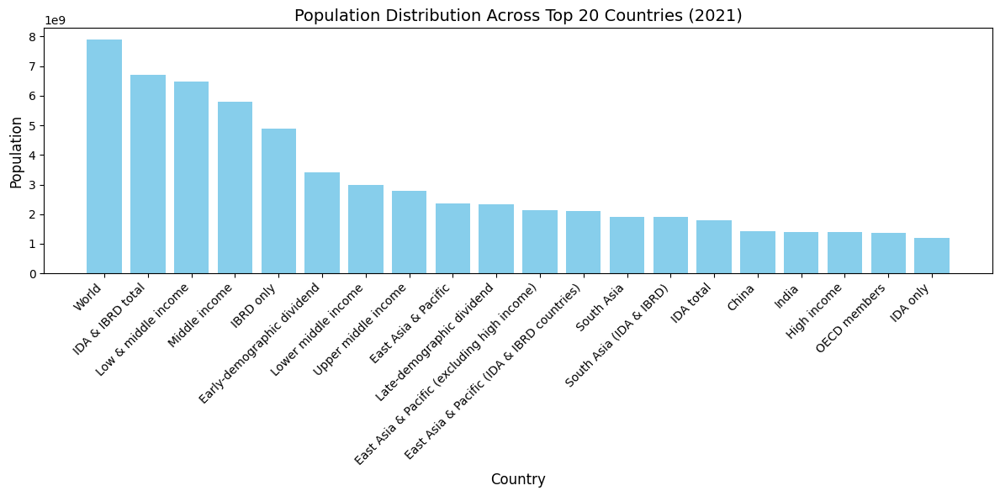

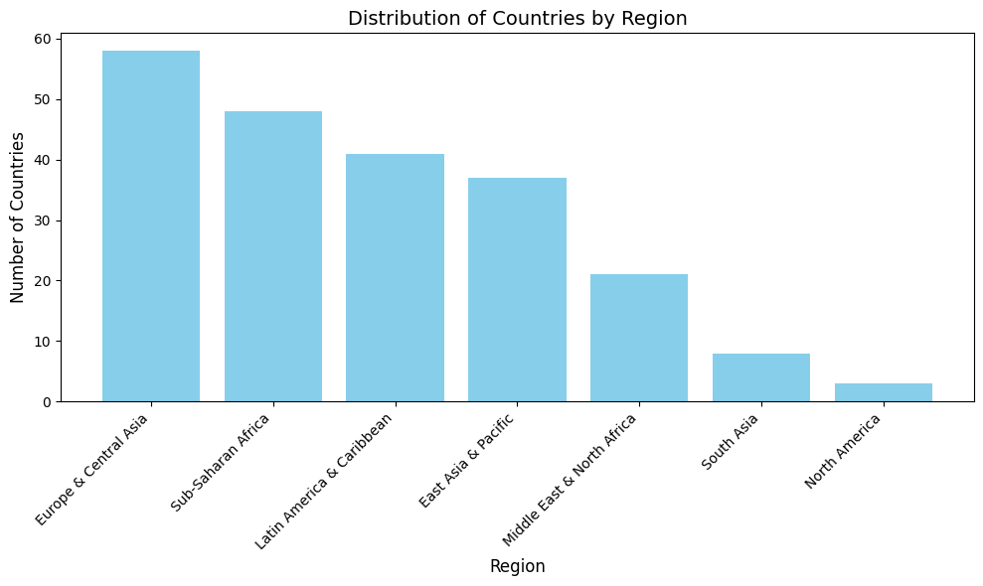

**Output:**

A bar chart showing the population distribution across the top 20 countries in 2021, emphasizing disparities in global population.