**UNIVERSITY OF ENGINEERING & TECHNOLOGYMARDAN**

**DEPARTMENT OF COMPUTER SCIENCE**



Name: Mumtaz Ali Registration No: 21MDBCS124

Section: A Subject : HCI

Instructor : Hameed Ullah Date :20/10/2024

Assignment NO#: 2

**Task #1:** Design a PSD Mockup Create a PSD (Photoshop Document) mockup for the user interface of your Final Year Project using any free online design tool. The tools below are recommended, but you can use others as well:

Canva:

Link: [Go to See Mockup in Canva](https://www.canva.com/design/DAGUMpe0Gac/Neps8dKa96nJ6SWLYrqOjQ/view?utm_content=DAGUMpe0Gac&utm_campaign=designshare&utm_medium=link&utm_source=editor)

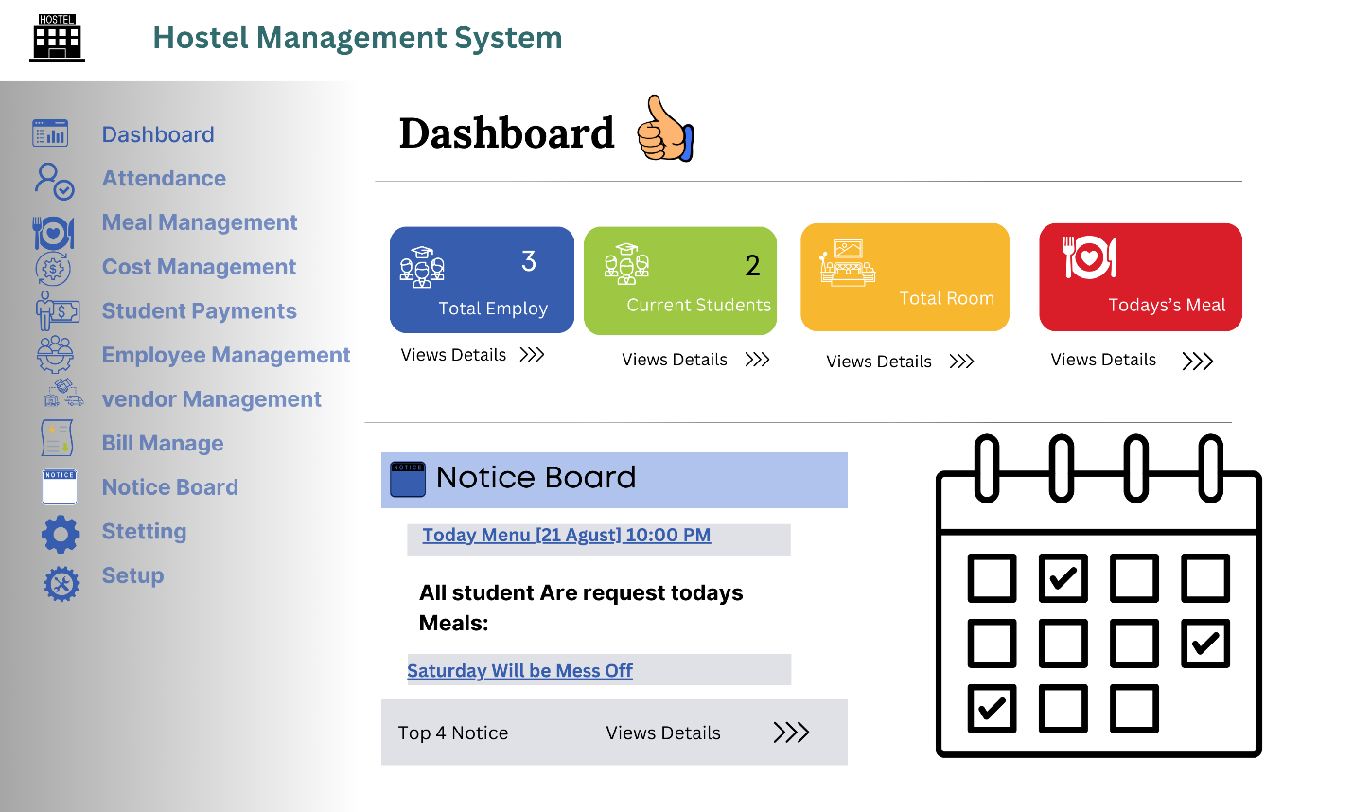

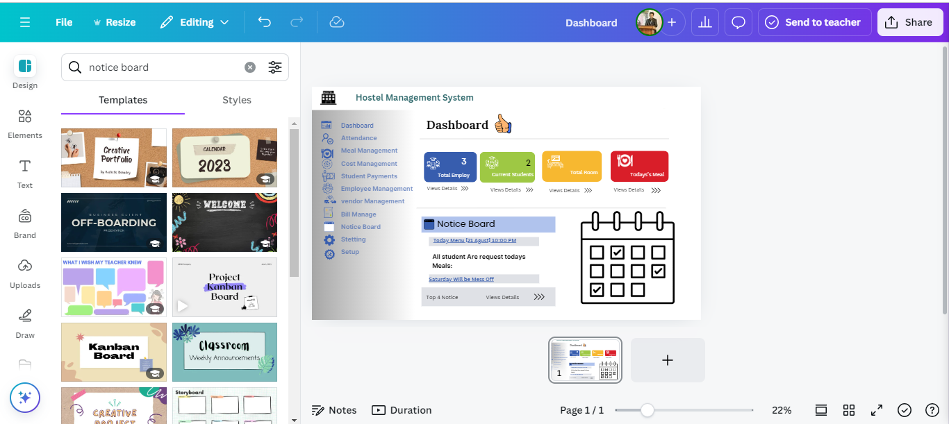

**Task #2:** Convert PSD to HTML/CSS Convert your PSD mockup from Task #1 into a functional webpage using HTML and CSS. Make sure to structure your code well and apply appropriate styling.

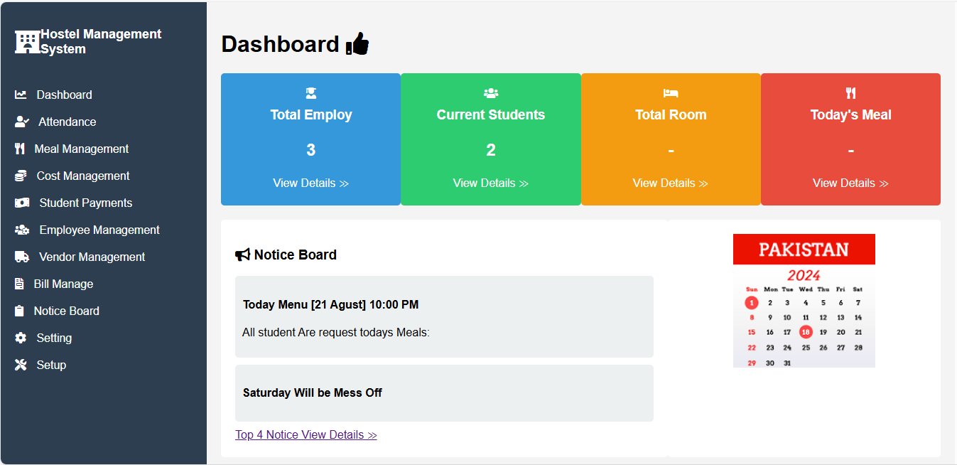

**Task #3: Upload to GitHub**

Upload both Task #1 (PSD/mockup design) and Task #2 (HTML/CSS implementation) to a GitHub

repository. Ensure your repository is organized and includes all necessary files

To showcase your work for these tasks, you should:

* Create a new repository on GitHub named "hostel-management-system-ui".
* Structure your repository as follows:

hostel-management-system-ui/

├── design/

│ └── hostel-management-dashboard.png

├── implementation/

│ ├── index.html

│ └── styles.css

├── assets/

│ └── (any additional assets, if used)

├── README.md

└── LICENSE.md

* In the design/ folder, include the PNG export of your Canva design.
* In the implementation/ folder, include your HTML and CSS files.
* Copy the README.md content provided above into your repository's README.md file. Make sure to update the [Your Name] placeholder with your actual name.
* Create a simple LICENSE.md file (you can use GitHub's license template feature when creating a new file).
* Commit and push all these files to your repository.
* In your repository settings, make sure the repository is public so it can be easily shared and reviewed.