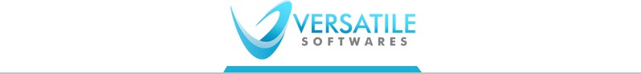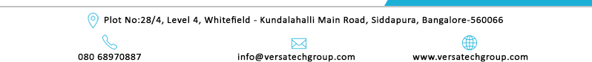

**Relieving Letter**

**Date: October 12, 2023**

**Employee Name: Kunchapu Prasad**

# Employee id: V/S-0810

**Designation: Full Stack Developer**

Dear kunchapu.

With reference to your letter dated on Sep 12th ,2023 we hereby with inform to you that your resignation has been accepted and you shall be relived from your duties as Full Stack Developer at the closing hours of Oct 12th,2023.

We would also want to conform that full and final settlement would be cleared in the next 30days with Organization, diligent and honest in performing your duties. We appreciate your contribution to Versatile Software and wish you all the best future endeavours.

Wish you all the best for your future from Versatile Software.

**Warm Regards,**

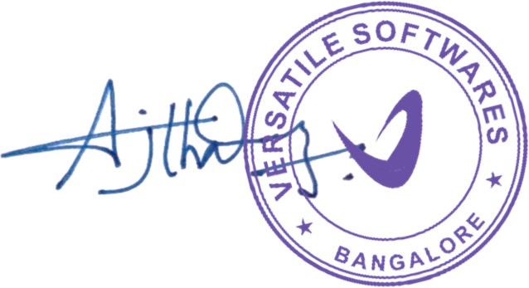

**For Versatile Softwares.**

**Ajith Varma**

**Manager– HRD**